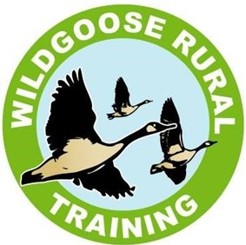
WILDGOOSE RURAL TRAINING Medication Policy
Premises Address:
Wildgoose Rural Training
Old Quarry Drive
Main Road
Hallow
WR2 6LS
Contact Number: 01905 620840
Plan Date: December 2023
Review Date: December 2026
Designated Staff Hollie Burfitt

Nathan Langley
Jim Hidderley

Wildgoose Rural Training will only administer medication on written instruction from the students’ place of residence whether that be a parent or carer.

Wildgoose Rural Training does NOT supply any medication themselves, and no medication is kept at the farm overnight unless stored under instruction and that will be in a safe.

The student must bring their medication in the original packaging and marked with their name and date of birth and any instructions. The medication will only be administered if we already hold written confirmation that this is to be done, or the medication is accompanied by written confirmation, signed and dated by a representative from the student’s place of residence.

All medication brought to the farm must be checked for a name and date of birth and added to service user records. You can find the MAR sheet in their personal folder. However if we are informed that a student has capacity to self-medicate then it will be the sole responsibility of them.

All medication will be locked in the safe as soon as they arrive, unless it’s an over-the-counter medication and they can self-medicate. In this case they can keep it in their bag. EpiPens will be kept with student or stored in a locked cabinet in the staff office.
.

Staff administering medicines will be appropriately trained by an external provider or by a member of staff that has been trained.

All medication can be administered by one staff member. In exceptional circumstances and where the medication risk assessment has evidenced a risk, two members of staff may be required.

Service users that self-administer should inform a member of staff, and this should be documented on their MAR sheet which is located in their individual file. Supervision for students who self-administer, can be completed by ANY member of the staff team.

PLEASE NOTE- A PHONE CALL HOME TO NOTIFY A PARENT OR CARER OF THE DOSGAE AND TIME MUST BE MADE.

Any surplus medication or out-of-date medication must be returned home with the service user so that they can dispose of it at their local Pharmacy.

If Midazolam is administered an ambulance will be called, it will then be documented in their individual incident file online, the duty manager notified, and parents or carers informed immediately.

Epilepsy training has been completed by most staff (see training log). However, this is not a legal requirement but completed for best practice.

Epilepsy care plans are also stored with each Buccolam dose within the meds cabinet to enable staff to suitably administer medication in the case of a seizure.

