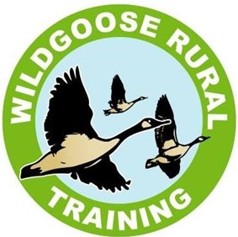

Wildgoose Rural Training Child Exploitation Policy
Wildgoose Rural Training centre is committed to ensuring children and young people are safe.
Wildgoose recognises the growing risk in relation to the exploitation of vulnerable young people, particularly those who are looked after or have emotional and/or mental health difficulties. For this reason, Wildgoose has high expectations in relation to the safeguarding of young people in our care, and the prevention of exploitation. This policy should be read in conjunction with Wildgoose’s safeguarding policy.

Premises Address:

Wildgoose Rural Training

Old Quarry Drive

Main Road

Hallow

WR2 6LS

Contact Number: 01905 620840

Plan Date: December 2023

Review Date: December 2026

Designated SMT Hollie Burfitt

Jon Wightman

Jim Hidderley

- What is Child Sexual Exploitation?
  - “Child sexual exploitation is a form of child sexual abuse. It occurs where an individual or group takes advantage of an imbalance of power to coerce, manipulate or deceive a child under the age of 18 into sexual activity (a) in exchange for something the victim needs or wants, and/or (b) for the financial advantage or increased status of the perpetrator or facilitator. The victim may have been sexually exploited even if the sexual activity appears consensual. Child sexual exploitation does not always involve physical contact: it can also occur through the use of technology. It requires knowledge, skills, professional curiosity and an assessment which analyses the risk factors and personal circumstances of individual children to ensure that the signs and symptoms are interpreted correctly and appropriate support is given.” (DfE 2017)
Child sexual exploitation is not a choice. It is a form of abuse. It is important to remember that even when a relationship appears consensual, it may be an exploitative relationship. There can be an interchangeable status between victim and perpetrator. Young people can be both victim and perpetrator. Males and females can be both victims and perpetrators.
It can be both penetrative and non-penetrative. It can take place in person or via technology. Child sexual exploitation involves perpetrators grooming children and then forcing, enticing, threatening, and/or being violent towards them.
It is child sexual exploitation when the child receives or thinks that they will receive something that they want or need in exchange for the sexual activity. This can take the form of gifts, drugs, alcohol, or if the child perceive that they are getting love, affection, protection or protecting their families/friends, increased status within their peer group or community. Young people are still victims even if they accept what the perpetrator is offering in exchange for sexual activity. Perpetrators take advantage of an imbalance of power.
While it may appear that some young people are 'choosing' to exchange sex to meet their needs, it is vital to remember that young people have limited options and so it is not a
'choice' as such but rather ‘constrained choices’ or ‘survival strategies’.

2. Risk Factors
2.1 'Peer relationships are increasingly influential during adolescence, setting social norms which inform young people’s experiences, behaviours and choices and determine peer status. These relationships are, in turn, shaped by, and shape, the school, neighbourhood and online contexts in which they develop. So children socialise in safe and protective schools and community settings they will be supported to form safe and protective peer relationships. However, if they form friendships in contexts characterised by violence and/or harmful attitudes these relationships too may be anti-social, unsafe or promote problematic social norms as a means of navigating, or surviving in, those spaces'

2.2 Children’s peer groups, communities and social media activity are either key risk factors or key protective factors. For example, if a child socialises with peers who have a positive influence on their thinking and behaviours, this will more than likely protect them within their communities and neighbourhoods. Likewise, if children socialise with peers who are themselves involved in risky activities such as substance misuse, gangs or exploitative relationships, this too may impact on the child’s safety and wellbeing in the community and their neighbourhoods.
2.3 Key risk factors and vulnerabilities for children;
∙ Having a physical or learning disability.
∙ Being in care (particularly those in residential care and those with interrupted care histories). ∙ Having a prior experience of neglect, physical and/or sexual abuse.
∙ Lack of a safe/stable home environment, now or in the past (domestic violence or parental substance misuse, mental health issues or criminality, for example).
∙ Going missing (for short or long periods).
∙ Substance misuse issues.
∙ Disengagement or absences from education/training/employment.
∙ Lack of positive activities or hobbies.
∙ Gang-association/involvement and/or criminal behaviour.
∙ Recent bereavement or loss.
∙ Social difficulties, such as anti-social or violent behaviour.
∙ Social isolation, such as a lack of a friendship group or support network. ∙ Lack of insight into vulnerabilities and risks.
∙ Emotional and/or communication difficulties.
∙ Absence of a safe environment to explore sexuality, sexual identity or gender identity. ∙ Economic vulnerability.
∙ Homelessness or insecure accommodation status.
∙ Connections with other children and young people who are being sexually exploited. ∙ Family members or other connections involved in adult sex work.
∙ Low self-esteem
∙ Poor self-confidence
2.4 Key risk indicators are;
∙ Unexplained money or gifts
∙ Going missing (for short or long periods) ∙ Being distressed or withdrawn on return
∙ Disengaging from existing social networks
∙ Secrecy around new associations
∙ Additional mobile phones or concerning use of technology
∙ Sexual health problems
∙ Disclosure of rape/sexual assault (and reluctance to report)
∙ Changes in temperament/emotional wellbeing
∙ Drug or alcohol misuse
∙ Secretiveness
∙ Unexplained physical injuries.
2.5 Staff must remember this is not an exhaustive list. Staff must remain alert to possible signs of child sexual exploitation even if young people do not have any of the above risk indicators or vulnerabilities evident.

3. Trafficking
3.1 Child trafficking is when children are recruited, moved or transported for the purposes of exploitation, slavery, or abuse. Children can be trafficked as part of sexual exploitation, criminal activity such as the selling of drugs, forced marriage, forced labour and benefit fraud. The Modern Slavery Act 2015 establishes that a person commits an offence if
the person arranges or facilitates the travel of another with a view to being exploited. Wherever a child has been recruited, transported or transferred for the purpose of exploitation, they should be considered to be a victim of trafficking. This includes whether or not they have been forced, deceived or the child/young person believes that they are traveling willingly from one location to another, for example, where a child takes a bus or walks from one location to another for the purpose of exploitation.
3.2 Children who are trafficked will experience physical, sexual and emotional abuse. Children are groomed and then threatened, coerced or intimidated. Children who are victims of trafficking will suffer significant trauma and this can have a long-lasting detrimental impact on their mental health and emotional wellbeing.
3.3 Possible signs of trafficking include a child who;
∙ spends a lot of time doing household chores;
∙ rarely leaves their house, has no freedom of movement and no time for playing; ∙ is orphaned or living apart from their family, often in unregulated private foster care; ∙ lives in substandard accommodation;
∙ isn't sure which country, city or town they're in;
∙ is unable or reluctant to give details of accommodation or personal details; ∙ might not be registered with a school or a GP practice;
∙ has no documents or has falsified documents;
∙ has no access to their parents or guardians;
∙ is seen in inappropriate places such as brothels or factories;
∙ possesses unaccounted for money or goods;
∙ is permanently deprived of a large part of their earnings, required to earn a minimum amount of money every day or pay off an exorbitant debt;
∙ has injuries from workplace accidents;
∙ gives a prepared story which is very similar to stories given by other children. 3.4 Staff must report any concerns regarding trafficking to the Designated Safeguarding Lead.

∙ Safeguarding children who may have been trafficked (PDF, 535.7 KB) ∙ Safeguarding trafficked children toolkit (DOCX, 685.4 KB) ∙ Safeguarding unaccompanied children who arrive in Kent (PDF, 439.5 KB)
Modern Slavery Act 2015
The Modern Slavery Act 2015 is an Act of the Parliament of the United Kingdom. It is designed to tackle slavery in the UK and consolidates previous offences relating to trafficking and slavery.
Modern Slavery Training
Modern slavery often includes slavery, servitude, forced and compulsory labour and human trafficking. The impact can be devastating for the victims.
This resource is designed to share examples of training products available to public sector professionals and other individuals that might come across victims to help raise awareness, better spot the signs and increase confidence in reporting modern slavery when potential cases are encountered.

https://www.gov.uk/government/publications/modern-slavery-training-resource-page Leaflets
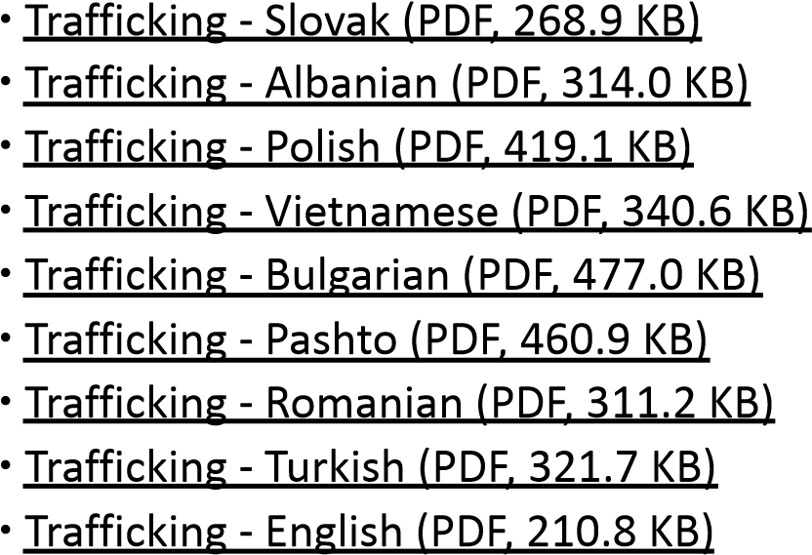
3.5 Trafficking concerns must be immediately referred to the National Referral Mechanism (NRM). The National Referral Mechanism (NRM) is a framework for identifying victims of human trafficking and ensuring they receive appropriate care. When a child or young person is trafficked, a range of agencies may be involved such as the police, the UK Border Agency
(UKBA), local authorities and non-governmental organisations such as charities. The NRM
makes it easier for these agencies to co-operate, share information and facilitate access to
advice, accommodation and support.
3.6 If there are immediate concerns that a pupil is being trafficked, staff must report this immediately to the Designated Safeguarding Lead and police.
3.7 For further information about reporting trafficking concerns or making a referral to the NRM, staff must speak to the Designated Safeguarding Lead and seek guidance from NSPCC Child Trafficking Advice Centre 0808 800 5000.

4. County Lines
4.1 “County Lines” is a national term used by police and law enforcement to commonly describe the approach taken by gangs and criminal networks originating from urban areas, who travel to locations such as county or coastal towns to sell class A drugs. Gangs typically use children, young people and vulnerable adults to deliver drugs to customers and this often involves the child being subjected to deception, intimidation, violence, and financial exploitation and grooming.
4.2 County lines relates to a group (not necessarily affiliated as a gang) establishing a network between an urban hub and county location, into which drugs (primarily heroin and crack cocaine) are supplied.
4.3 A branded mobile phone line is established in the market, to which orders are placed by introduced customers, with the line commonly (but not exclusively) being controlled by a third party, away from the market.
4.4 The group exploits young or vulnerable people to achieve the storage and/or supply of drugs, movement of cash proceeds and to secure the use of dwellings (commonly referred to as
‘cuckooing’).
4.5 The group, or individuals exploited by them, regularly travel between the urban hub and the county market, to replenish stock and deliver cash.
4.6 The group is inclined to use violence or threats and weapons, including knives, corrosives and firearms.
4.7 County Lines is a form of exploitation. Research says that some young people are more vulnerable than others to potential County Lines activity. Staff must ensure that they remain vigilant to potential risk factors in order to prevent risk from increasing and that they consider young people's vulnerabilities and risk factors as well as risk factors of the area.
4.8 Key risk factors for young people are:
∙ Young people/adults who have substance misuse issues living in ‘cuckooed’ premises. ∙ Young people who are looked after or who have been looked after and who are exploited for drug running purposes.
∙ Young people with mental health difficulties.
∙ Young people who go missing from their parents/carers.
∙ Young people who are withdrawn, who do not engage in school and have limited trusted adults around them. They are targeted by County Lines offenders due to their ability to operate without drawing attention to themselves.
4.9 Key risk factors of areas are:
∙ Towns with high unemployment.
∙ Towns with high levels of social housing and deprivation.
∙ Towns which are close to a prison
∙ Towns which have a probation centre nearby
∙ Towns which have a drug treatment centre
∙ Towns which have children’s homes
∙ Towns which have a train station or easy vehicle access

5. What to do if you have concerns that a pupil is being exploited
5.1 If there are immediate concerns for the pupil’s safety, staff must immediately report their concerns to the Designated Safeguarding Lead. The police must be notified if there are immediate concerns for a pupil’s safety or well being because of exploitation. Staff must share any concerns that they have with the Designated Safeguarding Lead, who will then support them to refer their concerns to the placing authority within one working day. The Designated Safeguarding Lead which is Hollie Burfitt must inform the CEO Jim Hidderley.
5.2 The Tutors must ensure that a preventative approach is taken and that all pupils are educated around the risks associated with grooming, online safety, safe/healthy relationships, sex including what consent means, and child sexual exploitation.
5.3 Phones and internet use can be a key risk factor relating to child sexual exploitation. If there are known risks relating to child sexual exploitation, wherever possible staff must supervise internet use. There must be procedures in place for pupil’s use of mobile phones in school.
5.4 Any concerns relating to online grooming must be immediately documented on Sleuth and reported to the Designated Safeguarding Lead. Staff must be aware of the Web Filtering
Policy.
5.5 Where risks or activities relating to possible exploitation are identified, staff must escalate this to the attention of the Designated Safeguarding Lead immediately. The placing authority must be notified within one working day unless there are immediate safeguarding concerns. It is recommended as best practice that all steps are taken to convene a multi-agency professionals meeting to review any potential child exploitation risks and agree actions to be taken to safeguard the young person/young people.
5.6 Child exploitation risks must be reviewed within governance meetings and within Senior Leadership Team meetings. The purpose of this is to ensure that information is being shared and that proactive measures are being taken to safeguard the young person/young people.
- What to do if a young person discloses that they have been exploited.
  - If a pupil discloses that they are being exploited, it is likely that this will be very traumatic for them. Staff must be aware of the potential impact that this could have on pupil's mental health and emotional wellbeing. Safety measures must be put in to support the pupil.
  - Staff must listen, ask open questions, write as much detail down as possible, and never promise to keep things secret. It is important that staff are open and honest with the pupil, and show them unconditional positive regard. It is likely that the pupil will need reassurance that they are safe and that they are not to blame. Staff must document all information onto Sleuth.
  - After a pupil has disclosed, staff must immediately report the information to the Designated Safeguarding Lead who will then support the staff member to report the information to the police and placing authority immediately.
  - Staff must ensure that the language they use is not 'victim-blaming'. Staff must show young people that they are non-judgmental and do not blame the young person for the abuse. If a young person has been sexually exploited by someone who they perceive as being their boyfriend, they may find it very traumatic to see this relationship as being exploitative and that the boyfriend did not love them as they perceived. It may take time for young people to understand and recognise that they have been exploited and so staff must be patient and support young people to get to this stage at the young person's own pace.
  - Designated Safeguarding Leads must ensure that staff known and understand the LSCB procedures for safeguarding young people against exploitation.
ANY CONCERNS PLEASE REPORT THEM TO

HOLLIE BURFITT – hollie@wgrt.org
JON WIGHTMAN – jon@wgrt.org
OR JIM HIDDERLEY – jim@wgrt.org

YOU CAN ALSO CONTACT THE
LOCAL SAFEGUARDING TEAM ON
01905 768053

