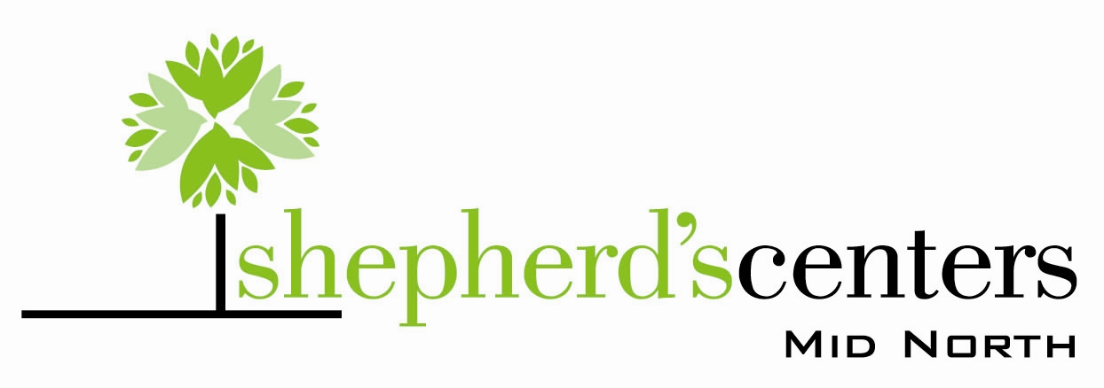

The Mid-North Shepherd’s Center is an interfaith program available to all persons 55 years of age and older. The Center offers many educational programs, a variety of activities and trips, as well as several types of support outreach and caring. The Center is “Where Seniors Continue to Learn, Serve and Grow”

Each year the Center offers an eight week Domestic Decisions series based on current local issues important to our members.

TOPICS FOR 2026:
- How Christian are “Christian Nationalists”
- The destruction of National Lands
- Demographic Change in Indiana
- The Childcare Crisis in Indiana
- Causes of Political Polarization
- Implications of the Immigration Crackdown
- AI Data Centers and Browsers
- Utilities, Increasing Energy Demands

Programs offered without charge on consecutive Wednesdays Oct. 21 – Dec. 16 at 11:00 followed by a an optional noon lunch (cost $10.00)

LOCATION:
38TH and Meridian St., Indianapolis, IN In the facilities of North United Methodist Church

October 21, 2026
How Christian are “Christian Nationalists”
A layman looks at the policies of the so-called “Christian Nationalists” and compares them with the tenets of the Christian faith that he was taught as a child.

Charles Hanson, MSEE University of Wisconsin Madison
Retired PE

October 28, 2026
The Destruction of National Lands
This administration is giving our national park land to big corporations.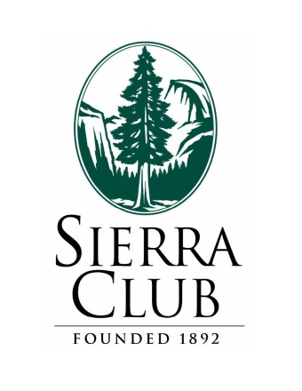
Lora Kemp, Sierra Club, Hoosier Chapter, Conservation Committee Chair and Forest Issue Activist

November 4, 2026
Demographic Change in Indiana
Indiana is changing. New people are coming in and your former neighbors are now elsewhere. The young are not replacing the old. And people are continuing to leave small towns for those that have grown bigger. Morton Marcus will tell us what is happening and what we can expect next.
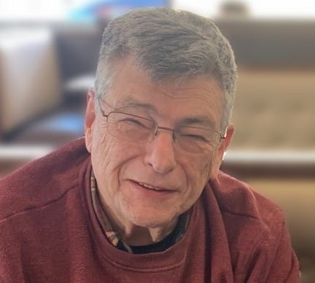
Morton Marcus, Ph.D
Research Economist (Ret.)
IU Kelley School of Business

November 11, 2026
The Childcare Crisis in Indiana
Reductions in government funding and lack of support have resulted in the closure of many much-needed childcare centers.
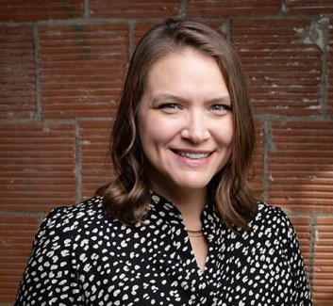
Ellen Kissling – Pres. & CEO
Early Learning of Indiana

November 18, 2026
Causes of Political Polarization
Our Political Polarization did not start with Trump, it started decades earlier. Professor Hanson will explain How and When it came about and present thoughts of possible solutions.
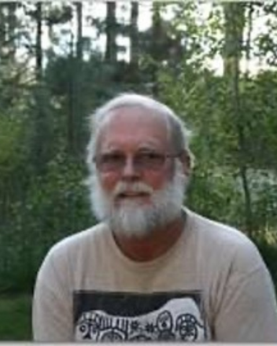
Paul Hanson, Ph. D.
Retired Professor of History
Butler University

December 2, 2026
Implications of the Immigration Crackdown
Political, financial, social, and food supply aspects.
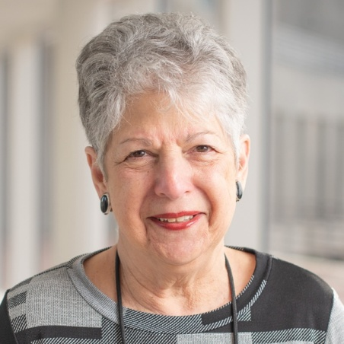
Sheila Kennedy, J. D.
Prof. Emerita, Ind. Univ. Sch. Of Law
December 9, 2026
AI Data Centers and Browsers
How did these developments come on us so fast? Should we have seen them coming?

George Zeltner MBA Wright State University(Ret)

December 16, 2026
Utilities, Increasing Energy Demands
Data centers, the importance of renewable energy sources, political aspects, etc.
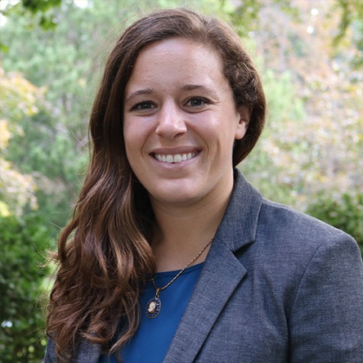
Rebecca TeKolste, M. A. Yale
Climate and Energy Senior Advisor
Hoosier Environmental Council

The Mid-North Shepherd’s Center is an interfaith program available to all persons 55 years of age and older. The Center offers many educational programs, a variety of activities and trips, as well as several types of support outreach and caring. The Center is “Where Seniors Continue to Learn, Serve and Grow”

Each year the Center offers an eight week Domestic Decisions series based on current local issues important to our members.

TOPICS FOR 2026:
- How Christian are “Christian Nationalists”
- The destruction of National Lands
- Demographic Change in Indiana
- The Childcare Crisis in Indiana
- Causes of Political Polarization
- Implications of the Immigration Crackdown
- AI Data Centers and Browsers
- Utilities, Increasing Energy Demands

Programs offered without charge on consecutive Wednesdays Oct. 21 – Dec. 16 at 11:00 followed by a an optional noon lunch (cost $10.00)

LOCATION:
38TH and Meridian St., Indianapolis IN In the facilities of North United Methodist Church

