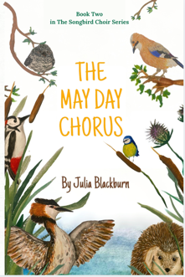 JULIA BLACKBURN
Book Information Sheet : The May Day Chorus by Julia Blackburn
Second book in The Songbird Choir Series — first book: The Songbird Army, third book coming Summer 2026
Rube the robin and the Songbird Choir are back! This time, the choir faces a new challenge when a mysterious group of birds threatens the harmony of their woodland home. As Rube and his friends—a blind bullfinch, a steadfast song thrush, and a fearless kingfisher—work together to restore peace, they learn that courage, cleverness, and unity can overcome even the trickiest foes.
▪ Publication date: 17 Feb 2026
▪ Publisher: Root & Branch Publishing
▪ Distribution: IngramSpark/Amazon
▪ Target Audience: Middle grade 8 -12
▪ Genre: Anthropomorphic eco-fiction for fans of classic animal adventures where courage and friendship overcome fear and cruelty
▪ Key themes: Courage and leadership • Friendship and unity • Protecting the environment • Problem-solving and teamwork • Finding your voice • Harmony in nature
▪ Comparison Titles: Watership Down, The Wild Robot, The Twitchers.
▪ ISBN: 978-1-0681782-5-2
Review copies available on request (print or digital). I’d love to share an advance copy with you — please let me know if you’d like to read it.
JuliaSBlackburn@gmail.com
www.JuliaBlackburn.co.uk
Instagram - JuliaBlackburnWrites

JuliaSBlackburn@gmail.com
www.JuliaBlackburn.co.uk
Instagram - JuliaBlackburnWrites
