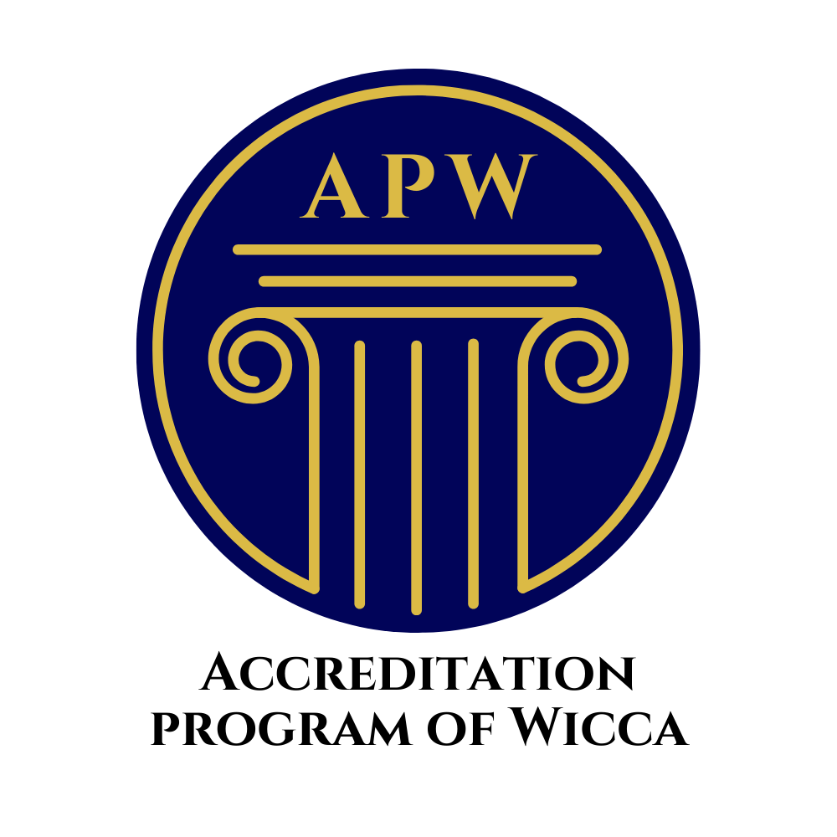

**Application Instructions**

The Accreditation Program of Wicca invites applications from all Wiccan programs of study. Please read the following instructions carefully before submitting your application. Please direct all questions about the application process to [apw@atcwicca.org](mailto:apw@atcwicca.org).

1. Gather all required materials before beginning the application form. Please reference the manual for details on the following:
   1. Financial documents required for your program level (seminary, coven, certification). This includes any TIN or identification numbers for your designated status, payroll, etc.
   2. Staff documents required for your program level. This includes staff qualifications, numbers, training, etc.
   3. Program overview documents such as curriculum maps, teacher or staff manuals, website address, etc.
   4. Sample lessons, assessments, curriculum overview, etc.
   5. Survey results
2. Complete the respective application form found below:
   1. Certificate Level: <https://forms.office.com/r/Y8bbWvFzTn>
   2. Coven Level: <https://forms.office.com/r/XNsUyr9jgM>
   3. Seminary/College Level: <https://forms.office.com/r/U6qvmyXF32>
3. When the form is completed successfully, you will be sent a receipt email. If you do not receive a receipt email within 24 hours after submission, please contact [apw@atcwicca.org](mailto:apw@atcwicca.org) for assistance.
4. Your application is not complete and will not be acted on until your application fee is received via PayPal. Use the PayPal button found on the website to complete your payment.
5. Once your application fee, completed application with all required support documentation is received, the committee will begin your program review. You will receive an email informing you when the review process was begun and you will be assigned a committee member as your direct contact as you move through the review process. The larger and more complicated your program, the longer the review process will take. Your assigned reviewer will send you an estimate review time after receiving all your support documentation and completing an assessment of the timeline.

**Thank you for your application!**