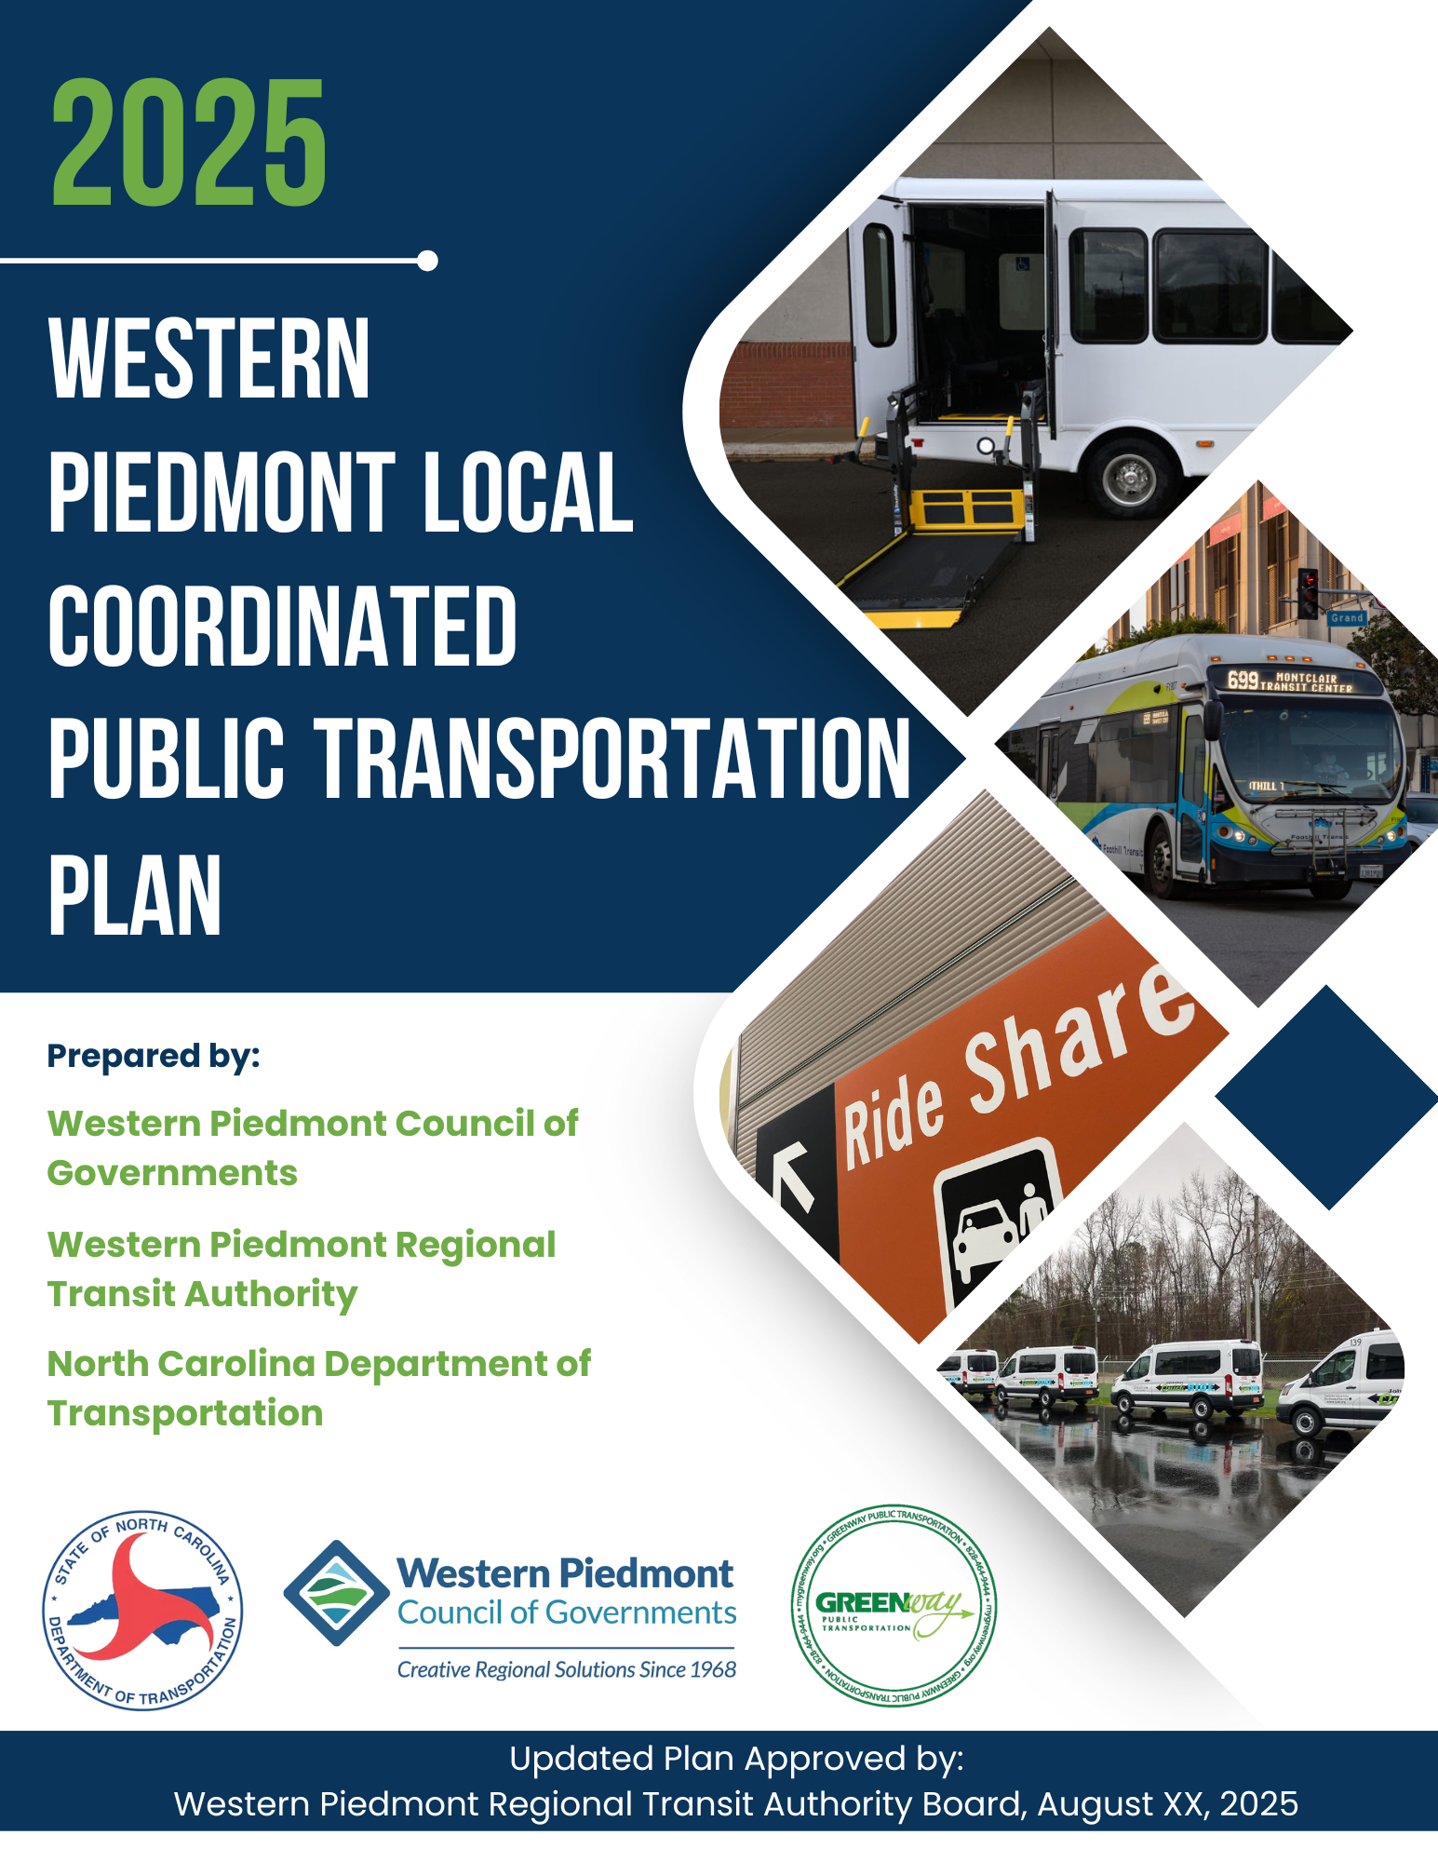

Table of Contents: Page
Section One: Introduction 3
Section Two: Background 4
Section Three: Federal Programs and Requirements 5
Section Four: Planning Process, Outreach, and Participation 7
Section Five: Transportation Needs 14
Section Six: Current Transportation Services and Resources 29
Section Seven: Unmet Transportation Needs 35
Section Eight: Recommendations 69
Section Nine: Outreach 74

SECTION ONE: INTRODUCTION

Purpose of the Plan
The purpose of the Local Coordinated Public Transportation Plan is to identify the transportation needs of individuals with disabilities, older adults, and those with lower incomes, and to identify and prioritize strategies for meeting those needs. The primary reason for this goal is to promote transportation opportunities among those who may otherwise be transportation disadvantaged. This purpose also supports managing resources efficiently and effectively, fostering cooperation among agencies and organizations, and creating economic development opportunities.

Promoting Transportation Opportunities

While transportation disadvantaged most obviously describes the physically impaired, it also can include those with mental disabilities, the elderly, as well as those who, because of personal or family economic circumstances, are unable to afford and maintain reliable personal transportation.

For these populations to enjoy the independent living and full participation in society that the general population has, they must be provided with transport that is suited to meet their needs. Such transportation options are as diverse as the populations they serve, and the travel needs those populations have. This range of services may include public transit fixed-route service, specialized demand response, paratransit, ridesharing, taxi cabs, and volunteer drivers. The trip purpose itself can vary from access to employment, medical care, childcare, education, recreation, social visits, among many others.

Managing Resources Efficiently
The cooperation that comes from a coordinated effort can serve to develop strategies that will address gaps in coverage as well as eliminate duplication of service. When possible, it can also allow for the sharing of resources.

The resulting increase of efficiency and the creation of economies of scale can lower operating costs for many transportation providers, an important benefit given the often-low number of resources and funding available. Perhaps more importantly, coordination can increase the quality of life to those most in need of transportation by providing improved service at lower costs.

Creating Economic Opportunities

Improving special needs transportation can create access to employment, job training, shopping, and other services for those who otherwise may not have such opportunities. Achieving the goals of the Coordinated Plan may therefore serve to promote self-sufficiency and equal opportunity for employment of individuals, thereby contributing to the economic health of the entire community.

SECTION TWO: BACKGROUND
The 2025 Local Coordinated Plan (LCP) is an update to the original plan adopted in 2008, plus subsequent updates in 2013, 2017, and 2021. Enacted by Congress in 2005, SAFETEA-LU (Safe, Accountable, Flexible, and Efficient Transportation Equity Act: A Legacy for Users) required the development and continual update of a Coordinated Public Transportation-Human Services Plan. Such a plan remains a requirement under the FAST Act (Fixing America’s Surface Transportation) of 2015. The Infrastructure Investment and Jobs Act (IIJA) took the place of FAST Act in November 2021. This plan update examines and addresses current and future transit needs of the Alexander, Burke, Caldwell, and Catawba region – as well as all local governments within each county. The region also included the Census-designated Hickory Urbanized Area.

FAST Act and IIJA legislation mandates that organizations receiving Federal Transit Administration (FTA) grants adopt a “locally developed” Coordinated Public Transportation-Human Services Plan to obtain additional funds. This plan will allow organizations and entities within the Greater Hickory region to receive FTA Section 5310 (Transportation for Elderly Persons and Persons with Disabilities) and 5307 (Urbanized Formula) funding grants.
Development and content of locally developed coordinated plans are intended to be specific to the needs and issues of each region. This coordinated plan was developed to address intra- and inter-regional needs and issues, and in a manner that allowed the providers, concurrent with regional Metropolitan Transportation Plan (MTP) updates, to directly update the regional coordinated plan. Further, the coordinated plan was developed in a manner that allows the WPRTA and WPCOG to adapt and expand the plan to incorporate programs and initiatives specific to the region.

Local Coordinated Plan
Federal law requires that projects selected for funding under the Enhanced Mobility for Individuals and Individuals with Disabilities (Section 5310) Program be "included in a locally developed, coordinated public transit-human services transportation plan," and that the plan be "developed and approved through a process that included participation by seniors, individuals with disabilities, representatives of public, private, and nonprofit transportation and human services providers and other members of the public" utilizing transportation services. These coordinated plans identify the transportation needs of individuals with disabilities, older adults, and people with low incomes, provide strategies for meeting these needs, and prioritize transportation services for funding and implementation.
The Local Coordinated Plan, as required by the FTA, must include the following:
- An assessment of available services that identifies current transportation providers (public, private, and non-profit)
- An assessment of transportation needs for individuals with disabilities and seniors
- Strategies, activities, and/or projects to address the identified gaps between current service and needs, as well as opportunities to achieve effectiveness in service delivery
- Priorities for implementation based on resources, time, and feasibility

SECTION THREE: FEDERAL PROGRAMS AND REQUIREMENTS
On December 4, 2015, President Obama signed into law the Fixing America’s Surface Transportation Act, or “FAST Act.” It is the first law enacted in over ten years that provides long-term funding certainty for surface transportation, meaning states and local governments can move forward with critical transportation projects, like new highways and transit lines, with the confidence that they will have a federal partner over the long term. As mentioned above, the Infrastructure Investment and Jobs Act (IIJA), also known as the Bipartisan Infrastructure Law, was enacted in November 2021 and authorizes historic investments in public transportation through FY 2026. The IIJA continues and expands support for the Section 5310 program, which provides capital and operating assistance to improve mobility for seniors and individuals with disabilities. Under the IIJA, 5310 remains a key tool for helping local agencies and nonprofits fill service gaps, enhance coordination, and ensure equitable access to transportation. The law emphasizes safety, accessibility, equity, and mobility options, aligning with 5310’s mission to support inclusive, community-based transit solutions. More information on these programs can be found throughout this document.

Congress establishes the funding for FTA programs through authorizing legislation that amends Chapter 53 of Title 49 of the U.S. Code. On December 4, 2015, President Obama signed the Fixing America’s Surface Transportation (FAST) Act, reauthorizing surface transportation programs through Fiscal Year 2020. Congress has since extended FAST by continuing resolutions.

FTA 5307 – Urbanized Area Formula Program

The Urbanized Area Formula Funding program (49 U.S.C. 5307) makes Federal resources available to urbanized areas and to Governors for transit capital and operating assistance and transportation-related planning in urbanized areas. An urbanized area is a Census-designated area with a population of 50,000 or more as determined by the U.S. Department of Commerce, Bureau of the Census.

The federal share is not to exceed 80 percent of the net project cost. The Federal share may be 90 percent for the cost of vehicle-related equipment attributable to compliance with the Americans with Disabilities Act and the Clean Air Act. The federal share may also be 90 percent for projects or portions of projects related to bicycles. The federal share may not exceed 50 percent of the net project cost of operating assistance.

FTA 5310 – Transportation for Elderly Persons and Persons with Disabilities

The purpose of 5310 is to improve mobility for seniors and individuals with disabilities by removing barriers to transportation. This program supports transportation services planned, designed, and carried out to meet the special transportation needs of seniors and individuals with disabilities in all areas – large urbanized (over 200,000), small urbanized (50,000-200,000), and rural (under 50,000). Eligible projects include both traditional capital investment and nontraditional investment beyond the Americans with Disabilities Act (ADA) complementary paratransit services.

Formula funds are apportioned to direct recipients, to states for rural and small urban areas (small UZAs), and designated recipients chosen by the governor of the state for large urban areas (large UZAs); or state or local governmental entities that operate a public transportation service. Direct recipients have flexibility in how they select subrecipient projects for funding, but their decision process must be clearly noted in a state/program management plan. The selection process may be formula-based, competitive, or discretionary. Subrecipients can include state or local government authorities, private non-profit organizations, or operators of public transportation.

FTA 5311 – Formula Grants for Rural Areas
This program provides capital, planning, and operating assistance to states and federally recognized Indian tribes to support public transportation in rural areas with populations less than 50,000, where many residents often rely on public transit to reach their destinations. It also provides funding for state and national training and technical assistance through the Rural Transportation Assistance Program.

Bus and Bus Facilities

The Grants for Buses and Bus Facilities program (49 U.S.C. 5339) makes federal resources available to states and designated recipients to replace, rehabilitate, and purchase buses and related equipment and to construct bus-related facilities, including technological changes or innovations to modify low or no-emission vehicles or facilities. Funding is provided through formula allocations and competitive grants. A sub-program provides competitive grants for bus and bus facility projects that support low and zero-emission vehicles.

Surface Transportation Block Grant – Direct Attributable (STBG-DA)

The Surface Transportation Program is U.S. DOT funding provided to states and localities for projects on any roads part of the Federal functional classification system that are not classified as minor local or rural collectors. States and MPOs have the option of transferring or “flexing” a portion of these funds for any projects that are eligible under FTA’s transit programs (except for any FTA eligible operating assistance). The federal share for these projects is 80 percent.

Congestion Mitigation and Air Quality Improvement (CMAQ)

CMAQ is U.S. DOT funding available to areas with air quality currently or recently in “non-attainment,” or not meeting national air quality standards. Projects funded by CMAQ must contribute to the attainment of ambient air quality standards by reducing pollutant emissions from transportation sources. CMAQ funding may be used by all projects eligible under FTA programs, including operating assistance for up to three years. CMAQ is also available for shared-ride services and pedestrian/bicycle improvements.
SECTION FOUR: PLANNING PROCESS OUTREACH/PARTICIPATION
As the regional planning agency for the Hickory urbanized area and the rural areas of Alexander, Burke, Caldwell, and Catawba Counties, the Western Piedmont Council of Governments (WPCOG) is the lead agency for the development of this Local Coordinated Plan. As the lead agency, WPGOG organized a Public Workshop to get input on developing the plan. The workshop invitation was sent to the following agencies –
- Alexander County
- City of Hickory Police Department
- WPCOG
- Burke Chamber
- Caldwell Chamber
- GHMPO
- CVCC
- Salvation Army
- Hickory Soup Kitchen
- United Way
- The Bridge Community
- Yokefellow
- Burke United Christian Ministries
- PACE@Home
- CCC&TI
- Burke Senior Center
- Caldwell Senior Center
- Burke Public Health
- Catawba Public Health
- Alexander Public Health
- Caldwell Public Health
- Kintegra
- Catawba Valley Medical Transport
- Caldwell DSS
- Catawba DSS
- Alexander DSS
- Burke DSS
- Neighbors Network
- Transit Riders
- NCWorks
- WPCOG, Area on Aging
- Transit riders
The following agencies attended the workshop. Notice of the workshop was provided via social media, emails, phone calls, and newspapers.
- Transportation Advisory Board
- Western Piedmont Regional Transit Authority
- CCC&TI
- NCWorks
- WPCOG staff
- GHMPO staff
- Area on Aging
- Adult Life Programs
- Caldwell Senior Center
- Burke County Senior Center
- Neighbors Network
- Catawba County Department of Social Services
- Caldwell County Yokefellow
- Kintegra Health
- High Country Community Health (Burke County)
- Burke County Health Department

Coordination
For this plan, coordination is defined as “a process through which representatives of different agencies or client groups work together to achieve any one or all of the following goals: more cost‐effective service delivery; increased capacity to serve the unmet needs; improved quality of service; and services which are more easily understood and assessed by riders.” Coordinating transportation means obtaining more results with existing resources through working with other individuals from different agencies, each with unique perspectives and goals.

Survey
A survey was developed to solicit information to help identify the transportation needs of individuals with disabilities, older adults, and those with lower incomes, and to identify and prioritize strategies for meeting those needs. The survey was published online and advertised via social media, transit stops, businesses, and email. The survey was filled out electronically through “Survey123.” Paper copies were provided at businesses and transit stops. The survey was launched on February 14, 2025, and closed on May 1, 2025. There were a total of 101 respondents. The survey results begin on page 35.

Planning Workshop

Notice of the workshop was advertised to a comprehensive, diverse population from all geographic areas of the region by the steering committee, transportation advisory board, focus group, WPRTA staff, and WPCOG staff. Notifications of the workshop were advertised by newspapers, social media, emails, phone calls, flyers, word of mouth, and online.

The 2025 Local Coordinated Plan (LCP) workshop was held on June 3 2025, from 2-4 PM. Averi Ritchie of the WPCOG began the workshop by presenting the purpose and intentions of the Local Coordinated Plan. The presenters then gave a synopsis on relevant legislation, funding opportunities, current fixed/flex routes, microtransit, and demand response service, as well as a concise update on the area’s demographics.
The workshop included an overview of the legislative updates under the FAST Act and IIJA, and an overview of current WPRTA Routes and schedules was given.
The group performed a Strengths, Weaknesses, Opportunities, and Threats (SWOT) analysis. This analysis is a group exercise that is solely based on workshop input. The analysis looks at strengths, weaknesses, opportunities, and threats of all transit providers to help inform decisions moving forward. The results of the SWOT analysis are as follows –
Strengths
- New technology – WPRTA is utilizing new technology for passenger counts at transit stops. Additionally, they have installed locators on each bus so riders will know how quickly to expect the next bus. They are also implementing applications for microtransit. These applications would have the capability for booking rides via smartphone and cashless fare collection.
- Americans with Disabilities Act (ADA) Compliance – Each transit provider has vehicles that are ADA compliant.
- Social Connectivity – Many transit providers felt that, because of various route expansions, there is more social connectivity for seniors, those with disabilities, and low-income residents. Seniors were specifically mentioned due to increased opportunities for outings. Transportation does not seem to be as much of an issue for accessing destinations.
- Openness to New Services – With the introduction of microtransit and the addition of other transportation providers, many attendees felt that the region is open to new services. As mentioned above, they were pleased with the technological advances of WPRTA.
- Student Emergency Options – Community College Representatives felt that the increased transit options would help students who may have no other transportation options.
- Microtransit in Rural Areas – WPRTA has expanded and continues to expand microtransit zones into areas that have no transit availability, aside from ADA paratransit services. Microtransit not only reduces the demand for ADA paratransit services but is a more convenient option for booking rides. Microtransit is a flexible, on-demand public transportation service that typically uses smaller vehicles (like vans or shuttles) and can be requested through an app, website, or call center. It operates in real-time or with short booking windows and may follow dynamic routes based on rider needs—blending the convenience of ride-hailing with the affordability and accessibility of public transit. ADA paratransit is a federally mandated service under the Americans with Disabilities Act (ADA) that provides door-to-door or curb-to-curb transportation for individuals with disabilities who are unable to use fixed-route transit systems. ADA paratransit service often requires riders to book at least 24 hours in advance.
- Responsiveness of Transit Agencies to Help Needs – Because of the increasing transit options and technologies, attendees felt that transit agencies are able to be more responsive in serving ridership.
- Emergency Response Services Offered – Many attendees felt that with the increasing transit options and technologies, transit could be a viable option in emergency response options. WPRTA recently helped transport seniors from an assisted living home after a fire.
- Community Events and Shuttle Service – Transit agencies were praised for assisting with providing transportation services to community events.
Weaknesses
- Morning Capacity of ADA Paratransit Vehicles – Many attendees felt that rides were limited before 9 AM for ADA Paratransit service. As mentioned previously, microtransit expansion could potentially reduce the demand for ADA Paratransit services.
- Misunderstandings on how ADA Paratransit Operates – As mentioned above, ADA paratransit is a federally mandated service under the Americans with Disabilities Act (ADA) that provides door-to-door or curb-to-curb transportation for individuals with disabilities who are unable to use fixed-route transit systems. ADA paratransit service often requires riders to book at least 24 hours in advance via dispatch. Many attendees felt that riders often think that ADA Paratransit is for medical appointments. ADA Paratransit can be utilized for most destination types.
- Lack of Regional Connectivity – There are vast rural areas within the four county region that make cross-county connections difficult to plan. Transit agencies are beginning to plan for cross county routes and microtransit zones.
- Few Transit Oriented Developments (TOD) - A lack of Transit-Oriented Developments (TODs) can limit the effectiveness and reach of public transportation systems. Without dense, walkable, mixed-use communities near transit hubs, ridership may remain low, leading to underutilized infrastructure and reduced fare revenues. This can also contribute to greater car dependency, increased traffic congestion, and higher greenhouse gas emissions. Additionally, the absence of TODs often means fewer affordable housing options near transit, exacerbating social and economic inequities by pushing lower-income residents farther from reliable transportation, jobs, and essential services.
- Car Seat Requirements in Smaller Transit Vehicles - Car seat requirements in smaller transit vehicles, such as those potentially used for microtransit, can be impractical and may unintentionally reduce ridership. These vehicles often serve diverse populations, including families, and operate on flexible schedules with shared rides. Requiring parents or caregivers to bring and install their own car seats can be a significant barrier, especially for those without access to a car seat or who are using transit spontaneously. Additionally, storing, securing, and managing car seats within limited vehicle space poses operational challenges for transit providers. These logistical hurdles can discourage use, particularly among families with young children, ultimately reducing the accessibility and effectiveness of the service.
- Misunderstandings on Grocery/Item Storage – Attendees mentioned that many riders feel that groceries (exceeding a certain number of bags) are not allowed on transit vehicles. Many riders utilize transit options primarily for food access. While an excessive amount of groceries or personal items is not permitted, riders are allowed to bring small carts for grocery/personal item storage to allow for more space.
- Lack of Bike Racks on Transit Vehicles and at Transit Stops – Attendees felt that, without additional bike racks on vehicles and at transit stops, ridership could be limited.
- Lack of ADA Compliant Infrastructure – Many attendees felt that lack of ADA compliant infrastructure at transit stops was a major issue. They also felt that there is a lack of ADA compliant infrastructure connecting most transit stops. A lack of ADA-compliant infrastructure—such as accessible sidewalks, curb ramps, bus stops, and boarding areas—significantly limits transit ridership by creating physical barriers for individuals with disabilities, older adults, and others with mobility challenges. When riders cannot safely or independently reach or use transit services, they are effectively excluded from the system, reducing both equity and overall ridership.
Opportunities
- Engagement and Educational Opportunities – It was suggested that transit agencies reach out to senior centers, specifically centers that provide assistance for those with hearing impairments.
  - Educate older adults on what is allowed (grocery storage, ADA Paratransit options, etc.) via transit services. Teach them how to utilize transit through ridership trainings.
- Advertisements on Transit Vehicles – Advertisements could provide transit agencies with additional income as well as inform riders of transit services. Many felt that it could serve as a great educational opportunity.
- Educate Service Providers in the Area – Increased communication among all transportation providers in the region is necessary to connect riders with necessary services. Many attendees were not aware of many of the services WPRTA now provides.
- Local Awareness of Local Match Needs – Local matches for various federal transit funding sources require matches of either 20% or 50%. While expanded transit services are needed, local matches are required to receive funding. Attendees felt that annual workshops for transit providers and local government partners could help educate the region on financial requirements for transit expansion.
- Regional Connectivity – While this was also considered a weakness, regional connectivity would provide the four-county region with many opportunities. Regional connectivity is essential to building an effective and equitable transit system, especially in a multi-county service area. When transit does not cross county lines—as is currently the case—it limits access to jobs, education, healthcare, and other essential services for riders who live, work, or travel between counties. This disconnect can create transportation deserts and isolate communities, particularly in rural or suburban areas where options are already limited. A more connected regional network improves efficiency, expands opportunity, and supports economic development by allowing seamless, coordinated movement across jurisdictional boundaries. Enhancing cross-county service is a critical step toward a more accessible and resilient transportation system for the entire region. WPRTA plans to work towards regional connectivity through studies and service expansion.
- Multi-Modal Opportunities – With increasing bicycle and pedestrian infrastructure, as well as the hope of the Western NC Passenger Rail Line, transit services will potentially gain significant multi-modal ridership. Transit boosts multimodal opportunities by serving as a central link that connects various forms of transportation into a cohesive, flexible network. Well-planned transit systems integrate with biking, walking, carpooling, and micromobility options like scooters or ride-hailing services, making it easier for riders to combine modes to complete their trips. Features like bike racks on buses, secure bike parking at stations, and pedestrian-friendly access to stops all enhance connectivity. This integration allows people to choose the most efficient, affordable, and sustainable option for each leg of their journey—ultimately reducing car dependency and improving overall mobility.
- Travel Training & Mobility Management - Travel training is a personalized educational program that teaches individuals—especially seniors, people with disabilities, or those unfamiliar with transit—how to safely and independently use public transportation. This can include route planning, boarding procedures, fare payment, and safety tips. Travel training empowers more people to use fixed-route services instead of relying on costlier paratransit, boosts rider confidence, and increases overall system ridership. It also promotes independence and improves access to employment, education, and healthcare. Mobility management is a strategic, person-centered approach to coordinating and improving transportation services by focusing on the rider’s needs rather than specific modes. It involves working across providers and agencies to connect people with the most appropriate and efficient travel options. Mobility management can reduce service duplication, improve regional coordination, and better serve populations with complex mobility needs. It also helps transit systems maximize resources, identify service gaps, and promote equitable access through partnerships, data integration, and customized trip planning. Attendees praised WPRTA’s current Mobility Manager for her efforts and suggested additional places to contact.
- Increased Community Buy-In - Increased community buy-in—such as incorporating local art into transit infrastructure—can significantly strengthen a transit system by fostering a sense of ownership, pride, and place. Public art at bus stops, transit centers, or on vehicles can make transit spaces more welcoming, vibrant, and reflective of the communities they serve. This not only enhances the rider experience but also builds public support for transit investments. When residents see their culture, history, and creativity represented in the system, they are more likely to value and advocate for it. Additionally, community partnerships around art projects can increase visibility, reduce vandalism, and help transit feel like a shared community asset rather than just a government service.
Threats
- No Comprehensive Applications – WPRTA explained that, with many of the upgraded technologies, there are no comprehensive applications. For example, the cash-free fare application is separate from the ride booking application and several others. Multiple applications could become a nuisance for transit agencies as well as ridership.
- Local Funding – As mentioned above, local matches for various federal transit funding sources require matches of either 20% or 50%. While expanded transit services are needed, local matches are required to receive funding. A lack of local funding to meet federal match requirements poses a significant threat to transit systems by limiting their ability to access and fully leverage available federal dollars.
- Fleet Maintenance and Costs - Fleet maintenance and associated costs pose a threat to transit systems by straining budgets, reducing reliability, and limiting service capacity. Aging or poorly maintained vehicles are more prone to breakdowns, leading to service disruptions, delays, and increased operational costs. Frequent repairs and downtime can reduce fleet availability, making it harder to meet rider demand or expand service. Additionally, as maintenance costs rise, transit agencies may be forced to divert funding from other priorities like route improvements, technology upgrades, or staff training.
- Not In My Back Yard (NIMBY) - NIMBYism ("Not In My Backyard") poses a threat to transit systems by creating resistance to the placement of essential infrastructure, such as bus stops, transit hubs, or shelters, in certain neighborhoods. Residents may oppose these facilities due to perceived concerns about noise, traffic, safety, or impacts on property values. This opposition can lead to delays, politically motivated relocations, or outright cancellations of planned transit improvements. As a result, transit agencies may struggle to place stops where they are most needed—especially in high-demand or underserved areas—leading to reduced access, inefficient routes, and inequitable service.

The purpose of the workshop was explained with a focus on people with disabilities, seniors, and low-income residents in the four-county region. The participants also learned about the “Coordinated Planning Process”. Using the above SWOT analysis, strategies were then developed to identify the gaps and create potential projects to close the gaps. Priorities were set and established for implementation. The participants also reviewed current services offered by the WPRTA.

Through the process of the workshop, participants identified transportation needs, provided strategies for meeting the local needs, and prioritized transportation services for funding and implementation.

SECTION FIVE: TRANSPORTATION NEEDS

Demographics

The 2023 American Community Survey indicated that the population in the four-county area was 370,030 people, a significant increase from the 2020 population of 365,276 people. According to the NC Office of State Budget and Management (NC OSBM), the region is estimated to grow to around 391,000 people by 2030, and to around 429,000 by 2050, growing at a rate of 7.1%, then 15.8%. Further, this growth is expected to be fueled by people immigrating to the region. Catawba County is expected to grow the most at 30.2% by 2050, with Alexander, Burke, and Caldwell following behind at 1.9%, 2.3%, and 1.6% respectively.

Urbanized Area

There is a Census-designated Urbanized Area in the Western Piedmont Area. This urbanized area is somewhat unusual, as the population density found in some areas within its boundaries would not suggest an “urban” designation. The area has the designation because there are several small municipalities with contiguous borders that combine to have a population that is characterized as “urban”. There is also a significant level of commuting between jurisdictions, which is one of the determinants that the Census uses in its formula to designate urbanized areas. The urbanized area is significant for this project, as the FTA allocates public transit funding to specific urbanized areas.

Population Density

The mean population density of the region is 226 people per square mile, with Catawba County having the most concentrated population (414 people per square mile) and Alexander County have the least concentrated population (139 people per square mile). Burke County has a density of 178 persons per square mile and Caldwell has a density of 174 persons per square mile. Population density is an important demographic feature to study when planning transit services. Typically, fixed-route transit can only be supported in areas with 1,500-2,000 people per square mile or more. Areas with lower densities call for more targeted services, such as deviated fixed-route or demand-response services. The current fixed/flex-route service area exhibits areas of fixed-route density, as do areas of Lenoir.

Employment Travel Patterns

Employment travel patterns based on the 2022 LODES data were compiled and analyzed by the WPCOG. This analysis showed that Catawba County is significant employment destination for the three other study counties. Additionally, Mecklenburg County has become a popular commuting destination since the last LCP. These data provide another opportunity for the regionalization of public transit services.

The following commuting patterns were indicated in the WPCOG analysis.
From Alexander County – 4,334 commuters to Catawba County
From Burke County – 6,466 commuters to Catawba County
From Caldwell County – 7,026 commuters to Catawba County
From Catawba County – 7,483 commuters to Mecklenburg County
From Western Piedmont Region – 12,609 commuters to Mecklenburg County

Demographics Indicating Transit Needs

The need for transportation services in an area is a function of the demographic and economic characteristics of the population, their access to alternative forms of transportation (personal vehicles and trucks), and their physical and mental abilities to operate a vehicle.

Need is a relative concept, rather than an absolute one, and so an examination of need must provide for a comparison between areas or population groupings. It may not include a figure for the number of trips “needed” by the population in that area or group, because such a figure is inherently subjective and dependent upon the definition of need. “Need” is likely to be much larger than “demand,” which is the number of trips likely to be taken at a particular fare and service level.

Accordingly, this analysis uses 2019-2023 American Community Survey data to present relative need in the study area. Relative need is calculated by ranking each Census and the 2019-2023 American Community Survey regarding the density and the percentage or the population in each of the following groups:

- Elderly persons 60-64 years of age
- Elderly persons 65 years of age and above
- Persons with disabilities, non-institutional, aged 18-64
- Persons with incomes below the poverty level
- Households with no vehicle available for use

This information is analyzed in two ways. The density of persons in each of these categories has been ranked, and the rankings summed to provide an overall ranking for each Census Tract in the four counties.

The high need areas in terms of people displaying transportation dependent characteristics are in the Hickory area, Newton, part of Conover, in the US 321-A corridor between Granite Falls and Lenoir, large portions of Lenoir, in Morganton, along the US 70 Corridor in the vicinity of Valdese, along the Burke County/Catawba County border (north of Interstate 40/Hildebran area), and in Taylorsville.

A similar analysis is performed using the same data but calculating the percentage of the population in each of the categories for each Census tract, and then ranking the percentages and summing the rankings to produce an overall ranking of the percentages. This is done to determine if areas that have small populations might also have a high percentage of that population in need of transportation services. This analysis shows a somewhat different pattern, with more of the rural areas showing needs, as would be expected. There are several areas that exhibit high transit needs based on the density and the percentage analyses, and these are: Morganton, Valdese, large portions of Lenoir, along the Burke County/Catawba County border (north of Interstate 40/Hildebran area), areas along the US 321-A Corridor between Granite Falls and Lenoir, portions of Hickory, Newton, and Conover, and Taylorsville.

Note: Though not related directly to 5310 funding, other Title VI populations were analyzed within the four county region using the same analyses as above. Other groups include but are not limited to single parent households and population under 18 years of age. Including populations such as single-parent households and individuals under 18 in a locally coordinated transit plan is essential for creating an inclusive transportation system. While not directly tied to 5310 funding, these groups often face unique mobility challenges—such as limited access to private vehicles, complex trip chaining needs (e.g., school, work, childcare), or reliance on others for transportation. By analyzing and considering their needs alongside traditional Title VI populations, transit planners can identify service gaps, prioritize resources more effectively, and develop solutions that support broader community access to education, employment, healthcare, and essential services. This comprehensive approach ensures the transit system serves the full range of residents who depend on it most. Please find the maps of these communities below.

Workers Commuting Regionally

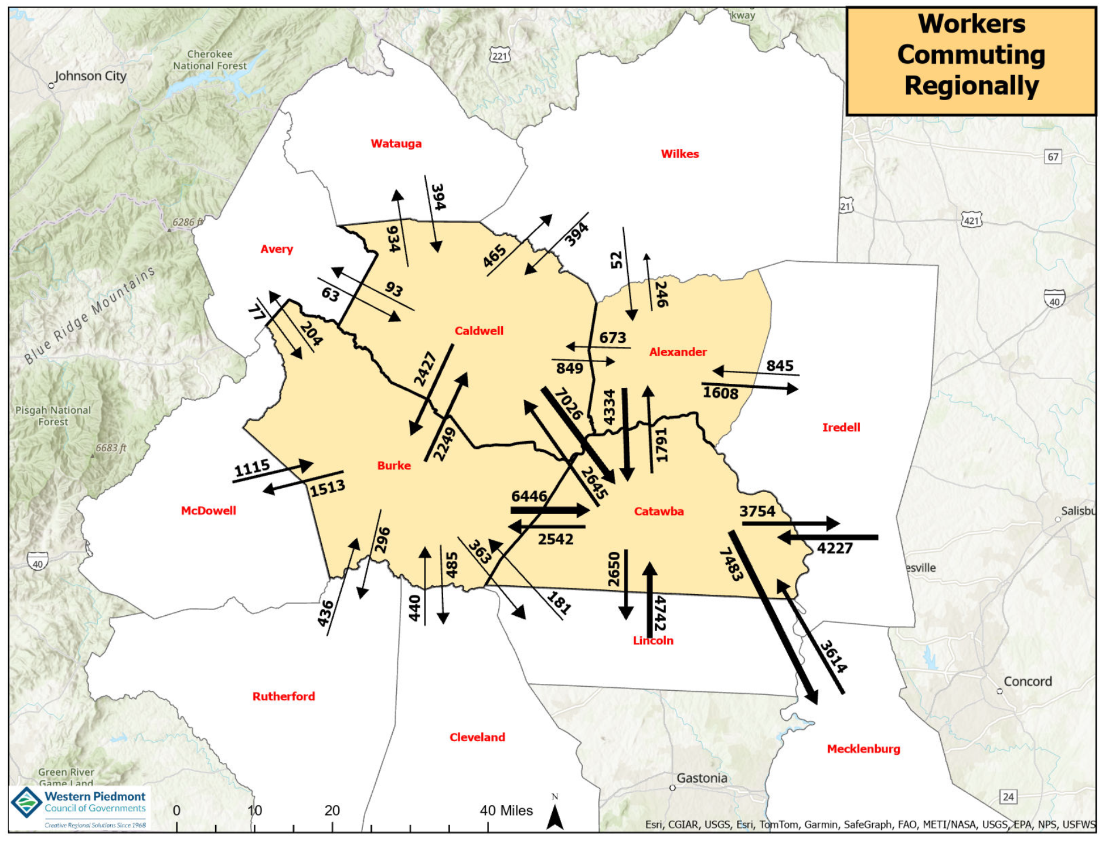

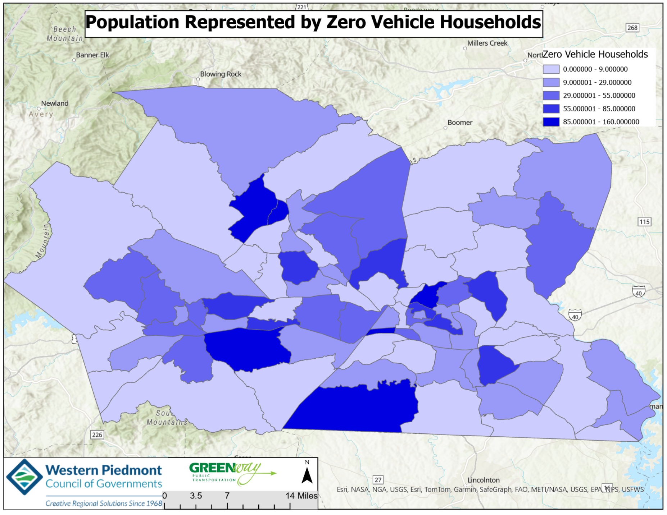
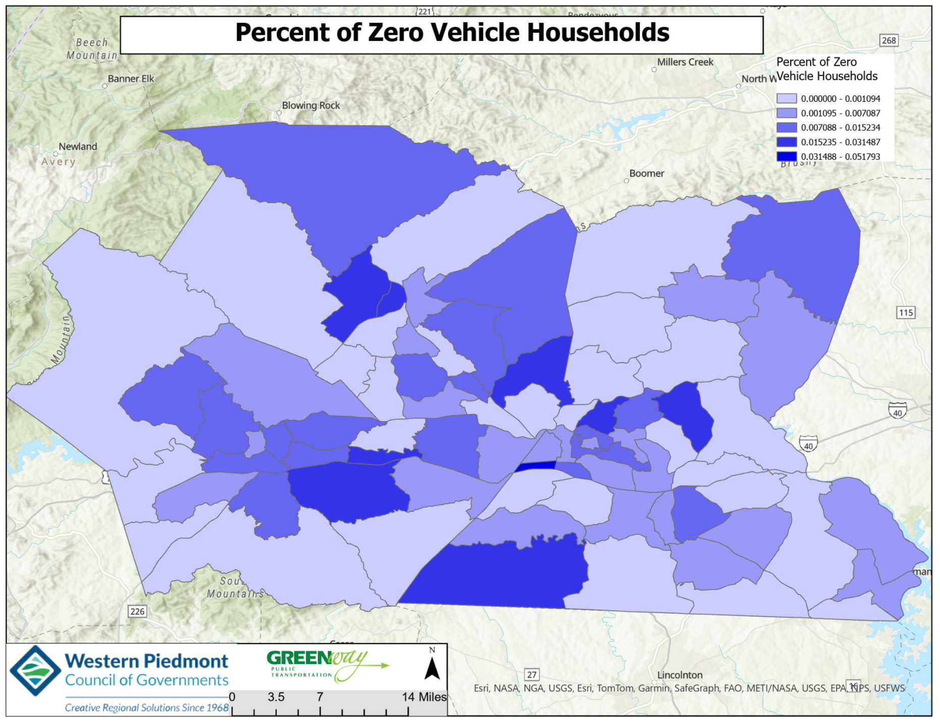

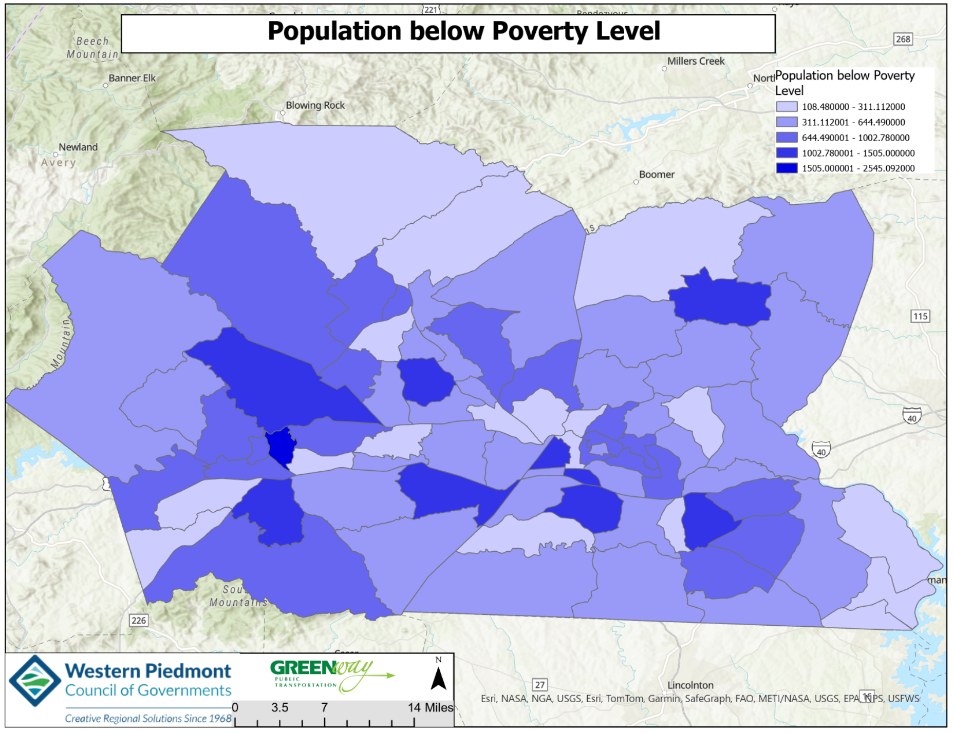

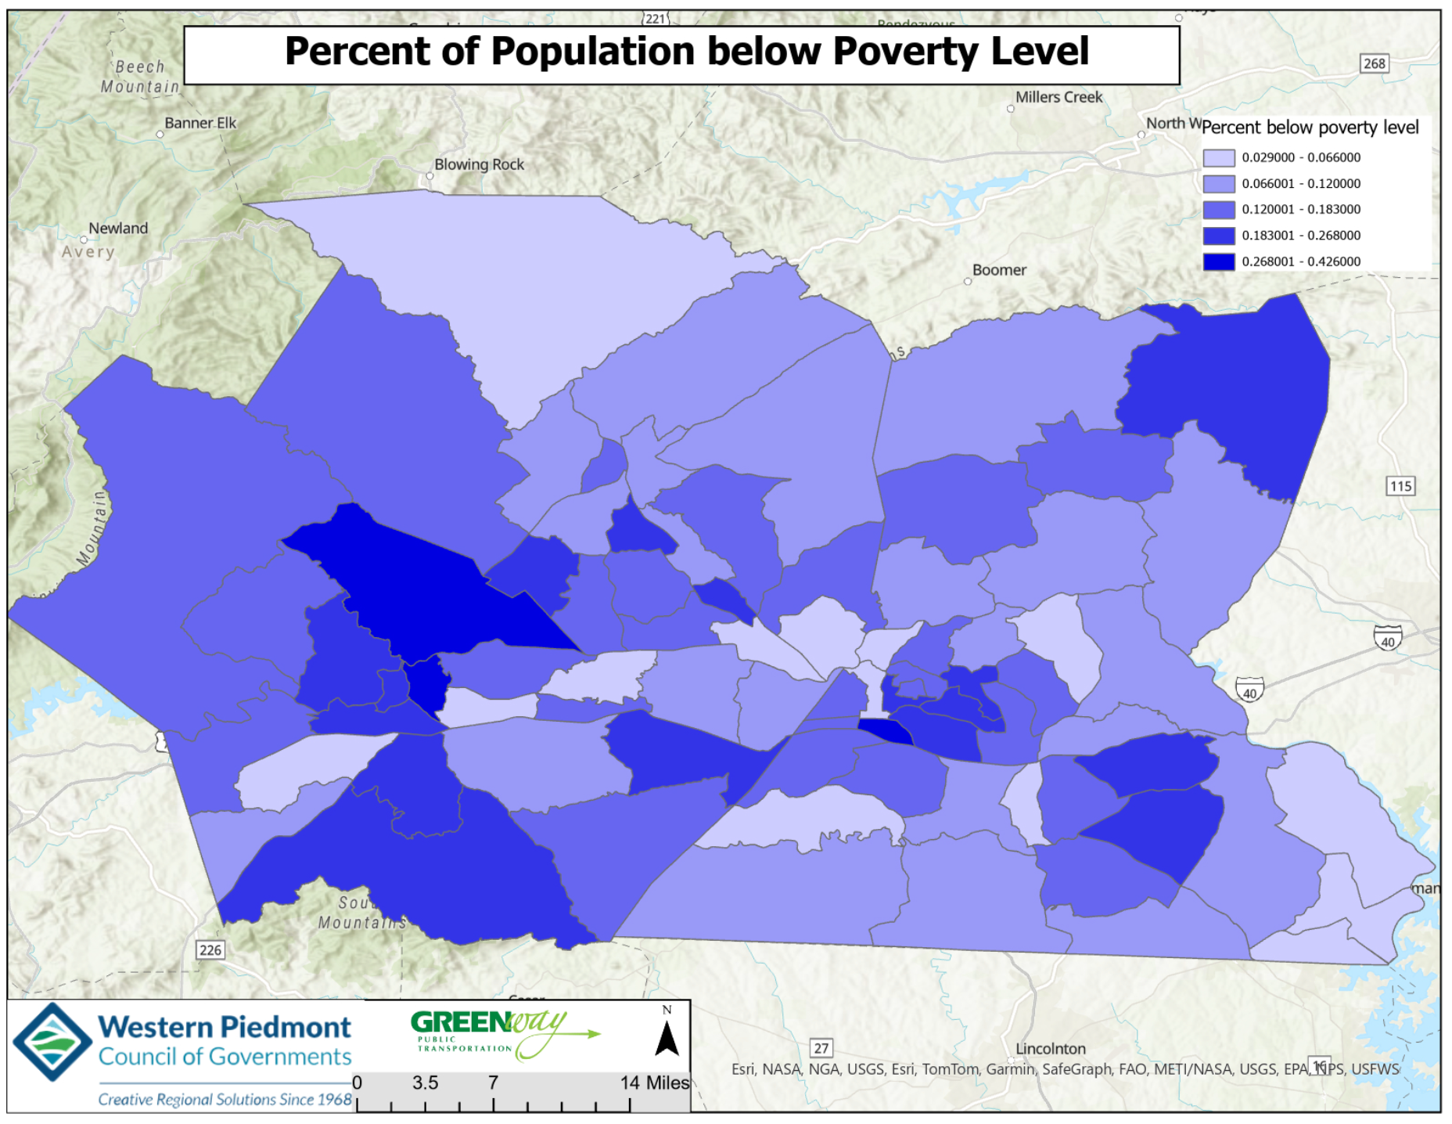

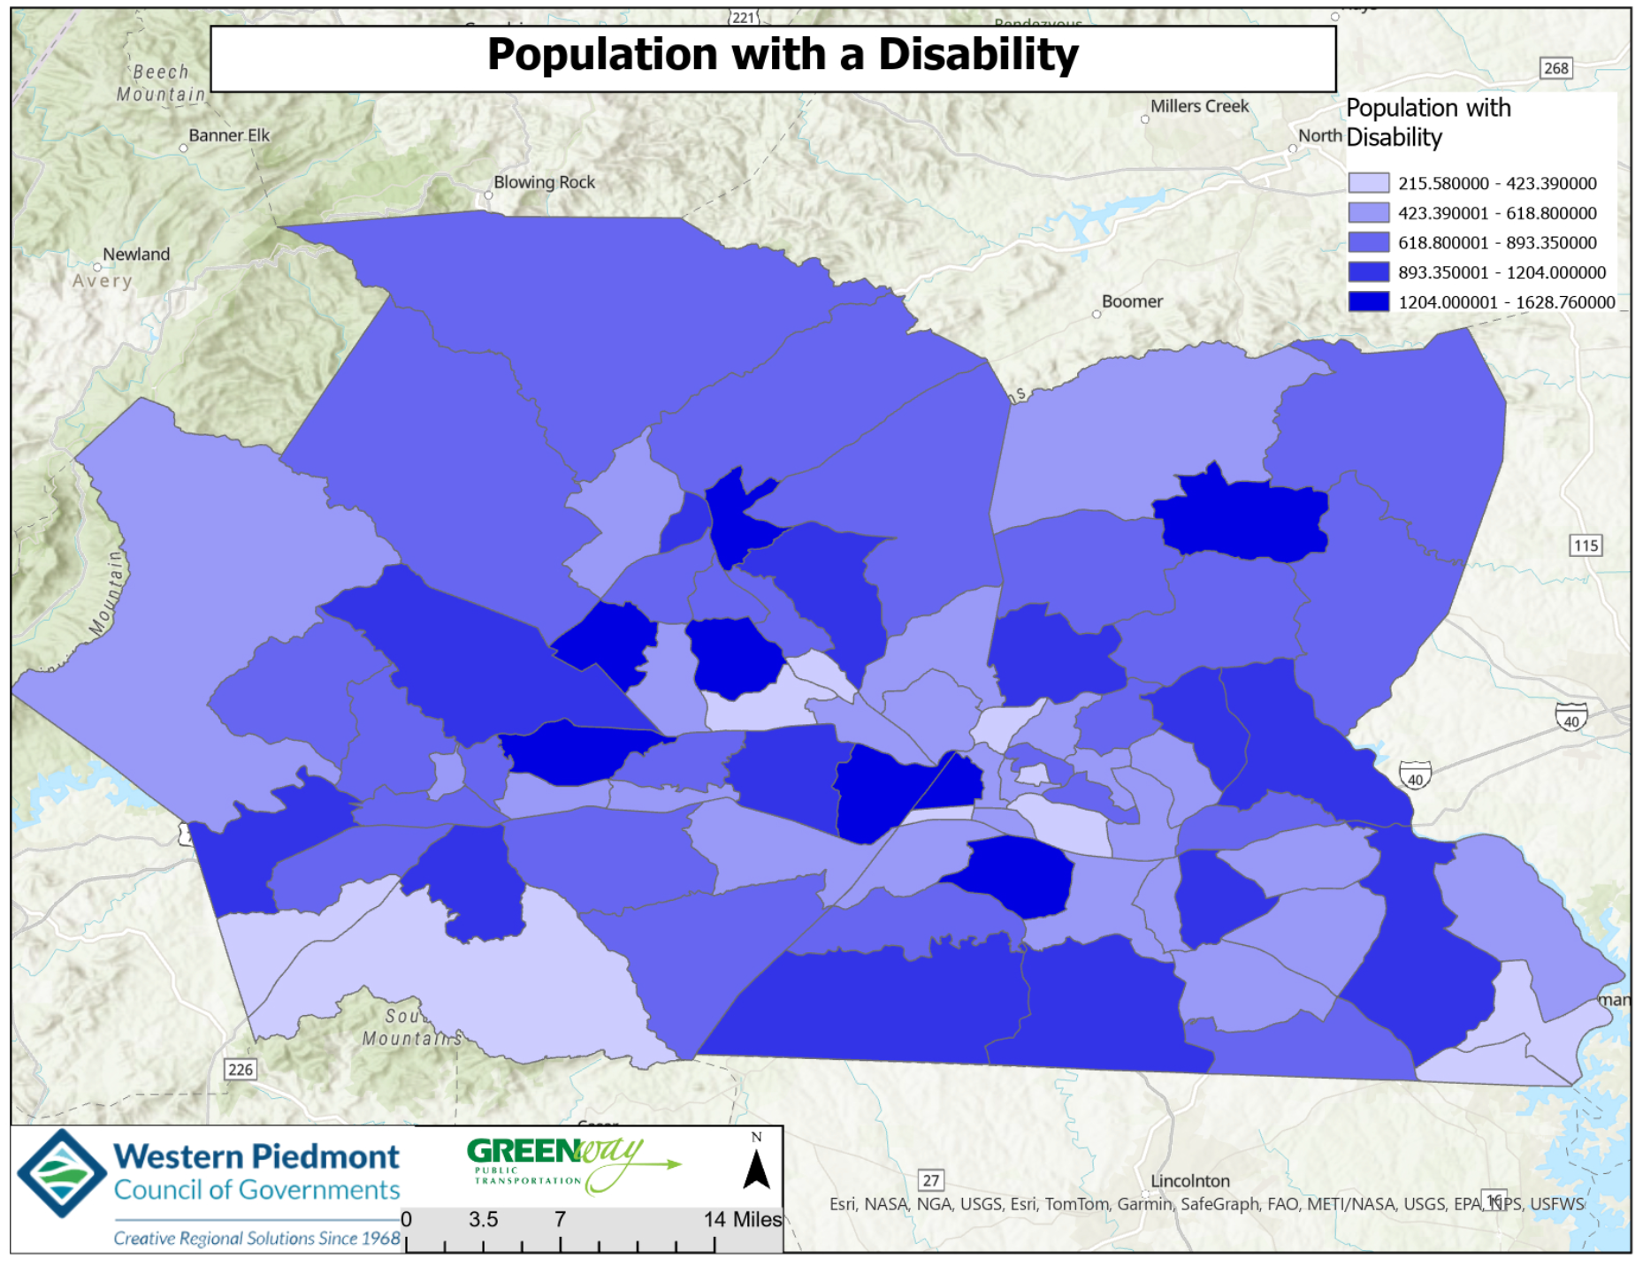

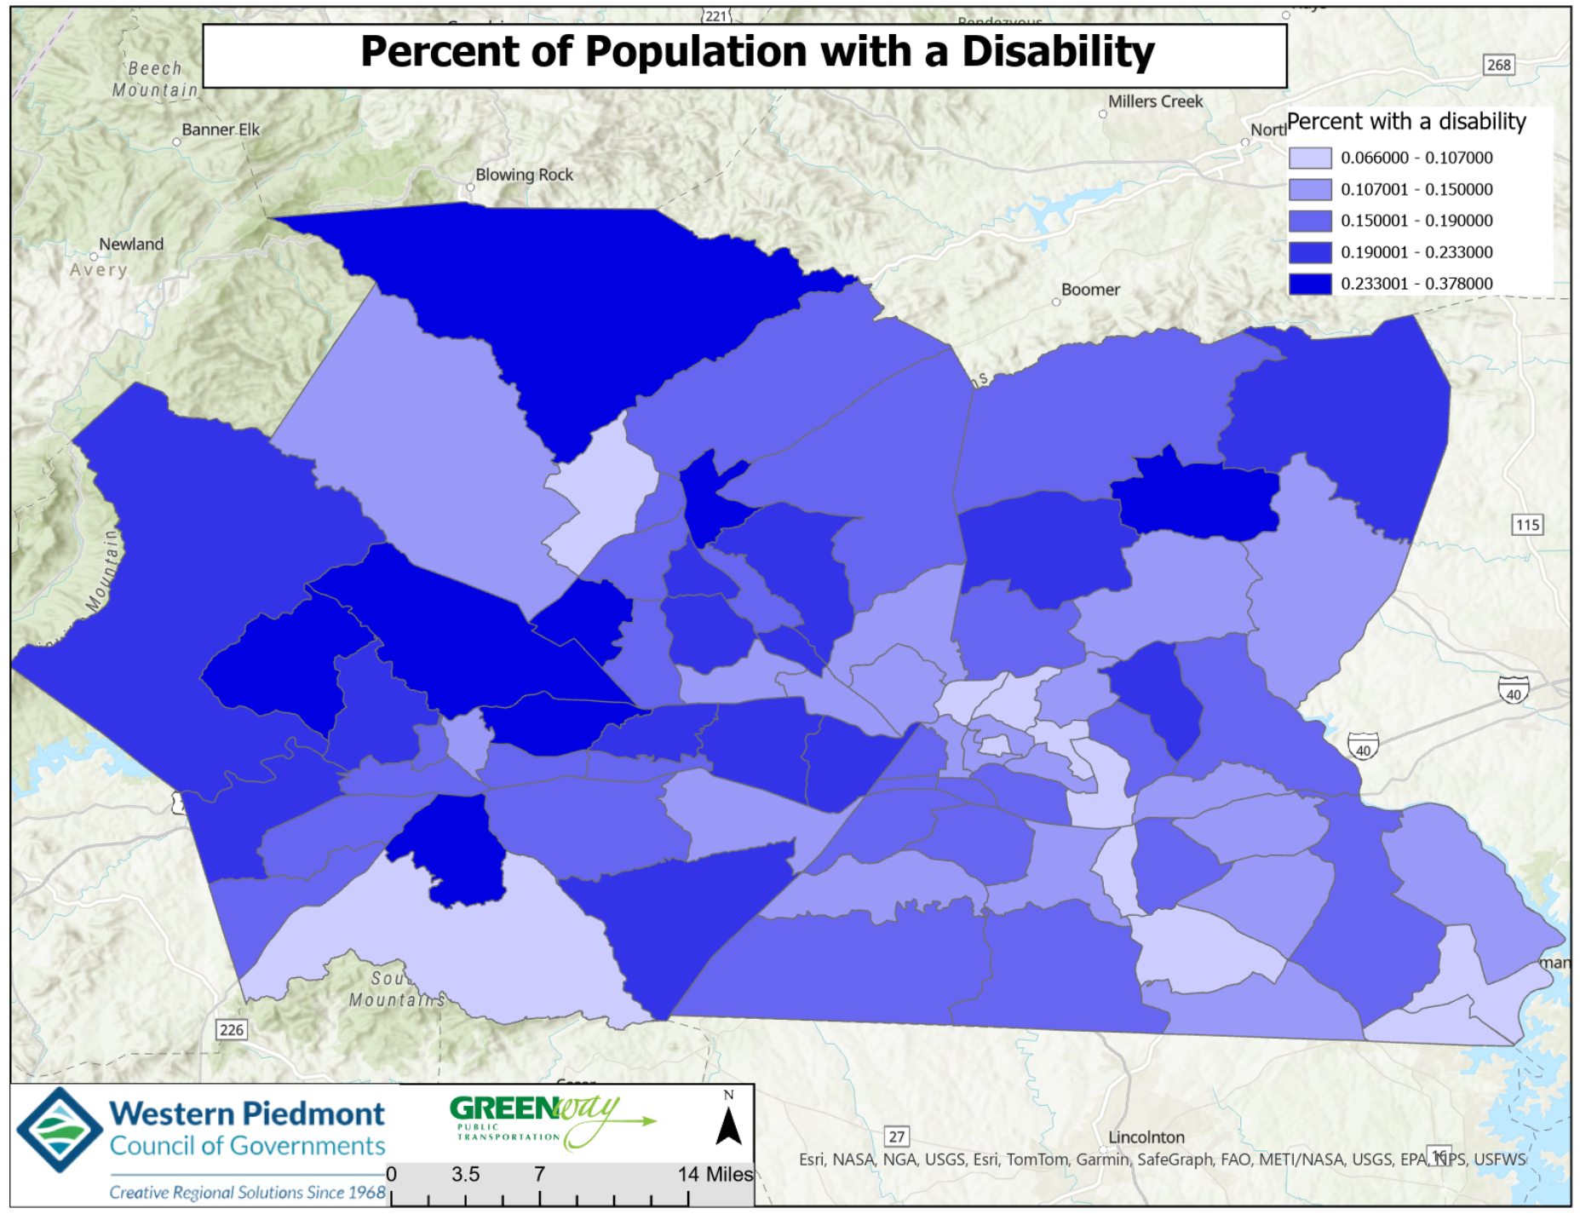

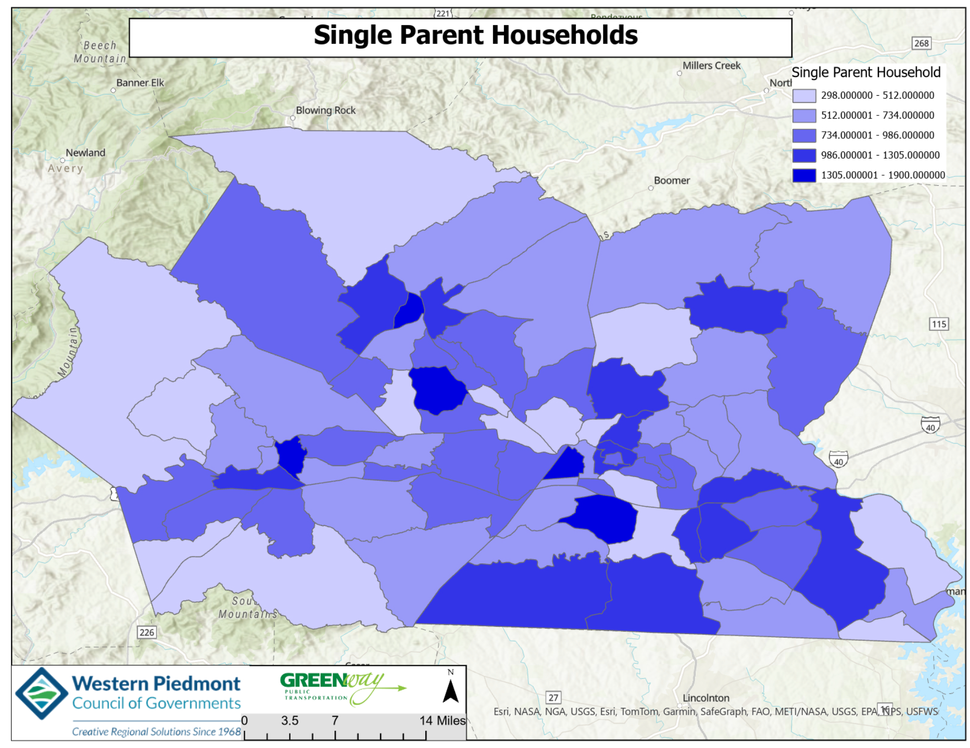

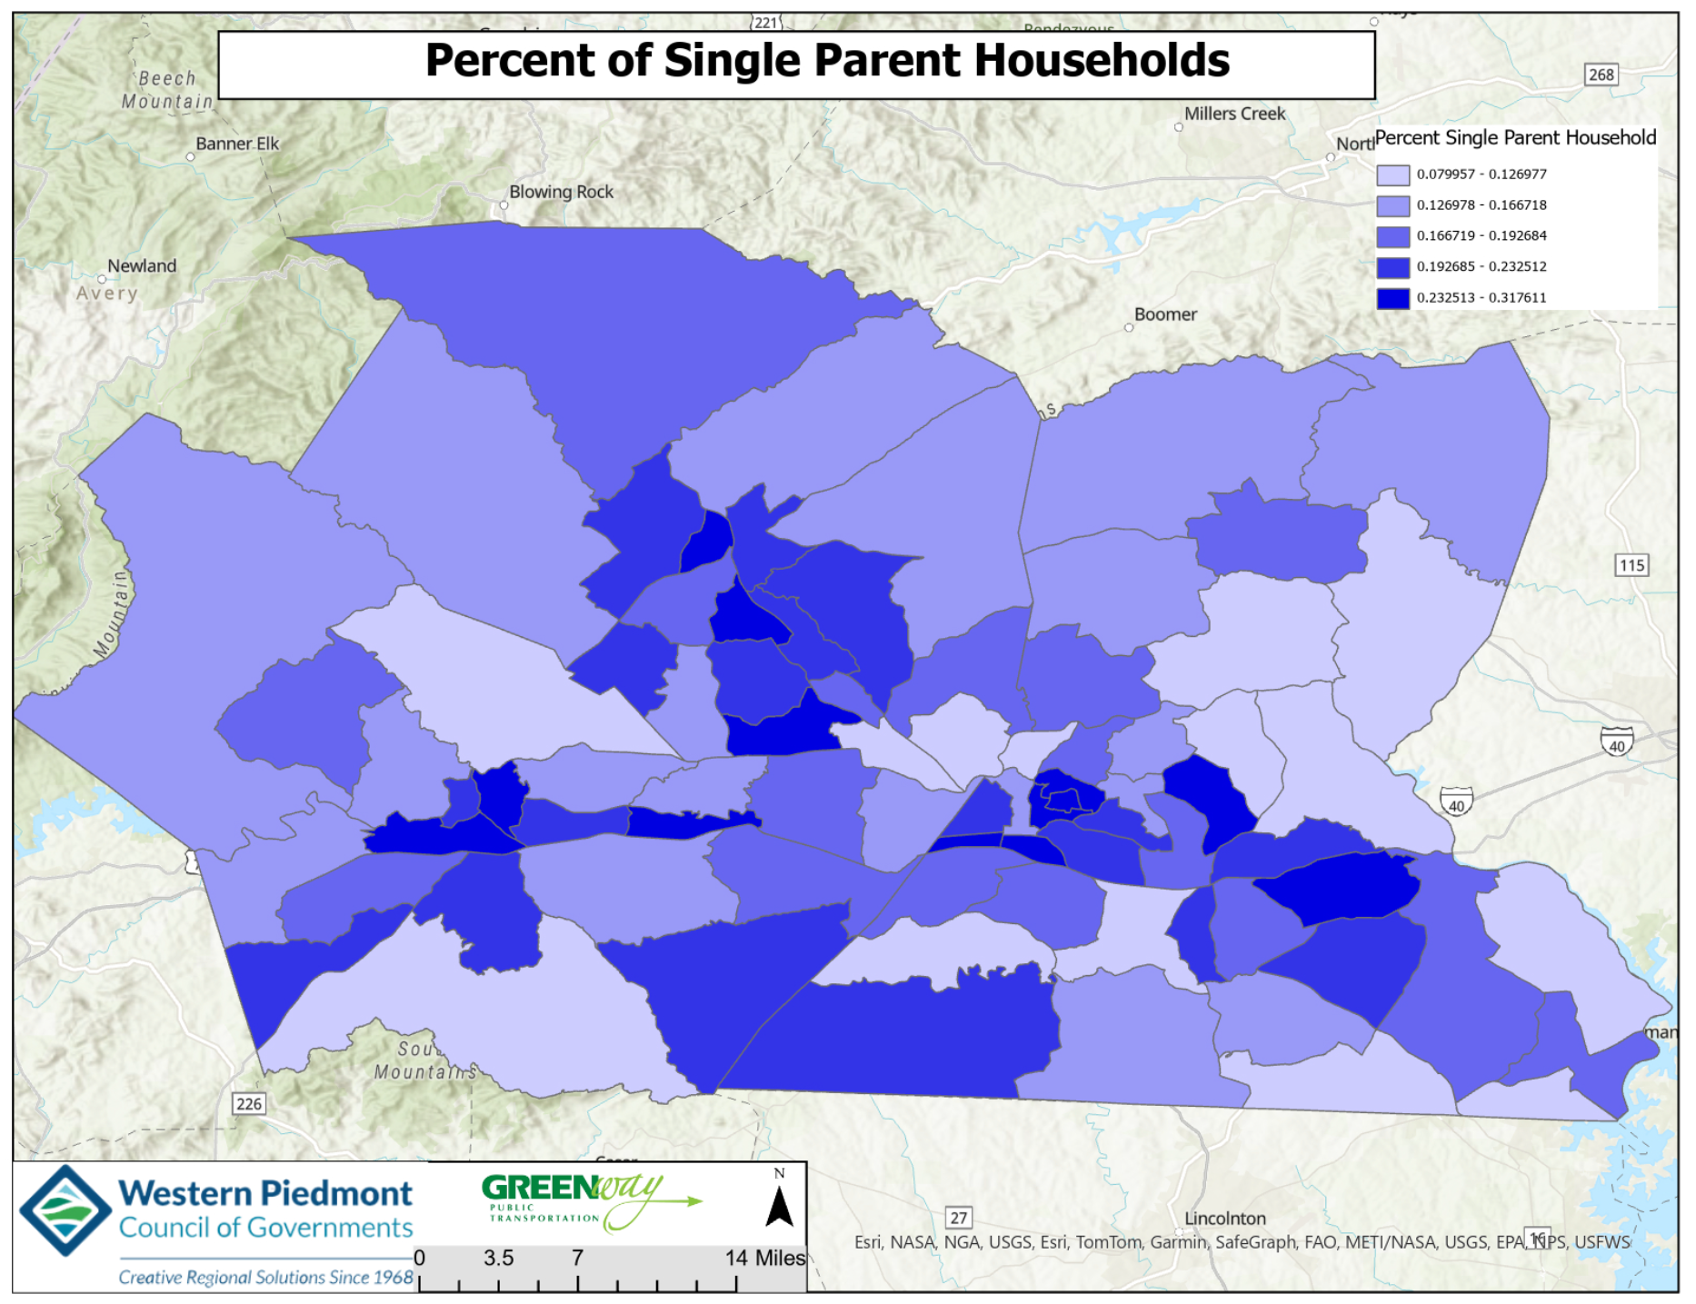
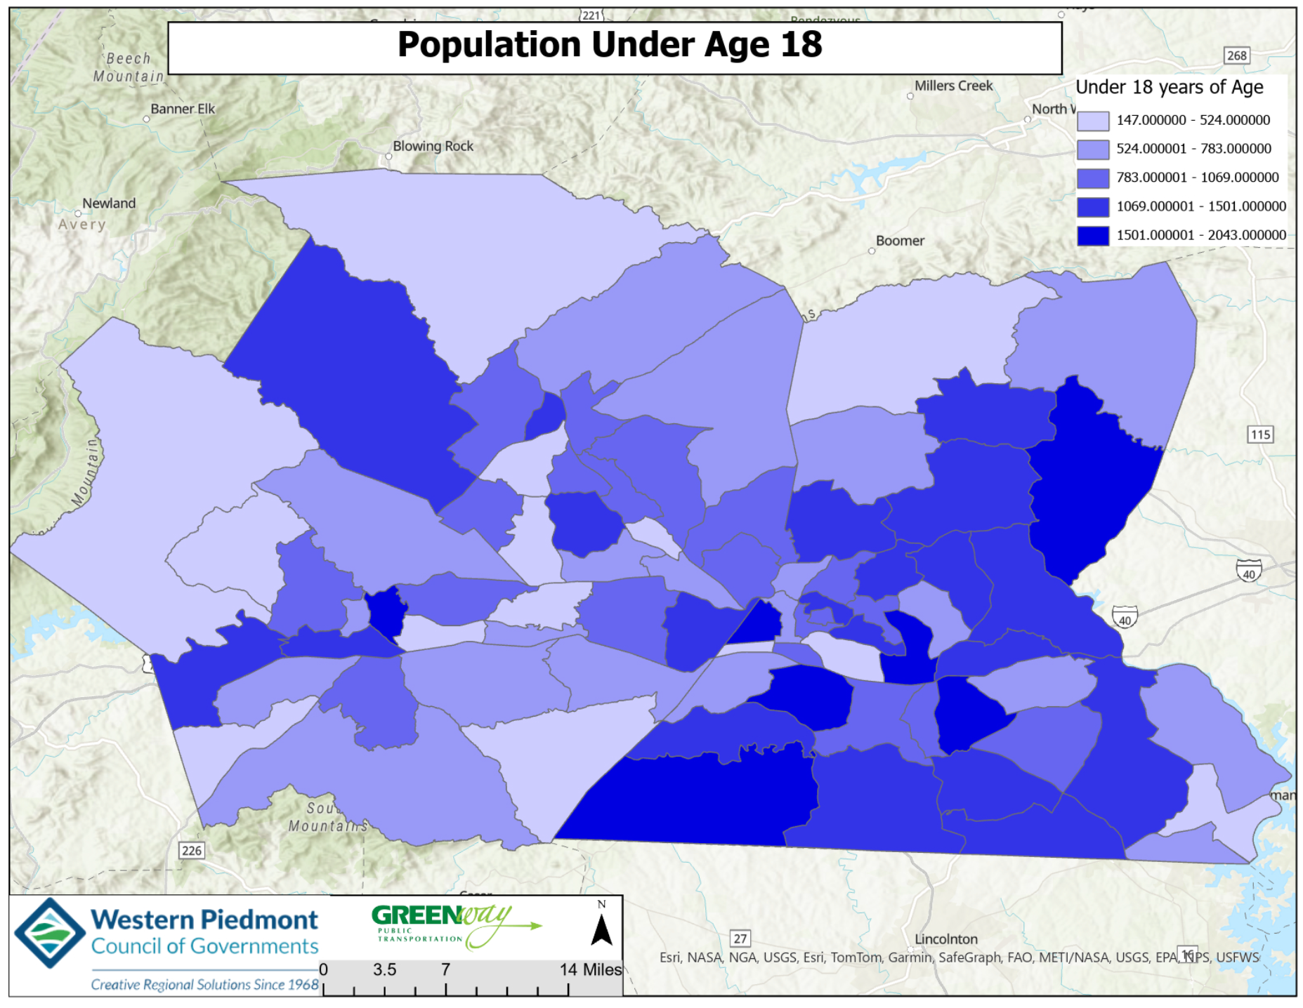
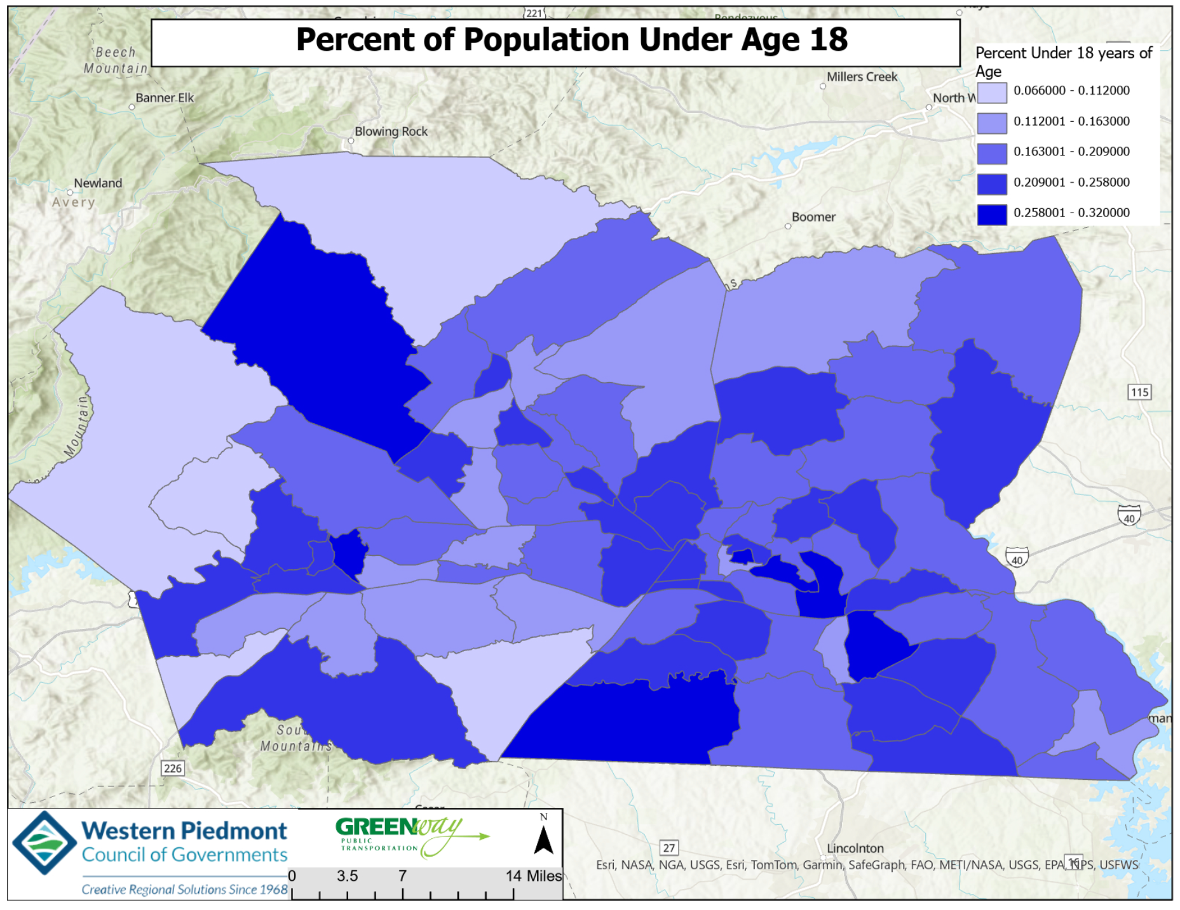

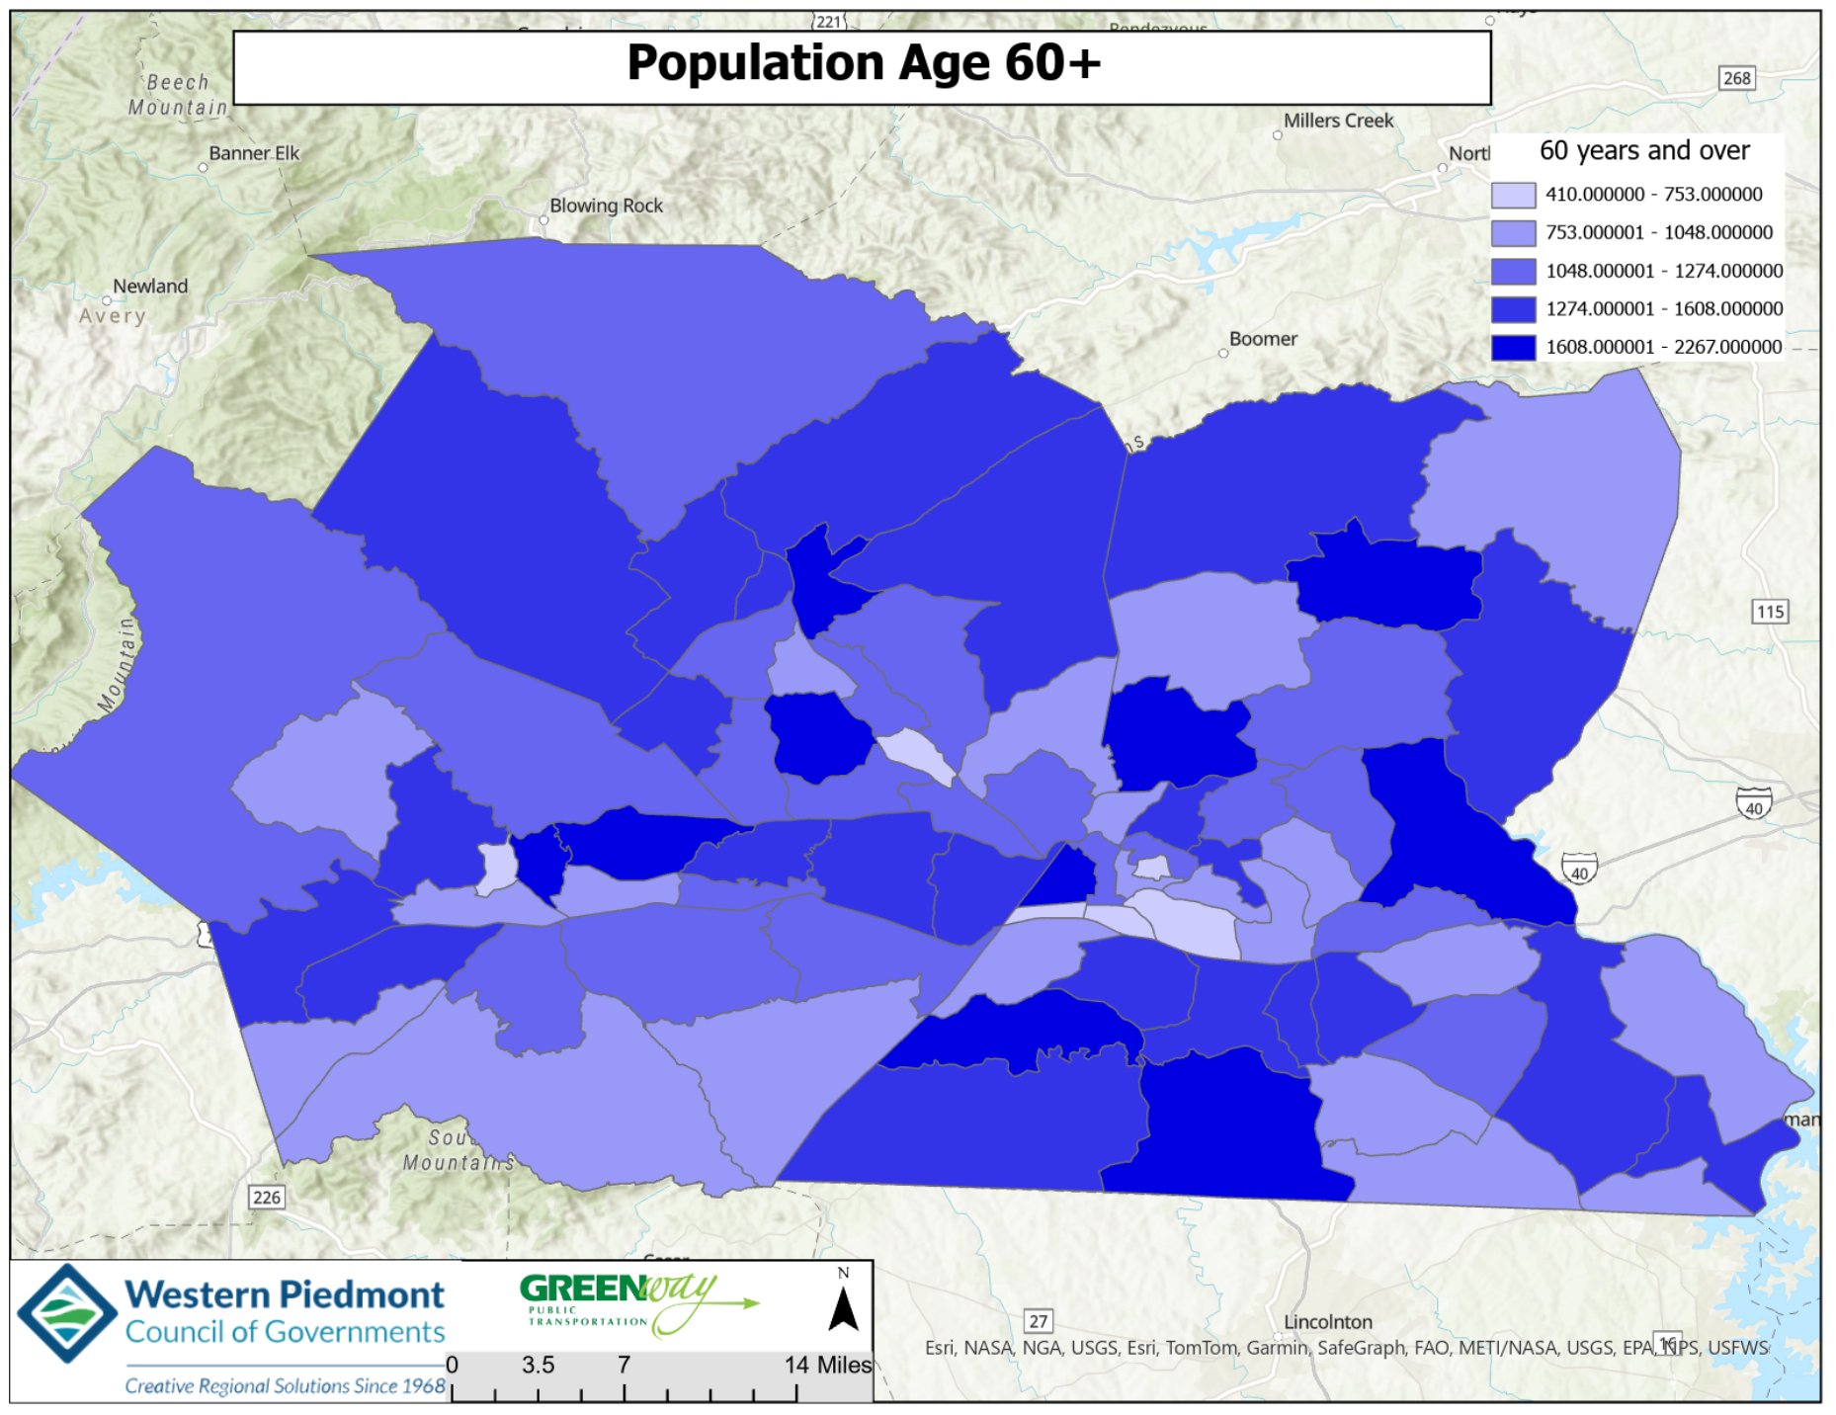

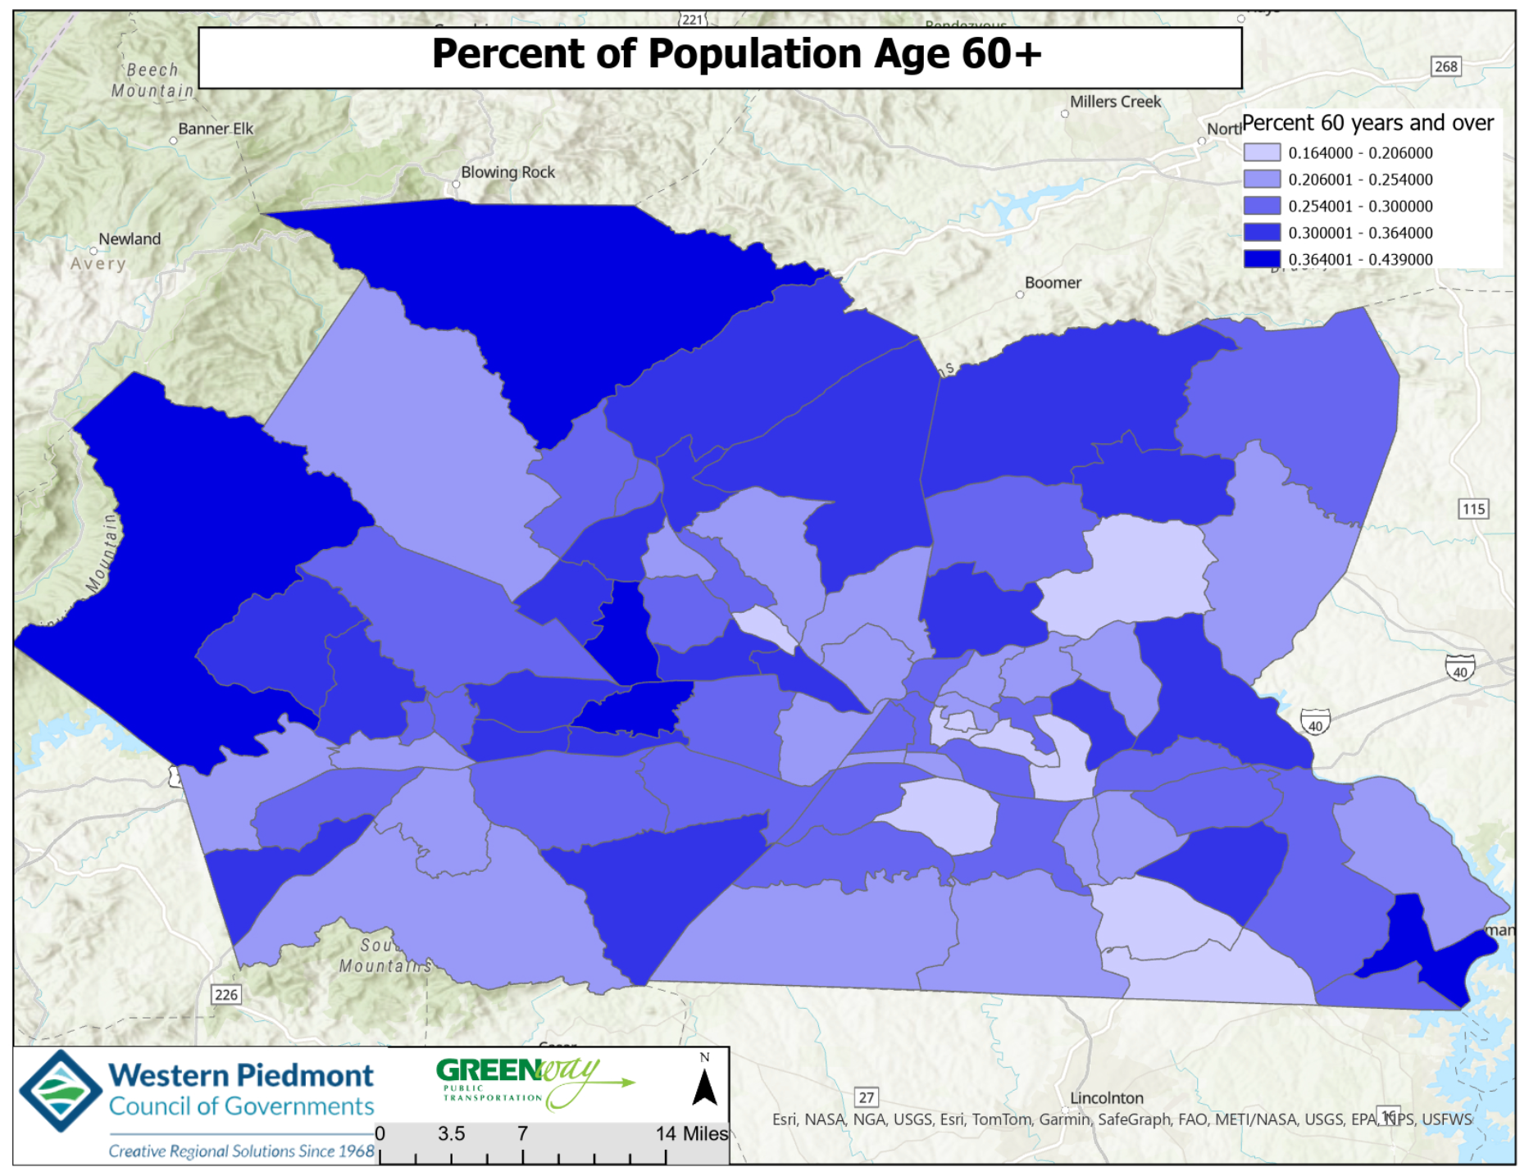

SECTION SIX: CURRENT TRANSPORTATION SERVICES AND RESOURCES

History of Public Transit in the Greater Hickory Region
Consolidation of public transportation operations for Alexander, Burke, Caldwell, and Catawba Counties to form the Western Piedmont Regional Transit Authority (WPRTA) took place in July 2008. Before this consolidation, community transportation was provided separately by each county. In Alexander County, community transportation was provided by Alexander County Transportation (ACT); in Burke County, by the Burke County Transit Administration (BCTA); in Caldwell County, by the Caldwell County Area Transit System (CCATS); and in Catawba County, by the Piedmont Wagon Transit System (PWTS). The only areas of the four counties that had fixed route transit at the time of the 2008 consolidation were the Catawba County cities of Hickory, Newton, and Conover, which was provided by the PWTS.

Following an extensive study and implementation process, on July 1, 2008, the Western Piedmont Regional Transit Authority officially came into being and became the first combined rural and urban regional transit authority in the State of North Carolina. The transit authority was the result of the consolidation of four independent community transportation providers in each of the respective counties. Officials in Alexander, Burke, Caldwell, and Catawba counties, along with the municipalities of Hickory, Newton, and Conover, passed resolutions to create the Western Piedmont Regional Transit Authority.

Mission Statement and Goals

The mission of the Western Piedmont Regional Transit Authority (WPRTA) is to enhance the quality of life in the region by delivering safe, convenient, and environmentally friendly transportation solutions.

Transportation services provided shall be designed to maintain and encourage the use of public transportation and shall contribute to the economic vitality of the community, the conservation of natural resources, and the protection of the environment.

The goals of WPRTA are as follows:

- Provide cost effective transportation services which optimize the utilization of personnel, vehicles, and other resources.
- Provide transportation services which meet the mobility needs of the community, within available financial resources.
- Develop funding options which assure the continued stable operation of transportation services at a public subsidy level acceptable to the community.
- Develop policies which assure, as much as possible, that transit services are designed and operated to encourage maximum utilization by the community. Service should be provided first in areas where the greatest potential for use exists.
- Promote the use of public transportation services within the community. This includes both providing adequate and up‐to‐date information on services available and aggressively marketing the transit system.
- Expand public transportation to new areas of the community as demand estimates and population densities indicate that service will be sufficiently utilized within established service standards.

Currently Available Public Transportation Services Offered by WPRTA

Currently Available Public Transportation Services Offered by the Western Piedmont Regional Transit Authority

Urban fixed route transit services in Hickory, Newton, and Conover

Americans with disabilities (ADA) complementary ¾ mile paratransit service

Flex route service in Taylorsville, including a ¾-mile deviation zone

Flex route service in Morganton, including a ¾-mile deviation zone

Microtransit zone in Morganton, Drexel Valdese, and Rutherford College

Microtransit zone in Caldwell County covering Lenoir, Granite Falls, Hudson, Sawmills, and Gamewell

Rural and urban general demand response service (ADA Paratransit) in Alexander, Burke, Caldwell, and Catawba Counties

DSS Medicaid transportation program

Vocational Rehabilitation Service

Burke Literacy

Caldwell Family Resource Center

Burke Council on Alcoholism

Adult Day Care

Developmentally disabled groups

Home and Community Care Block Grant Programs that service elderly passengers

General and medical demand response transportation

Private transportation providers operate in Burke County, providing trips brokered by WPRTA

Department of Social Services Temporary Assistance for Needy Family (TANF) programs

Other Public Human Service Transportation Providers

Catawba County Department of Social Services

Caldwell County Department of Social Services

Private Transportation Providers:

Abby Cab

Burke Christian Tours

Catawba County Medical Transportation

Catawba Valley Medical Services

Hickory Hop

Lyft

Medivan

Premier Transportation

PACE

Neighbors Network

Uber

Current WPRTA Routes
Alexander
Hours: 8 am-5 pm, Monday-Friday
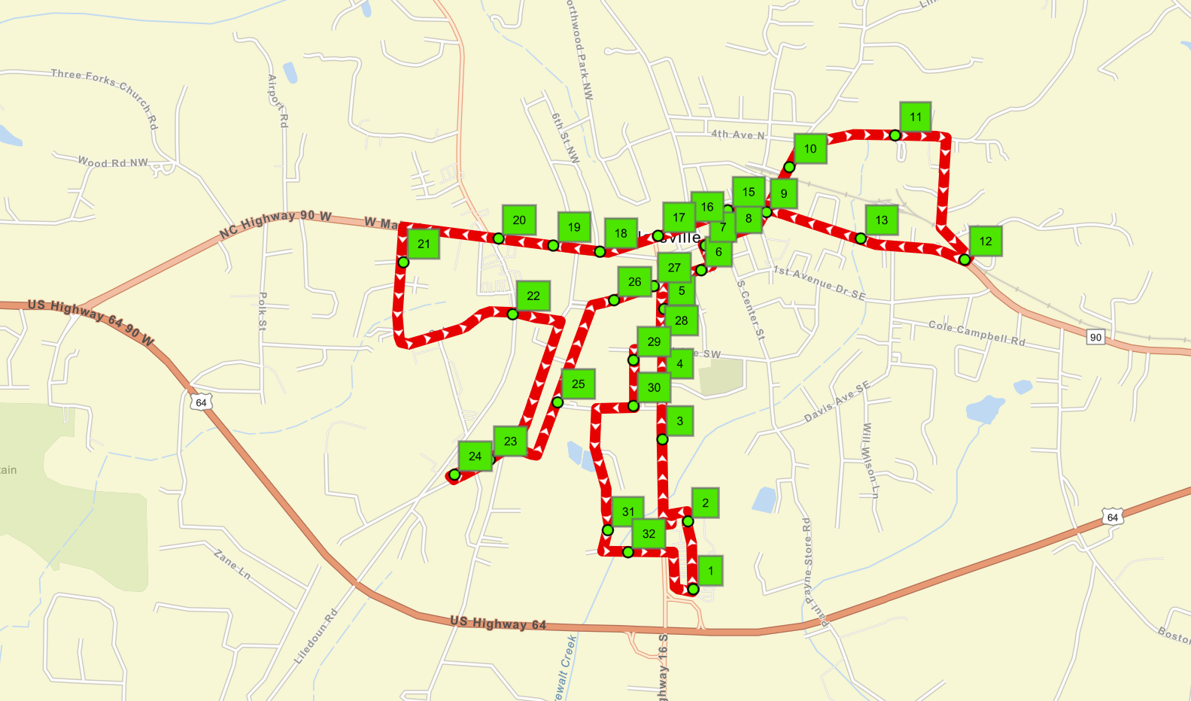

Burke
- These routes will deviate up to ¾ of a mile. The larger polygon shows the microtransit service area (same day service – just a call to dispatch).
- Hours: Burke 7 am-5 pm, Monday-Friday.

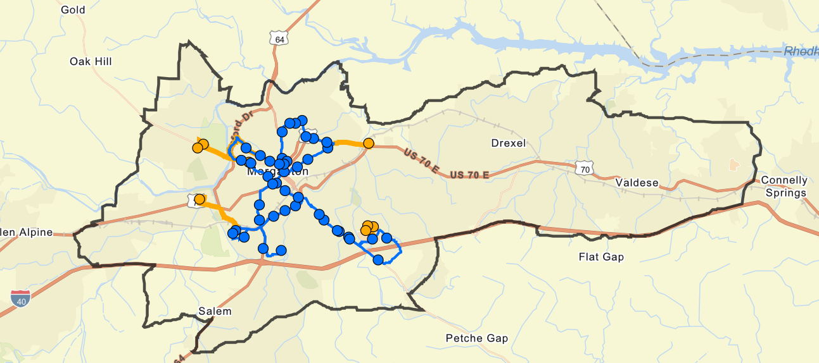
Caldwell
Hours: Caldwell 7 am-5 pm, Monday-Friday.
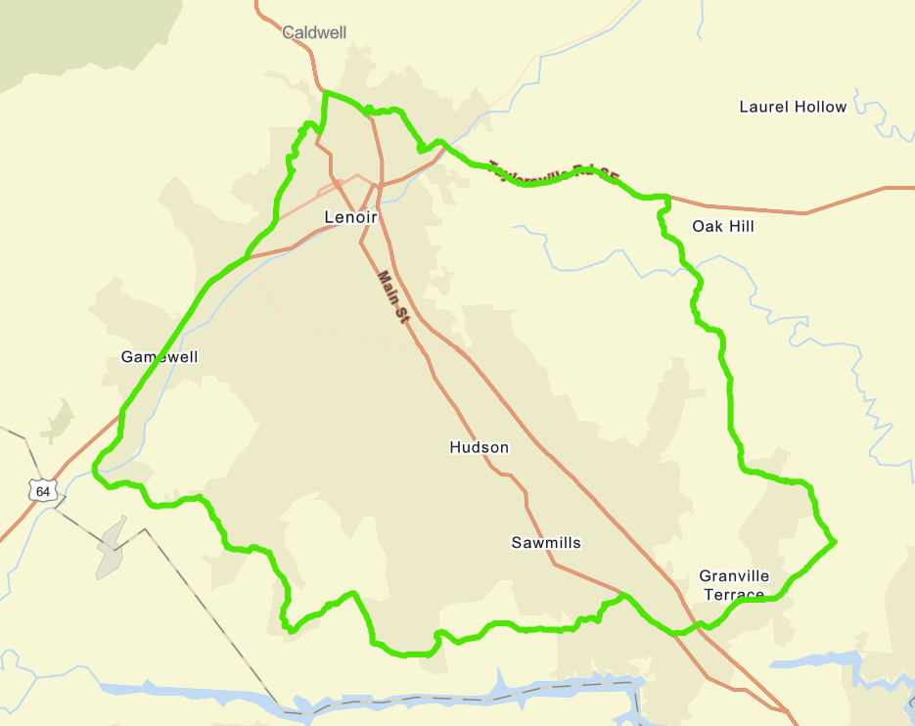

Catawba
Hours: Catawba Fixed Route hours Monday - Saturday are 8:35 am-5:35 pm.

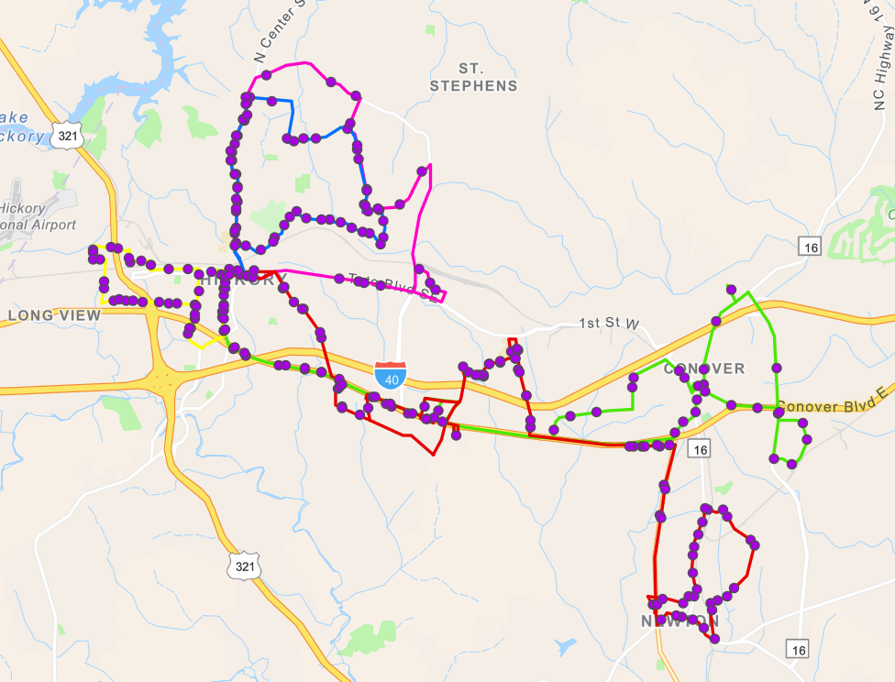

Demand Response Service: This service is offered in all 4 counties. The WPRTA demand response service is available to the general public. The demand response service offers shared rides, curb to curb, public transportation in Alexander, Burke, Caldwell, and Catawba counties. Service is offered upon seat and route availability. New passengers are encouraged to call the scheduling office for service information and individual trip planning. Service requests may be made during normal business hours by 12:00 p.m. on the preceding business day that service is requested; however, additional notice is recommended. Reservations may be made between the hours of 8:30 a.m. and 5:00 p.m. Monday through Friday. Same-day service requests are not available. The trip requests for both the destination and return shall be scheduled at the time of the request.

Microtransit is a flexible, on-demand public transportation service that typically uses smaller vehicles (like vans or shuttles) and can be requested through an app, website, or call center. It operates in real-time or with short booking windows and may follow dynamic routes based on rider needs—blending the convenience of ride-hailing with the affordability and accessibility of public transit.

Planned Route Changes

Catawba
In this scenario, routes 5-7 would be converted to microtransit service.

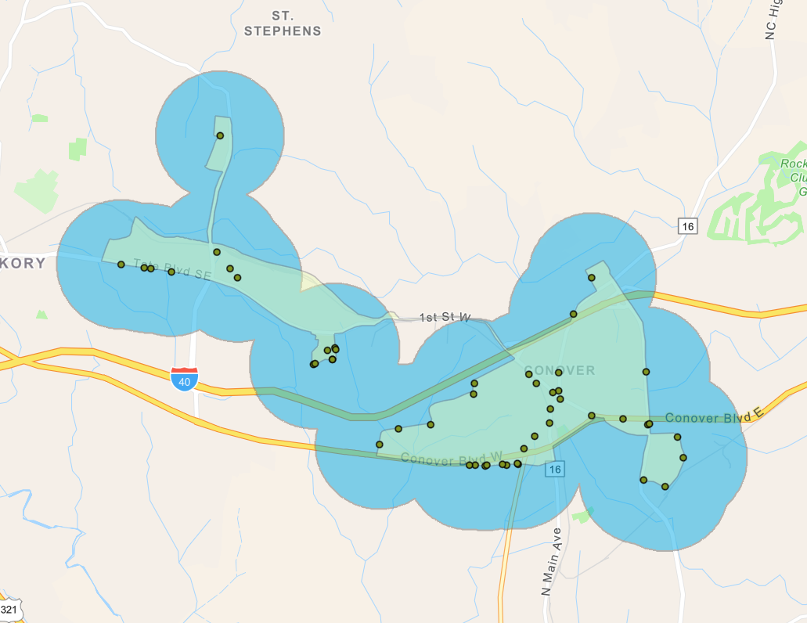
SECTION SEVEN: UNMET TRANSPORTATION NEEDS AND ISSUES

Survey Recap
In addition to the LCP workshop, a survey was also posted online with paper copies provided at Senior Centers and transit stops. The survey platform was Survey 123, and was live from February 14, 2025, to May 1, 2025. There was a total of 101 participants whose feedback is listed below:

Summary of Major Findings
This document summarizes the results of a regional survey assessing public transportation needs.
Key findings include:
- Strong demand for improved regional connectivity, expanded service hours, and cashless payment options.
- Barriers include lack of routes near residences, inconvenient schedules, and bus stop accessibility.
- Priority improvements include expanded routes in disadvantaged areas, transit app features, and connections to recreation facilities.
- Importance placed on reliability, affordability, safety, and accessibility.
Participant Summary
Age Distribution:
- 65+: 45%
- 44-64: 33%
- 25-44: 19%
- 18-24: 4%
- Under 18: 0%
Race:
- White: 83%
- Black/African American: 9%
- Hispanic/Latino: 4%
- American Indian/Alaska Native: 1%
- Other/Prefer not to answer: 3%
Income:
- < $15,000: 10%
- $15,001 - $29,999: 21%
- $30,000 - $49,999: 19%
- $50,000 - $74,999: 18%
- $75,000 - $99,999: 8%
- $100,000+: 3%
- Prefer not to answer: 17%

Current Travel Modes
- Personal car: 83%
- Public transit: 19%
- Walking: 5%
- Ride-share (e.g., Uber/Lyft): 2%
- Agency services / medical transport: ~6-7%

Barriers to Transit Use
- Prefer personal transportation
- Lack of routes near residence
- Inconvenient schedules
- Bus stop accessibility issues
- Safety concerns
- Uncertainty about how to use transit

Desired Service Improvements
- Regional connectivity (41%)
- Expanded service hours (38%)
- Cashless fare options (technology to pay) (38%)
- Expanded routes in disadvantaged areas (38%)
- Connections to recreational facilities (21%)
- Transit app features (16%)

Charts and Graphs
The following charts and graphs show a summary of all questions answered via survey.

Age Distribution
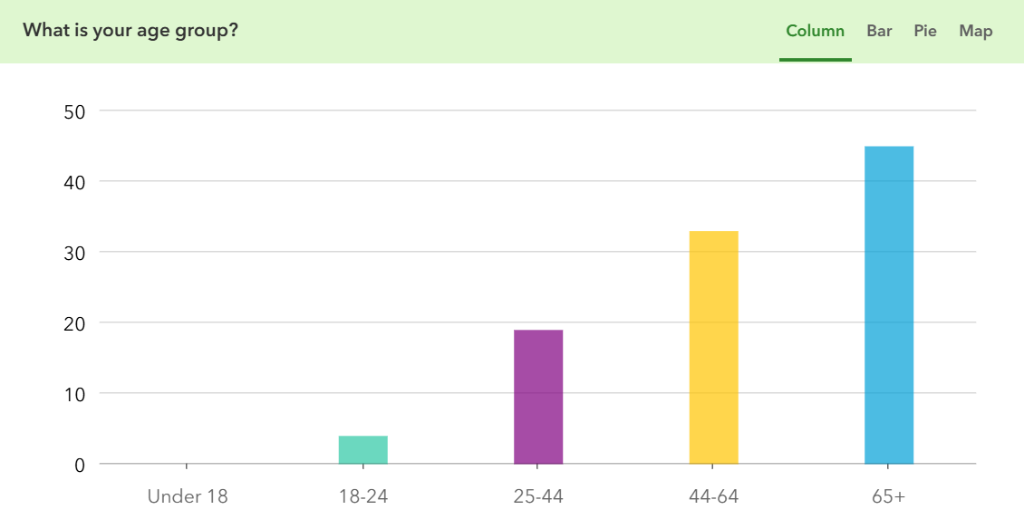
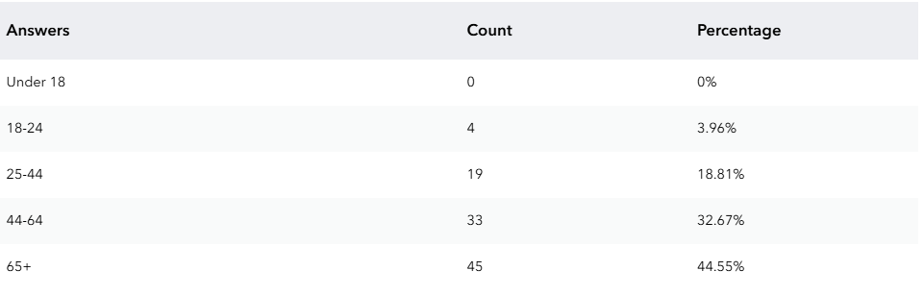

Current Travel Modes
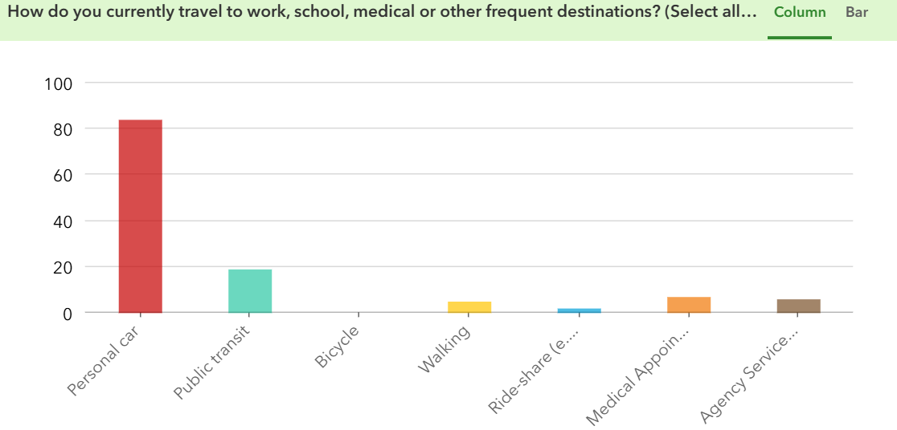
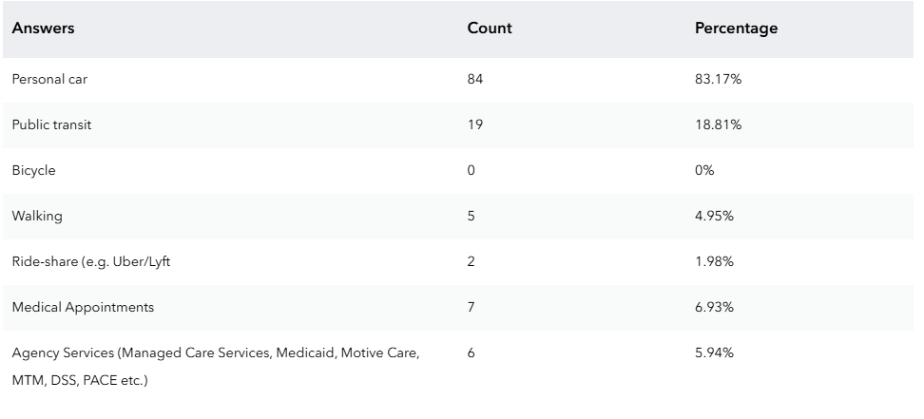

Most Utilized Transit Options
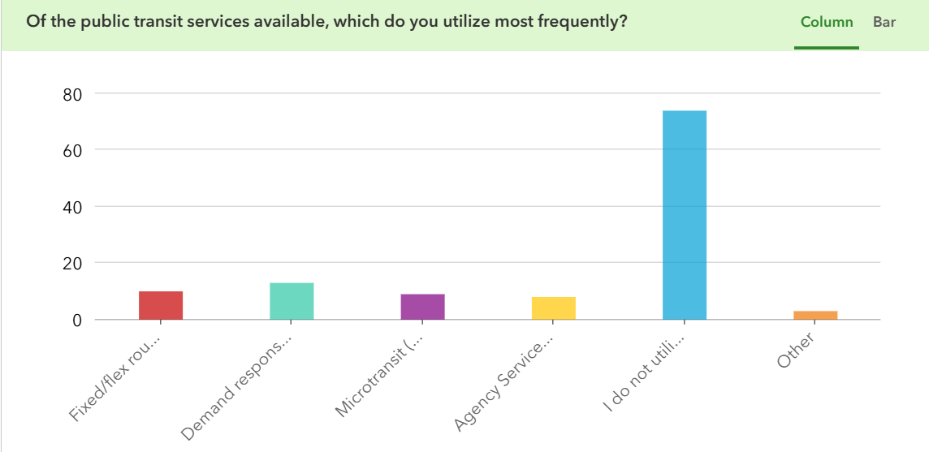

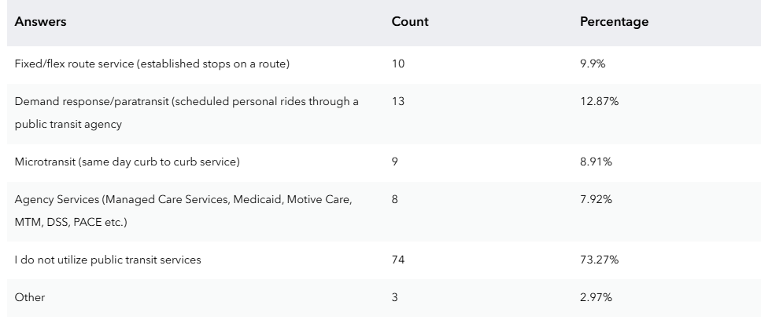

Where do you live?
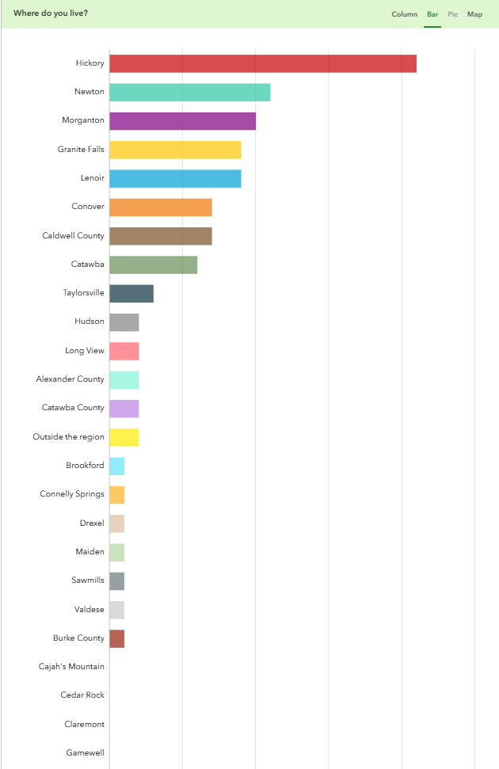

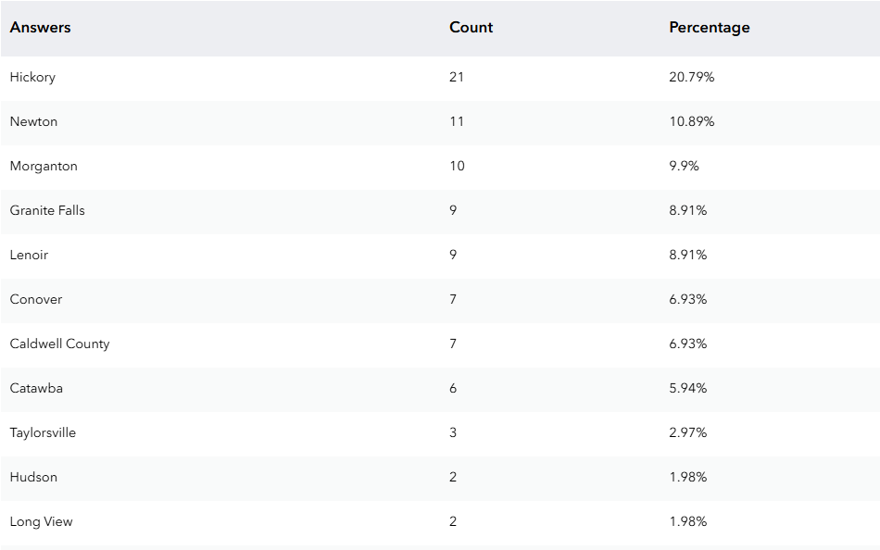
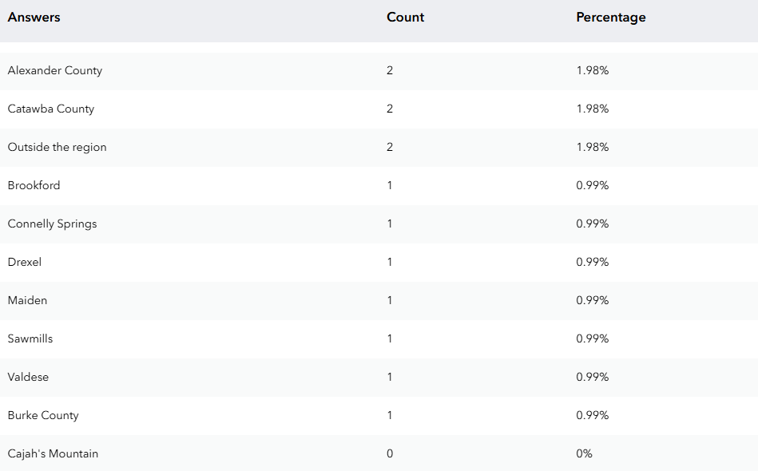

Where do you work?
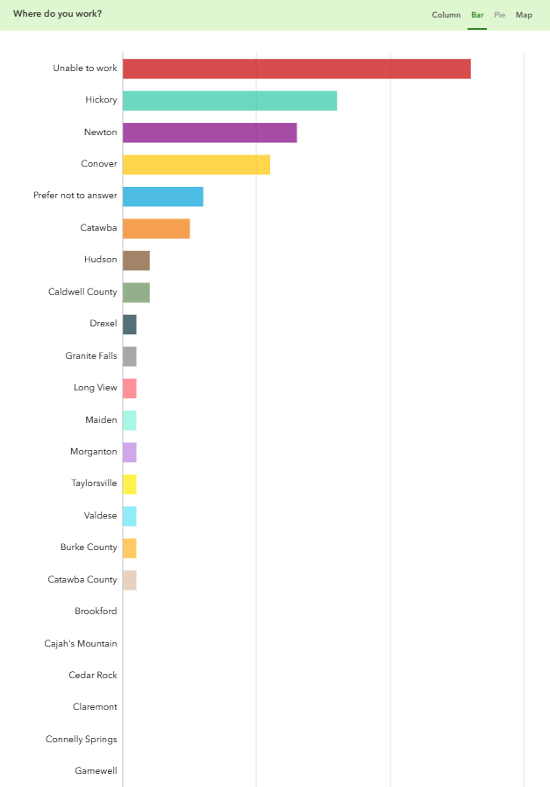

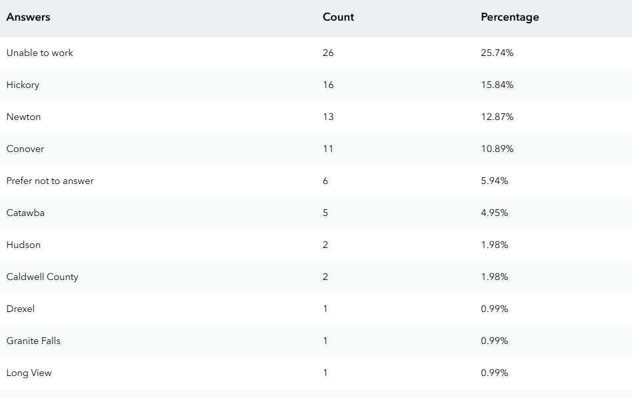
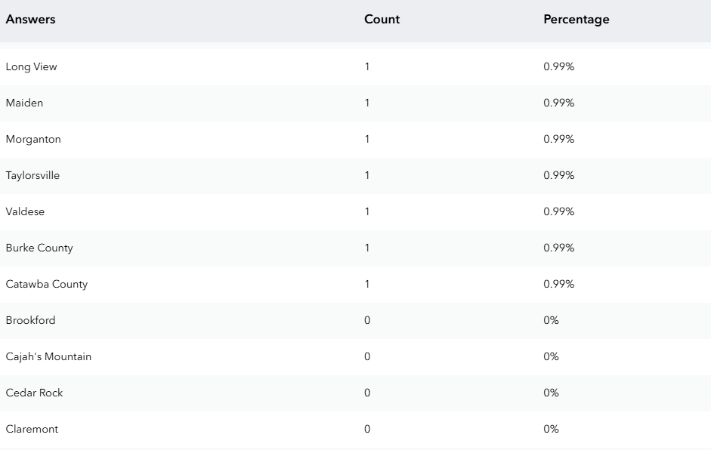
Race

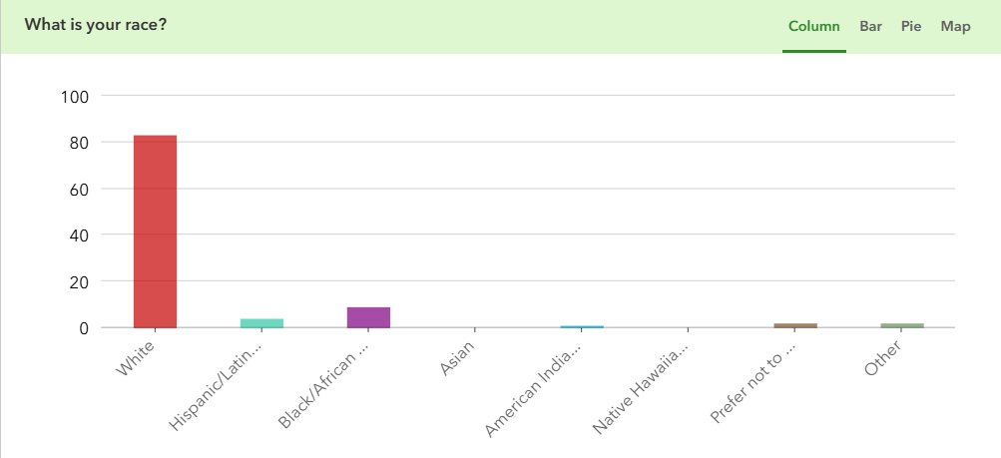

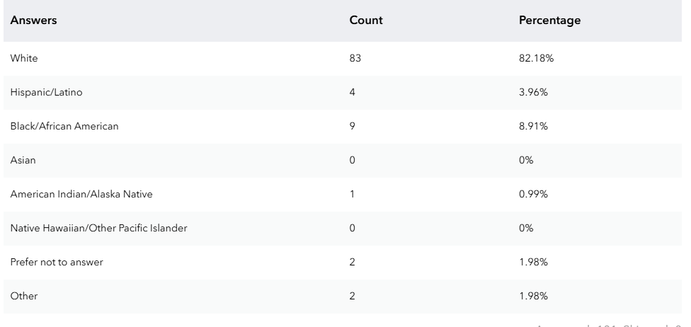

Income

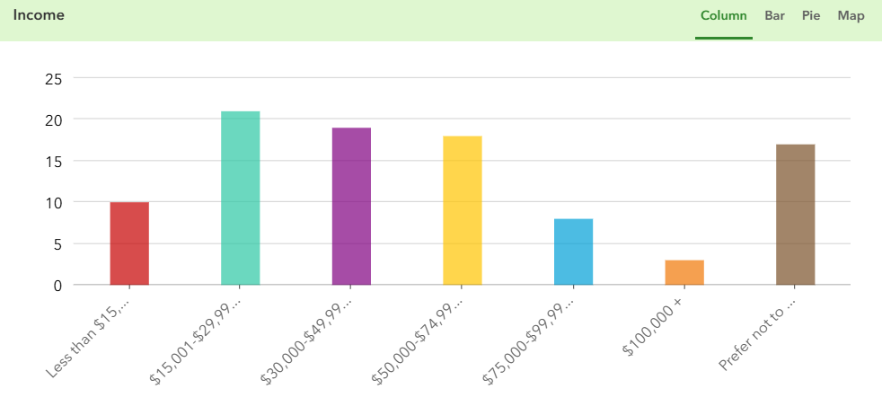
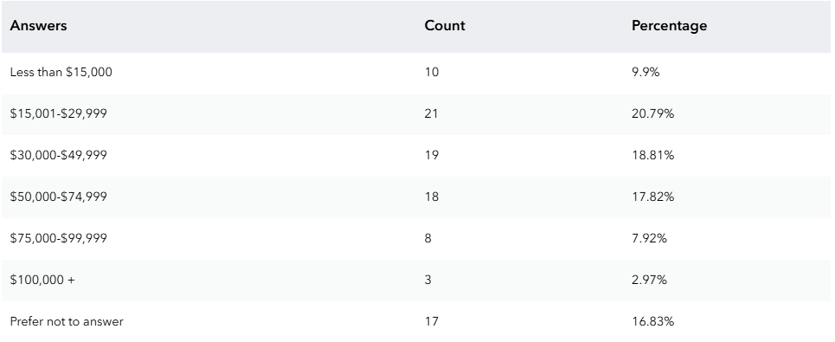

Transit Usage

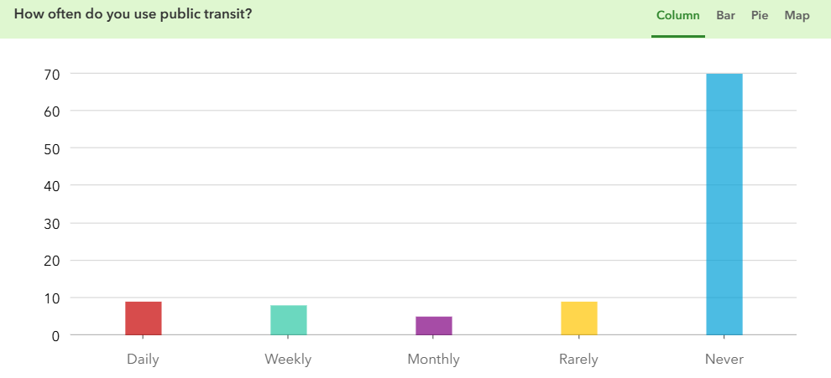
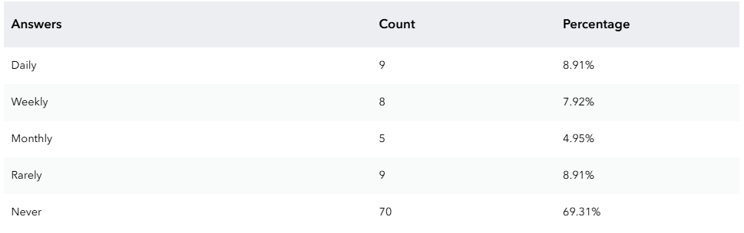

Concerns and Transit Use
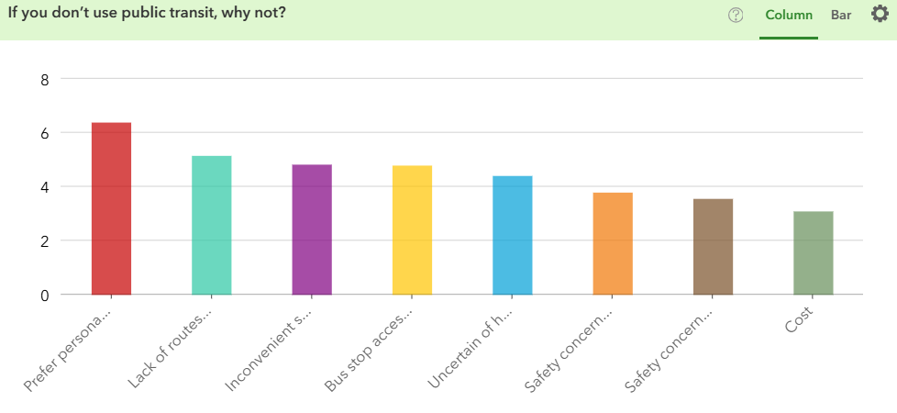

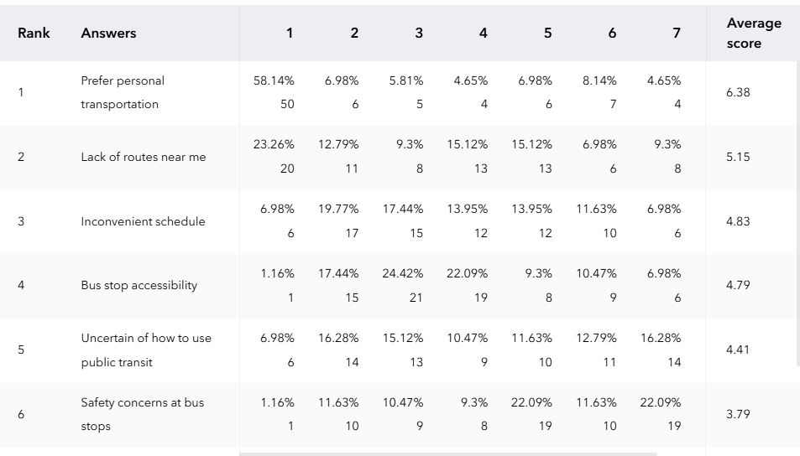
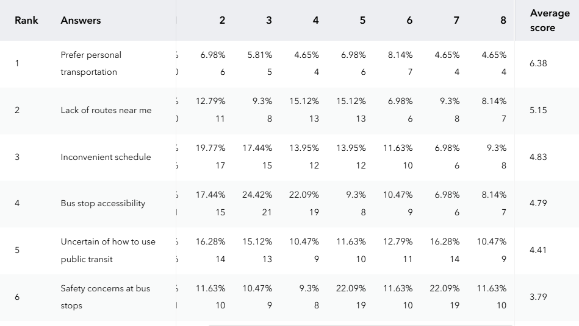

Main Transit Destinations
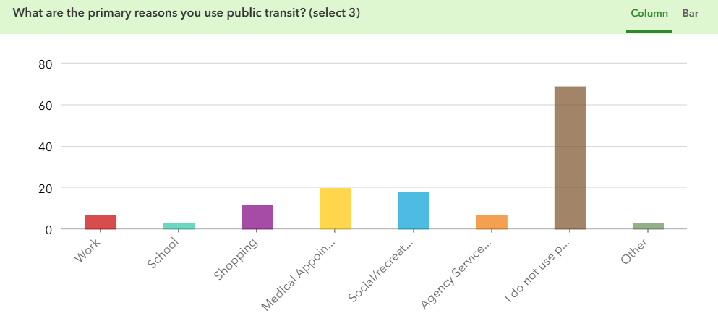

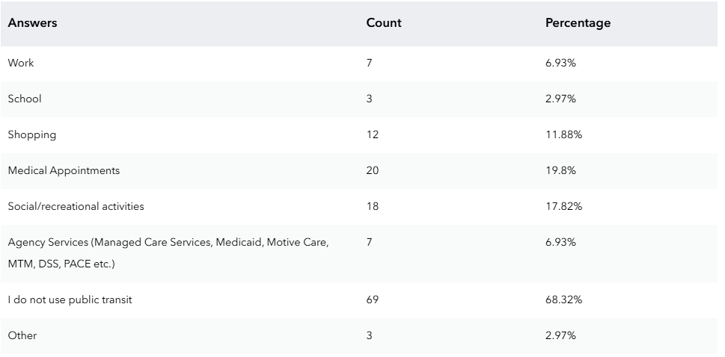

Fares
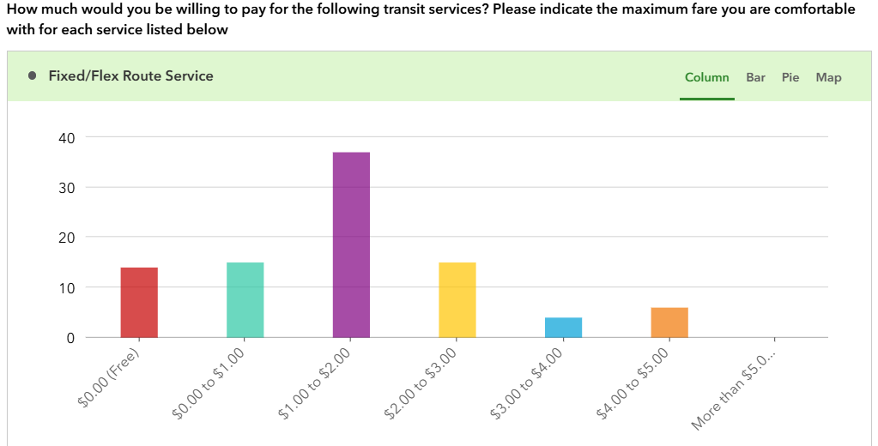

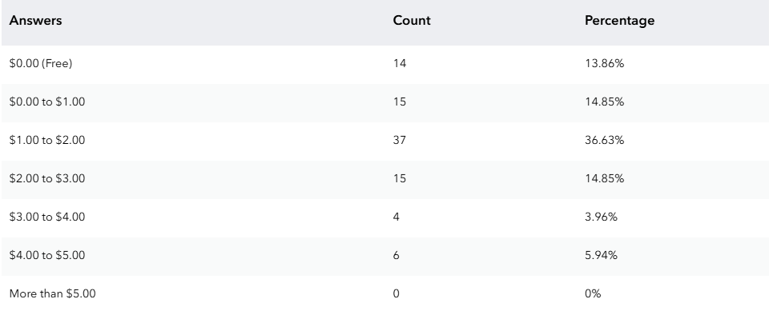

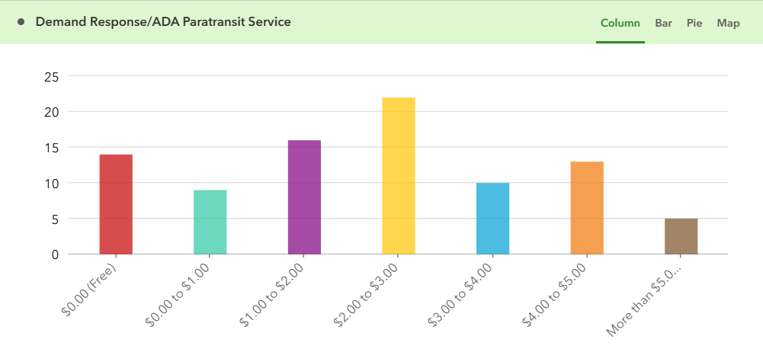
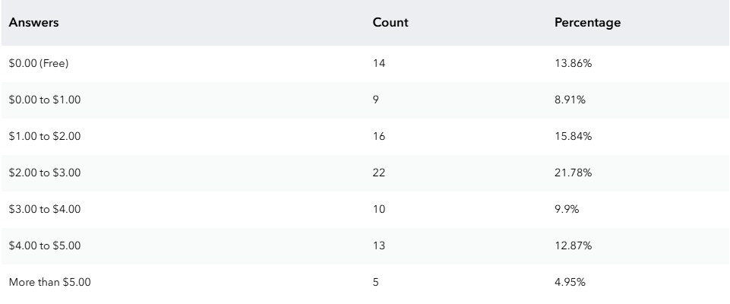

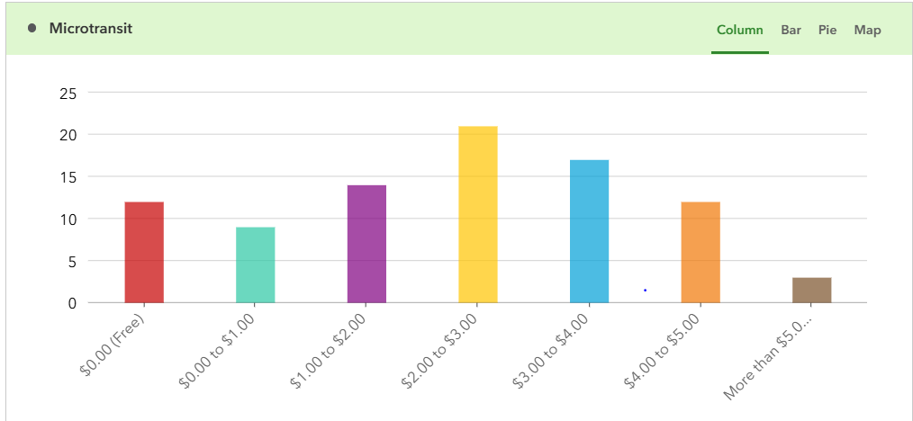

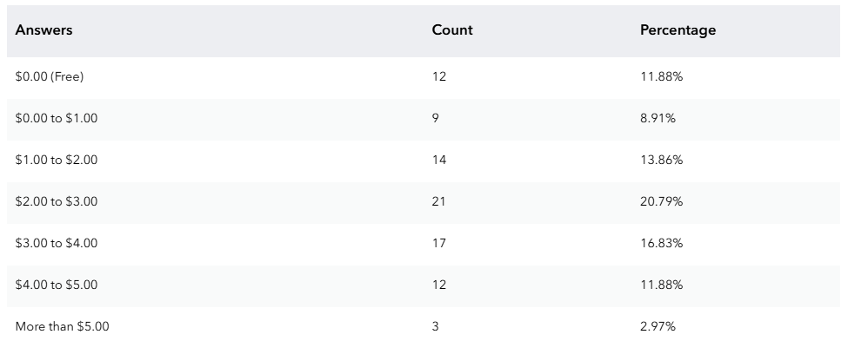

Barriers to Transit Use
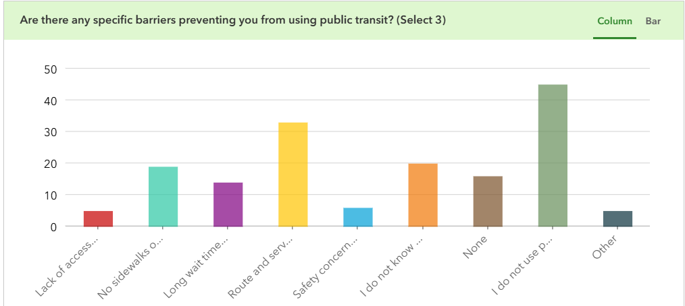

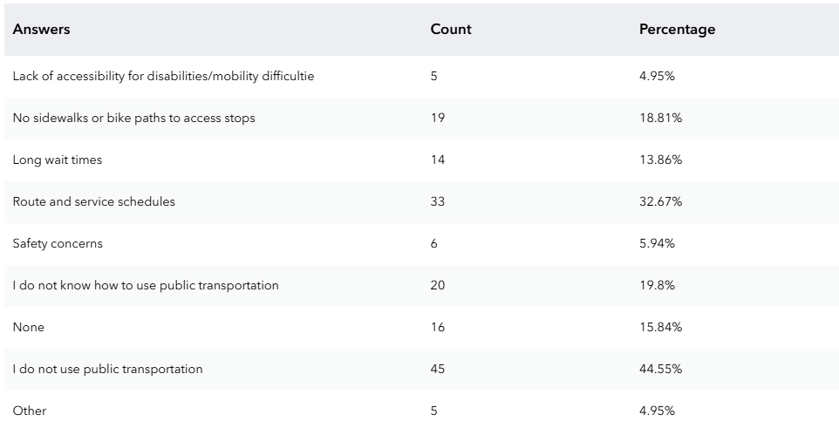

Desired Transit Improvements

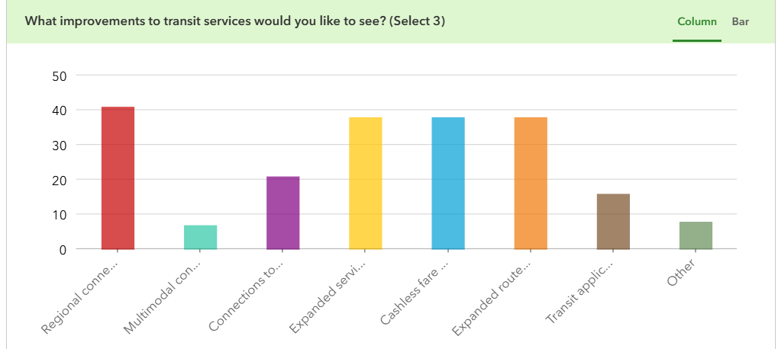

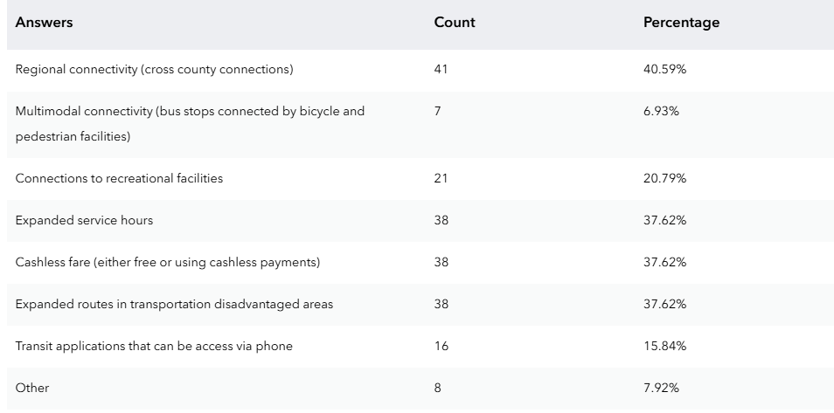

Most Important Transit Qualities

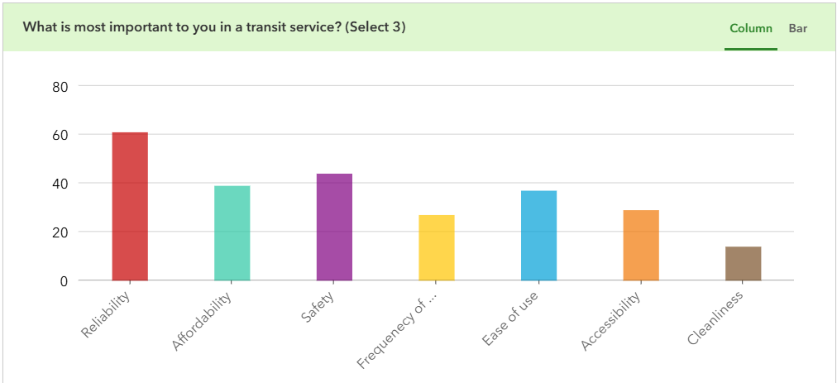

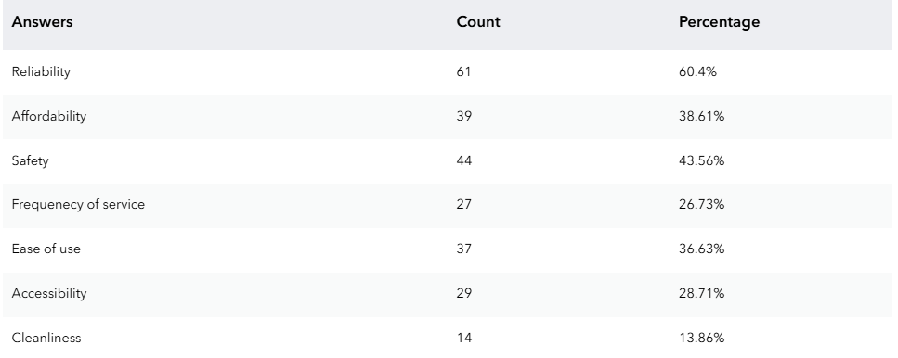

Time to Access a Transit Stop
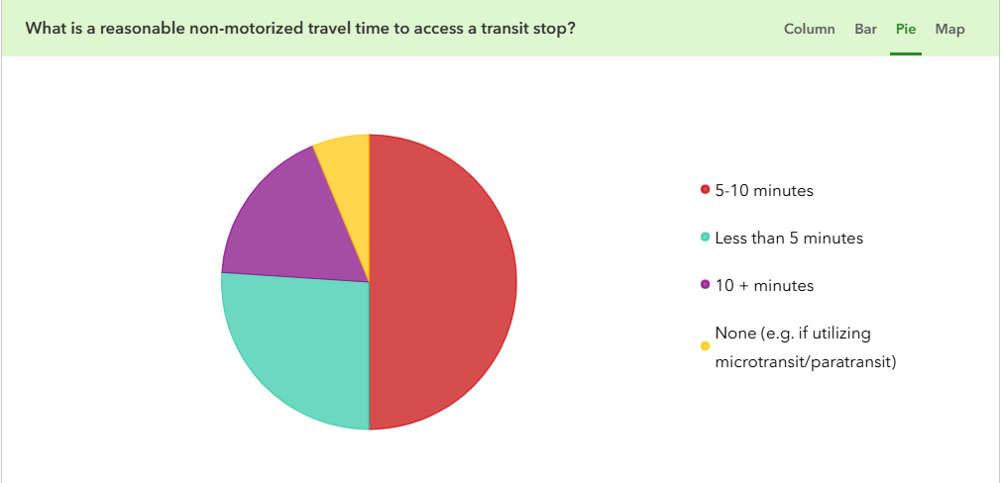

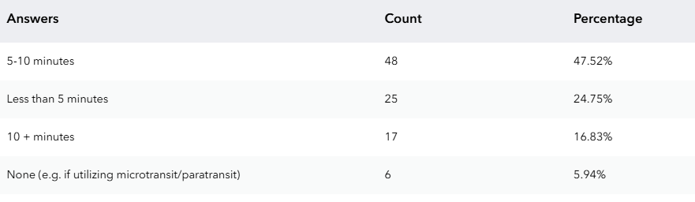

Most Needed Times for Transit
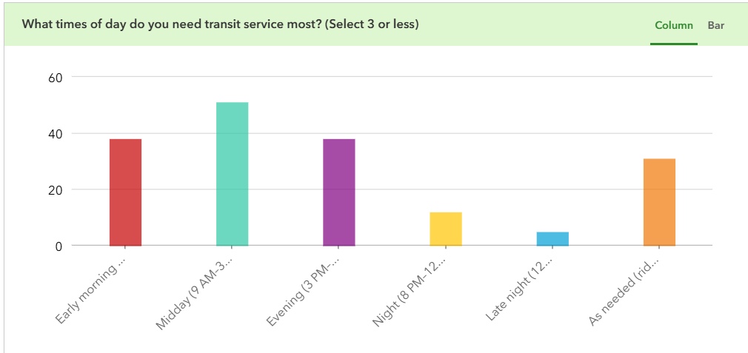

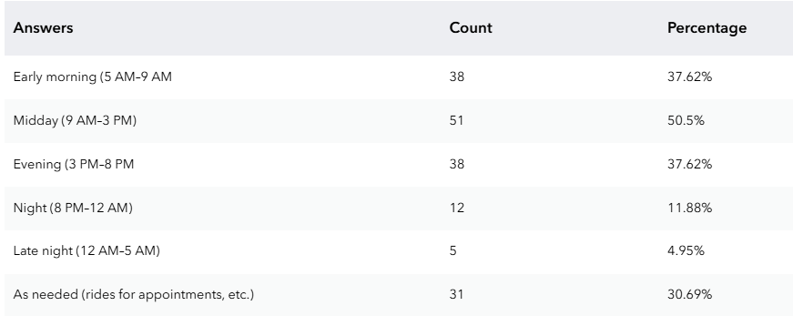

Service Offered Vs. Community Needs

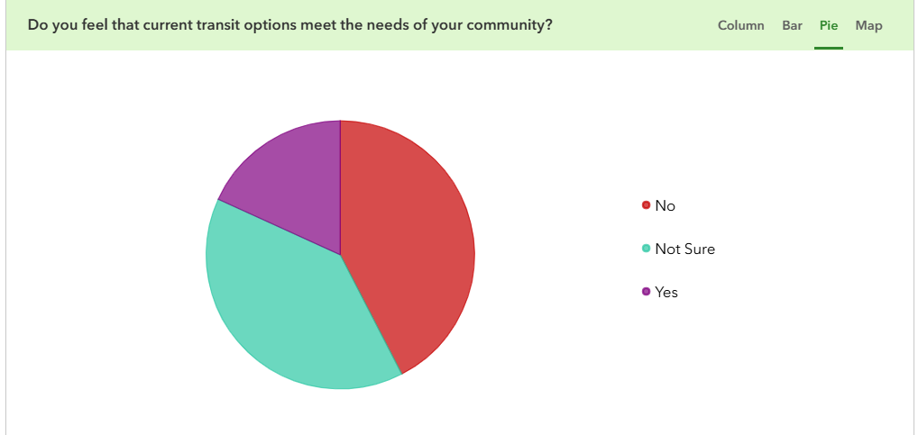

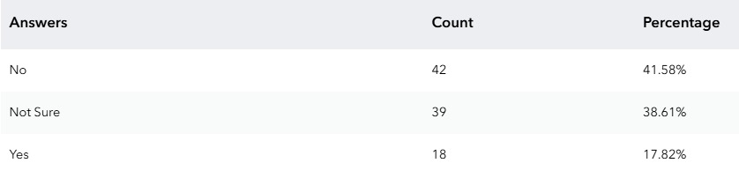

The following graphics are word clouds. The larger the word, the more times the word was mentioned.

Specific Groups Facing Transit Challenges
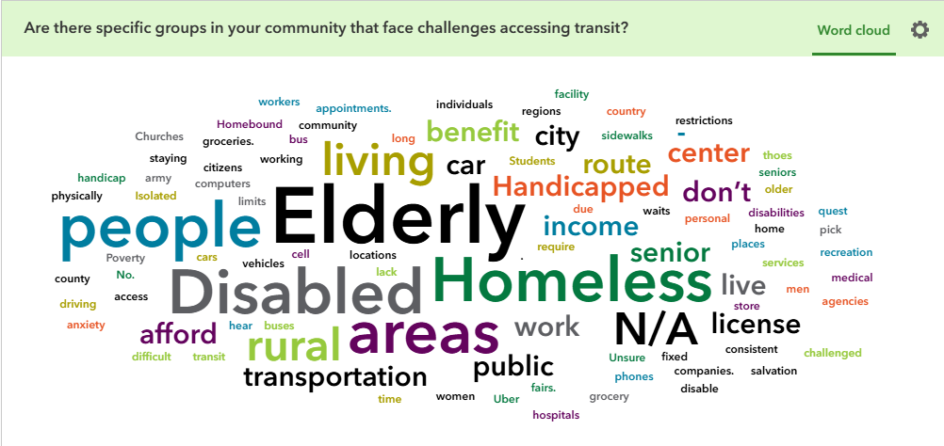
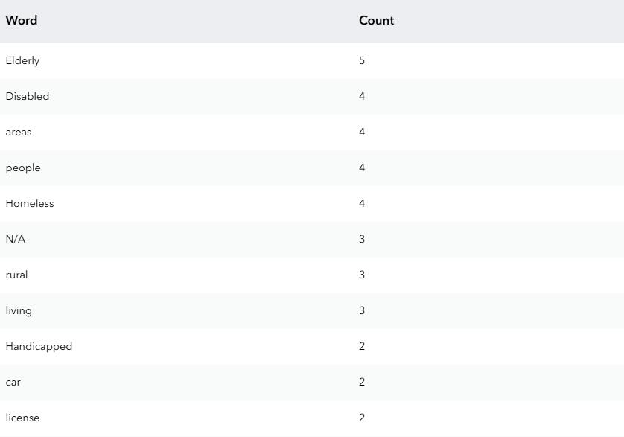

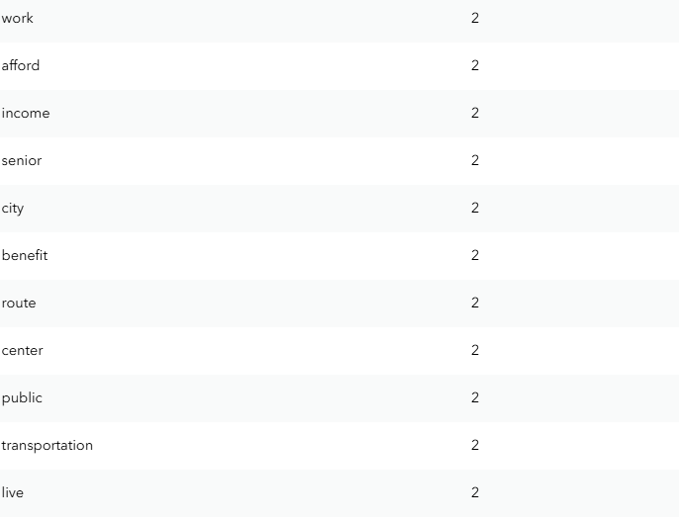
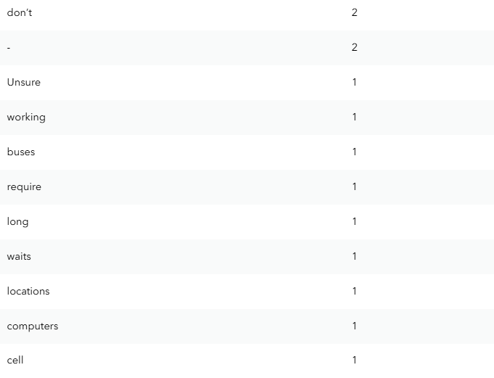
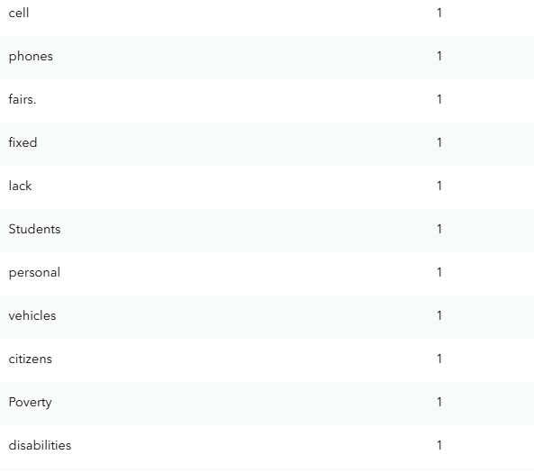
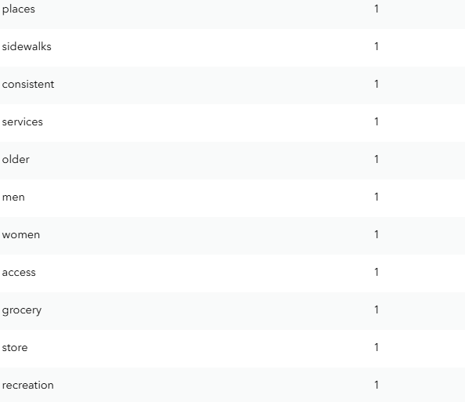
Areas in need of Transit Service

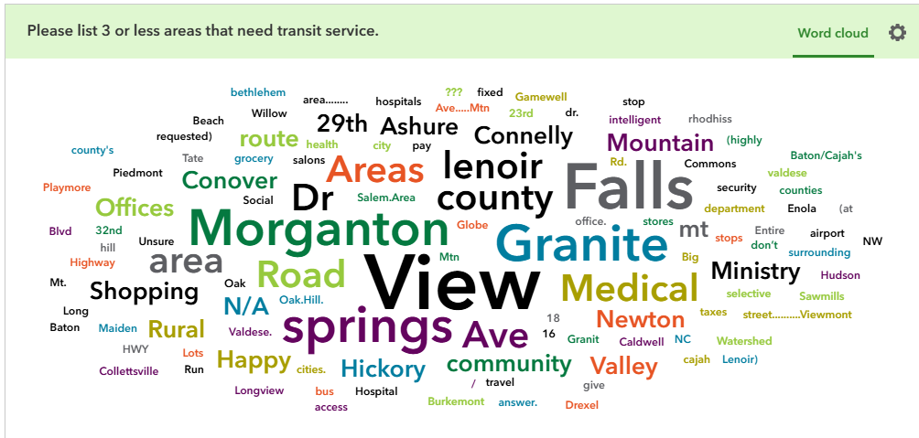

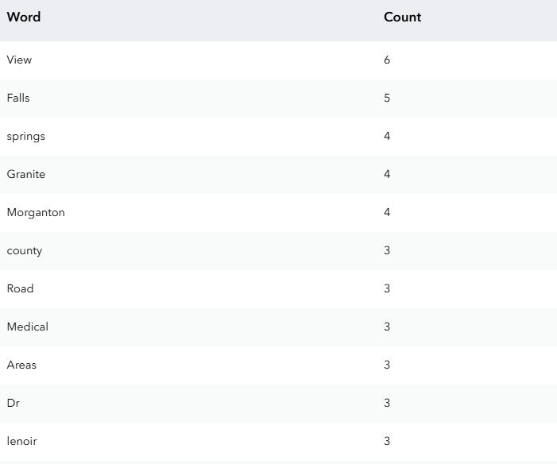
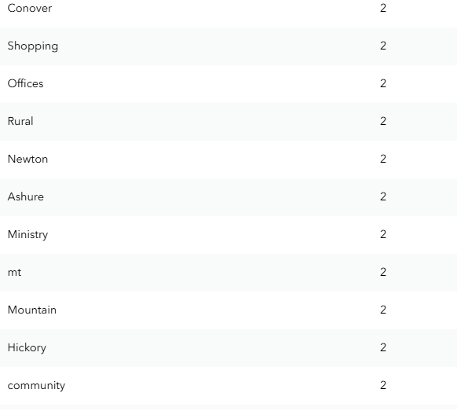
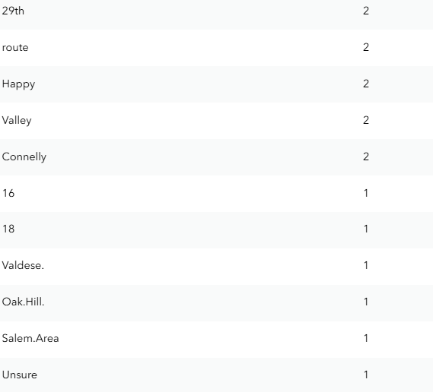
Areas that need Bus Stop Improvements
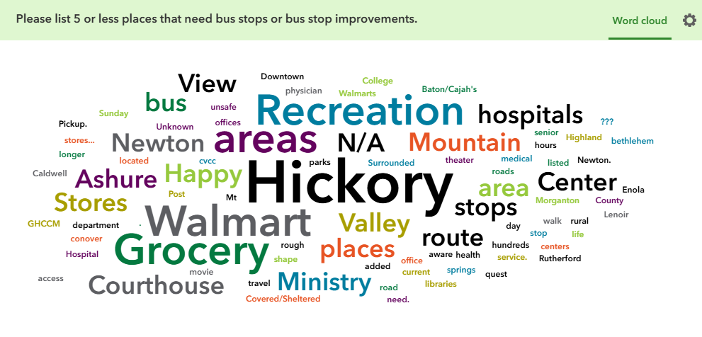

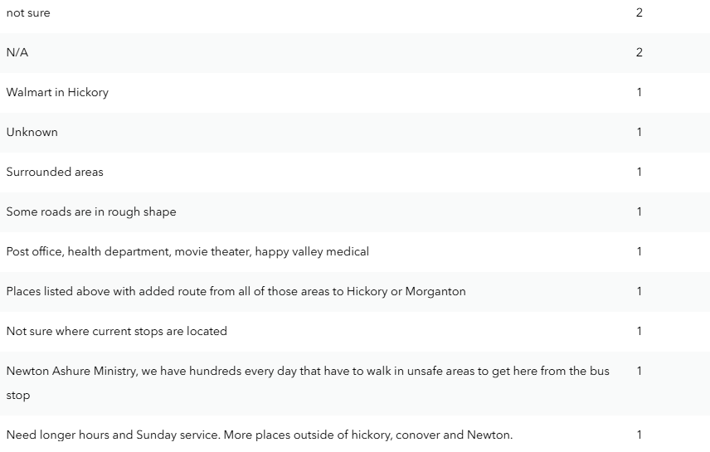
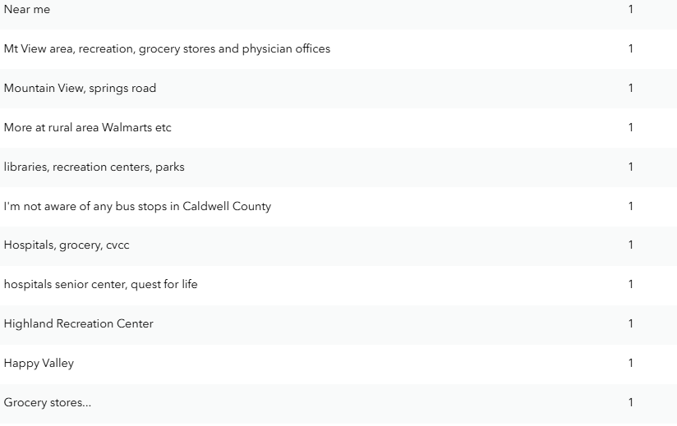

Informing the Public of Transit Services
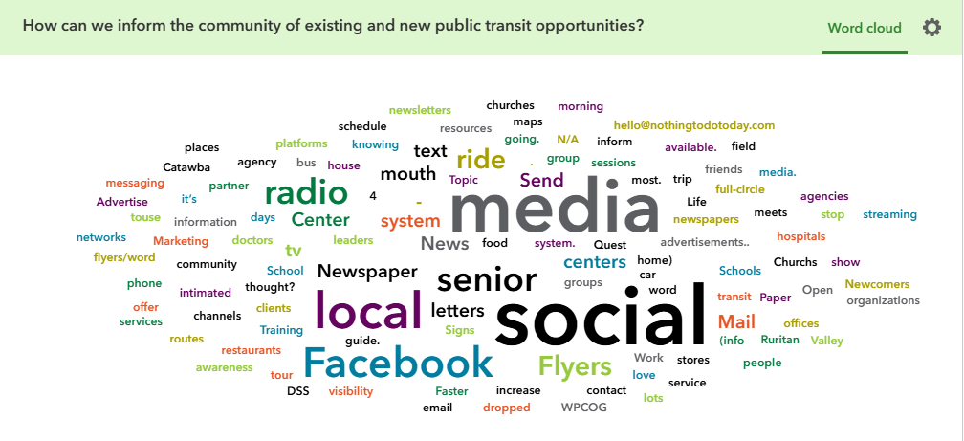
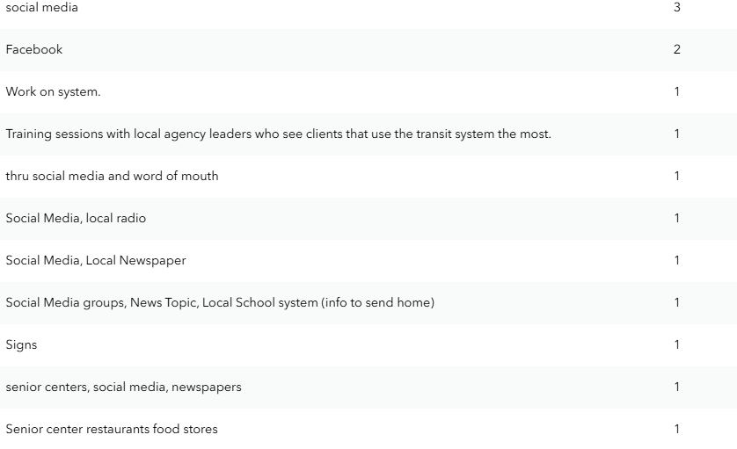
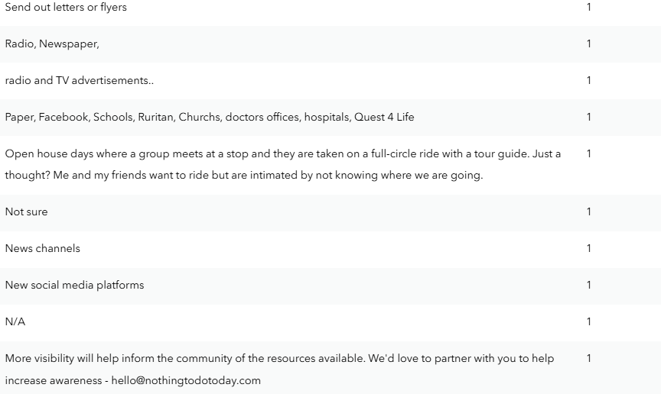
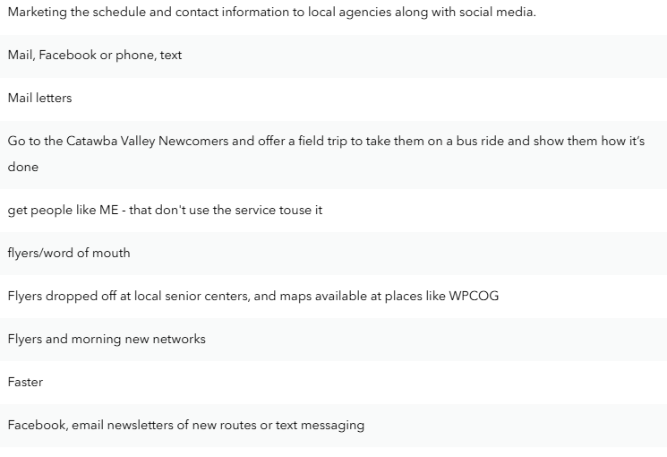
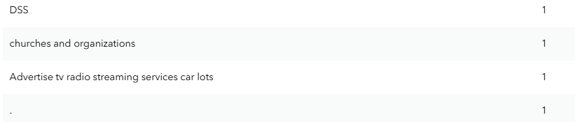
Any additional questions or concerns?
- I feel they are doing a great job building our local service. It take time. People need to know that
not at the moment
- No
- I am often confused about why I can't get rides at 5am, but i'm ADA. You should do anything I want. I know there's some people who can ride the bus like a taxi service. Going 5-10 places a day with no restrictions.
- We are huge advocates of public transportation at Nothing to Do HKY - our area is limited in its growth by its transportation. People complain about the lack of parking and the traffic, yet they don't utilize public transportation.
- For children needing car seats: to find a safe way of travel for them without having to carry their car seat
- No
- No
- I like that service is improving. I see more and more mini busses around the unifor
- I would like to see a service that can transport people to other cities like Hickory, Charlotte, Raleigh, and Asheville to see shows, and festivals, and concerts in the late afternoon or evening.
- No. Thank you!
- Even though I do not use the services, I feel strongly that our area needs to continue them.
- Have no idea how to call for service
- None
- I would like buses down Robertson rd
- I would like them to run later in the evening in Catawba County
- I don't like the kind of people that ride buses.
- I would like to attend Comma performances.I as well as other seniors don’t drive at night.
- No
- None
- No sure
- It would be nice to have an option for affordable safe transportation home from town if we wanted to have a few drinks on a dinner date.
- Existing bus stops near benches and shade and sidewalks. The bus system needs to go more into rural areas.
- Please call if you wish: Jane Duralia

**There was an additional question asked about community advocates that we could contact on behalf of transit within each community. Because personal information was listed, staff did not include contacts within the plan.

SECTION EIGHT: RECOMMENDATIONS

Recommended Strategies and Potential Projects
Recommended strategies and potential projects were derived from two major sources: the 2008 WPRTA Implementation Plan, plus the 2013, 2017, 2021, and 2025 Coordinated Plan Workshops. This section documents these strategies and projects.
While the WPRTA Implementation Plan was not primarily a service planning study, some logical service expansion ideas were discussed during development of the Plan. These concepts are based on the
configuration of the urbanized area, coupled with the current demand for human service agency-based trips. The funding flexibility currently permitted for Federal Section 5307 transit providers in small urban areas would allow the introduction of demand response and microtransit expansion services in urbanized corridors that do not currently have regular route service. Human service agency-based trips can be provided along these routes and the revenues derived from the agencies can be used as local match for the federal funds.
These corridors include the Lenoir to Hickory Corridor along US 321-A and the Morganton to Hickory Corridor along US 70. In order to make this service cost
effective, it is proposed that these routes be based on the current human service agency demand for service in these corridors, with the current human service riders scheduled on these routes.
Other new services that could be developed in the region were cited in the 2009 Local Coordinated Transportation Plan and were reinforced in 2013, 2017, 2021, and 2025 Local Coordinated Transportation Plan workshops and surveys. Possible future service includes the following:

- Corridor service from Taylorsville to Hickory (NC 16 and NC 127)
- Corridor service from Taylorsville to Statesville (US 64 and NC 90)
- Circulator service in Morganton (implemented in 2018)
- Circulator service in Lenoir (microtransit service is now available for Lenoir and several surrounding local governments – implemented in 2024)
- Connectivity between Hildebran and Hickory
- Circulator service in Long View and Hildebran
- Additional technologies such as applications for cashless fare options and booking trips
- Additional technologies for applications that show bus locations (locators have been installed on vehicles – implemented in 2025)
- Additional infrastructure is needed at transit stops with little or no ADA accessibility (an ADA transition plan is in development and is slated for adoption in 2025)
- Additional technologies for collecting ridership data (Automatic Passenger Counters have been installed on most vehicles – implemented in 2025)
- Additional specific employment transportation service with extended hours/days of service
- Additional rural general public demand response/other modes of service delivery
- Additional human service contractual trips
- Additional urban general public demand response/other modes of service delivery
- Additional group type trips to support senior and disabled transportation to destinations such as congregate meals, group shopping, dialysis and more

Implementation Priorities
In addition to identifying the region’s transportation needs and what activities to coordinate, the Local Coordinated Plan Steering Committee also considered it priorities and how to implement them.

As indicated by the facilitators at the planning workshop, one goal of the planning process was to examine public transportation services that are provided within the four counties of Alexander, Burke, Caldwell and Catawba. The needs and activities identified by the workshops and surveys in terms of their priorities demand certain actions that are essential in the implementation of the Local Coordinated Plan.
Actions that require little funding or have already begun should be part of the first phase of implementation. Others may require more time to implement because they require federal and state participation.

The following sections detail action items by type of activity.

WPRTA Education and Outreach
In an effort to meet some of the identified needs, it is necessary to provide information and coordinate with stakeholders: the Departments of Social Services and other human service agencies, such as, Exodus House, Centro Latino, and faith based organizations and, indeed, the NC Department of Transportation- Public Transportation Division, on how best to address these needs. Local businesses are also important. The implementation of the fixed route service in Taylorsville is a successful outcome of WPRTA education and outreach efforts with the elected officials of the town.

Promote Community Outreach and Marketing
WPRTA should utilize outreach techniques in order to better engage the public for the continued development and implementation of the coordinated planning process. Some techniques include a once-a- year open house for the general public and inviting representatives from the public to Transportation Advisory Board meetings. The latter may also involve training participants about the technical and policy issues surrounding transportation and transit planning.
- Educate older adults on what is allowed (grocery storage, ADA Paratransit options, etc.) via transit services. Teach them how to utilize transit through ridership trainings.
- Advertisements on Transit Vehicles – Advertisements could provide transit agencies with additional income as well as inform riders of transit services. Many felt that it could serve as a great educational opportunity.
- Educate Service Providers in the Area – Increased communication among all transportation providers in the region is necessary to connect riders with necessary services. Many attendees were not aware of many of the services WPRTA now provides.

Local Awareness of Local Match Needs
Local Awareness of Local Match Needs – Local matches for various federal transit funding sources require matches of either 20% or 50%. While expanded transit services are needed, local matches are required to receive funding. Workshop attendees felt that annual workshops to transit providers and local government partners could help educate the region on financial requirements for transit expansion.

Regional Connectivity
Regional Connectivity – While this was also considered an opportunity and a weakness among workshop attendees, regional connectivity would provide the four county region with many opportunities. Regional connectivity is essential to building an effective and equitable transit system, especially in a multi-county service area. When transit does not cross county lines—as is currently the case—it limits access to jobs, education, healthcare, and other essential services for riders who live, work, or travel between counties. This disconnect can create transportation deserts and isolate communities, particularly in rural or suburban areas where options are already limited. A more connected regional network improves efficiency, expands opportunity, and supports economic development by allowing seamless, coordinated movement across jurisdictional boundaries. Enhancing cross-county service is a critical step toward a more accessible and resilient transportation system for the entire region. WPRTA plans to work towards regional connectivity through studies and service expansion.

Identify opportunities to increase funding for human service transportation to meet some of the specific needs that are identified in the plan
The Transportation Advisory Board can develop a common message regarding the need to enhance human service transportation in the region and to identify specific methods to communicate these needs to decision makers. For example, it may prove helpful to develop fact sheets and other educational materials to inform local Boards of Commissioners and City and Town Councils of regional human service coordination goals, including the need for additional funding. It could also be beneficial to coordinate visits to elected officials to present the materials in person. A long-term strategy could also consist of identifying and seeking future opportunities, which have the potential for a dedicated funding to support human service transportation services and programs.

Some grant programs, such as Transportation for Elderly Persons and Persons with Disabilities (Section 5310), may also be available to assist in implementing programs to support the region’s coordination goals. The WPRTA should seek out such opportunities and prepare grant applications.

WPRTA should research and document potential funding opportunities for human services transportation and transportation related activities. They will also work with local, state, and federal agencies to discover or create matching opportunities for federal transportation grants, and assist determining the most
effective use of these funds. Given the changing funding landscape at the state and national level, and the simultaneously increasing costs and need for public transportation, this activity should be ongoing in nature.

Implement travel training programs
Promote the development of programs that raise awareness among individuals of the transportation options that are available to them, and instruct them as to how to access and navigate the transportation system. Such a program can include published materials, classroom style sessions, and volunteer travel escort partners.

Identify opportunities for pooling or sharing human service transportation agency funding across the service area
Transportation funds are received by a multitude of human service agencies located within the service area. Developing better communication and coordination of this funding would maximize the availability
of funding to the community. Referral of clients to other appropriate agencies for transportation funding is important for the optimization of all available transportation funds.

Facilitate schedule coordination at major connections
Improved schedule coordination could make connections easier to plan and potentially reduce wait times for riders. WPRTA should continue to work with operators to refine timetables and coordinate route schedules.

Maintain GIS database of demographic data
WPCOG will continue to maintain data on the population with the regional planning area. In addition to obtaining such data from traditional sources WPCOG will seek opportunities to expand its demographic databases through pursuing and building data sharing partnerships.

Maintain GIS database of regional employment and activity centers
WPCOG will continue to utilize existing datasets work with partner agencies (primarily municipal planning departments) to develop geographic databases of current and future land uses in order to better understand regional employment and activity centers.

Inventory conditions and install amenities at and around transit stops that encourage pedestrian and bicycle access
An inventory of current conditions and a geographic assessment of deficiencies are underway in the form of an ADA Transition Plan. This plan is slated for adoption in 2025. Once adopted, this plan will assist WPRTA in funding opportunities for needed 5310 – related upgrades at transit stops. This plan is required to ascertain priorities toward improving pedestrian and bicycle access. Other similar inventory efforts should be encouraged and undertaken. These and comparable efforts should be utilized to identify priority locations for the installation of pedestrian and bicycle accessibility amenities. Improvements should be installed or facilities retrofitted in collaboration with municipal and local government agencies.
- Multi-Modal Opportunities – With increasing bicycle and pedestrian infrastructure, as well as the hope of the Western NC Passenger Rail Line, transit services will potentially gain significant multi-modal ridership. Transit boosts multimodal opportunities by serving as a central link that connects various forms of transportation into a cohesive, flexible network. Well-planned transit systems integrate with biking, walking, carpooling, and micromobility options like scooters or ride-hailing services, making it easier for riders to combine modes to complete their trips. Features like bike racks on buses, secure bike parking at stations, and pedestrian-friendly access to stops all enhance connectivity. This integration allows people to choose the most efficient, affordable, and sustainable option for each leg of their journey—ultimately reducing car dependency and improving overall mobility.
- Increased Community Buy-In - Increased community buy-in—such as incorporating local art into transit infrastructure—can significantly strengthen a transit system by fostering a sense of ownership, pride, and place. Public art at bus stops, transit centers, or on vehicles can make transit spaces more welcoming, vibrant, and reflective of the communities they serve. This not only enhances the rider experience but also builds public support for transit investments. When residents see their culture, history, and creativity represented in the system, they are more likely to value and advocate for it. Additionally, community partnerships around art projects can increase visibility, reduce vandalism, and help transit feel like a shared community asset rather than just a government service.

Conduct an evaluation of programs activities on an annual basis; report findings to the Transportation Advisory Board
Collect data and monitoring the coordination activities. The resulting information should be compared to the expectations developed as a short-term strategy. It is also important to document a more qualitative assessment of coordination activities to assess barriers that may have prevented successful program implementation, lessons learned or strategies that have been proven especially effective. The results of this evaluation should be shared with relevant stakeholder groups and future work should be modified to meet revised expectations.

Expand or adjust service in underserved or inappropriately served areas or time periods
Efforts should be made to identify gaps or deficiencies in the fixed route system and strategies developed to supplement or adjust to a service level more appropriate to the needs of the transportation disadvantaged population. Data and surveys can inform decisions as to where service should be added or extended to better serve, for example, group housing or workplaces for the disabled, medical facilities for the elderly, or employment centers with opportunities for the training or hiring of low-income persons.

Adjust fleet sizes and/or operations where existing service is inappropriate
Work to identify and secure the funding necessary to allow transit operators or demand service providers to purchase new vans or paratransit vehicles or supplement operations in order to more appropriately meet the needs of their customers. Such resources, however, should only be directed toward expansions of service that decrease identified regional gaps in service and won’t contribute to duplicative service between agencies.

Implement mobility management technologies and continue current Mobility Management Activities
Travel Training & Mobility Management - Travel training is a personalized educational program that teaches individuals—especially seniors, people with disabilities, or those unfamiliar with transit—how to safely and independently use public transportation. This can include route planning, boarding procedures, fare payment, and safety tips. Travel training empowers more people to use fixed-route services instead of relying on costlier paratransit, boosts rider confidence, and increases overall system ridership. It also promotes independence and improves access to employment, education, and healthcare. Mobility management is a strategic, person-centered approach to coordinating and improving transportation services by focusing on the rider’s needs rather than specific modes. It involves working across providers and agencies to connect people with the most appropriate and efficient travel options. Mobility management can reduce service duplication, improve regional coordination, and better serve populations with complex mobility needs. It also helps transit systems maximize resources, identify service gaps, and promote equitable access through partnerships, data integration, and customized trip planning. Workshop attendees praised WPRTA’s current Mobility Manager for her efforts and suggested additional places to contact.

Intelligent Transportation Systems (ITS) technologies that assist in regional trip planning and coordinated service delivery include such online system mapping and trip planning, automatic vehicle location, electronic fare payment and collection systems, communications equipment, and computer aided dispatch. Many of these applications are in progress. The TAB can assist service providers in determining the need for such technologies and the best means to finance technology projects. The council can also assist in facilitating the inter-agency coordination required for their success and ensure their appropriate implementation in the context of region-wide mobility management.

SECTION NINE: OUTREACH FOR 2025 LOCALLY COORDINATED PLAN

Outreach Flyers
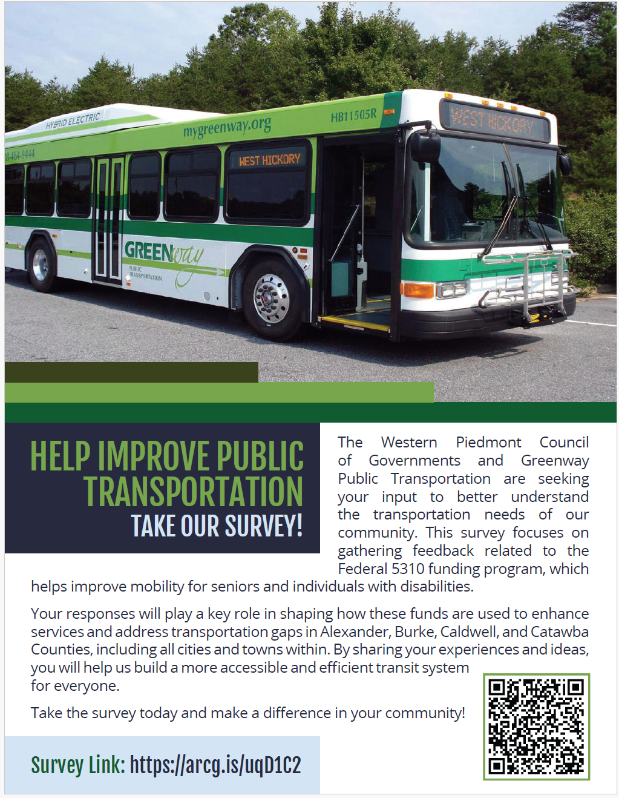

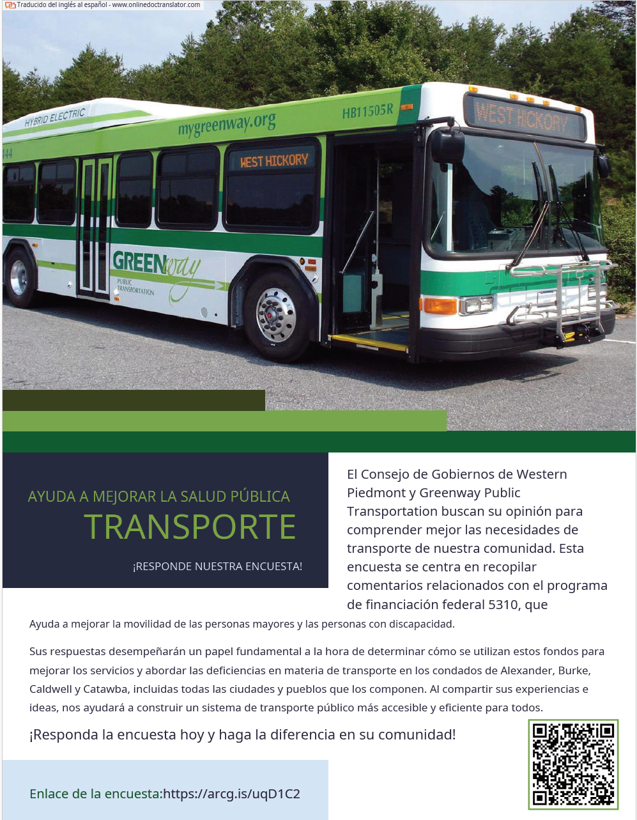

Paper Copies of Survey (English and Spanish)

Public Transportation - Assessment of Needs Survey (Locally Coordinated Plan)

Public Transportation- Assessment of Needs Survey (Locally Coordinated Plan)

Western Piedmont Council of Governments and Greenway Public Transportation are conducting this survey to better understand the transit needs of our community, particularly in relation to the Federal 5310 funding program. The 5310 program provides funding to enhance mobility for seniors and individuals with disabilities, and the feedback we gather will directly influence how these funds are allocated to improve services. By participating in this survey, you will help us identify transportation gaps, challenges, and opportunities for improvement in the region. The region includes Alexander, Burke, Caldwell, and Catawba Counties as well as all cities and towns within. Your input will be crucial in shaping the Locally Coordinated Transit Plan, ensuring that the resources from the 5310 program are used effectively to create a more accessible and efficient transit system for all residents.

A description of each service currently being offered by Greenway Public Transportation is included below.

Service Descriptions:

Fixed and Flex Route Service: This is a traditional bus service with scheduled routes that pick up and drop off at designated stops throughout the region. The fare is $1.25 per ride, or $0.60 for seniors. Children 5 and under can ride for free.

Demand Response/ADA Paratransit Service: This is a door-to-door transportation service designed for individuals with disabilities who are unable to use the fixed-route service. The fare is $2.50 each way for trips within the service area, and $5 for each way if the destination is outside the designated service area. Children 5 and under can ride for free.

Microtransit Service: A flexible, on-demand transit service where passengers can book rides by calling the service directly. It operates in a specific service area, and fares are $2.50 each way, with free rides for children 5 and under.

Thank you for your input!

Service Descriptions:
Fixed and Flex Route Service
Traditional bus service with designated stops. Fare: $1.25 per ride ($0.60 for seniors). Free for children 5 and under.
Demand Response/ADA Paratransit Service
Door-to-door service for individuals with disabilities. Fare: $2.50 per trip within service area, $5 outside service area.
Microtransit Service
On-demand flexible transit. Fare: $2.50 per trip. Free for children 5 and under.

Survey Questions:
- What is your age group?
  - Under 18
- 18-24
- 25-44
- 44-64
- 65+

- How do you currently travel? (Select all that apply)
  - Personal car
  - Public transit
  - Bicycle
  - Walking
  - Ride-share (e.g., Uber/Lyft)
  - Medical Appointments
  - Agency Services

- Which public transit service do you use most frequently?
  - Fixed/Flex Route
  - Demand Response/Paratransit
  - Microtransit
  - Agency Services
  - I do not use public transit
  - Other

- Where do you live? (Select one)
  - Alexander County
  - Burke County
  - Caldwell County
  - Catawba County
  - Hickory
  - Lenoir
  - Morganton
  - Taylorsville
  - Conover
  - Newton
  - Granite Falls
  - Hudson
  - Valdese
  - Long View
  - Rutherford College
  - Drexel
  - Sawmills
  - Gamewell
  - Cajah's Mountain
  - Brookford
  - Hildebran
  - Rhodhiss
  - Maiden
  - Claremont
  - Catawba
  - Troutman
  - St. Stephens
  - Other (please specify)

- Where do you work? (Select one)
  - Alexander County
  - Burke County
  - Caldwell County
  - Catawba County
  - Hickory
  - Lenoir
  - Morganton
  - Taylorsville
  - Conover
  - Newton
  - Granite Falls
  - Hudson
  - Valdese
  - Long View
  - Rutherford College
  - Drexel
  - Sawmills
  - Gamewell
  - Cajah's Mountain
  - Brookford
  - Hildebran
  - Rhodhiss
  - Maiden
  - Claremont
  - Catawba
  - Troutman
  - St. Stephens
  - Other (please specify)

- How often do you use public transit?
  - Daily
  - Weekly
  - Monthly
  - Rarely
  - Never

- If you don't use public transit, why not?
  - Prefer personal transportation
  - Inconvenient schedule
  - Lack of routes near me
  - Uncertain of how to use public transit
  - Safety concerns
  - Cost
  - Bus stop accessibility

- What are the primary reasons you use public transit? (Select 3)
  - Work
  - School
  - Shopping
  - Medical Appointments
  - Social/Recreational
  - Agency Services
  - Other

- How much would you be willing to pay for the following services? Fixed/Flex Route Service
- $0.00 (Free)
- $0.00 to $1.00
- $1.00 to $2.00
- $2.00 to $3.00
- $3.00 to $4.00
- $4.00 to $5.00
- More than $5.00

Demand Response/ADA Paratransit Service
- $0.00 (Free)
- $0.00 to $1.00
- $1.00 to $2.00
- $2.00 to $3.00
- $3.00 to $4.00
- $4.00 to $5.00
- More than $5.00

Microtransit
- $0.00 (Free)
- $0.00 to $1.00
- $1.00 to $2.00
- $2.00 to $3.00
- $3.00 to $4.00
- $4.00 to $5.00
- More than $5.00

- What barriers prevent you from using public transit? (Select 3)
  - Lack of accessibility
  - No sidewalks or bike paths
  - Long wait times
  - Route and service schedules
  - Safety concerns
  - Do not know how to use public transit
  - None
  - Other

- What improvements would you like to see? (Select 3)
  - Regional connectivity
  - Multimodal connectivity
  - Connections to recreational facilities
  - Expanded service hours
  - Cashless fare
  - Expanded routes
  - Transit applications
  - Other

- What is most important in a transit service? (Select 3)
  - Reliability
  - Affordability
  - Safety
  - Frequency of service
  - Ease of use
  - Accessibility
  - Cleanliness

- What is a reasonable non-motorized travel time to access a transit stop?
  - Less than 5 minutes
  - 5-10 minutes
  - 10+ minutes
  - None (if using microtransit/paratransit)

- Do you feel that current transit options meet the needs of your community?
  - Yes
  - No
  - Not Sure

- Are there specific groups in your community that face challenges accessing transit?

- Please list 3 or less areas that need transit service.

- Please list 5 or less places that need bus stops or bus stop improvements.

- Is there a community advocate we could speak to on behalf of transit within your community?
- How can we inform the community of existing and new public transit opportunities?

- Any additional questions or concerns?

Transporte Público - Encuesta de Evaluación de Necesidades (Plan Coordinado Localmente)
El Western Piedmont Council of Governments y Greenway Public Transportation están llevando a cabo esta encuesta para comprender mejor las necesidades de transporte de nuestra comunidad, particularmente en relación con el programa de financiamiento federal 5310. El programa 5310 proporciona fondos para mejorar la movilidad de personas mayores y personas con discapacidades, y los comentarios que recopilemos influirán directamente en cómo se asignan estos fondos para mejorar los servicios. Al participar en esta encuesta, nos ayudará a identificar brechas en el transporte, desafíos y oportunidades de mejora en la región. La región incluye los condados de Alexander, Burke, Caldwell y Catawba, así como todas las ciudades y pueblos dentro de ellos. Su opinión será crucial para dar forma al Plan de Transporte Coordinado Localmente, garantizando que los recursos del programa 5310 se utilicen de manera efectiva para crear un sistema de transporte más accesible y eficiente para todos los residentes.

A continuación, se incluye una descripción de cada servicio actualmente ofrecido por Greenway Public Transportation.

Descripción de los Servicios:
Servicio de Ruta Fija y Flex
Este es un servicio de autobús tradicional con rutas programadas que recogen y dejan pasajeros en paradas designadas en toda la región. La tarifa es de $1.25 por viaje, o $0.60 para personas mayores. Los niños de 5 años o menos viajan gratis.

Servicio de Respuesta a la Demanda/Paratránsito ADA
Este es un servicio de transporte puerta a puerta diseñado para personas con discapacidades que no pueden utilizar el servicio de ruta fija. La tarifa es de $2.50 por viaje dentro del área de servicio y $5 por viaje si el destino está fuera del área de servicio designada. Los niños de 5 años o menos viajan gratis.

Servicio de Microtransporte
Un servicio de transporte flexible y bajo demanda donde los pasajeros pueden reservar viajes llamando directamente al servicio. Opera dentro de un área de servicio específica y las tarifas son de $2.50 por viaje, con viajes gratuitos para niños de 5 años o menos.

¡Gracias por su participación!

Preguntas de la Encuesta:
- ¿Cuál es su grupo de edad?
  - Menos de 18 años
  - 18-24 años
  - 25-44 años
  - 44-64 años
  - 65+ años

- ¿Cómo viaja actualmente? (Seleccione todas las que correspondan)
  - Automóvil personal
  - Transporte público
  - Bicicleta
  - Caminando
  - Servicio de transporte compartido (ej. Uber/Lyft)
  - Citas médicas
  - Servicios de agencias

- ¿Qué servicio de transporte público utiliza con mayor frecuencia?
  - Ruta Fija/Flex
  - Respuesta a la Demanda/Paratránsito
  - Microtransporte
  - Servicios de Agencias
  - No uso transporte público
  - Otro

- ¿Dónde vive? (Seleccione una opción)
  - Condado de Alexander
  - Condado de Burke
  - Condado de Caldwell
  - Condado de Catawba
  - Hickory
  - Lenoir
  - Morganton
  - Taylorsville
  - Conover
  - Newton
  - Granite Falls
  - Hudson
  - Valdese
  - Long View
  - Rutherford College
  - Drexel
  - Sawmills
  - Gamewell
  - Cajah's Mountain
  - Brookford
  - Hildebran
  - Rhodhiss
  - Maiden
  - Claremont
  - Catawba
  - Troutman
  - St. Stephens
  - Otro (especifique)

- Dónde trabaja? (Seleccione una opción)
Condado de Alexander
  - Condado de Burke
  - Condado de Caldwell
  - Condado de Catawba
  - Hickory
  - Lenoir
  - Morganton
  - Taylorsville
  - Conover
  - Newton
  - Granite Falls
  - Hudson
  - Valdese
  - Long View
  - Rutherford College
  - Drexel
  - Sawmills
  - Gamewell
  - Cajah's Mountain
  - Brookford
  - Hildebran
  - Rhodhiss
  - Maiden
  - Claremont
  - Catawba
  - Troutman
  - St. Stephens
  - Otro (especifique)

- ¿Con qué frecuencia usa el transporte público?
  - Diario
  - Semanal
  - Mensual
  - Rara vez
  - Nunca
- Si no usa el transporte público, ¿por qué no?
  - Prefiero transporte personal
  - Horario inconveniente
  - Falta de rutas cercanas
  - No sé cómo usar el transporte público
  - Preocupaciones de seguridad
  - Costo
  - Accesibilidad de la parada de autobús

- ¿Cuáles son las principales razones por las que usa el transporte público?
(Seleccione 3)
  - Trabajo

  - Escuela
  - Compras
  - Citas médicas
  - Social/Recreacional
  - Servicios de agencias
  - Otro

- ¿Cuánto estaría dispuesto a pagar por los siguientes servicios?

Servicio de Ruta Fija/Flex:

  - $0.00 (Gratis)
  - $0.00 a $1.00
  - $1.00 a $2.00
  - $2.00 a $3.00
  - $3.00 a $4.00
  - $4.00 a $5.00
  - Más de $5.00
Servicio de Respuesta a la Demanda/Paratránsito ADA:

  - $0.00 (Gratis)
  - $0.00 a $1.00
  - $1.00 a $2.00
  - $2.00 a $3.00
  - $3.00 a $4.00
  - $4.00 a $5.00
  - Más de $5.00

Microtransporte:

  - $0.00 (Gratis)
  - $0.00 a $1.00
  - $1.00 a $2.00
  - $2.00 a $3.00
  - $3.00 a $4.00
  - $4.00 a $5.00
  - Más de $5.00

- ¿Qué barreras le impiden usar el transporte público? (Seleccione 3)
  - Falta de accesibilidad
  - No hay banquetas o ciclovías
  - Largos tiempos de espera
  - Horarios y rutas del servicio
  - Preocupaciones de seguridad
  - No sé cómo usar el transporte público
  - Ninguna
  - Otro

- ¿Qué mejoras le gustaría ver? (Seleccione 3)
  - Conectividad regional
  - Conectividad multimodal
  - Conexiones a instalaciones recreativas
  - Ampliación de horarios de servicio
  - Pago sin efectivo
  - Expansión de rutas
  - Aplicaciones de transporte
  - Otro

- ¿Qué es lo más importante en un servicio de transporte? (Seleccione 3)
  - Confiabilidad
  - Asequibilidad
  - Seguridad
  - Frecuencia del servicio
  - Facilidad de uso
  - Accesibilidad
  - Limpieza

- ¿Cuál es un tiempo razonable de viaje no motorizado para acceder a una parada de transporte?
  - Menos de 5 minutos
  - 5-10 minutos
  - Más de 10 minutos
  - Ninguno (si usa microtransporte/paratránsito)
- ¿Cree que las opciones de transporte actuales satisfacen las necesidades de su comunidad?
  - Sí
  - No
  - No estoy seguro

- ¿Hay grupos específicos en su comunidad que enfrentan dificultades para acceder al transporte?
- Mencione hasta 3 áreas que necesiten servicio de transporte.
- Mencione hasta 5 lugares que necesiten paradas de autobús o mejoras en las paradas existentes.
- ¿Hay algún representante comunitario con quien podamos hablar en nombre del transporte público en su comunidad?
- ¿Cómo podemos informar a la comunidad sobre oportunidades de transporte público existentes y nuevas?
- ¿Tiene alguna pregunta o inquietud adicio
LCP Workshop Sign In Sheet

