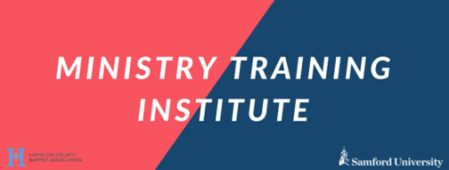
Upcoming Classes at HCBA for our Extension Program
Samford University Ministry Training Institute

Register online at baptistassociation.com
*Cost is $50 per course if paid online and $60 if paid on the first day of class (check only)*
ALL COURSES ARE AVAILABLE IN PERSON AND ONLINE!
Fall 2026 Courses
ZMTI 105: The Minor Prophets
Teacher: John Trewhella
Location: White Oak Baptist Church (310 Memorial Drive, Chattanooga, TN 37415)
Time: Tuesdays at 6pm Dates: August 18th – October 6th
Description: The Minor Prophets are not minor in their importance or significance. These
often-overlooked prophetic books hold incredible relevance for our world today. Students will learn more about
the authors, their prophecies, and the historicity behind their messages.

ZMTI 106A: Biblical Foundations 1
Teacher: Kenneth Ware
Location: White Oak Baptist Church (310 Memorial Drive, Chattanooga, TN 37415)
Time: Tuesdays at 6pm Dates: October 20th – December 8th
Description: Many Christians have not taken the time to study the various doctrines of
the Bible that are critical to our spiritual growth. The first section of Biblical Foundations will engage students
in doctrines such as the Trinity, the second coming, the afterlife, etc. An Understanding of these Biblical
foundations will lead believers to a deeper relationship with God.

Spring 2026 Courses
ZMTI 106B: Biblical Foundations 2
Teacher: Kenneth Ware
Location: White Oak Baptist Church (310 Memorial Drive, Chattanooga, TN 37415)
Time: Tuesdays at 6pm Dates: January 19th – March 9th
Description: Many Christians have not taken the time to study the various doctrines of
the Bible that are critical to our spiritual growth. The first section of Biblical Foundations will engage students
in doctrines such as the Trinity, the second coming, the afterlife, etc. An Understanding of these Biblical
foundations will lead believers to a deeper relationship with God.

ZMTI 104: The Person of the Holy Spirit
Teacher:
Location: White Oak Baptist Church (310 Memorial Drive, Chattanooga, TN 37415)
Time: Tuesdays at 6pm Dates: March 23rd – May 11th
Description: The Holy Spirit is the most misunderstood person of the trinity and
yet his role is critical to our salvation, growth, and work of the church. This course is designed to increase the
student’s knowledge of the work, person, and doctrine of the Holy Spirit.

