STANDARD OPERATING PROCEDURE
Environmental Health Monitoring (EHM)
Sentinel Free Soiled Bedding (SFSB) Sampling
Static and Ventilated Racks with Cage Level Filtration

For static cages and ventilated rack systems with cage level filtration (ex. Lab Products, Innovive, Animal Care Systems, Thoren, etc.), environmental dust sampling cannot be used. To replace the use of live animal sentinels in these situations, a piece of media and flocked/sticky swabs can be passed through a traditional soiled bedding cage that does not contain sentinel animals. Samples will be collected approximately every 3 months.

- Frequency of Diagnostic Sample Collection
  - Samples are collected once every three months (i.e. quarterly) from the soiled bedding cages (SBC).
  - Once the samples are collected, a new SBC is obtained from cage wash.
- Collection of soiled bedding
  - The soiled bedding cage (SBC) will be labeled so that it is associated with the animals under surveillance.
  - For convenience, the SBC can match the cage type used to house the animals under surveillance.
  - If the cage that is used to collect soiled bedding is static, it must have a static cage lid to allow for air exchange
  - The SBC will be kept on the same rack to represent the location/source of soiled bedding from animals under surveillance.
  - At each cage change, transfer a tablespoon (15 mL) - 2 oz (60 mL) of soiled bedding from each colony cage and place it into the SBC.
  - If the SBC becomes full, start a new cage, and retain both cages for sample collection.
- Materials Needed
  - Gloves
  - 50 mL sterile conical tube
  - 1 collection media
  - 3 flocked or sticky swabs
- Procedure
  - Label the 50 mL conical tube with:
    - Date
    - Room Number
    - Rack Number
  - Put on new gloves.
  - Remove the piece of media from its plastic pouch and place it into the SBC.
  - Remove 3 swabs from their individual wrappers and place them into the SBC.
  - The soiled bedding is thoroughly mixed, by hand, in the SBC.
  - Exposing the media:
    - The media is grasped and pushed through the soiled bedding in a zig-zag pattern 10 times.
    - The piece of media is then flipped over and passed a 2nd time through the soiled bedding in the same forward and backward zig-zag pattern. (Figure 1)
    - Solid pieces of bedding, nesting material, and fecal pellets can be gently removed from the piece of media if present.
    - Place it in the 50 mL conical tube
  - Exposing the swabs:
    - Grasp the handle of all 3 swabs at the same time.
    - Pass the tips through the bedding in a circular motion making 10 complete revolutions (Figure 2).
    - Solid pieces of bedding, nesting material, and fecal pellets can be gently removed from swab tips if present.
    - Once exposed, place the entire sticky swab in the same 50 mL conical tube as the media and break off the ends.
    - Close the tube
    - Clean the work area with a general disinfectant
    - Remove gloves
  - All samples can be stored at room temperature until submission.

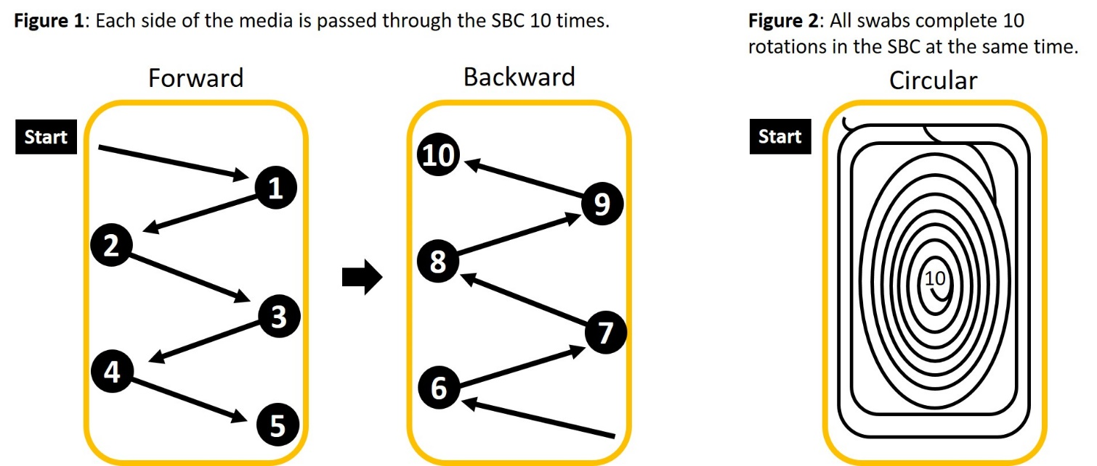

- Preventing Cross-Contamination
  - Between each SBC, clean the work surface making sure to pick up pieces of bedding or fecal pellets that might have spilled
  - Gloves should be disposed of between each SBC that is sampled to prevent cross contamination between samples
  - Repeat the procedure for each SBC in the housing room starting at step 4a (above)
- Changing or moving racks within a collection cycle
  - It is up to user discretion to transfer the SBC to the new rack, dispose, or submit for testing. Contact your caging manufacturer or diagnostic lab for additional guidance.

Notes to the user: The procedure above represents one method. Yet, there is little data to support a single method as an industry standard. Below are common variations on the theme that can be added or exchanged at the end users discretion.
- Fecal PCR: There is a potential for enhanced parasite, protozoal, viral, and bacterial detection with the collection of a pooled fecal sample from the SBC. The number of pooled fecal samples collected is up to the end user. The pooled fecal sample(s) should always be submitted within their own tube and not in the same tube as the media and swabs.
- Number of swabs: The rationale to submit swabs with media is to enhance nucleic acid collection for pathogen detection. The use of swabs (as compared to another piece of media), or the number of swabs has not been validated or defined in the literature. The number of swabs submitted is up to the end user.
- Media and swab exposure: The two primary methods include media and/or swabs in the SBC for the duration of the collection period (indwelling) or media and swab exposure exclusively at the end of the collection period (single exposure). There is limited data to suggest that either method is better for pathogen detection. How the media and/or swabs are exposed is at the discretion of the end user.

Diagnostic Company Sample Submission: Contact your diagnostic laboratory when first submitting environmental health monitoring samples to make sure that the materials and pooling procedures meet the labs acceptance criteria for submission.

