STANDARD OPERATING PROCEDURE
Environmental Health Monitoring
Exhaust Dust Testing (EDT) in IVC Tecniplast Rack System

For Tecniplast IVC cages, exhaust dust from the rack can be monitored using the Interceptor media. This media is placed in a holder positioned in the exhaust area or plenum of the blower or rack to collect dust for approximately 3 months prior to collection and submission.

- Frequency of Diagnostic Sample Collection
  - Media are collected once every three months (i.e. quarterly)
  - Once the samples are collected, a new media is placed in the holder. At the discretion of the end user, such as if the holder will be moved between racks, the media holder may be washed prior to placing a new media to remove any old dust that may remain. Two Interceptor can be placed on the same holder.
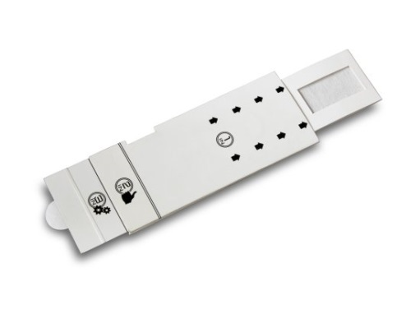
  - Multiple media or swabs may be pooled together for submission, and media or swabs may also be pooled with other samples such as swabs from resident animals. Note that pooling may not be ideal due to possible dilution of any positive sample(s). Please contact your testing laboratory for details on how pooling can work in your situation.
- Materials Needed
  - Gloves
  - 50ml Sterile conical tubes
  - The Interceptor filter media
  - The Interceptor filter holder depends on the Tecniplast rack blower used.

Smart Flow Blower filter holder Sky Flow Blower filter holder
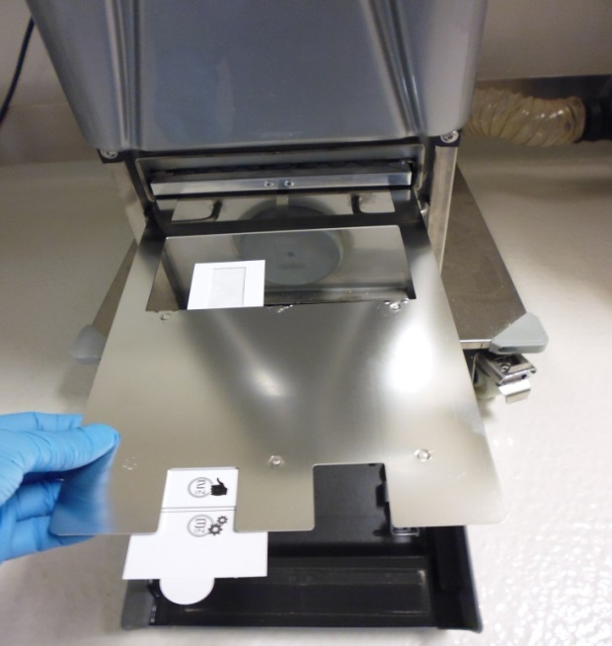
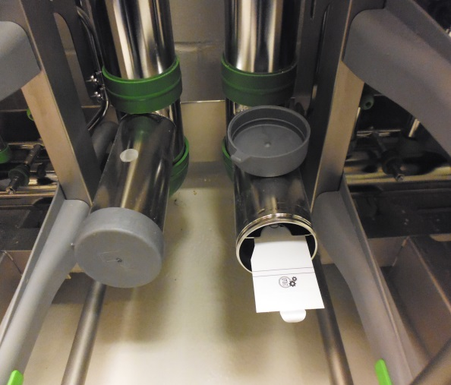

- Procedure
  - Label the interceptor media with:
    - Date in
    - Date out (3 months later)
    - Room number
    - Racks number(s)
  - Place Interceptor filter media in the metal Interceptor filter holder (Smart Flow blower):
    - With clean gloves, open the bottom door of the blower. Remove the pre-filter and place it on the interior of the open door.
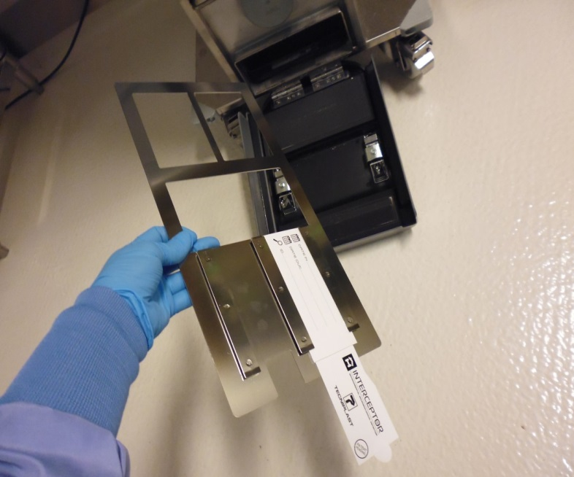
    - Insert the opened interceptor filter into one slot of the filter holder and replace the pre-filter.
    - The media must stay inside the cardboard holder until it placed properly in the blower underneath the pre-filter.
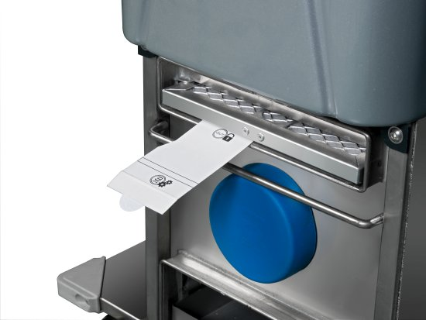
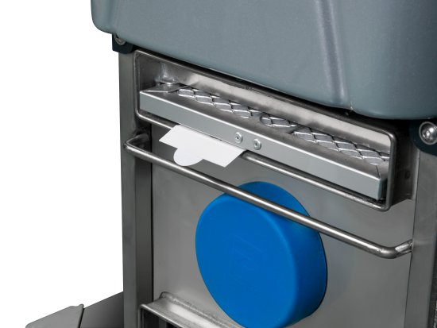
    - Once the metal holder is properly placed, push the sliding tab to expose the media to the air flow from the blower/plenum.
    - Once correctly in place, close the blower door and remove gloves.
  - Place Interceptor media in the metal Interceptor filter holder (Sky Flow Blower):
    - With clean gloves, remove the rubber cap on the metal holder and place it on top of the holder.
    - Insert the Interceptor media into the metal holder. Push the media completely through the metal holder; there should be no resistance when pushing the media. The media will then be outside the cardboard holder and exposed to airflow inside the plenum.
  - Collect media every 3 months (Smart Flow and Sky Flow).
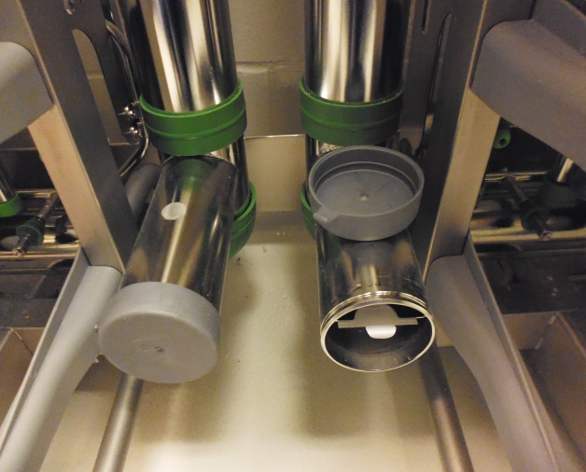
    - Ensure the media has been in place for approximately 3 months prior to submission by checking the date. The Interceptor media should not be removed during the pre-filter changes.
    - Wearing clean gloves, gently pull on the media card tab to allow the filter to slide into the card.
    - Remove the media from the metal holder to prepare it for shipment to the diagnostic laboratory.
    - Use clean gloves on a sterile surface to open and expose the filter. Use sharp sterile scissors to cut the cardboard below the filter line – be careful not to lose the dust. Insert the piece of filter into a labeled 50 ml sterile conical tube by pinching it in the center to keep the dust side facing into the conical tube.
    - Media can be pooled based on operational requirements and recommendations from the diagnostic laboratory.
    - Change gloves between blowers.
    - If Smart flow blower, remove the metal Interceptor filter for cage wash, then remove and dispose of gloves before handling another filter.
    - If Sky flow blower, remove and dispose of gloves after handling the dirty filter, as a new interceptor filter will need to be placed.

- Procedure for manual plenum swabbing
  - Label conical tubes with
    - Room number
    - Rack number
    - Date of collection

  - Collect plenum swabs every 3 months
    - Ensure that the rack has not been cleaned in the past 3 months to ensure there is enough dust.
    - Using a sticky swab, rotate the swab in the hoses, drawers, and surfaces of the prefilter. The same swab can be reused for several plenums.
    - Insert the tip of the swab inside a clean tube. A maximum of 10 swabs are permitted per tube. Up to 3 racks be pooled per sample.
- Changing or moving racks within a collection cycle
  - It is up to user discretion to transfer media to the new rack, dispose, or submit for testing. If choosing to transfer media, it is critical to ensure that the collection media stays with the cages. Contact your caging manufacturer or diagnostic lab for additional guidance.
Notes to the user: Contact your diagnostic laboratory when first submitting environmental health monitoring (EHM) samples to make sure that the materials and pooling procedures meet the labs acceptance criteria for submission.
References:Tecniplast Interceptor Filter information : https://www.tecniplast.it/en/product/interceptor.html

