STANDARD OPERATING PROCEDURE
Environmental Health Monitoring
Exhaust Dust Testing (EDT) in IVC Allentown Rack System

For Allentown IVC ventilated racks without cage level filtration, either SentinelTM media or sticky swabs can be used to sample debris from the exhaust plenum of the rack over 3 month periods.

- Frequency of Diagnostic Sample Collection
  - Media are collected once every three months (i.e. quarterly)
  - Multiple media or swabs may be pooled together for submission, and media or swabs may also be pooled with other samples such as swabs from resident animals. Note that pooling may not be ideal due to possible dilution of any positive sample(s). Please contact your testing laboratory for details on how pooling can work in your situation.
- Materials Needed
  - Gloves
  - 50ml Sterile conical tubes
  - The Sentinel TM media & The Sentinel TM media holder OR Sticky Swabs
  - Step stool or mobile ladder (to access the exhaust hose when placing media)
- Procedure for using SentinelTM media
  - Label the conical tube with:
    - Date in
    - Date out (3 months later)
    - Room number
    - Racks number(s)
  - Place media for the first time
    - Turn the blower off and open the vertical exhaust plenum door
    - Put new gloves on and insert media, beveled side first and the red dot facing away from you into the metal holder at the top of the open exhaust plenum. Close the vertical exhaust plenum door.
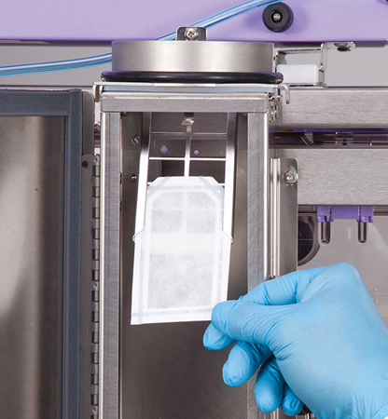
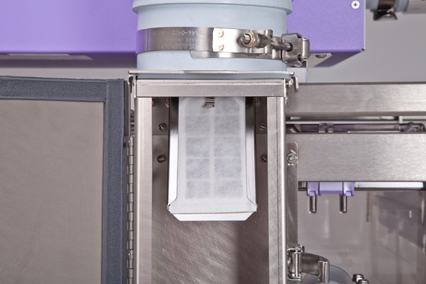
    - Turn on the blower.
  - Collect media every 3 months
    - Ensure the media has been in place for approximately 3 months prior to collection by checking the dates
    - Wearing clean gloves, place soiled media in the conical tube by rolling/folding media paper to easily insert into the tube with the red dot facing inward.
    - After handling media, remove and change gloves immediately to prevent accidental cross-contamination of other items in the room.
    - Close conical tube lid. Close plenum door, replace rack to starting position, re-attach hoses.
    - Once the samples are collected, a new media is placed in the holder. At the discretion of the end user, such as if the holder will be moved between racks, the media holder may be washed prior to placing a new media to remove any old dust that may remain.
    - Multiple media may be pooled together for submission, and media may also be pooled with other samples such as swabs from resident animals. Please contact your testing laboratory for details on how pooling can work in your situation.
- Procedure for manual plenum swabbing
  - Label conical tubes with
    - Room number
    - Rack number
    - Date of collection
  - Collect plenum swabs every 3 months
    - Ensure that the rack has not been cleaned in the past 3 months to ensure there is enough dust.
    - Open the side panel of the Allentown rack to expose the horizontal exhaust plenums.
    - Using a sticky swab, rotate the swab inside the plenums. The same swab can be reused for several plenums.
    - Insert the tip of the swab inside a clean tube. A maximum of 10 swabs are permitted per tube. Up to 3 racks be pooled per sample.
- Changing or moving racks within a collection cycle
  - It is up to user discretion to transfer media to the new rack, dispose, or submit for testing. If choosing to transfer media, it is critical to ensure that the collection media stays with the cages. Contact your caging manufacturer or diagnostic lab for additional guidance.
- Decommissioned racks
  - Label conical tube with
    - Room number
    - Rack number
    - Date of collection
  - Follow steps for either media testing or manual plenum swabbing as listed above. Samples may be sent out to be tested or pooled with other filters to be collected at another time.
- Minimum exposure time
  - SentinelTM media that has been in a rack that houses animals for at least 30 days is eligible for submission. This includes new racks put into service at least 30 days before collection and racks that were decommissioned after the last quarterly media collection.
  - Manual swabbing of racks that have been housing animals without cleaning for at least 30 days are eligible for swabbing. This includes new racks put into service at least 30 days before collection and racks that were decommissioned after the last quarterly swabbing.

Notes to the user: Contact your diagnostic laboratory when first submitting environmental health monitoring (EHM) samples to make sure that the materials and pooling procedures meet the labs acceptance criteria for submission.
References: Allentown Sentinel TM information: https://www.allentowninc.com/sentinel/

