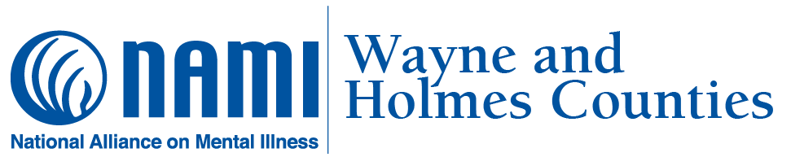
Volunteer Opportunities
Thank you for your interest. As a 501c3 non-profit organization, NAMI Wayne and Holmes Counties relies heavily on community support and volunteers. This allows us to continue to improve the lives of persons affected by mental illness, at no cost. We truly cannot do what we do without YOU! Our needs change from time to time. Your availability may change from time to time. We will work with both of these factors and your skills to plug you into a volunteer role. Below are ways you can help.
Volunteers help to fulfill our Mission:
To provide a place of safety where all person affected by a mental health concern feel accepted and build hope through peer-based programming, and to deliver education, suicide prevention, and support to family members and the community.

- Community Event Volunteer: Be a warm and friendly face to share NAMI information at community events, set up/tear down display tables, field follow-up questions to NAMI staff member.
  - Time Commitment: This is “as needed” and tends to be busier in the spring and fall seasons.

- Fundraising Committee Member: Attend monthly committee meetings, support NAMI staff in needed tasks at events, especially the Walk and 5K for Wellness in May. This opportunity helps to build awareness of NAMI in the community.
  - Time Commitment: 3rd Tuesday of each month at 9:00 AM (meetings), as needed for events

- Office/Administrative Support: Can include answering phones, greeting visitors, sorting files and materials, preparing mailings, cleaning.
  - Time Commitment: ongoing

- MOCA House Program Volunteer: Be a warm and friendly support to peers in recovery. Involves recreational activities, discussion groups, help with meals in the kitchen, gardening, advocacy, and light housekeeping. Training is provided.
  - Time Commitment: ongoing

- Family Support Volunteer: If you have helped a family member with mental health concerns, this opportunity involves helping other families. You can provide support once a month at our family support group, or in our 8-session Family-to-Family education program. Training is provided.
  - Time Commitment: 1st Tuesday of each month at 6:30 PM in Wayne County, 3rd Monday of each month at 6:30 pm in Holmes County(family support group), or seasonal (fall and spring sessions of Family-to-Family)
For more information, contact us at 330-264-1590 or info@namiwayneholmes.org

