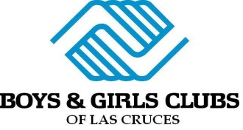
The Spot Family Entertainment Center Permission Slip
ALL
WHAT: We plan to go roller skating at The Spot in El Paso and will have lunch there as well. Mixed-gender staff members will accompany members, and we will take our B&GC vans to transport members. Our goal is to take as many members as possible, but if we get an overflow based on the number of vans we can take, it will be a first come, first serve day of.

A paper waiver MUST be completed before we leave at 9:00 am.

WHERE: 8500 Dyer St. Suite 80
El Paso, TX 79904

WHEN: Friday, July 18th. 9 am – 3 pm
Departure at 9:00 am

COST: $9
Skate assist ($6) and additional spending money are optional.
To ensure money is safe, members are encouraged to leave money at the Front Desk. Where they will place the money in a zip lock bag with their name on it and send it on the field trip. If the members keep their money, it is their responsibility to keep track of their money the entire day.
Please refer to page 5 under Personal Objects in the Parent Guide.

____Yes, I give my child permission to attend the field trip.

Child’s Name: ___________________________________________ Member Number: ___________

Parent Signature: _____________________________________________________

Emergency Contact Name & Number: __________________________________

LIABILITY RELEASE AND MEDICAL RELEASE:
I/We agree that the Boys & Girls Club of Las Cruces will not be liable for any injuries suffered, consequences of accidents, or illness not caused by the negligent or intentional acts of the Boys & Girls Club Staff. In case of a serious emergency, I authorize the Boys & Girls Club of Las Cruces staff to take my son/daughter for medical treatment as necessary after I have been contacted.

Parent Signature: ___________________________________________ Date:___________________

