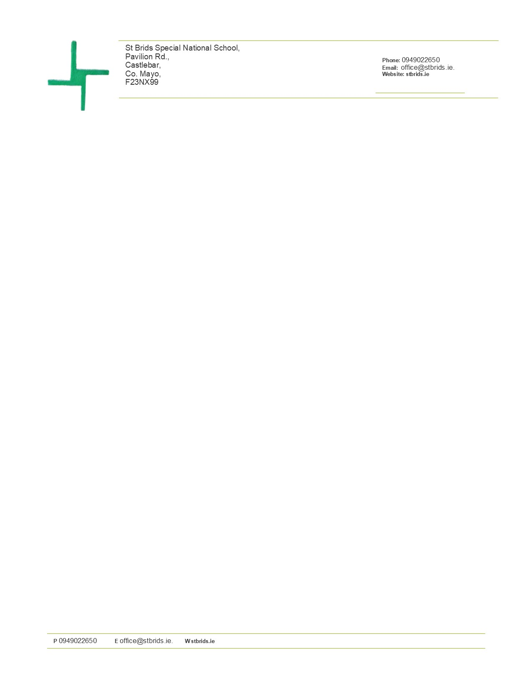

**Child Safeguarding Statement and Risk Assessment**

**Child Safeguarding Statement**

St. Brids is a special school providing education to pupils aged 4 – 18 years old.

In accordance with the requirements of the Child Protection Procedures for Schools 2025, [Children First Act 2015](http://www.irishstatutebook.ie/eli/2015/act/36/enacted/en/pdf), [Children First: National Guidance for the Protection and Welfare of Children 2017](https://assets.gov.ie/25844/b90aafa55804462f84d05f87f0ca2bf6.pdf), [the Addendum to Children First (2019)](https://assets.gov.ie/25819/c9744b64dfd6447985eeffa5c0d71bbb.pdf), the [Child Protection Procedures for Primary and Post Primary Schools (revised 2023)](https://www.gov.ie/en/collection/12bee3-child-protection-procedures-in-schools/) and [Tusla Guidance on the preparation of Child Safeguarding Statements](https://www.tusla.ie/uploads/content/4214-TUSLA_Guidance_on_Developing_a_CSS_LR.PDF), the Board of Management of this school has agreed the Child Safeguarding Statement set out in this document.

1. The Board of Management has adopted and will implement fully and without modification the Department’s *Child Protection Procedures for Primary and Post Primary Schools (revised (2023)* as part of this overall Child Safeguarding Statement

1. The Designated Liaison Person (DLP) is Mr. Andrew Maxwell (Principal).

1. The Deputy Designated Liaison Person (Deputy DLP) is Mr. Steven Ellis (Deputy Principal).

1. The Relevant Person is Mr. Andrew Maxwell (Principal).

1. The Board of Management recognises that child protection and welfare considerations permeate all aspects of school life and must be reflected in all of the school’s policies, procedures, practices and activities. In its policies, procedures, practices and activities, the school will adhere to the following principles of best practice in child protection and welfare:

St. Brid’s will:

* recognise that the protection and welfare of children is of paramount importance, regardless of all other considerations;
* fully comply with its statutory obligations under the Children First Act 2015 and other relevant legislation relating to the protection and welfare of children;
* fully co-operate with the relevant statutory authorities in relation to child protection and welfare matters;
* adopt safe practices to minimise the possibility of harm or accidents happening to children and protect workers from the necessity to take unnecessary risks that may leave themselves open to accusations of abuse or neglect;
* develop a practice of openness with parents and encourage parental involvement in the education of their children; and
* fully respect confidentiality requirements in dealing with child protection matters.

St. Brid’s will also adhere to the above principles in relation to any adult pupil with a special vulnerability.

1. The following procedures/measures are in place:

* In relation to any member of staff who is the subject of any investigation (howsoever described) in respect of any act, omission or circumstance in respect of a child attending the school, the school adheres to the relevant procedures set out in Chapter 7 of the *Child Protection Procedures for Schools 2025* and to the relevant agreed disciplinary procedures for school staff which are published on the [gov.ie](https://www.gov.ie/) website.
* In relation to the selection or recruitment of staff and their suitability to work with children, the school adheres to the statutory vetting requirements of the [National Vetting Bureau (Children and Vulnerable Persons) Acts 2012 to 2016](https://revisedacts.lawreform.ie/eli/2012/act/47/revised/en/pdf) and to the wider duty of care guidance set out in relevant Garda vetting and recruitment circulars published by the Department of Education and available on the [gov.ie](https://www.gov.ie/) website.
* In relation to the provision of information and, where necessary, instruction and training, to staff in respect of the identification of the occurrence of harm (as defined in the 2015 Act) the school:
  + - Has provided each member of staff with a copy of the school’s Child Safeguarding Statement
    - Ensures all new staff are provided with a copy of the school’s Child Safeguarding Statement
    - Encourages staff to avail of relevant training
    - Encourages Board of Management members to avail of relevant training
    - The Board of Management maintains records of all staff and Board member training
* In relation to reporting of child protection concerns to Tusla, all school personnel are required to adhere to the procedures set out in the *Child Protection Procedures Schools 2025*, including in the case of registered teachers, those in relation to mandated reporting under the Children First Act 2015.
* All registered teachers employed by the school are mandated persons under the Children First Act 2015
* In accordance with the Children First Act 2015 and the Addendum to Children First (2019), the Board has carried out an assessment of any potential for harm to a child while attending the school or participating in school activities. A written assessment setting out the areas of risk identified and the school’s procedures for managing those risks is included with the Child Safeguarding Statement.
* The various procedures referred to in this Statement can be accessed via the school’s website, the [gov.ie](https://www.gov.ie/) website or will be made available on request by the school.

1. This statement has been published on the school’s website and has been provided to all members of school personnel, the Parents’ Association and the patron. It is readily accessible to parents and guardians on request. A copy of this Statement will be made available to Tusla and the Department if requested.

1. This Child Safeguarding Statement will be reviewed annually or as soon as practicable after there has been a material change in any matter to which this statement refers.

This Child Safeguarding Statement was adopted by the Board of Management on September 2025

This Child Safeguarding Statement was reviewed by the Board of Management on September 2025

**Signed:** **Signed:** **Date**

Chairperson Principal/Secretary to the Board

**Child Safeguarding Risk Assessment**

Written Assesment of Risk in St. Brid’s.

In accordance with section11 of the Children First Act 2015 and with the requirement of Chapter 9 of the Child Protection Procedures for Schools 2025 the following is the Written Risk Assessment of St. Brid’s.

|  |  |  |
| --- | --- | --- |
| 1. **List of School Activities** | 1. **The School has identified the following risk of harm in respect of its activities -** | 1. **The School has the following procedures in place to address risk identified in this assessment -** |
| **School Staff** |  |  |
| Training of school personnel in Child Protection matters | Harm not recognised or reported promptly | Child Safeguarding Statement & DES procedures made available to all staff  DLP& DDLP attended Oide Training 18/9/25 – Connaught Hotel, Galway  Awaiting date from Oide re Whole Staff Training  BOM records all records of staff and board training |
| Classroom teaching | Harm by school personnel | Child Safeguarding Statement  All teachers Garda Vetted |
| One to one teaching | Harm by school personnel | Glass in door and or window through which teacher and pupils are visible  Another member of staff knows where the pupil is at all times |
| Substitute/Temporary Teachers covering for teachers on sick leave, maternity leave, parental leave or other type of leave | Harm to pupils | Child Safeguarding Statement made available to the substitute teacher  All substitute teachers Garda Vetted and have a statutory declaration. References are checked if appropriate. |
| Pupils in the office with an adult | Harm to pupils | Desk between adult and pupil  Glass in window and door through which adult and pupil are visible |
| Student teachers participating in teaching practice in school | Harm to pupils | Child Safeguarding Statement  All students are Garda Vetted by their organisation and there is a joint vetting agreement in place between the organisation and the school  Class Teacher remains with the student teacher at all times |
| School nurse | Harm to pupils | Garda vetted by HSE  Two nurses come to examine pupils usually  Nurse takes two or more pupils at a time.  Glass in window and door through which nurse and pupils can be seen |
| Educational Psychologist assessing a pupil | Harm to pupils | Garda vetted by NEPS  Table between psychologist and pupil  Glass in door and window through which psychologist and pupil are visible |
| Sport coaches coming in to teach rugby, football, hurling, | Harm to pupils | Child Safeguarding Statement  All coaches are Garda Vetted by their organisation and there is a joint vetting agreement in place between the organisation and the school  Class Teacher remains with the sports coach at all times |
| Use of external personnel to supplement the curriculum e.g. drumming teacher, dancing teacher, Zumba teacher, | Harm to pupils | Child Safeguarding Statement  All personnel are Garda Vetted  Class Teacher remains with the person at all times |
| Intimate care needs | Harm by school personnel | See Intimate Care Policy  Regular review of pupil needs  Pupil personal plans for pupils with intimate care needs  Advice sought from special needs support service |
| **Pupils outside of the Classroom** |  |  |
| Daily arrival and dismissal of pupils | Harm to pupils | Arrival and dismissal to and from buses, supervised by SNAs.  Pupils escorted from buses to classroom and classroom staff. |
| Breaks and lunch times | Harm by other pupils | Adult supervision required at all times on the yard. Access to yard is limited to school personnel due to fencing and gates.  Yard rules |
| Toilet areas | Inappropriate behaviour, adult entering the toilet | Toilets are in all classrooms.  There are specific toilets assigned to staff and visiting adults. |
| Pupils walking around the school on messages | Harm to pupil by unknown adult | Front door is locked magnetically |
| School Tours | Harm to pupil  Venues /destinations are checked for appropriateness | Teacher and SNAs to travel with class.  Extra adult school personnel to support when deemed necessary. |
| **Management of Pupils in School** |  |  |
| LGBT Children/Pupils perceived to be LGBT | Bullying | Anti-Bullying Policy  Code of Behaviour |
| Managing of challenging behaviour amongst pupils | Injury to pupils and staff | Health & Safety Policy  Code Of Behaviour  Anti Bullying Policy  NEPS and other outside agencies behavioural intervention recommendations.  Working with parents and all stakeholders. |
| Administration of Medicine  Administration of First Aid | Harm to pupil | School nurses to administer medicines and first aid when possible.  Teachers and SNAs to seek witness when administering medications. |
| Prevention and dealing with bullying amongst pupils | Harm to pupil | Anti-bullying policy  Bí Cinnealta Guidelines.  Code of Behaviour |
|  | Bullying | Anti-Bullying Policy  Bí Cinnealta Guidelines.  Code of Behaviour |
| Use of technology for online teaching and remote learning, e.g. Zoom | Bullying,  Harm to pupil | Code of Behaviour and Anti-bullying policy  Education of pupils, parents and all stakeholders to heighten awareness.  Bí Cinnealta Guidelines. |
| Use of video/photography/other media to record school events | Bullying, harm to pupils | Data protection policy  Permission from parents to take and use photographs of their child on POD enrolment form  Parents are asked at concerts/events not to share those photos on social media but to use for their own personal family. |

|  |
| --- |
| **Important Note:** It should be noted that risk in the context of this risk assessment is the risk of “harm” as defined in the Children First Act 2015 and not general health and safety risk. The definition of harm is set out in Chapter 4 of the *Child Protection Procedures for Primary and Post-Primary* |