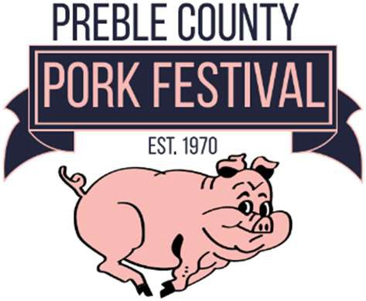
2026 Pork Festival Royalty Entry

Festival Dates: September 19-20, 2026

Contest Date: Sunday, May 3, 2026
Applications and all appropriate paperwork due
Male or Female Age 16 to 24 years old may apply!
April 17,2026
Application Submission

One Evaluation from Mentor/Advisor/Employer emailed back by April 24, 2025

PORK FESTIVAL ROYALTY ENTRY FORM DEADLINE April 17, 2026
I, am submitting this entry form, my activities resume, an essay and a photo of myself, with the understanding that if selected as the Pork Festival Royalty, I will be REQUIRED to attend, participate and represent the Preble County Pork Festival during the entire 2026 event and throughout the following year as needed.
Participant Signature
Parent’s Signature (under 18 only)
Participant School___________________________
Name
Age
Address
City/State Zip

Parent/Guardian

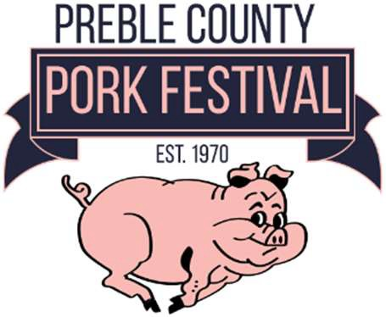
Preble County Pork Festival
Royalty Mentor Recommendation Form

Deadline is April 24, 2026 (IF THIS RECOMMENDATION DOES NOT ACCOMPANY THE APPLICATION BY THE DEADLINE THE CONTESTANT WILL BE DISQUALIFIED)
I, , am interested in running for Preble County Pork Festival Royalty Contest. The Pork Festival Royalty Committee would like a Mentor’s input about qualities to fulfill the responsibilities.
Mentor, please comment on the following topics and return this form to the Preble County Royalty Committee porkfestivalcoordinator@gmail.com to be used in the application process. Thank you!
(This form must be completed by a non-relative of the applicant.) How would you rate the applicant:
(Check (x) appropriate rating) Above Average (4) Average (2) Below Average (1)

Maturity/judgment/self-confidence:
Leadership Abilities:
Enthusiasm/energy/flexibility:
Interaction with Community:
Attendance/participation in meetings/Activities:

Do you recommend this applicant for consideration for Preble County Pork Festival Royalty: Yes No Mentor/Employer Signature
Mentor/Employer Print
Date

Please return this form to the Preble County Pork Festival Royalty Committee at porkfestivalcoordinator@gmail.com (please do not return to applicant).

This form will remain confidential. Thank you for completing this recommendation.

For Office Use Only Total Evaluation Points:

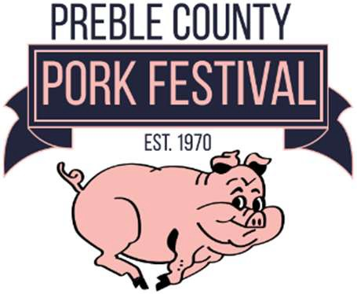
Please Print or Type:

Preble County Pork Festival Royalty Contest Entry
Media News Release

Contestant Name:
Parent(s)/Guardian Name:
Contestant Age:
Home Town:
High School Name:

High School Graduate: Yes No
If yes Graduation Year: If no Fall 2025 Year in High School:

Attending College in the Fall of 2026? Yes No
If yes Name of College:
Fall 2026 Year in College:

High School/College Activities (i.e. basketball, student council, cheerleading, volleyball, class officer, band):

Describe Pork Festival Participation or Volunteer opportunities and what Festival means to you:

Other Community Service Organizations i.e. church, scouts:

Other accomplishments:

