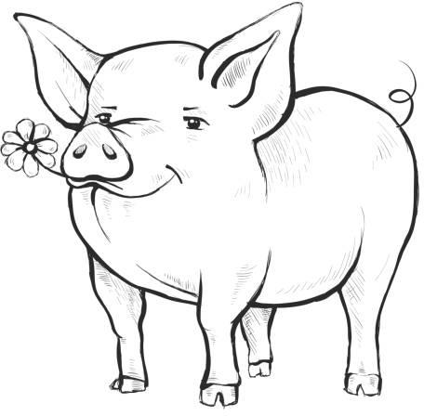CREATE-A-PIG CONTEST

Pre-Registration Form

Please return this form to [porkfestivalcoordinator@qmail.com](mailto:porkfestivalcoordinator@qmail.com) or mail to Preble County Pork Festival, PO Box 818, Eaton Ohio 45320

**Preble County Pork Festival September 20 & 21, 2025**

Students throughout Preble County are invited to Create A Pig for the Preble County Pork Festival. Pigs will be judged, and prizes will be awarded. The purpose of the project is to promote local culture and events through creativity and imagination. Participants are encouraged to use this year's

theme “Pigs are Pretty in Preble County” Categories are as follows:

**(1) Most Unique (2) Prettiest (3) Carve-a- Pig**

**P-K - Third Grade**  **Fourth Grade - Eighth Grade**  **Ninth Grade- Twelfth Grade**

Each category and age group will be judged individually, and the winners will be awarded

$25 first place, $15 second place and $10 third place.

|  |  |
| --- | --- |
| **1st**  **1st 1st** | **2nd**  **2nd 2nd** |
| **1st** | **2nd** |
| **1st** | **2nd** |
| **1st** | **2nd** |
| **1st** | **2nd** |
| **1st** | **2nd** |
| **1st** | **2nd** |

**Most Unique PK-3**

**4th-8th grades 9-12 grades**

**Prettiest PK-3**

**4th-8th grades 9-12 grades**

**Carve-A-Pig PK-3**

**4th-8th grades 9-12 grades**

**3rd places 3rd places 3rd places**

**3rd places 3rd places 3rd places**

**3rd places 3rd places 3rd places**

Bring all entries to the Educational Exhibit Area located in Building 38 (Rabbit Barn) on the Preble County Fairgrounds between 4pm and 6pm Friday, September 19 or 8-10am Saturday, September 20, 2025.