BARLOW & BEAR’S THE UNOFFICIAL BRIDGERTON MUSICAL
EARNS GRAMMY NOMINATION FOR “BEST MUSICAL THEATRE ALBUM”

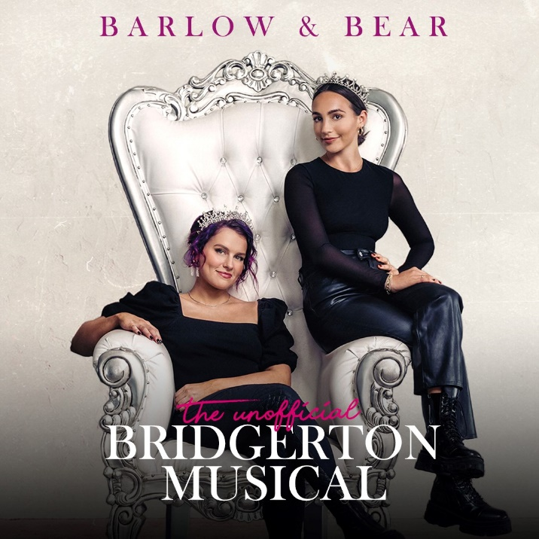
---
Stream the Full Album HERE

FOR IMMEDIATE RELEASE: Songwriting duo Barlow & Bear, Abigail Barlow and Emily Bear, the smash hit duo who were recently named to Forbes 2022 “30 Under 30” after they broke the internet with their joyously transcendent original musical take on “Bridgerton,” have been nominated for a Grammy for “Best Musical Theater Album” for their recently released, The Unofficial Bridgerton Musical. The young newcomers to the Grammys, Barlow and Bear are competing against musical albums with songs by music legends from Burt Bacharach and Bob Dylan to Stephen Schwartz and Andrew Lloyd Webber. The Unofficial Bridgerton Musical hit #1 on iTunes U.S. Pop Albums within two hours of release, and Top 10 worldwide. #BridgertonMusical has reached more than 260 million views and with 48 million likes between them this year as their legion of fans have connected with irrepressible songs such as “Ocean Away” (a take on “Daphne’s Song”) and “Burn for You.”

The Grammys will air on CBS and stream live and on demand on Paramount+ on Monday, Jan. 31, 2022, at 8-11:30 p.m. ET / 5-8:30 p.m. PT.

The Unofficial Bridgerton Musical album, consisting of 15 songs with sweeping orchestrations, clever lyrics, power ballads, and pop topline reflects a uniquely contemporary artistic vision that seamlessly merges classical, pop and Broadway influences. Music and lyrics are by both Abigail Barlow and Emily Bear, with vocals by Abigail Barlow and orchestrations and vocals by Emily Bear. Mixed by Scott Smith, the full album is produced by Emily Bear, with Joris Hoogsteder co-producing “If I Were A Man” with Bear.

Stream the album here: https://onerpm.link/barlowandbear

Track List:
“Tis The Season”
“Lady Whistledown”
“If I Were A Man”
“Penelope Featherington”
“The Ruse”
“Fool For You”
“Alone Together”
“Entertain Me”
“Friend Turned Foe”
“Burn For You”
“Worker Bee”
“Every Inch”
“Burned Me Instead”
“Balancing The Scales”
“Ocean Away”

# # #

ABOUT ABIGAIL BARLOW:
Abigail Barlow is a 22-year-old singer-songwriter / TikTok star known best for her independent pop hit “Heartbreak Hotel,” which peaked at #2 on iTunes and currently has more than 6.5 million streams. She, along with her writing partner Emily Bear, is also the mastermind behind the viral Bridgerton Musical which has exploded on TikTok. Her artful lyricism and unique melodies have garnered international acclaim. As a young teenager, Abigail’s love of performing live was refined when she found a worldwide audience online with performance platforms YouNow and Musically. A 2017 Shorty Award nominee, she was a founding creator on TikTok — writing and performing her original music in real time for a growing fanbase. Now at well over 2.3 million followers on the platform, Abigail has been able to connect and collaborate with many established artists. Namely Megan Trainor, who, after discovering Abigail on the app, co-wrote & produced a track on Abigail’s self-titled debut EP in 2020 titled “Phantom Feelings.” The sky seems to be the limit for Abigail as she continues to independently release music of her own while also creating new compositions with her writing partner, Emily Bear.

ABOUT EMILY BEAR:
An award-winning composer and recording artist since the age of five, Bear has achieved groundbreaking success as a pianist, composer, and singer-songwriter. Her expertise and love for film and media scoring highlights her ability to move between musical styles and to communicate story through music.

Bear's film and media roster includes Disney, DreamWorks, Warner Bros., and Universal. Clients value her ability to create both the score for a project as well as the songs. Whether she is creating a cinematic orchestral soundtrack or writing a pop song, Bear pulls from her skills in jazz, classical, musical theatre and pop.

Her long-time mentor, Quincy Jones says, “I am at once astounded and inspired by the enormous talent that Emily embodies. She is the complete 360-degree package, and there are no limits to the musical heights she can reach. Not only is she a concert level classical pianist, a Billboard topping jazz pianist, acclaimed jazz and classical composer, and superbly talented singer/songwriter, she is one of the kindest humans I know. Emily has a unique ability to seamlessly transition from classical to jazz, from be-bop to bossa nova, from blues to classical, to popular music; her potential is truly endless. Her compositions are stunning, and she effortlessly combines elements of all types of music. I have been in the business for over 70 years now and I have yet to see another artist like her.”

She has performed her original compositions and arrangements with orchestras and ensembles on legendary stages around the world, including at Carnegie Hall, Lincoln Center, Hollywood Bowl, and Montreux Jazz Festival. Honored by the Songwriters Hall of Fame, Bear’s instinct for writing and singing pop music has led to collaborations with top songwriters and producers in the industry.

Bear has received high accolades across musical styles from orchestral to pop, including ASCAP Concert Music Composer of the Year, Herb Alpert Jazz Composer of the Year, W Magazine’s “It Girl” of the year, and was honored by the Songwriters Hall of Fame. She has been featured in news stories around the world including Variety, People, Entertainment Weekly, The Boston Globe, Sunday London Times, Playbill, as well as on BBC, NPR’s All Things Considered, and The Kelly Clarkson Show.

Over the years, Bear has garnered more than 40 million views on YouTube and a documentary on her life received an EMMY Award. She has appeared 7 times on the Ellen DeGeneres Show with her first featured appearance at age six. Growing up in front of the world, Bear has helped raise millions for charities through events and performances and is passionate about the importance of arts education.

Contact:
Ray Costa
PLEASE NOTE NEW MAILING ADDRESS
Costa Communications Inc.
8033 W. Sunset Blvd. # 916
Los Angeles, CA 90046
rcosta@costacomm.com
ofc. 323-650-3588
cell. 323-828-6180
rcosta@costacomm.com

