ANDY JACKMAN ESTATE AUCTION

ZANE GANSEMER

MARK EASTER
401 CHERRY STREET

OCTOBER 25th-LOUISVILLE, NE @ 10am
VEHICLES & TRACTORS SELLING AT NOON
TRACTORS & TRAILER
Ford 1900 4WD
VEHICLES
1923 4-door Chevy-tore down
Plymouth 1949 2 door-body is good, Upholstery descent
’51 Chrysler 4-door New Yorker w 331 hemi
’53 Chevy pickup-no box
Lots of old car parts –
(fenders, doors, head lights, spoke rims, & more)
POWER TOOLS
18’ & 32” extension ladder
12’ folding ladder
8’ step ladder
Extension cords
7 ¼” Milwaukee saw
Chop saw
Central machinery belt & sander
Dunlap sander
Detail sander
Rockwell portable table saw
Skil drive circular saw
Band saw
Rigid miter saw on stand
16” Stihl chainsaw (in case)
½ ton pickup truck crane w cable wench
Rigid Tri stand
Compact battery jump-starter 300
12 speed heavy duty drill press
Craftsman 10” drill press ½ hp
Air lift 1000
120v flux wire welder
Lincwelder AC-225-S
Yes welder ARC-205DS
Thermal arc
3 in 1 thermal arc
Cutting torch set
Welding rods
New welding helmet
Central Machinery 30” shear, press brake &
slip roll-new
Reddy heater
Tristar 6” bench grinder
6 drawer toolchest
U.S. General double stack (like new) Toolchest
Craftsman 6” metal turning lathe
Sanborn 230 v air compressor
Quincy QTS-5 air compressor
Powerfist pipe bender
SMALL EQUIPMENT
3pt hitch scoop
3pt hitch box blade
3pt hitch tool carrier
Snow blades for pick-up
3pt hitch lift bar
Pull type spreader
Loader buckets
2 pickup toolboxes
Frame for car port
Toro snowblower
Wheelchair lift for car/pickup

diesel w Ford 771 loader & bucket & 3pt hitch-runs good
Allis Chalmers WD45 tractor w loader & bucket ??
Farmall ‘C’ w new tires-doesn’t run
JD B tractor-like new tires, doesn’t run ??
JD 6x4 gator-runs good
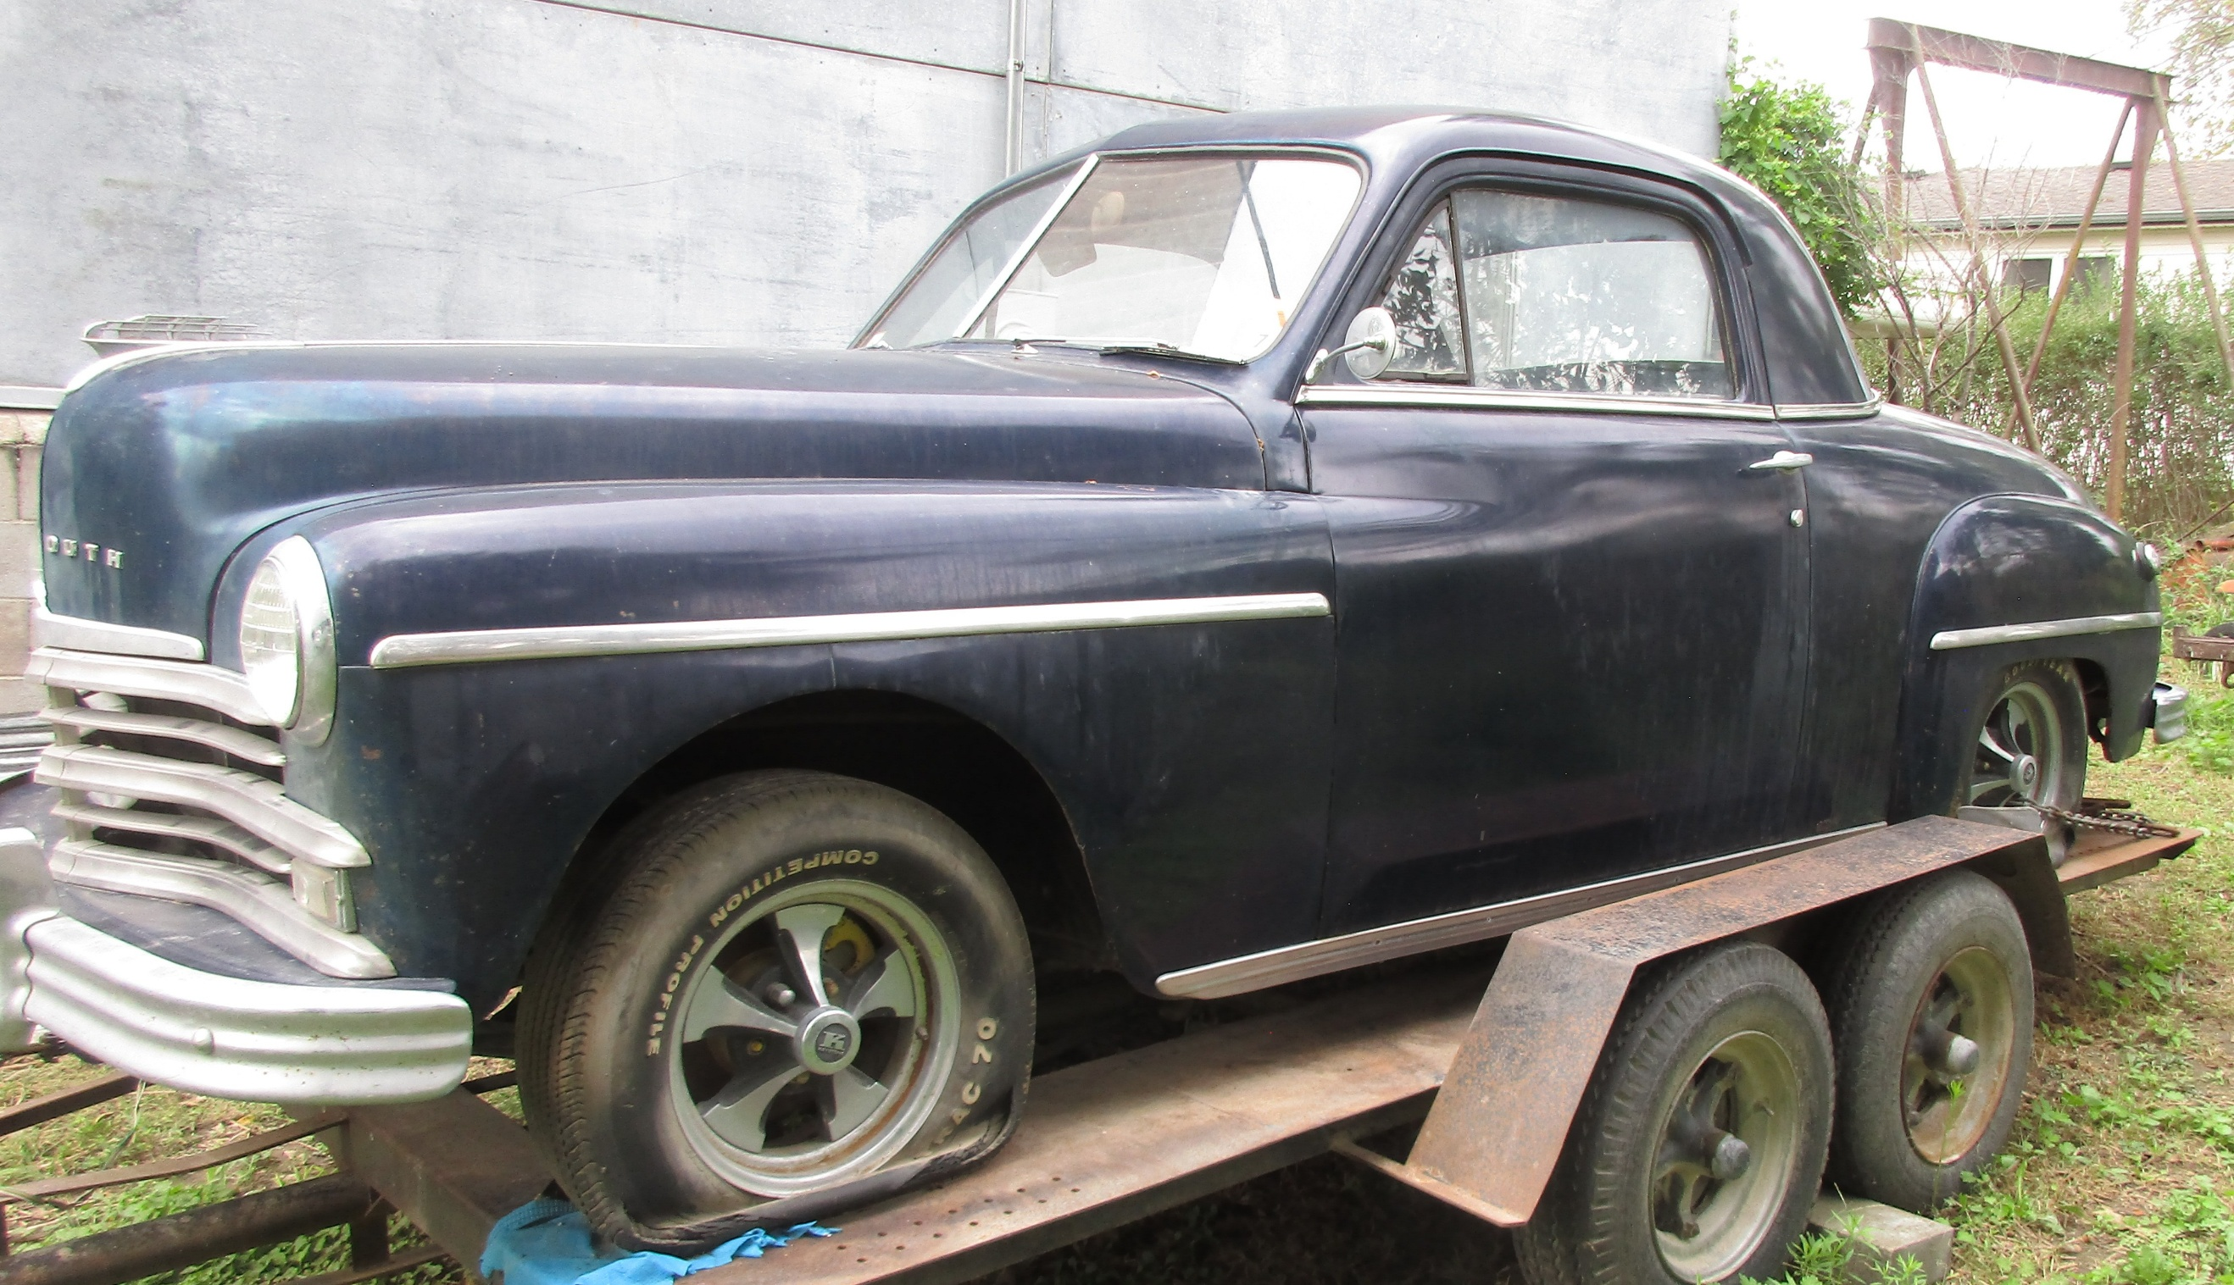
Tandem axle flatbed-factory
Homemade tandem axle trailer
Snowmobile trailer
6x8 ft flatbed trailer
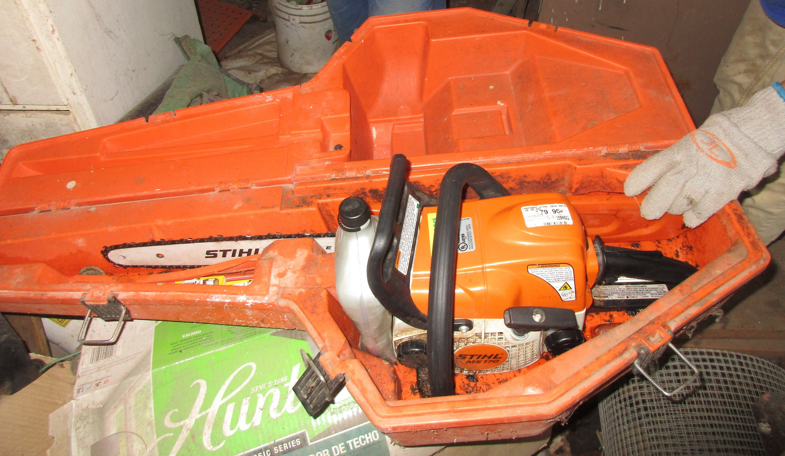
Pickup box trailer w camper
Mini bike
2 Power karts (1 restorable & 1 not)
Concrete buggy-needs work
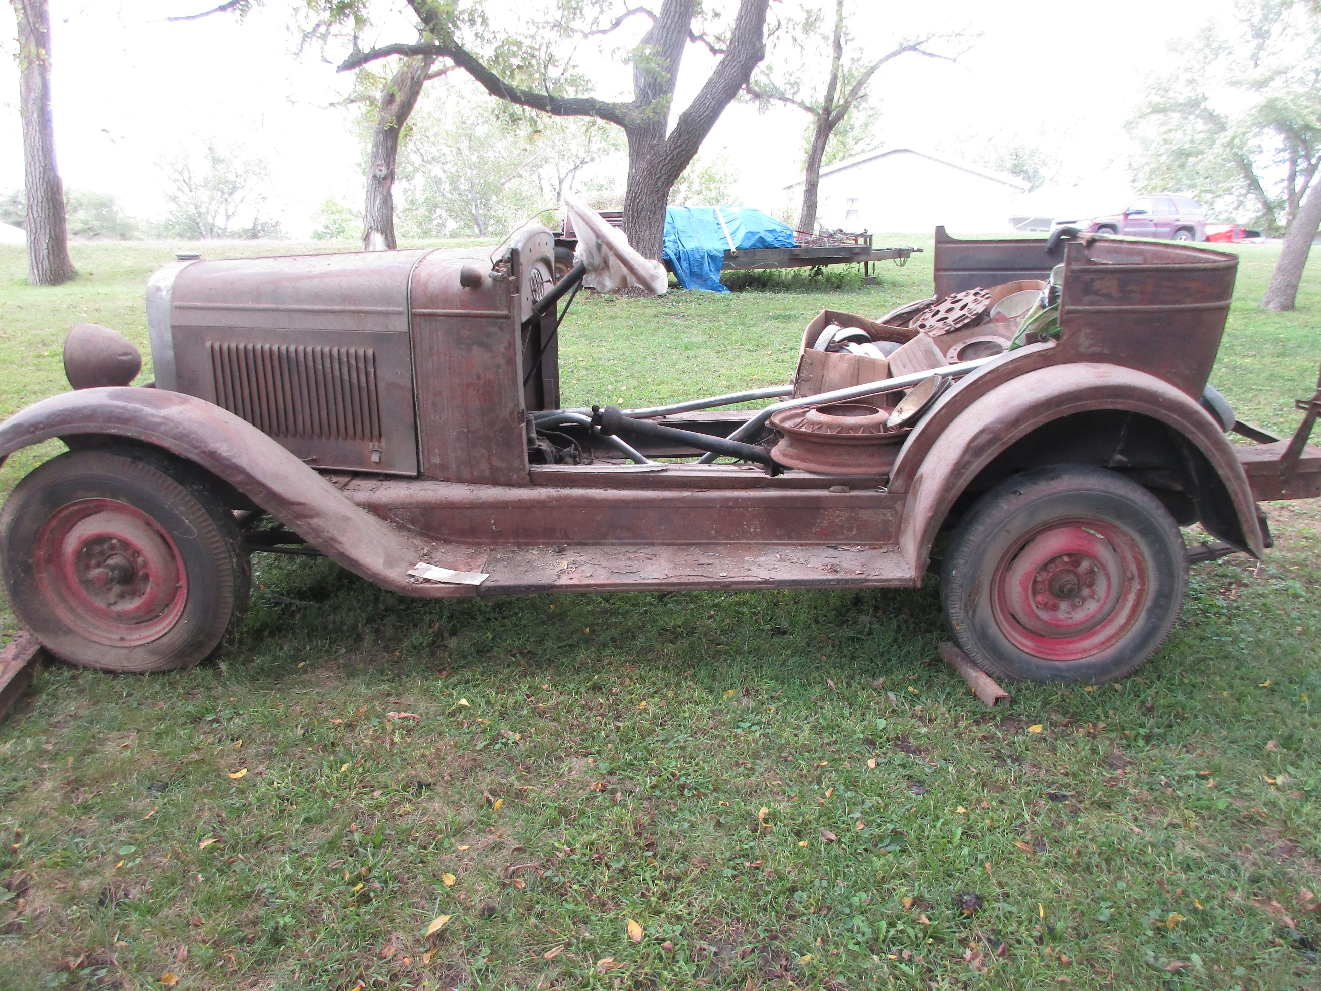
JD RX75 riding mower-not running ??
SMALL HAND TOOLS
Punches & chisels, pliers
furniture clamps, straps, snips
Drill bit set, socket sets
Nut driver sets
Screw extractor set
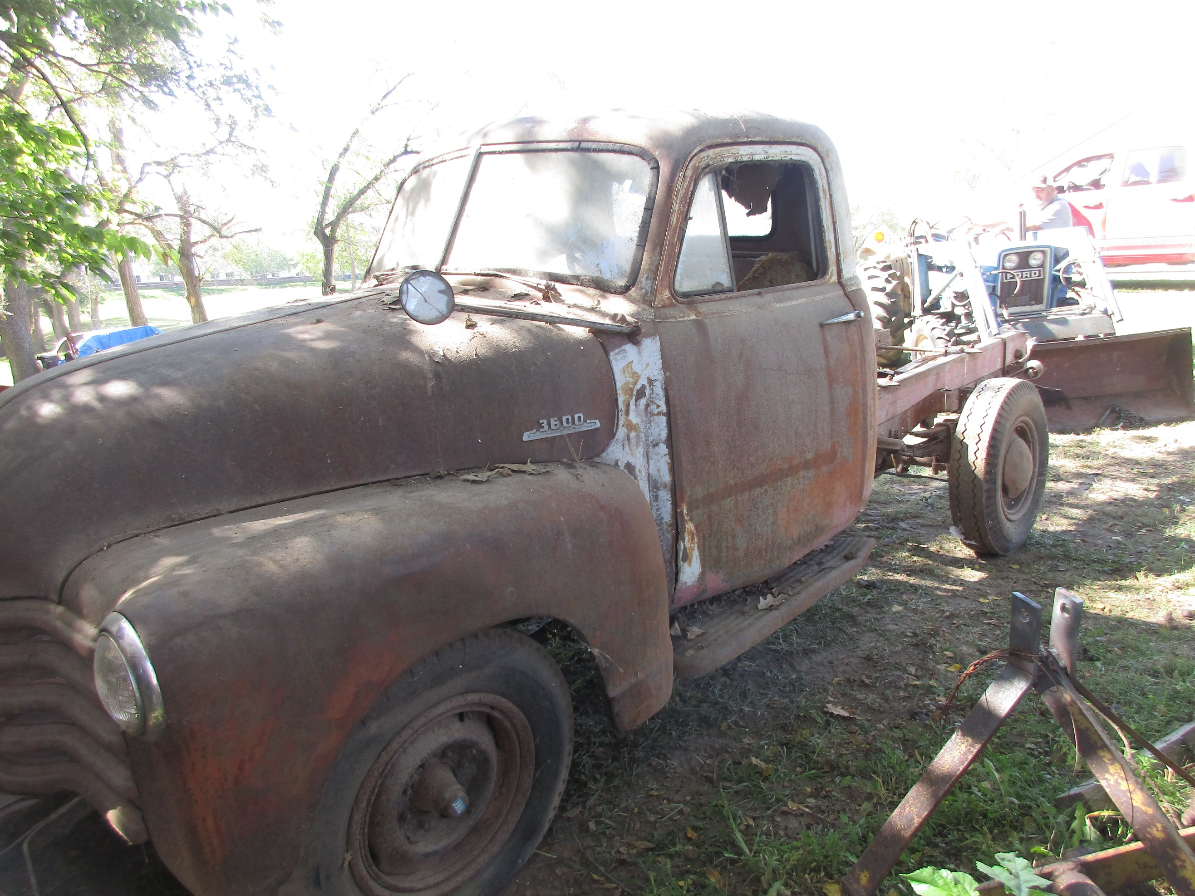
E-clips, hand riveter
Dynamic hinges, cob fork
Creepers, limb cutter
Drill grind, ramps, hydraulic jacks
Dual claw wrenching bar
Travellite Wench
Spark plug wire set
MAC TR combo rethreading set (fractional & metric)
Berger level & transit level model 200B
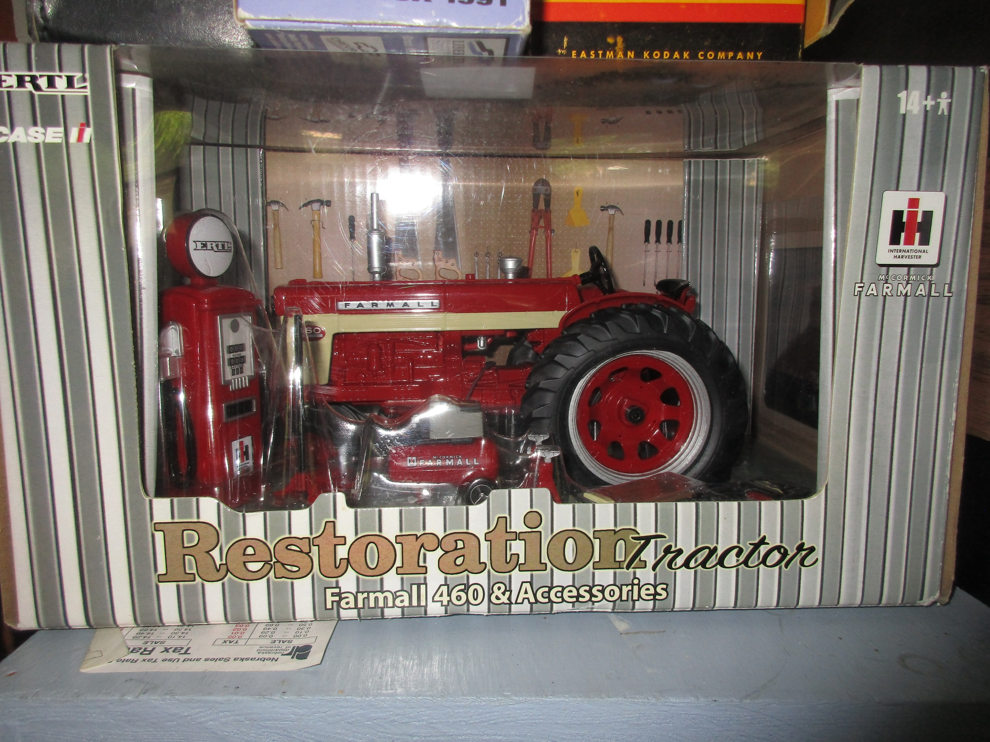
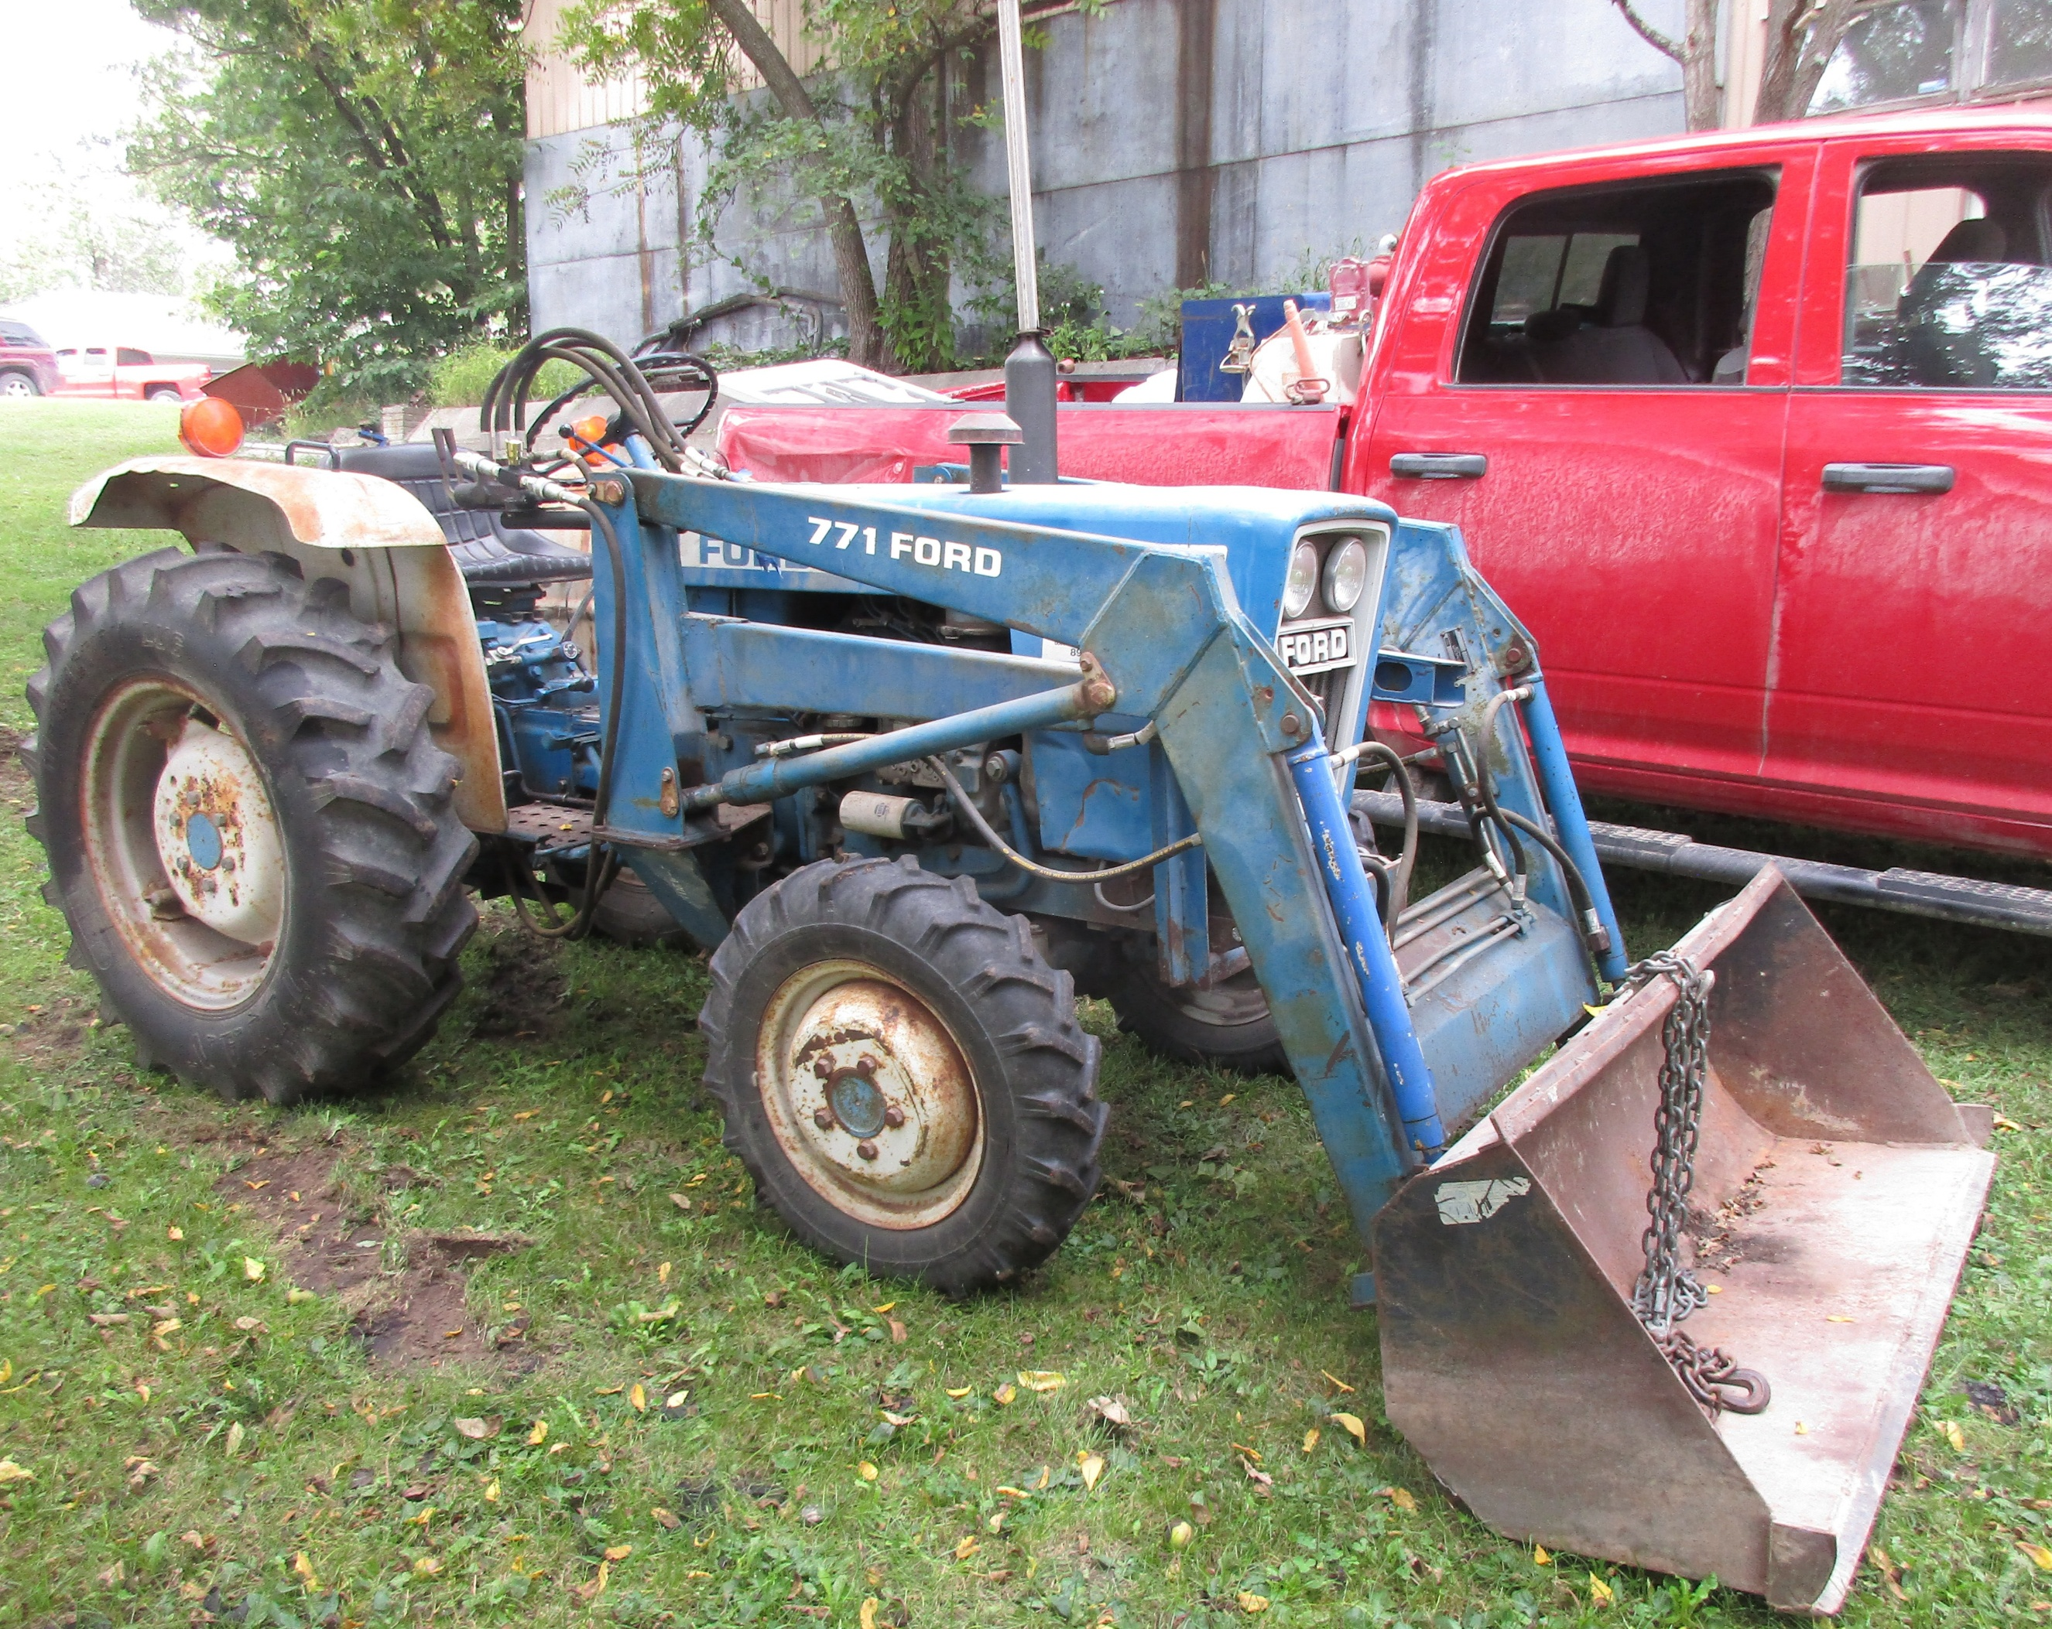
6 gauge 600v-50’ wire
Folding crates, dolley’s,
Log chains, binders
Pipe threading kit
Open & boxed end wrenches, screwdrivers
Sockets sets, hammers
Small squirrel cage fan
Vise, Tool Shop work bench
8’ tool holder, Caulking gun
20-ton hydraulic jack
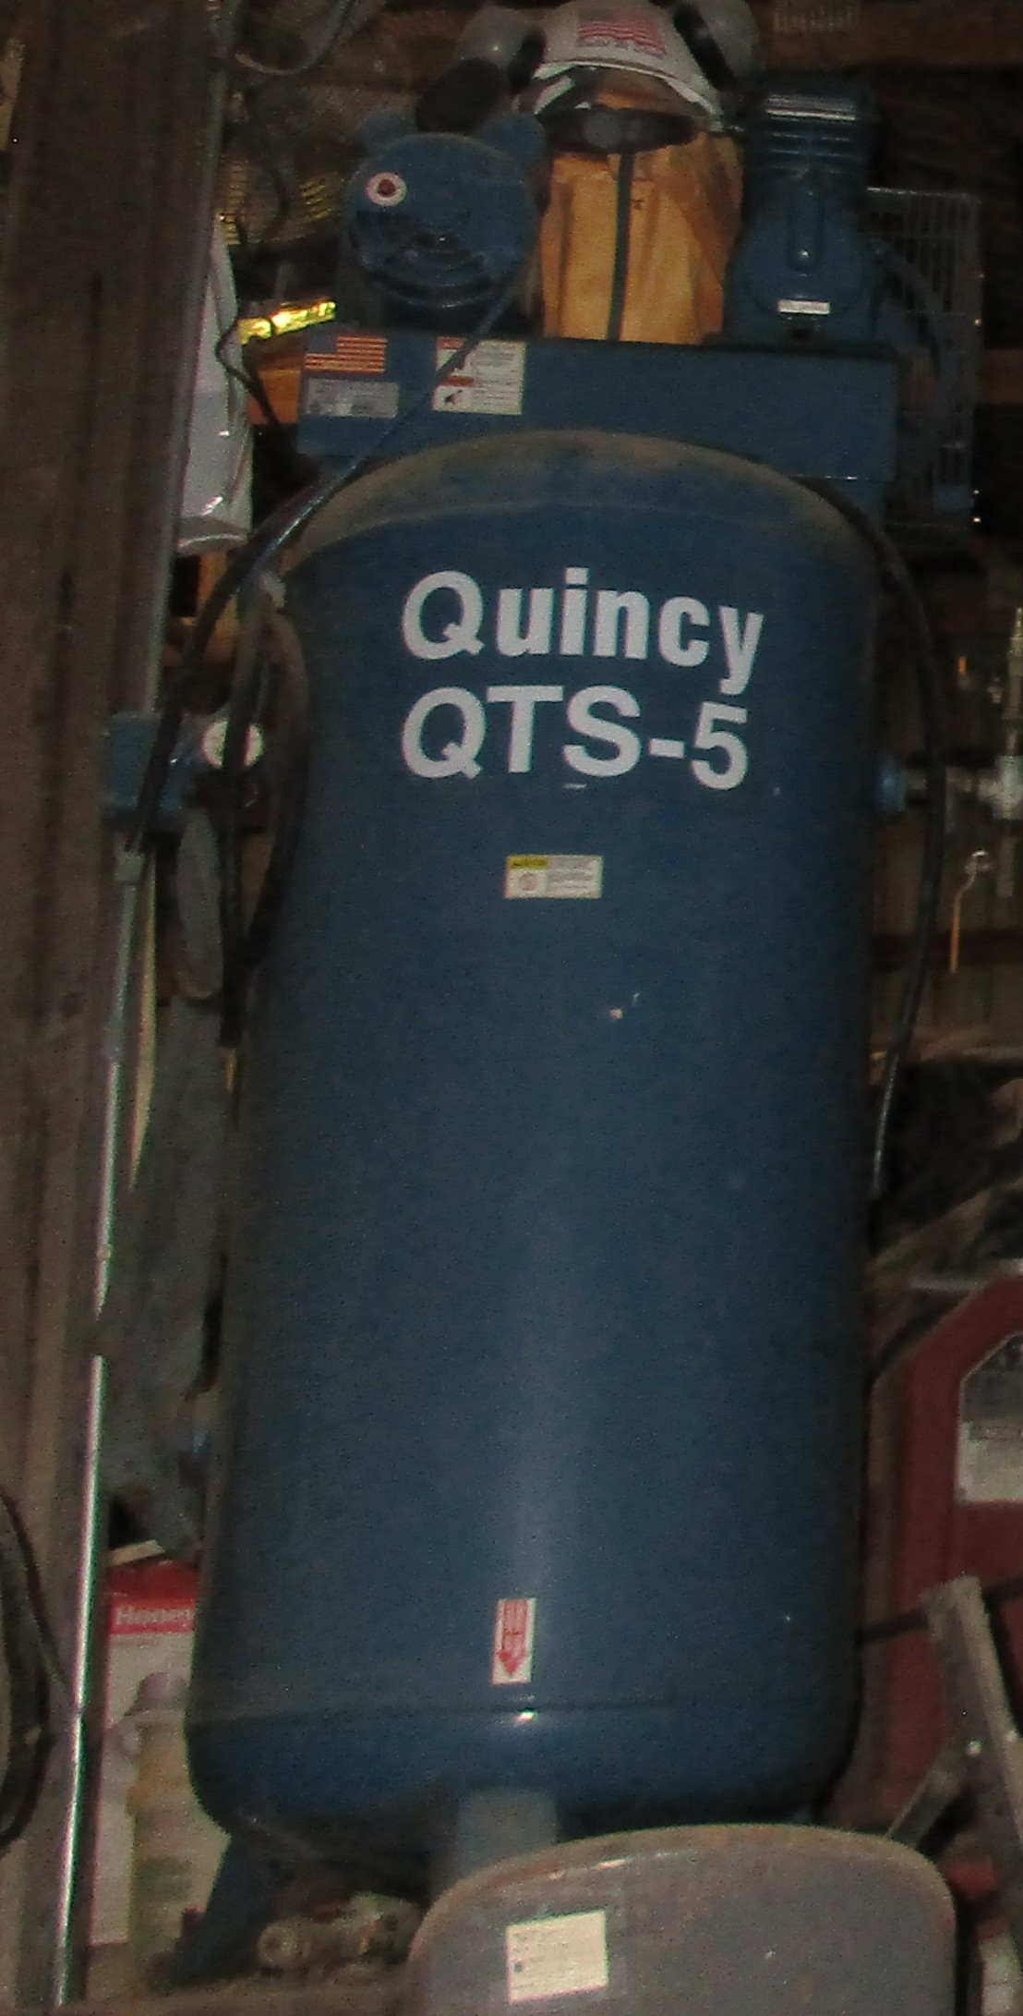
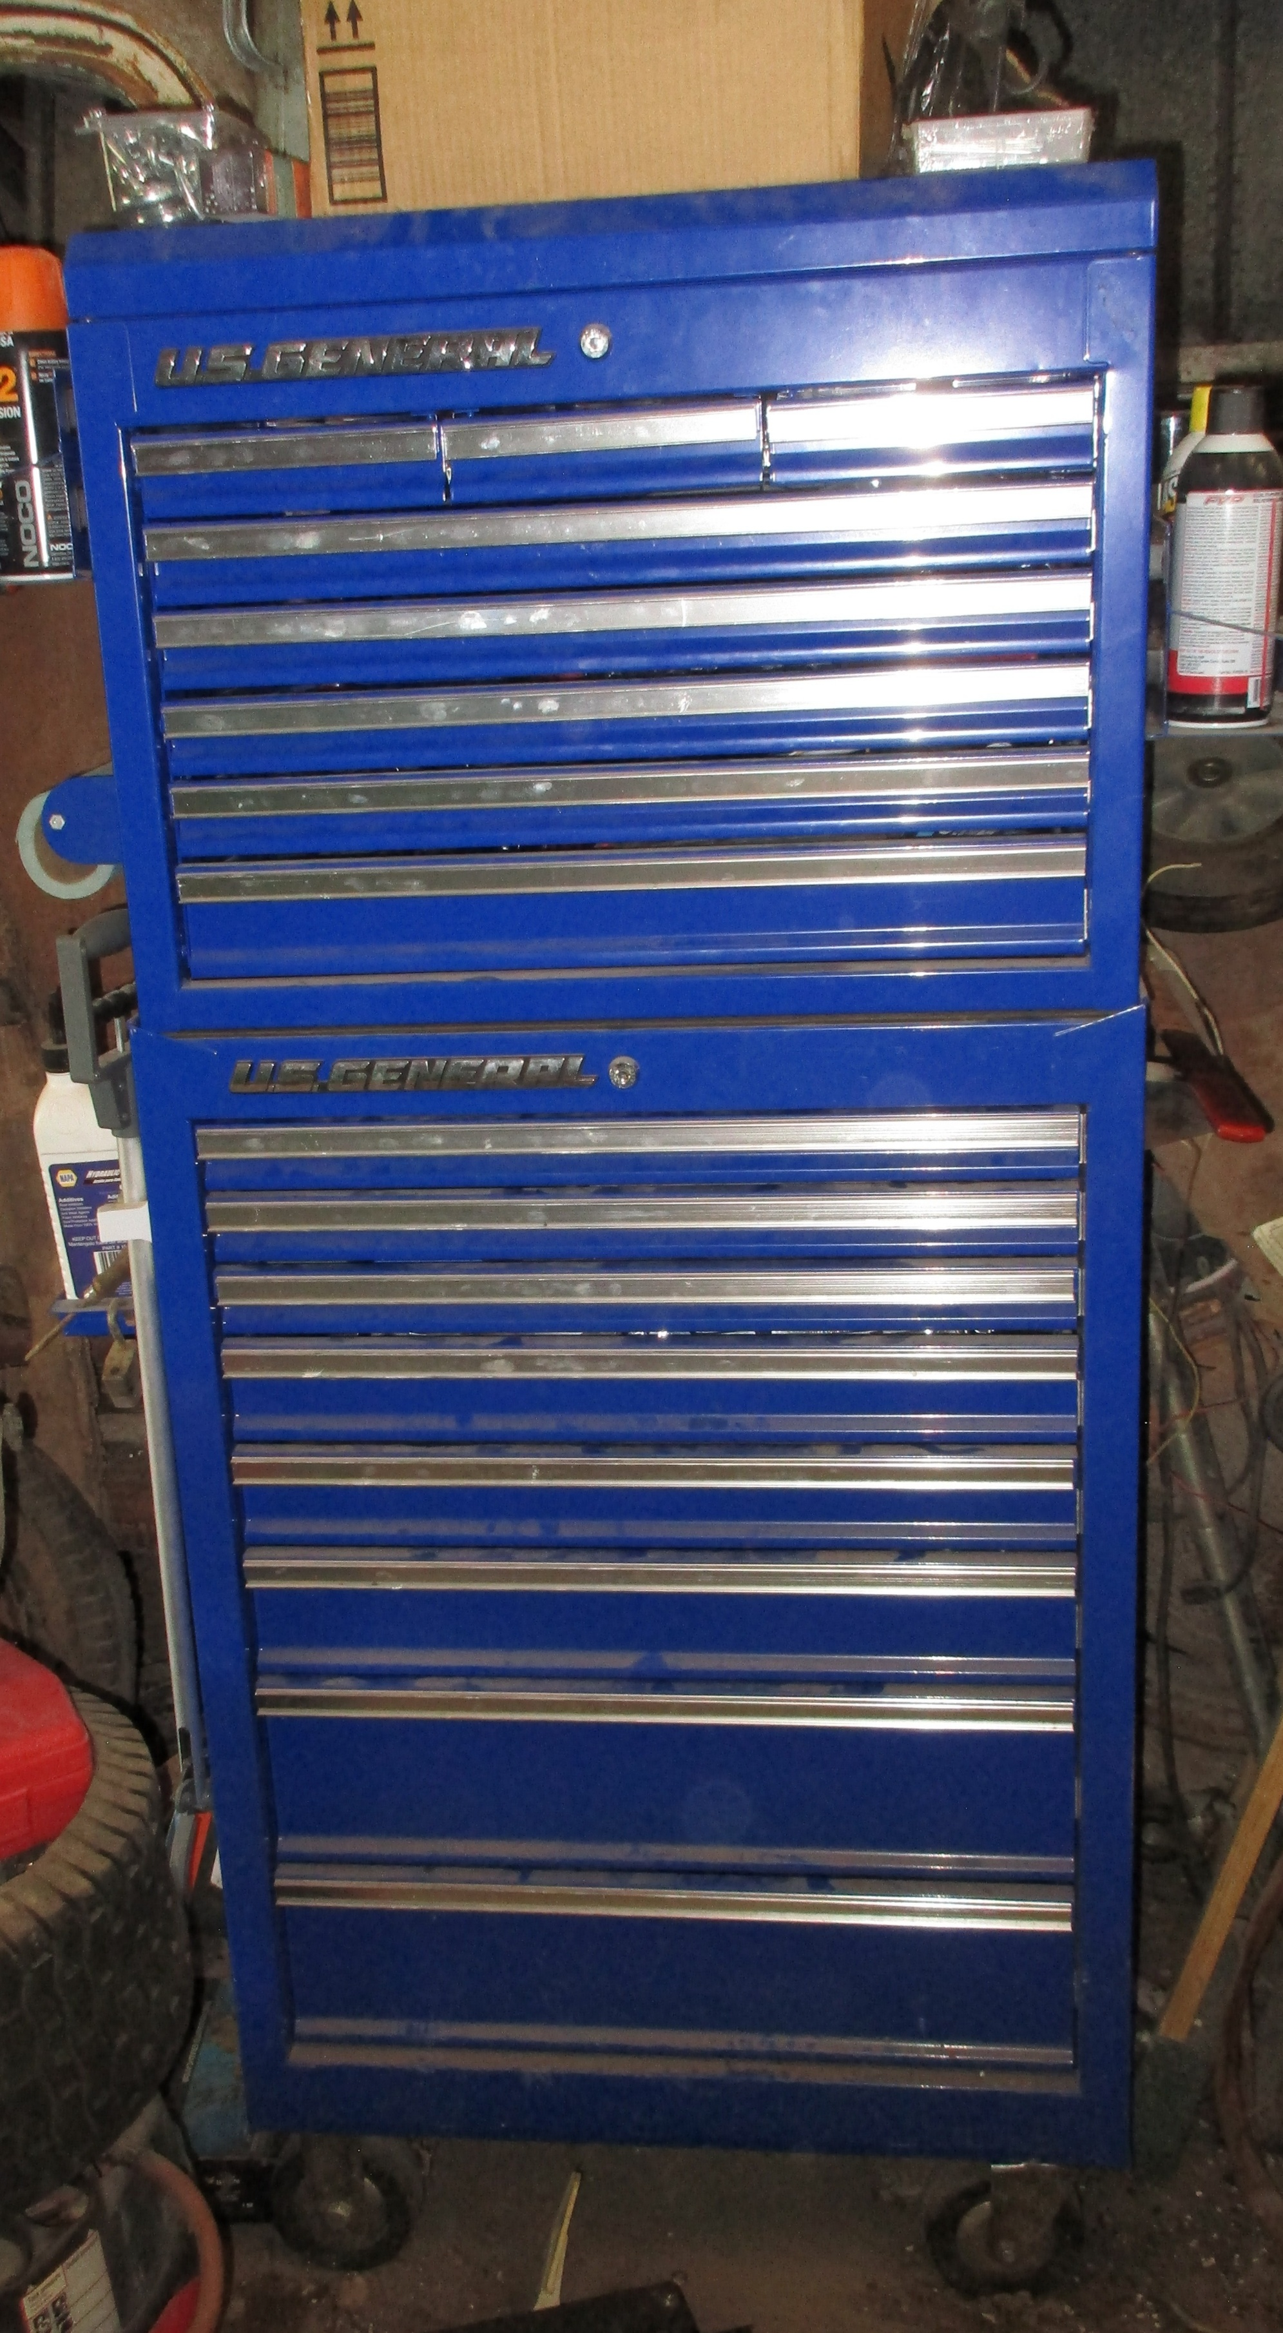
(LOTS OF MISC TOOLS)
FURNITURE & MISC
2 leather chairs, Couch, end tables, lamps
Kitchen clock, regulator clock
Patio table & 4 chairs
Ladies roll top desk
Queen size bed headboard & footboard
7 drawer dresser, 5 drawer dresser
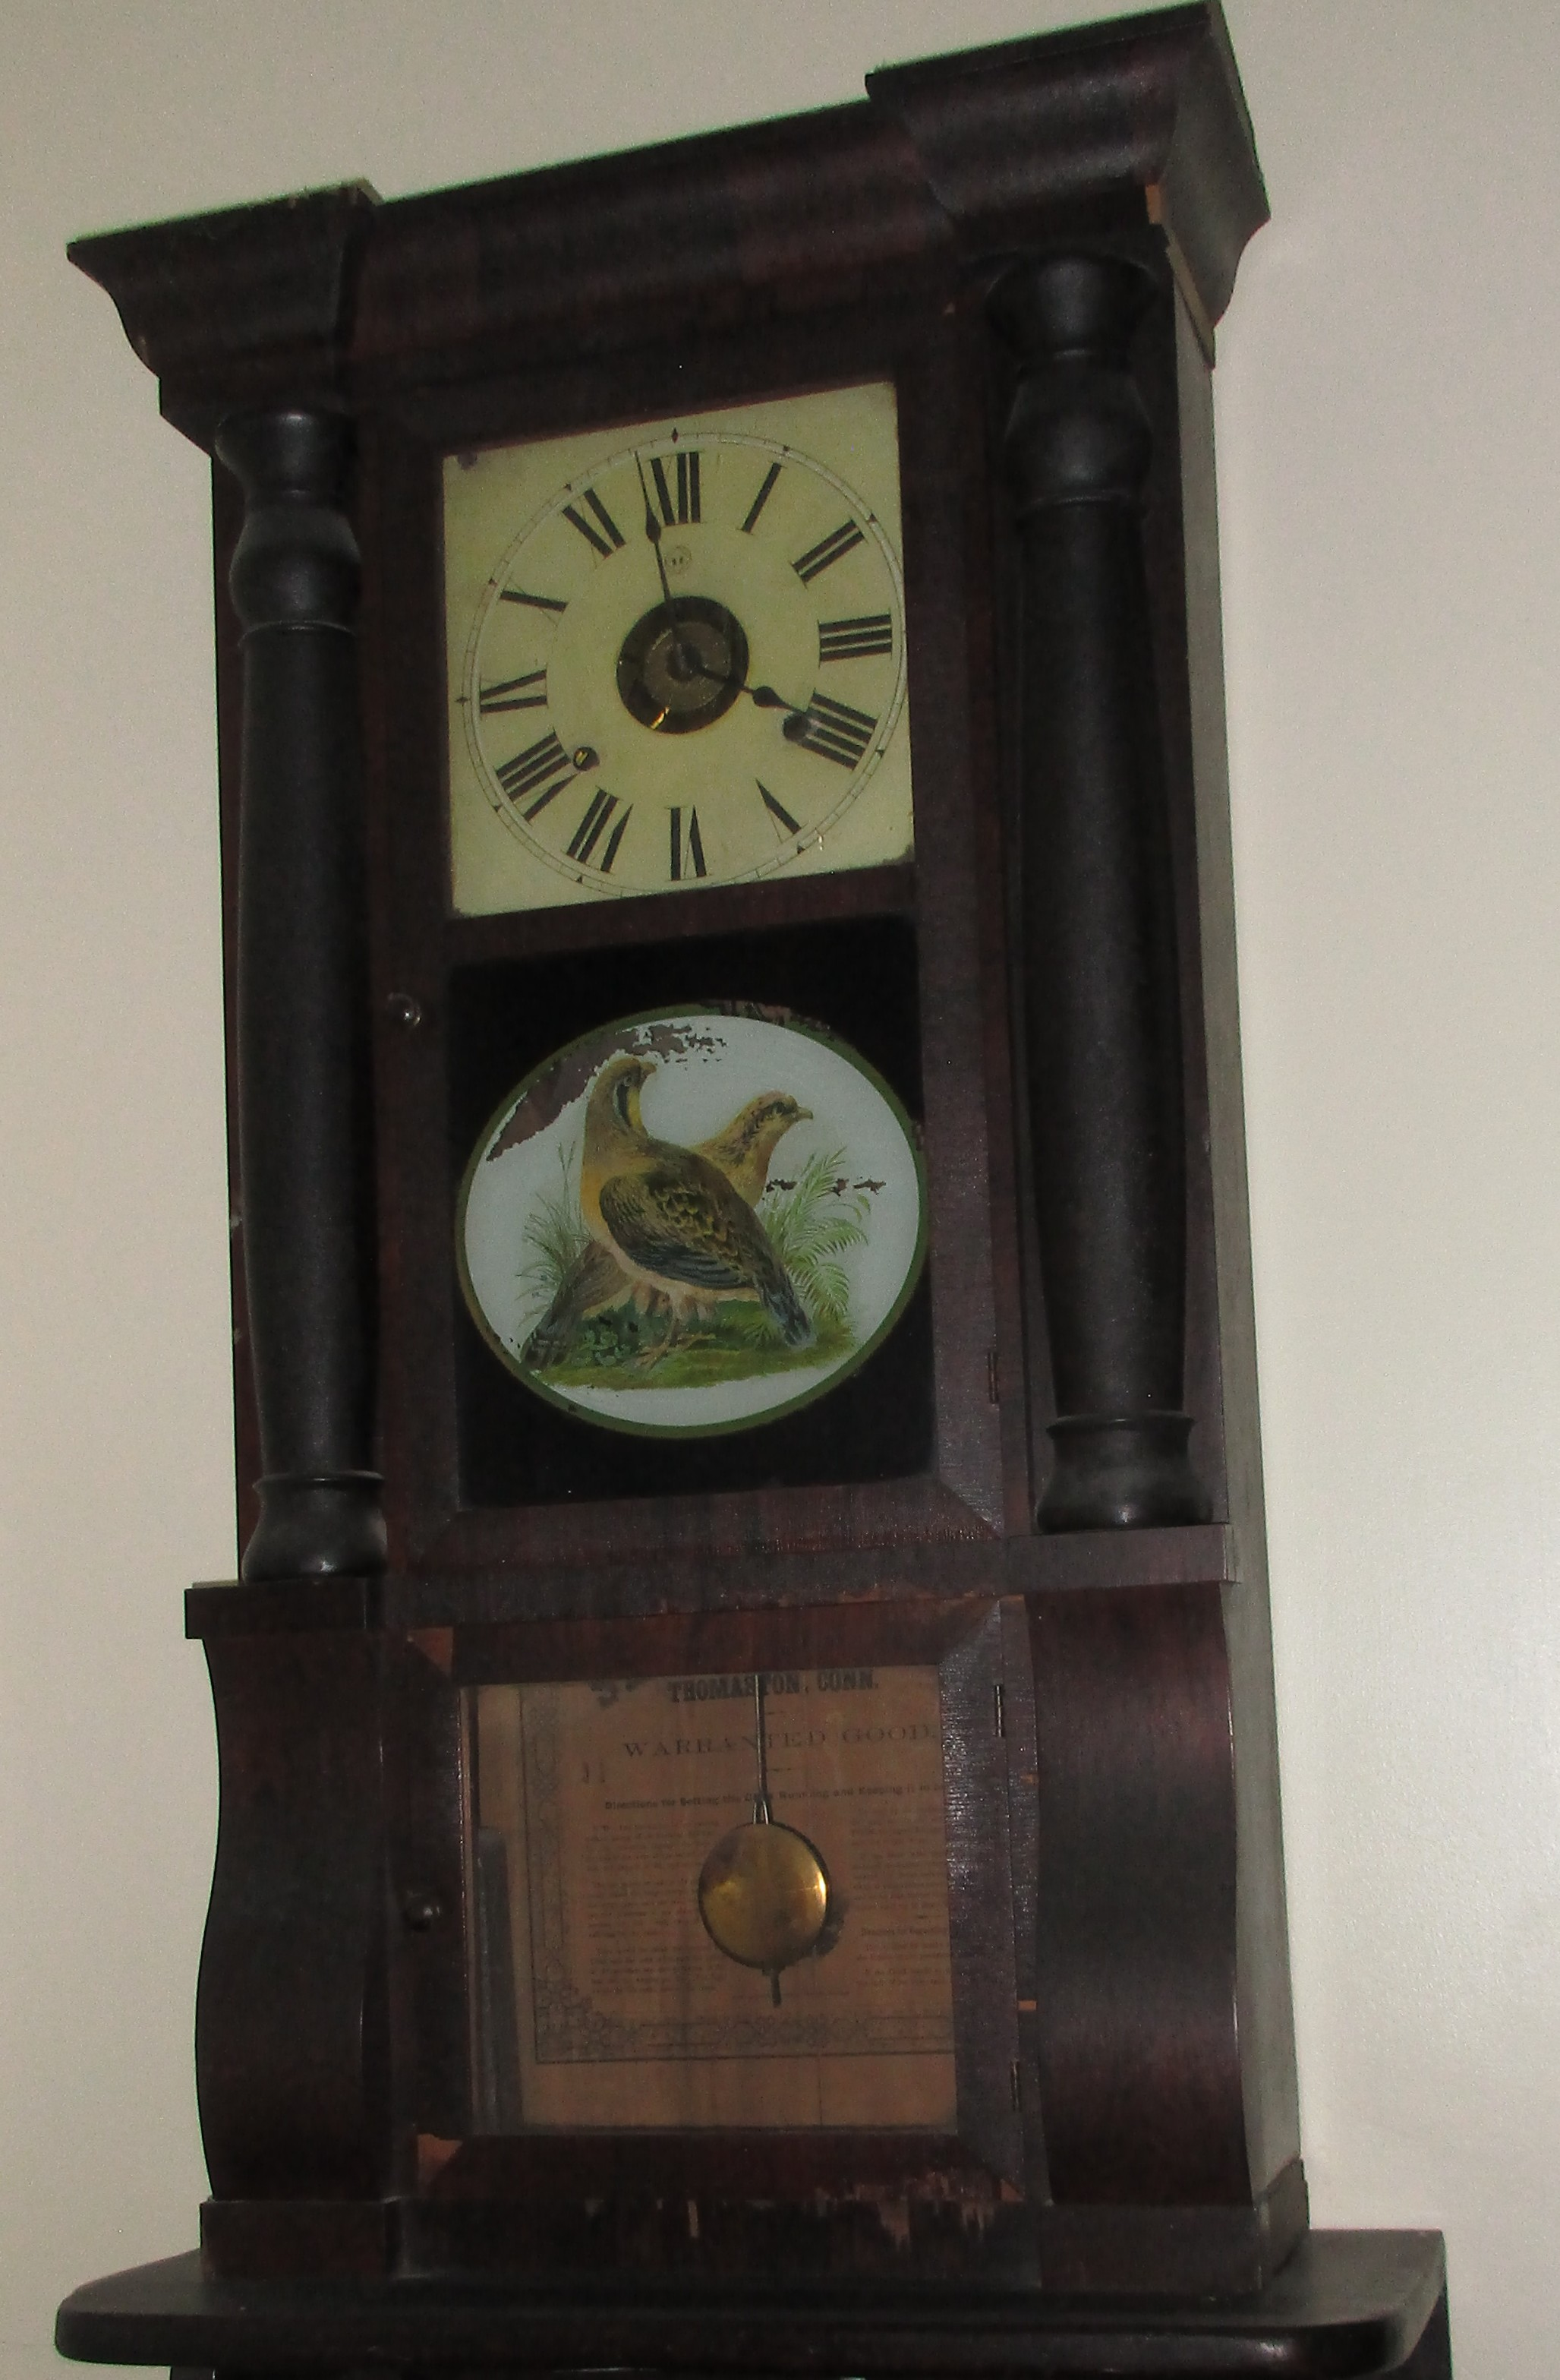
Daybed w mattress, Full size bed w mattress
Jelly roll cabinet
Barber pole, lockers
2 gal western crock
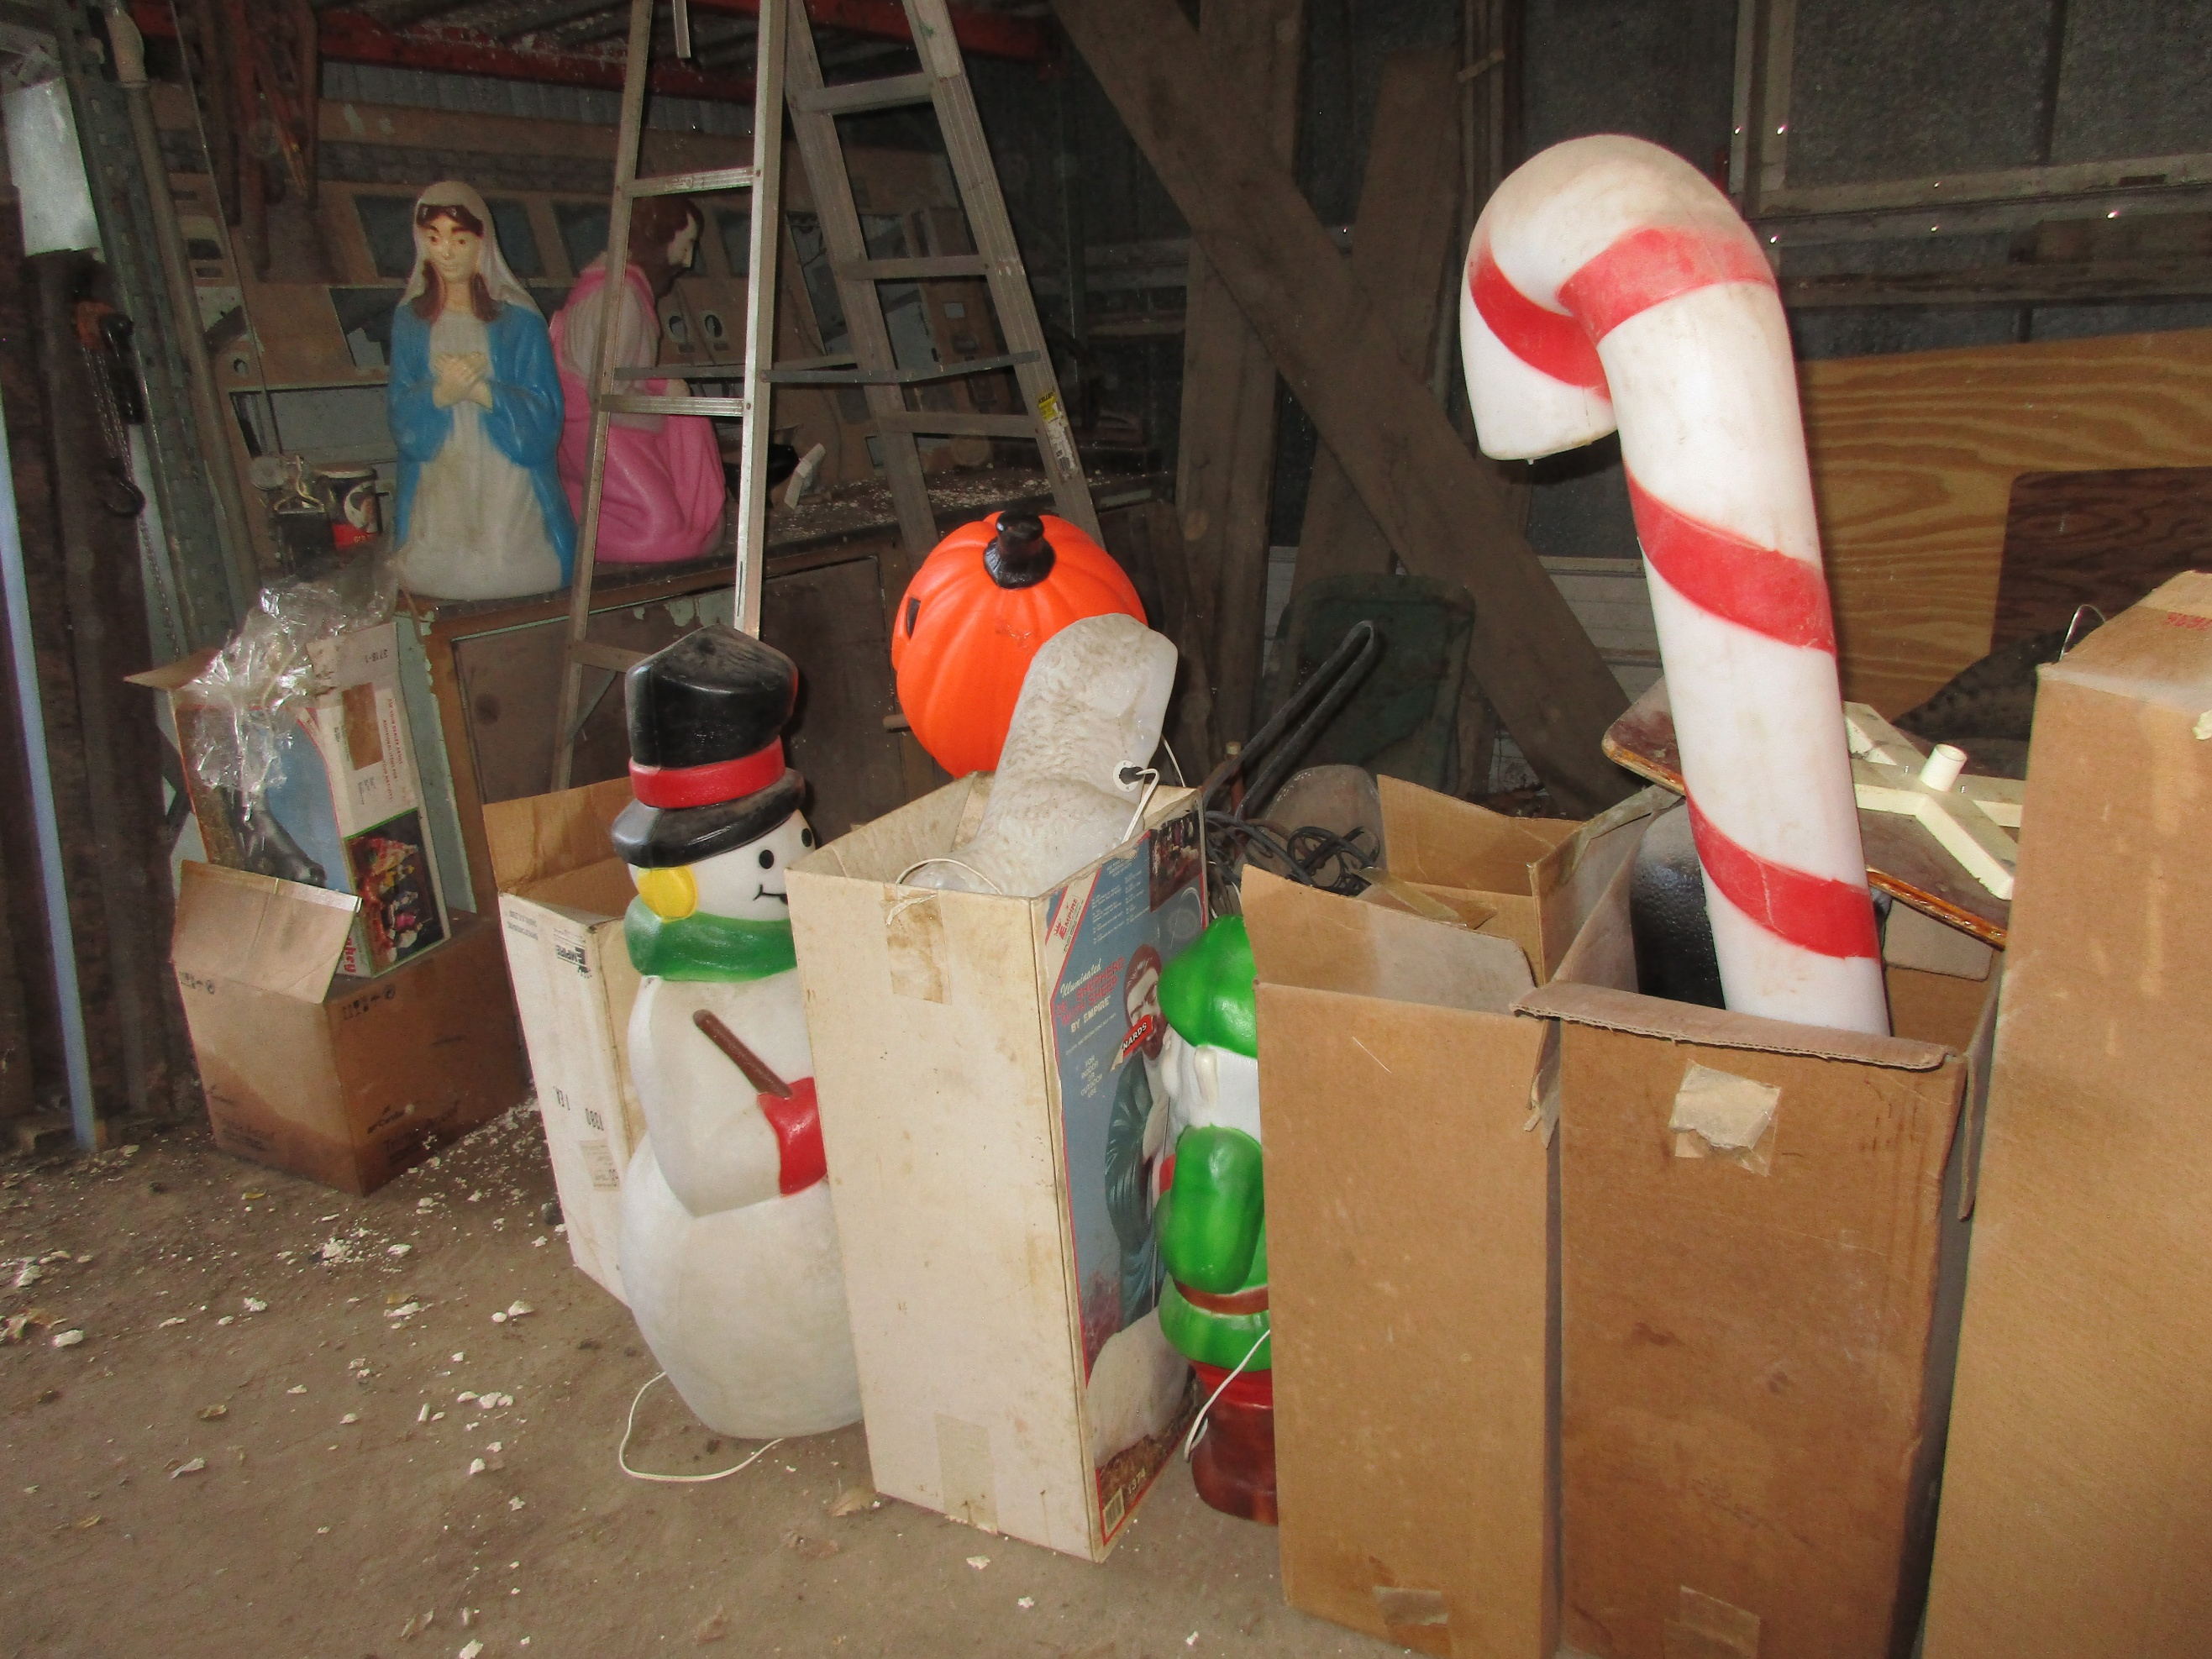
RR lantern, Coca cola syrup bottle
Cast iron pan, canning jars
Maytag wringer washer on stand
Schwinn air-dyne ergometer exercise bike
Toy International Restoration tractor in box
Milk can, Parking meter
G.L. RALL feed mill thermometer
20+ Outside plastic medium size Christmas decorations
Patio chairs, Neon ‘OPEN’ sign
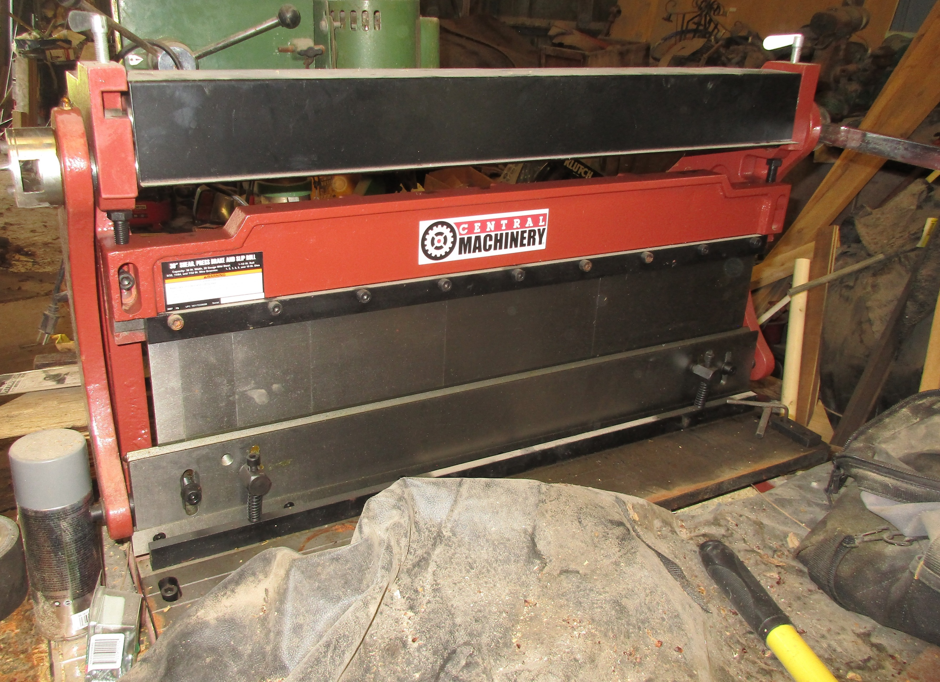
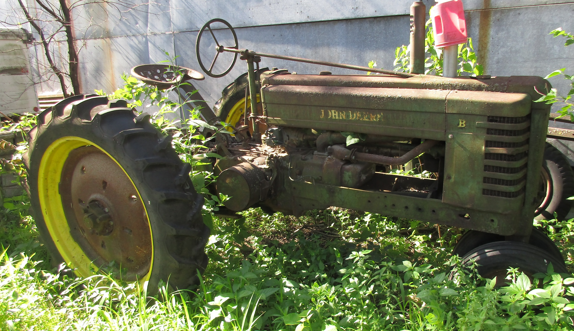

Round horse tank, Metal kerosine can
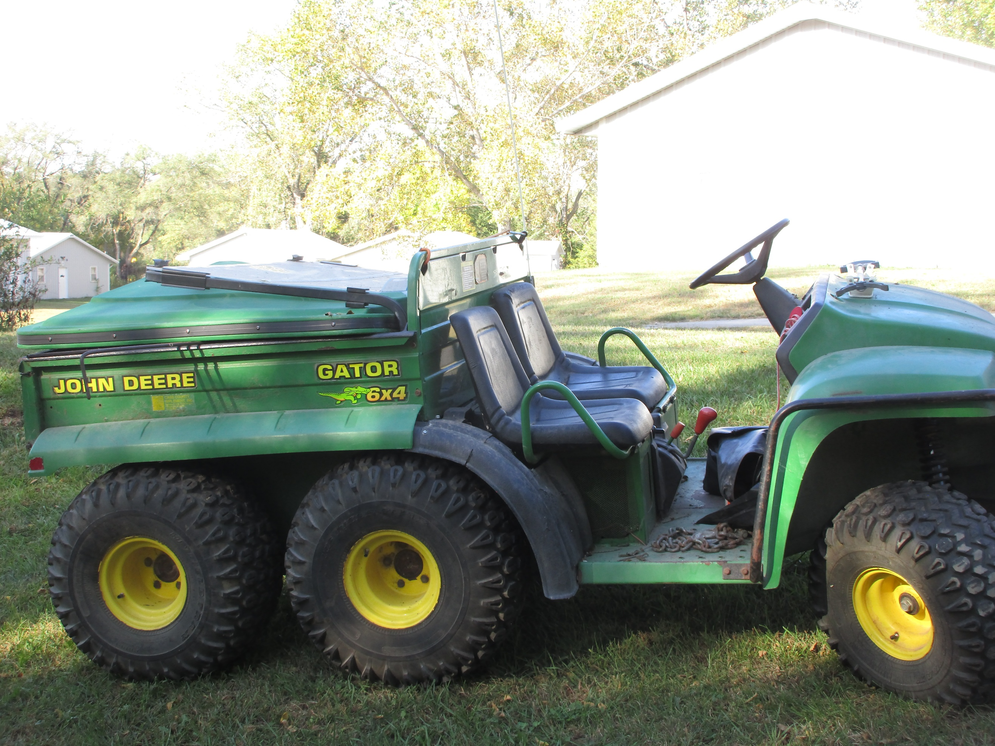
Vintage 4 wheel tricycle, Electra bike
Tires & rims (all sizes)
Propane patio heaters
Iron wheels, Well pump
Motor stand, Tarps
Cast iron chairs & bench rails

Dodge Ram hood ornament-new
New tractor seat
JOHN HENDERSON, AUCTIONEER 402-227-0114 www.hendersonauction.net ZANE GANSEMER, AUCTIONEER 402-227-5170 www.gpEaster.com
MARK EASTER 402-297-1212 www.goEaster.com Will take cash, check (with proper ID) & credit card. Not responsible for accidents or items after bid purchase. Everything sold as is, where is, with no warranties (written or implied). HENDERSON AUCTION SERVICE, NEHAWKA, NE. www.hendersonauction.net. Auctioneer note: WE ARE NOT RESPONSIBLE FOR ANY DAMAGE TO ITEMS IF NEEDING HELP WITH LOADING. Still going thru and finding so much more!!!! LUNCH WILL BE AVAILABLE WE SELL ONLINE & ONSITE OR BOTH. Will end up breaking into 2 rings

