REVIEW OF FOREIGN GYMNOCLADUS SPECIES
- By Eric Martindale, Oct 4, 2026
Source published in May, 2026: https://www.researchgate.net/publication/405261248_Taxonomic_review_of_the_genus_Gymnocladus_Fabaceae_Caesalpinioideae_Gleditsieae_with_emphasis_on_Asian_species_including_a_new_species_G_sanctus

This is a condensed version of the above technical report that is published in reachgate.com. This document contains basic information and very limited scientific jargon. It is more readable by the general public, and illustrates the important images. Aside from Gymnocladus dioicus, there are five Gymnocladus species native to places outside of North America. All five are native to Asia. The purpose of this document is to list the reasons to exclude each Asian Gymnocladus species from being the Mastodon Coffeetree. Botanists reading this can then refer to the source link, as needed.

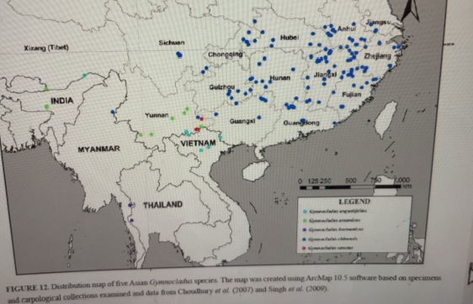
Distribution of foreign Gymnocladus species. All are in Asia.

All five species are rare to extremely rare in the wild, and only one, G. chinensis (Chinese soap tree) is commonly planted. All of these species prefer limestone or otherwise calcareous soils. All have very small and narrow leaflets. Chinese soap tree is a small to mid-size tree, and the others are small trees.

G. sanctus, was identified in 2024 from an old growth specimen found at a temple in Yunnan, China. Sanctus means sacred. Its leaf is a 99% match for one variety of Kentucky Coffeetree, which is not the most common variety. The five Asian Gymnocladus species are as follows:

- Gymnocladus chinensis = Planted across a broad area of southeastern China. Sometimes called the Chinese Soap tree or Chinese Coffeetree. Slow-growing tree 5 – 25 m tall. Can attain moderate girth. Lives in subtropical forests, and prefers evergreen edges. It can be a pioneer species in forest clearings. Exists sparsely in the wild, but has a conservation status of Least Concern (LC) because it has been widely propagated. Pulp from the bean pods is used by women to wash their hair, and the tree has other unspecified “traditional medicinal uses”
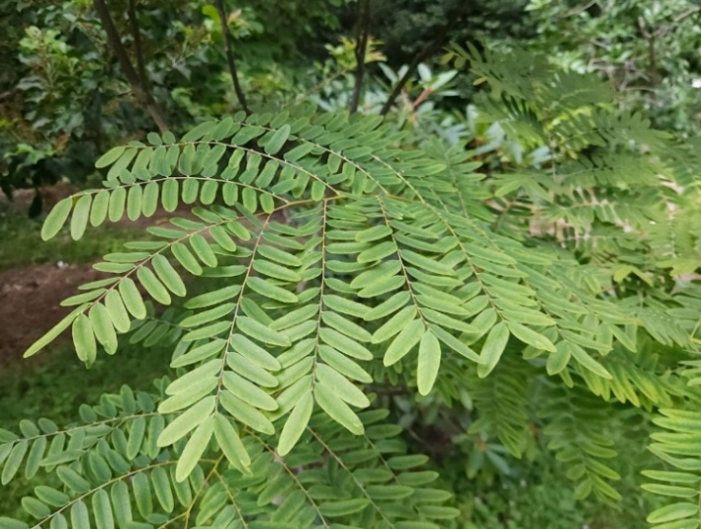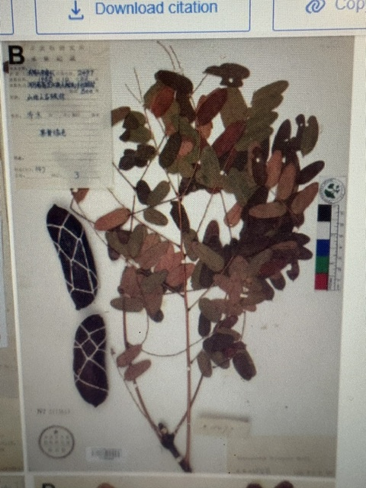
G. chinensis “Chinese soap tree” has a great many leaflets, far more than any G. dioicus variety

Reason to exclude: Bean pods are different shape. The leaflets are very small (and much more numerous). Leaves have no terminal leaflet stem. Tree size is also way too small. Subtropical species which can survive sub-freezing temperatures at least down to 15 degrees Fahrenheit. Since the winters in Bejing are too cold for this species, survival in New Jersey would be marginal at best. Surviving 19 winters doesn’t matter if one out of twenty New Jersey winters would kill them off.

- Gymnocladus assamicus = Assam (India), Bhutan, and Yunnan province in China
This is a tropical deciduous tree in northeast India growing up to 17 meters in height. Has a smooth bark like an Ailanthus. Classified as “Critically Endangered” due to habitat loss. Seed pods produce a rotten banana-like odor. Ripe pods are used as a soap and shampoo substitute by indigenous peoples. Flowers are purple, and the pods are elongated and look a bit like Black Locust pods.

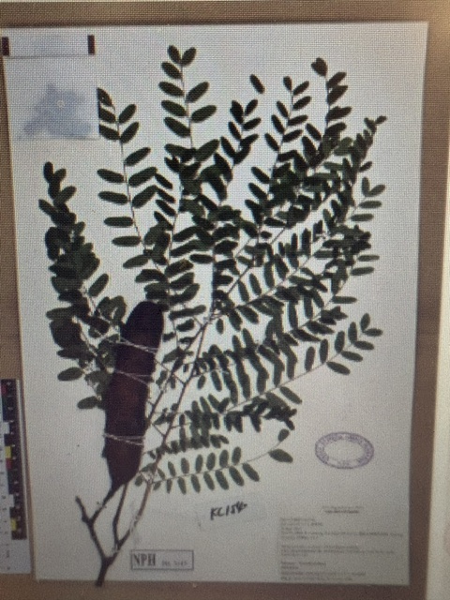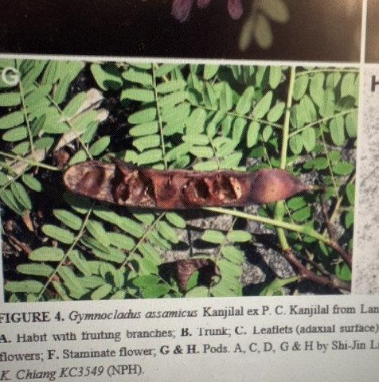

Reasons to exclude: tree size too small. Bean pods too long and narrow, and look nothing like the North American species. Leaflets are the smallest of any Gymnocladus species. This is a tropical species that would not survive in New Jersey.

- Gymnocladus burmanicus = Located in the mountains of the southern panhandle of Myanmar, and the border area of Thailand. Rare tree, not much information online. Described by C.E. Parkinson in 1928. Deciduous tree 8-17 m tall, occurring in tropical dry open forests. Some G. Augustifolius were identified as G. burmanicus before the former was declared its own species. Leaflets 3.5 – 7 cm long.

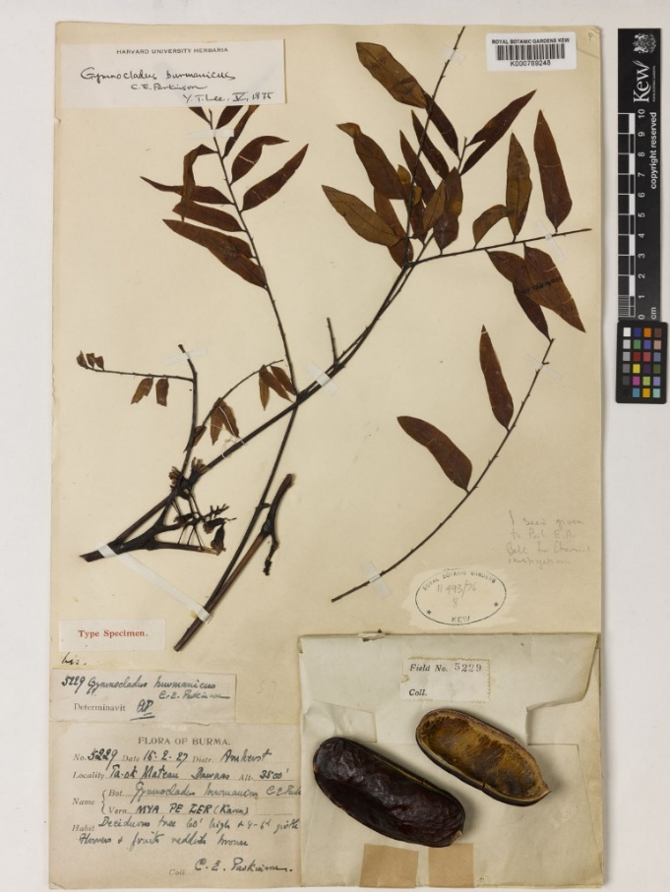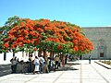

Reason to exclude: Leaflets too elongated and too small. Tree size too small. Tropical species that would not survive New Jersey winters.

- Gymnocladus angustifolius aka Vietnamese Coffeetree. Deciduous tree 10 – 30 m tall. Grows in tropical monsoon forests. Most stands were logged by the 1990’s, and only those in deep valleys and on steep slopes escaped logging. Located in northernmost Vietnam and the border area inside China. A distant population is near the Tibet-India border. Rare tree described in 1980. Turns red in the Fall. Critically endangered.
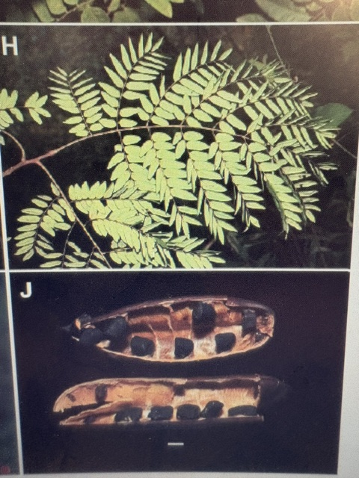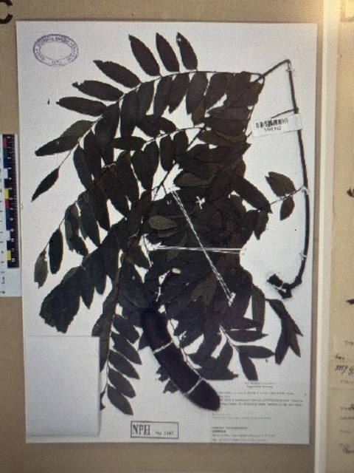

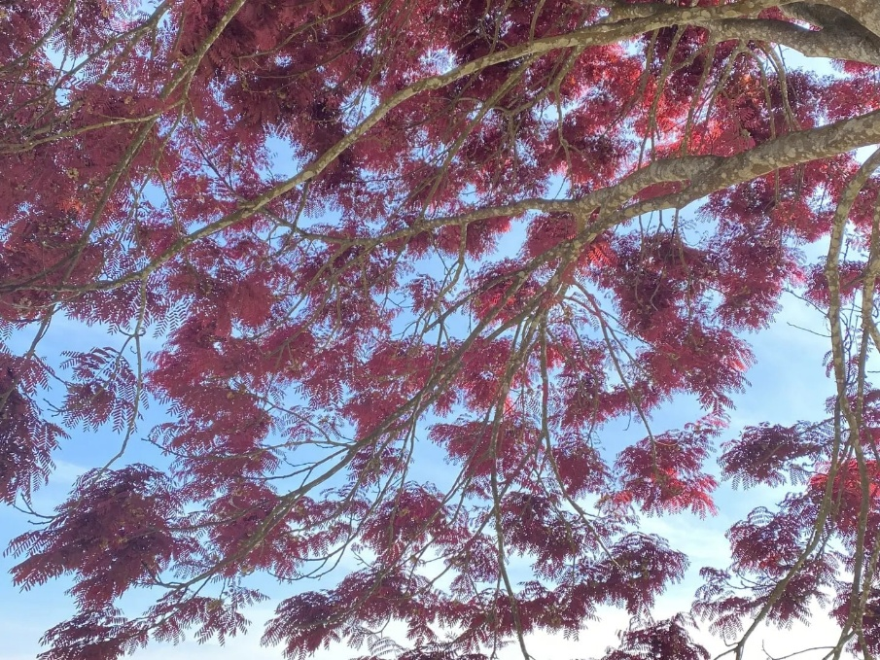 Note how this species also has the tufts.

Reasons to exclude: bean pods way different, leaflets too small. Leaves turn red instead of yellow in the Fall. Tropical species that would not survive New Jersey winters.

- Gymnocladus sanctus = Newly described species known as Huguosi Soapbean. Found in eastern Yunnan Province, China. There are two populations, as described in 2024. One population is a single very large female specimen growing at a sacred temple. It is known locally as “The Sacred Tree”, and it is worshipped. Another population was found about 100 km away, totaling only 7 individuals. These 7 are all mature, but only 1 is a female producing bean pods. In total, there are only 8 of them known, same as G. hesperia.

When this species was described in 2024, reports say “only a small number of wild trees documented”. This is not entirely correct. The only two G. sanctus images found online show mature trees growing in densely developed villages. It’s reasonable to speculate that they are all growing in villages. The technical report did not clarify if any specimens were found growing in actual natural settings. They just consider a village in a rural area to be “natural”. I disagree.

213 m, 4 September 2023, B. Pan 4144 [holotype HITBC (barcode HITBC0129398!), isotypes NPH (barcodes NPH04061!,
NPH04062!)].
Diagnosis:—Gymnocladus sanctus most closely resembles the only American species in the genus, G. dioicus; as both
species have supra-axillary buds, and pale-coloured flowers and generally estipellate leaves with ovate to oblong-ovate
leaflets. It can be distinguished from G. dioicus by its generally lanceolate-ovate to oblong (vs. ovate) leaflets, which
are thinly coriaceous (vs. chartaceous), pinkish (vs. greenish) flowers, and its smaller and thicker (8–12 × 3–4.5 ×
2.5–3 cm vs. 12–25 × 3–7 × 0.6–0.8 cm), sparsely puberulent (vs. glaucous) pods, as well as its geographic distribution
(native to Southwest China vs. native to North America).
Description:—Deciduous trees, up to 25 m tall, dioecious. Bark whitish gray to brownish gray, ± reticulately
fissured or smooth when old. Branchlets purplish brown, covered with conspicuous grayish-white lenticels. Bud supra-
axillary. Leaves bipinnate, 15–70 cm long, alternate; petioles and rachis covered with prominent lenticels, denser
toward base, puberulent with sparse, light yellow to pale, somewhat curved hairs when young, glabrescent with age;
pointlet often present, ca. 3 mm, hairy as rachis. Pinnae 2–4-jugate, alternate to sub-opposite, 7–30 cm; rachilla hairy
as rachis, base pulvinate, conspicuously rugose; pointlet often present, 1–3(–14) mm, hairy as rachilla. Stipels not
observed (absent from all examined material). Leaflets 3–5(–6) pairs, opposite to alternate, generally lanceolate-ovate
to oblong, less frequently ovate, 4–12 × 1.5–4 cm, thinly coriaceous; base rounded to broadly cuneate or sometimes
cordate, ± asymmetrical with midvein closer to lower margin; apex acute to caudate-acuminate; adaxial surface very
sparsely puberulent with pale to yellowish, ± appressed hairs when young, denser along midvein, glabrescent with
age; abaxial surface sparsely puberulent with yellowish hairs, denser near base and along midvein and secondary
veins; midvein and secondary veins impressed adaxially when mature, prominent abaxially; petiolules ca. 3 mm
long, puberulent with light yellow, ± ascending, somewhat curved hairs. Inflorescence a multi-branched panicle with
numerous flowers.
6. Gymnocladus sanctus B. Pan bis, K. W. Jiang, E. D. Liu & B. Xiao, sp. nov. Figs. 8, 9, 10 & 11E.
TYPE:—CHINA. Yunnan: Wenshan, Guangnan, Liancheng, Lianhu Community, Huguo Temple, cultivated as a sacred tree, elev.
1,213 m, 4 September 2023, B. Pan 4144 [holotype HITBC (barcode HITBC0129398!), isotypes NPH (barcodes NPH04061!,
NPH04062!)].
Diagnosis:—Gymnocladus sanctus most closely resembles the only American species in the genus, G. dioicus; as both
species have supra-axillary buds, and pale-coloured flowers and generally estipellate leaves with ovate to oblong-ovate
leaflets. It can be distinguished from G. dioicus by its generally lanceolate-ovate to oblong (vs. ovate) leaflets, which
are thinly coriaceous (vs. chartaceous), pinkish (vs. greenish) flowers, and its smaller and thicker (8–12 × 3–4.5 ×
2.5–3 cm vs. 12–25 × 3–7 × 0.6–0.8 cm), sparsely puberulent (vs. glaucous) pods, as well as its geographic distribution
(native to Southwest China vs. native to North America).
Description:—Deciduous trees, up to 25 m tall, dioecious. Bark whitish gray to brownish gray, ± reticulately
fissured or smooth when old. Branchlets purplish brown, covered with conspicuous grayish-white lenticels. Bud supra-
axillary. Leaves bipinnate, 15–70 cm long, alternate; petioles and rachis covered with prominent lenticels, denser
toward base, puberulent with sparse, light yellow to pale, somewhat curved hairs when young, glabrescent with age;
pointlet often present, ca. 3 mm, hairy as rachis. Pinnae 2–4-jugate, alternate to sub-opposite, 7–30 cm; rachilla hairy
as rachis, base pulvinate, conspicuously rugose; pointlet often present, 1–3(–14) mm, hairy as rachilla. Stipels not
observed (absent from all examined material). Leaflets 3–5(–6) pairs, opposite to alternate, generally lanceolate-ovate
to oblong, less frequently ovate, 4–12 × 1.5–4 cm, thinly coriaceous; base rounded to broadly cuneate or sometimes
cordate, ± asymmetrical with midvein closer to lower margin; apex acute to caudate-acuminate; adaxial surface very
sparsely puberulent with pale to yellowish, ± appressed hairs when young, denser along midvein, glabrescent with
age; abaxial surface sparsely puberulent with yellowish hairs, denser near base and along midvein and secondary
veins; midvein and secondary veins impressed adaxially when mature, prominent abaxially; petiolules ca. 3 mm
long, puberulent with light yellow, ± ascending, somewhat curved hairs. Inflorescence a multi-branched panicle with
numerous flowers.
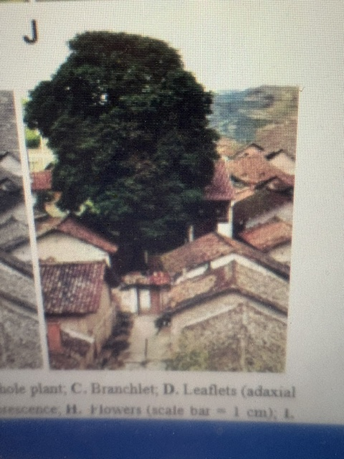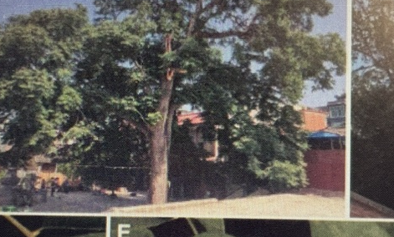
G Sanctus growing in urban areas of Yunnan, China.

G. sanctus is a medium size tree that most closely resembles the only American species in the genus, G. dioicus. The leaflets are a good size, and much larger than the other Asian species. The G. sanctus leaves duplicate the leaflet pattern of one variety G. dioicus. It is nothing like the Mastodon Coffeetree specimens.

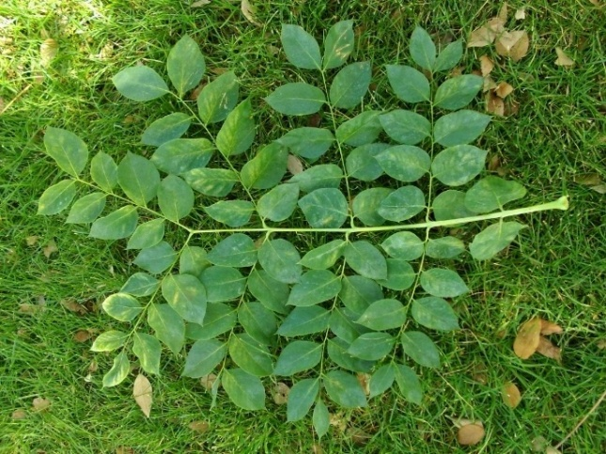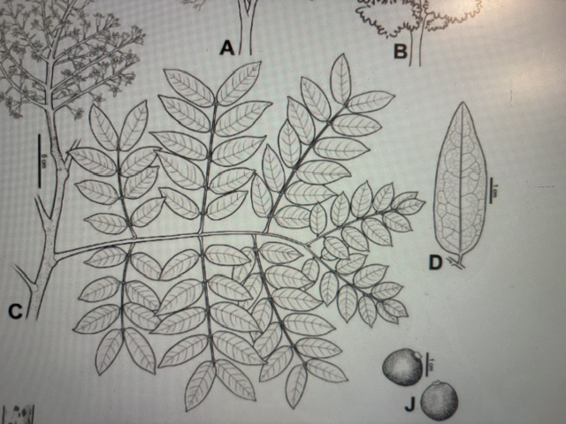
“Variety B” of G. dioicus scientific drawing of G. sanctus

The scientific drawing of the G. sanctus leaf is a shocking and a 99% match to Leaf #3 of G. dioicus that I illustrated in the chapter “Natural Variation of Kentucky Coffeetree”.

The classic variety of G. dioicus looks very different from the above leaf, which I call “Variety B”. It remains to be seen whether or not Variety B of G. dioicus will ultimately be determined to be yet another species. Scientists comparing G. sanctus to G. dioicus may have looked only at classic Gymnocladus, what I call “Variety A”. It would be interesting to see if the flowers of Variety B are more similar to G. sanctus than to Variety A. I cannot rule out the possibility that the Chinese somehow sourced the seeds of Variety B over 150 years ago, and that Variety B is actually G. sanctus.

I described the other four Asian species just for the purposes of eliminating them from consideration as being the Mastodon Coffeetree. They are completely irrelevant to any further research on American Gymnocladus because they are all too different from both G. dioicus and G. hesperia.

I am devoting significant text here to G. sanctus because information on this species is much more relevant to the investigation of how many Gymnocladus species exist in the United States.

I suspect it is impossible for one deciduous tree species to be native to both China and the United States. A botanist can confirm if this is a rule. Therefore, G. sanctus is indeed native to China. These are different species, but very closely related. Perhaps the American version shown on the left (which is not a classic Kentucky Coffeetree) travelled over the Bering Land Bridge to Asia during the warm Eocene climate, and that was the ancestor of the G. sanctus.

And what of the Solitair specimen?

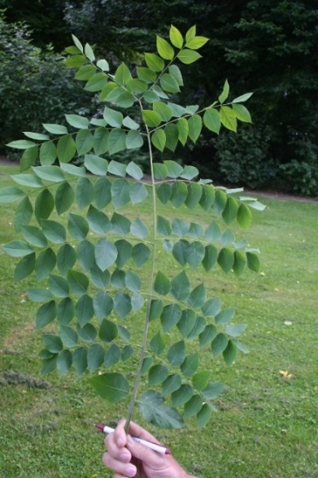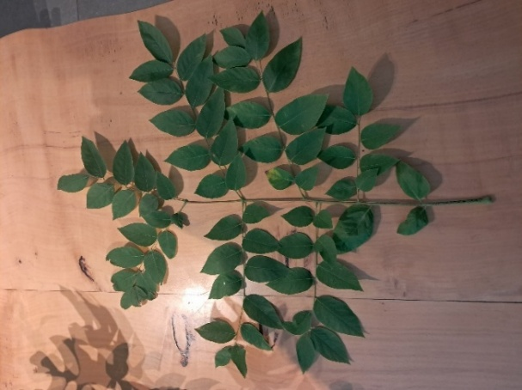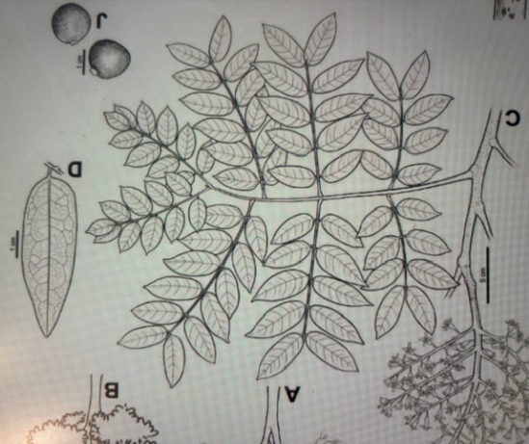
LEFT TO RIGHT: classic G. dioicus, the Solitaire specimen, and the G. sanctus scientific drawing

Interesting how the Solitaire specimen also looks much more like G. sanctus than a classic G. dioicus. It is starting to look like there could be more Coffeetree species in the United States, not just G. dioicus and G. hesperia.

Here’s a snippet of the scientific report on G. sanctus
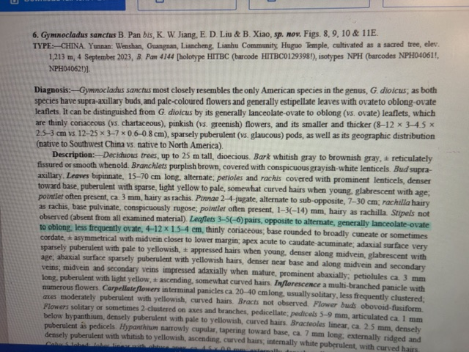

The original bean image (below) from the technical report also contains a bean pod called (E) of the Sanctuary Coffeetree, G. sanctus. It was much smaller and looked shriveled. The technical report does not clarify if their image is from a fertile seed pod. Information like that is valuable, readers cannot be left guessing. I cropped it out of the image because it might be an infertile bean pod from the sole female specimen.

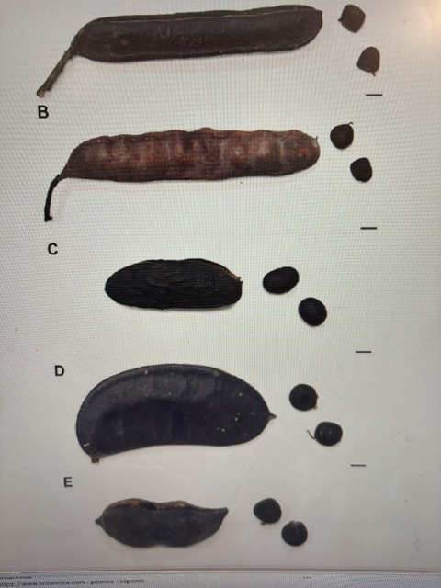
(A) augustifolius is the top bean pod (B) assamicus (C) chinensis (D) dioicus

