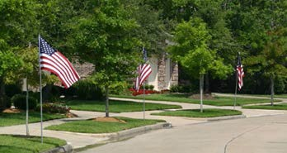
FLY THE FLAGS
Copley-Norton Lions Club
SIGN UP TODAY!

Help the community celebrate the Red, White & Blue all summer and fall!

From Memorial Day - Flag Day - Independence Day - Labor Day - Patriot Day - Election Day to Veterans Day
The Copley-Norton Lions Club will place a flag in your front yard (visible from the road) a few days before Memorial Day and pick it up a few days after Veterans Day. You are guaranteed to have a clean 3 ft. x 5 ft. American Flag flying from a sturdy 10 ft. galvanized metal pole that is supported by a 1 in. PVC pipe placed in the ground. Proceeds will benefit the Copley and Norton communities.

*****************************************************************
Copley-Norton Lions Club - Fly the Flags Program 2024

Mail Form & Check to: Copley-Norton Lions Club, 2748 Floraway Dr., Norton, OH 44203

Name:
Phone:

Street Address:

City:
Email Address:

Flag Location:
Subscription Service Just $35.00/year Includes Everything!
Provide details (e.g., 15’ from road & 10’ east of driveway)
Consider underground utilities, roof drains, invisible fence, etc.

C-N Lions Club Contact: Kim Miller – 234.238.5493 / copleynortonlions@gmail.com

