Monthly Labyrinth Reflection
Sacred Silence | “The Creator writes the Gospel  Not in books alone,  But on trees and flowers  And clouds and stars”  Adapted from Martin Luther
Not everyone senses a spiritual presence in a church, mosque, or other building. However, many folks do profess to get a “gut feeling”, a tickle, a whispery sensation leading them to believe another presence accompanies them in their outdoor solitude.  Spiritual leaders from many traditions advise us to make room for moments of sacred silence each day. Carve out time to escape the chaos of our loud, demanding internal and external worlds.  - As you step into the Labyrinth, pause.  - Simply be still.  - Breathe and listen.  - Release distractions, fears, and concerns you have momentarily left behind you.  - When you are ready, follow the path, walking at your own pace towards the center. Continue to listen as you walk. Listen to the natural sounds around you and to any whisperings that may arise within you.  - Once you reach the center, stay as long as you like. Listen and be open to receiving peace, wisdom, and strength from the spiritual presence surrounding you.  - As you leave, hold on to insights you may have received while wrapped in the gentle arms of sacred silence along the path.  Answers to questions, a calmer spirit, or a peaceful nothing at all.  “The divine radio is always singing if we could only make ourselves ready to listen to it, but it is impossible to listen without silence.”  Mahatma Gandhi  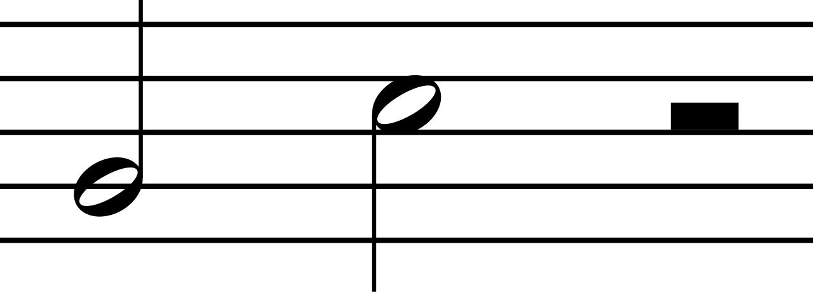 | - As you walk, take a moment to choose a “word” that best describes one of the amazing gifts of grace you find surrounding you today.  - This gift might be a color, a flower, a tree, a leaf, cloud, a wave on the river, stones at your feet, or some other token of grace and love.  - Focus your attention on this one word or gift that captures and holds your attention.  - Be on the lookout for this treasure as you travel to the center of the labyrinth.

