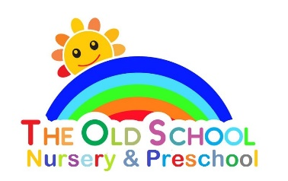

Sun protection policy

Our purpose is to protect your child from skin damage caused by the sun’s strong rays. In order to achieve this:

- Please provide your child with a suitable sun hat, clearly labelled with your child’s name.

- A loose top which covers your child’s shoulders is preferable, both for comfort and protection.

- On sunny days please apply a high factor sunscreen on your child before they come to playgroup.

- Staff are not authorised to apply sunscreen on your child.

- If a child does not have a hat with them; and the sun is particularly hot, we may request that the child plays inside.

- We will discuss with the children, during the summer months, why we must protect our skin from the sun and how to protect it.

- We will provide a shaded area in our outdoor play area.

