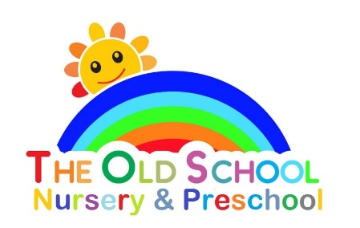

Snacks, drinks and lunchtime – policy and procedure

The sharing of refreshments can play an important part in the social life of the playgroup as well as reinforcing children’s understanding of the importance of healthy eating.

We ask the parents to provide a healthy snack for their child, which should be in a named container. We take a break for snack time half way through the session.

We also ask the children to bring in their own named water bottle, which they have access to throughout the session.

A drink of milk or water is also offered to the children.

On special occasions, such as birthdays, the children may be offered a treat, such as a piece of birthday cake, after the fruit. We will have regard to any allergies which the children may have.

We will occasionally organise cooking activities with the children; on most occasions the prepared food will be taken home, although in some instances the food prepared may be eaten at playgroup.

We have regard to any allergy or food intolerance which a child may suffer from and will ensure these items are not used.
We will never use, or offer, nuts at playgroup.

The dietary rules of religious groups and also of vegetarians/ vegans are known and met in appropriate ways.

Children bring in their own packed lunch if they are staying for both the morning and afternoon sessions. Parents are asked to fill their child’s lunchbox with healthy choices and are also requested to not give their child any food item containing nuts or that has been prepared in an area where nuts are present, or any chocolate items. Children may bring in their own drink; although water is available for all children. Child: Adult ratios are adhered to always whilst the children are eating; on occasion a member of staff will sit at the table with the children and eat their own lunch.

