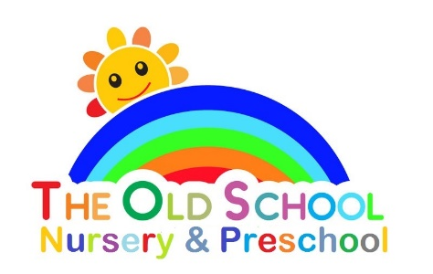

Inclusion Policy

All children have the right to be included in every activity provided by The Old-School Playgroup; irrespective of race, ethnicity, culture, special need or disability.

Reasonable adjust will be made to provide every child with the opportunity to join in.

We will adapt activities to meet the needs of individual children. (We will also ensure that activities are age appropriate).

Staff will be positive role models in promoting inclusion and equal opportunity.

The Old-School Playgroup’s effectiveness in promoting and providing inclusive practise and equal opportunities for all will be continually monitored and evaluated by means of reflective practise and self-evaluation. We will seek the views of parents, the children and members of staff.

