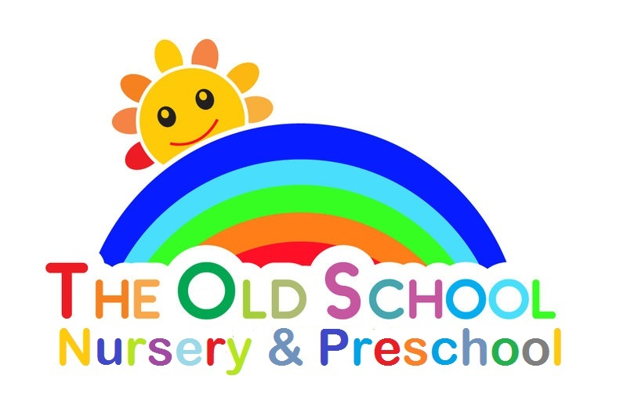

Equal Opportunities Policy

The Old School Playgroup works in accordance with all relevant legislation, as referred to on the Admissions Policy.

We believe that the group’s activities should be open to all children and families, and to all adults committed to their welfare. We aim to ensure that all who wish to work in or volunteer to help with, our playgroup have an equal chance to do so. We acknowledge the benefits of a mixed-age workforce and recognise children can learn about the importance of diversity.

We recognise….

- Each religion is unique and each individuals/ families beliefs are important to them.
- The ethnic origins of staff, children and their families will be respected and reflected.
- Every persons cultural and linguistic background should be recognised and celebrated.
- Ability, we acknowledge children attending our playgroup have individual strengths and weaknesses which staff will identify and support.
- Gender, all individuals entering our playgroup will be treated equally and fairly, regardless of their gender.
- Age, we value staff/parents/carers of all ages and recognise their different contributions are equally valuable.

Families joining our playgroup are made aware of its equal opportunities policy.

Employment
This playgroup will appoint the best person for each job and will treat fairly all applicants for jobs and all those appointed.
Commitment to implementing the playgroups Equal Opportunities Policy will form part of the job description for all workers.

Families
This playgroup recognises that many different types of family successfully love and care for children.

Festivals Our aim is to show respectful awareness of all the major events in the lives of the children and families in the playgroup, and in our society as a whole, and to welcome the diversity of backgrounds from which they come.

In order to achieve this, we aim to acknowledge all the major festivals which are celebrated in our area and/or by the families involved in the playgroup.

- Without indoctrination in any specific faith, children will be made aware of the festivals which are being celebrated by their own families or others, and will be introduced where appropriate to the stories behind the festivals. If a family wishes to do so, we will invite them to share their festival with the Playgroup.
- Children will be encouraged to welcome a range of different festivals, together with the stories, celebrations and special food and clothing they involve, as part of the diversity of life.

The curriculum
All children will be respected and their individuality and potential recognised, valued and nurtured. Activities and the use of play equipment offer children opportunities to develop in an environment free from prejudice and discrimination. Appropriate opportunities will be given to children to explore, acknowledge, and value similarities and differences between themselves and others.

Resources
These will be chosen to give children a balanced view of the world and an appreciation of the rich diversity of our multi-racial society.
Materials will be selected to help children to develop their self- respect and to respect other people by avoiding stereotypes and derogatory pictures or messages about any group of people.

Special needs
This playgroup recognises the wide range of special needs of children and their families in the community, and will consider what part it can play in meeting these needs.
Any events planned by this playgroup will take into account the needs of people with disabilities.

Discriminatory behaviour/remarks
These are unacceptable in our playgroup.

The response will aim to be sensitive to the feeling of the victim(s) and to help those responsible to understand and overcome their prejudices.

Language
Information will be clearly communicated; while acknowledging the need of the individual. We will endeavour to provide information in the home language where an understanding of English is limited.
Bilingual/multilingual children and adults are an asset. They will be valued and their languages recognised and respected in our playgroup. The playgroup will endeavour to learn key words in the child’s language.

Food
Medical, cultural, and dietary needs will be met.

