

707-443-0833
940 Broadway St. Eureka, CA. 95501

Hours:
Mondays - Fridays 9:00 AM – 4:00 PM
Closed Saturdays & Sundays

Product Rental Information

Rental Period
For a one-day rental rate, you are welcome to pick up your items the day before your event any time between 9:00 am and 4:00 pm and return between the same times the day after your event ends. If your return day falls on a Sunday, we are closed. You may return your items on Monday. Long-term rentals can be quoted upon request.

Deposit
A 50% deposit is required to secure any reservation. The full rental fee is due at least 10 business days in advance of the rental date.
Reserved orders MUST be finalized at least 10 business days in advance of your event date. No refunds will be made for cancellations or reductions after this date. There will be no refunds for unused equipment.

Delivery Service
Delivery rate depends on the location where you want your order delivered. We have a base starting rate for all cities, but your pricing is subject to change depending on mileage and labor intensity of your specific order. Delivery service is to the door at street level. Additional charges will incur for anything other than street level, or long- distance areas not easily accessible to our delivery trucks. We are required to set up and tear down all staging, dance floors, and pagoda tents. We do not set up or tear down any other items. All equipment is to be stacked and ready for pick up in the drop off area at the agreed time. If we did not set something up for you. it’s your responsibility to take it down.

Accessories
- Bubble Machine- $25.00
  - Bubble Juice 1 qt.- $8.00
- Fog Machine- $50.00 (Comes with full tank of fluid)

- Megaphone- $25.00
- DJ System (comes with two speakers / stands)- $200.00
- Bluetooth Speaker Kit- $20.00 - $50.00
- Digital Projector- $75.00
- Projector Screen- $20.00
- 13’ Inflatable Movie Screen- $50.00

Lighting
- Bistro String Lights 56’- $20.00
- Strobe Light- $20.00
- 16” Disco Ball w/ pin spotlights- $50.00
- Color Splash Lights- $30.00 (see website for options)
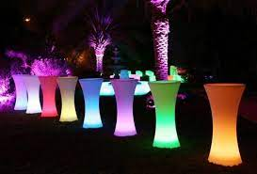
- Hamster Up Lights (Case of 10)- $60.00
- Cocktail Table Light- $10.00

Pipe and Drape
- 8’x10’ Section- $30.00
- Black or White Drape
NOTE: Other color options are an additional coast. Ask for more details.

Dinnerware, Flatware & Glassware
All dinnerware, flatware and glassware are sent out carefully cleaned, counted, and wrapped. In turn, they must be returned clean and in their original containers to avoid extra charges. Shortages or breakage (including chips) will be charged to the customer at replacement cost. Please report any shortages immediately upon receipt of items. An additional day of rent will be charged for dishes or flatware that are returned dirty.

Beverage Service
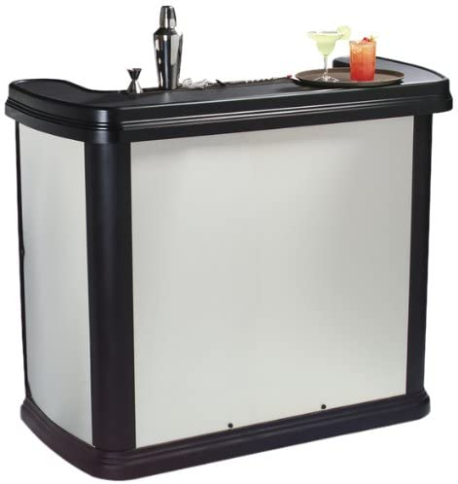
- Stainless steel portable bar- $150
- Black marble folding bar- $50.00
- Bar Stool- $4.25
- Water/Beer Pitcher- $1.50
- Silver Champagne/Wine Buckets- $15.00
- Wine carafes 1L- $1.00
- Beverage Tubs- $10.00
- Beverage Dispenser with diffuser- $15.00
- Thermal Pitchers- $2.25
- 5 Gallon Thermos- $10.50
- 2.5 Gallon Thermos - $6.75
- 10 Cup Air Pots- $7.00
- Coffee Makers 36, 55 & 100 cup-$10.00- $15.00

Serving Bowls
- Glass- $15.00
- Stainless- $12.75
- Plastic Footed- $12.75
- Cut Plastic- $9.75

Glassware *All glassware is rented out in case quantities.
- 12oz Stemmed Beer- $19.80 per 36
- 16oz Pint Beer- $12.50 per 25
- 6oz Fluted Champagne- $19.80 per 36

- Excalibur Water Glasses- $18.00 per 36
- Water Goblets- $12.50 per 25
- 9oz Lowball- $8.75 per 25
- Margarita- $4.00 per 9
- Martini- $5.00 per 9
- Mason Jar Glasses- $7.00 per 16
- 6oz Wine Glasses- $21.60 per 36
- 10oz Wine Glasses- $18.75 per 25

China *All China rented out in case quantities.
- White China Collection
- 10” Dinner Plate- $10.00 per 20
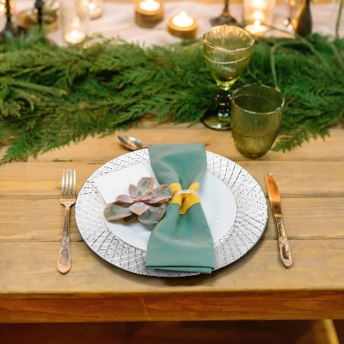
- 7” Salad plate- $8.00 per 20
- Bread and Butter Plate- $6.00 per 20
- Saucers- $4.00 per 20
- Coffee Cup- $6.00 per 20
- Bouillon Bowls- $5.00 per 16
- Pasta Bowls - $2.00 per 5
- Gold Rim Collection
- 10” Dinner Plate- $3.00 per 5
- 7” Salad plate- $2.50 per 5
- Bread and Butter Plate- $2.00 per 5
- Saucers- $1.50 per 5
- Teacup- $6.00 per 20
- Soup Bowl- $2.00 per 5
- Vegetable Bowl- $2.00 per 5

Eco Friendly Palm Leaf Plates (Purchase only) *10 day advance notice required
- 10” Dinner Plate- $12.50 per 25
- Salad Plate - $10.00 per 25
- Palm Leaf Fork 50ct. – $7.50
- Palm Leaf Knife 50ct. - $7.50

Stainless Flatware *All flatware is rented out in bundles of 10.
Chose from two flatware collections: Hammered Silver or Gold Stainless Steel

- Dinner Forks- $3.00 per 10
- Salad Forks- $3.00 per 10
- Dinner Knives- $3.00 per 10
- Teaspoons- $3.00 per 10
- Soup Spoon- $3.00 per 10
- Steak Knives- $3.00 per 10

Serving Trays
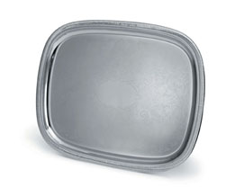
- Stainless Rectangular and Round Trays- $2.50
- Plastic Round and Rectangular Trays- $2.50
- Gold Rim Oval Platter- $2.00
- Large Gold Rim Oval Platter- $3.00
- Large Black serving Tray- $3.00
- 3-tiered Silver Serving Dish- $20.00
- 3-tiered Wood Serving Dish- $20.00

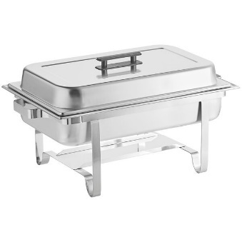
Chafing Dishes
- 8qt Rectangular Chafer- $13.00
- 8qt Divided Rectangular Chafer- $
- Round Chafer- $12.00
- Half 4qt Rectangular Chafer- $7.00
- Chafer Sterno Fuel- $2.00

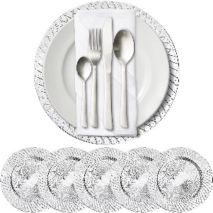
Buffett Equipment
- Charger Silver Plastic $2.00 per 5
- Charger Gold Leaf $2.00 per 5
- Serving Forks- $2.00
- Serving Spoons (slotted or non-slotted)- $2.00
- Tongs- $2.00
- Cake Knife and Serving Set- $6.00
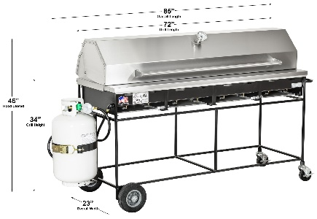
- Ladles- $2.00
- Electric Roaster- $15.00

Barbecues
- 3’x22” Charcoal BBQ- $60.00
- 5’x22” Charcoal BBQ- $80.00
- 3’x22” Propane BBQ (Includes Propane)- $150.00
- 5’x22” Propane BBQ with hood & thermometer (Includes Propane)- $220.00
- Propane powered hotplate- Single $20.00 Double $40.00
Stock Pots
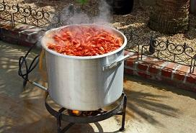
- 3 Gallon- $8.50
- 4 Gallon- $8.50
- 6 Gallon- $10.00
- 8 Gallon- $10.00
- 15 Gallon- $12.00
- 20 Gallon- $12.00

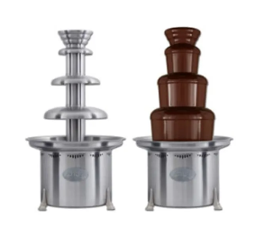
Chocolate Fountains
- Medium Chocolate Fountain- $80.00 (Includes 4lb of chocolate)
- Large Fondu Fountain (holds up to 20lb.) - $650.00
  - 6” Bamboo Skewers (100 ct.)- $1.25
  - Sephra Chocolate Melts 2lb bag - $15.00 (Dark, Milk or White)

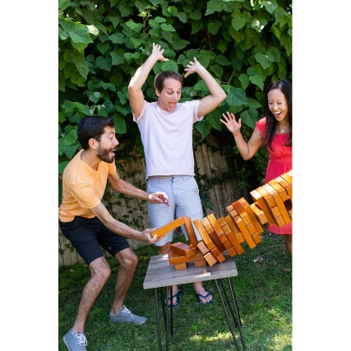
Games
- Dunk Tank- $200.00
- Raffle Drum- $10.00
- Corn Hole- $30.00
- Giant Jenga- $20.00
- Giant Connect Four- $30.00
- Tic-Tac-Toe- $10.00
- Horseshoe Game- $20.00
- Axe Throwing- $20.00

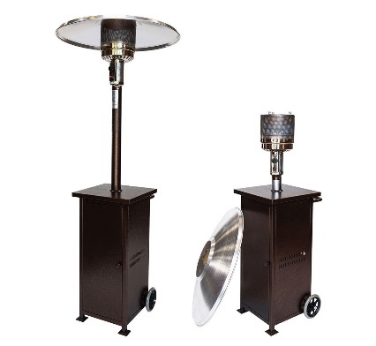
Heaters
- Patio Heaters- $75.00 (Including propane)
- Tent Heaters- $100.00 (including Propane)

Concession Equipment

- Popcorn Machine- $80.00
- Popcorn Bags (100ct)- $3.75
- Popcorn Pack with Butter- $2.25
- Snow Cone Machine- $50.00
- Snow Cone Cones (100ct)- $5.99
- Straws (100ct)- $3.00
- Snow Cone Syrup- $11.00 per gal.
- Snow Cone Syrup Dispenser- $5.00
- Cotton Candy Machine with Bubble Top- $80.00
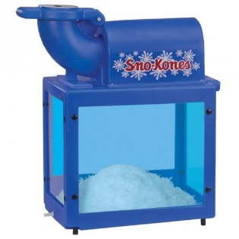
- Cotton Candy Cones (100ct)- $5.00
- Cotton Candy Floss (Half Gallon)- $12.50
- Cotton Candy Bags (100ct)- $12.99
- Nacho Cheese/chip warmer $40.00
- Nacho Cheese warmer- $20.00
- Hot Dog Roller- $25.00
- Bun Steamer -$25.00
- Slush Machine- $95.00

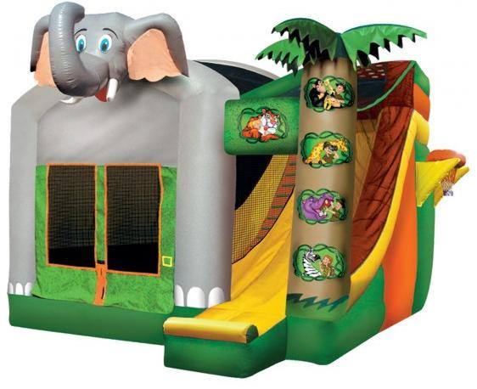
*Bounce Houses
- Crayon Jumper (ages 5 & under)- $150.00
- Castle Jumper with Slide- $200.00
- Racing Obstacle Course- $300.00
- Dual Lane Slide- $250.00
- Cinderella’s Carriage -$350.00
Jumper: | Size: | Capacity:
Crayon Jumper | 12' L x 10' W x 8' H | 300 lb.
Castle Jumper | 15' L x 14' W x 17' H | 800 lb.
Racing Obstacle Course | 12' L x 19' W x 16' H | 900 lb.
Dual Lane Slide | 25' L x 13' W x 22' H | 900 lb.
Cinderella's Carriage | 60' L x 30' W x 17' H | 800 lb.
*Most bounce houses must be delivered and assembled on
site. We ask that you schedule deliveries at least two weeks in advance.

*Dance Floors & Stages
- *Staging 4’x4’ pieces- $40.00 each (can be 1’’ - 3’ high)
  - Stage Stairs (for 2’ or 3’ high)- $20.00
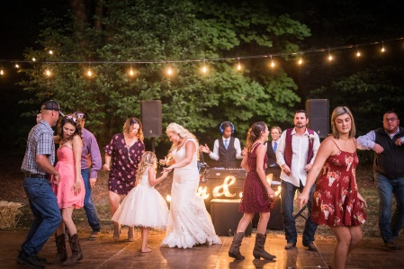
*We must assemble all stage legs before delivery. You must have the height of you stage finalized two weeks before your delivery. We absolutely can not change the height of the stage on delivery.
  - Birch 4’x4’- $20.00 each
  - Cherrywood 3’ X 4’ - $30.00 each
  - Dark Walnut 3’ X 4’- $50.00 each *NEW!
*All staging and dance floors must be delivered and assembled on site. We ask that you schedule deliveries at least two weeks in advance.

Lightweight Canopies
- 10x10 Pop Up Tent- $100.00
- 10x10 Sides- $10.00 (solid, windows, doors)

Pagoda Tents (We must deliver, set up, and take down all pagoda tents)
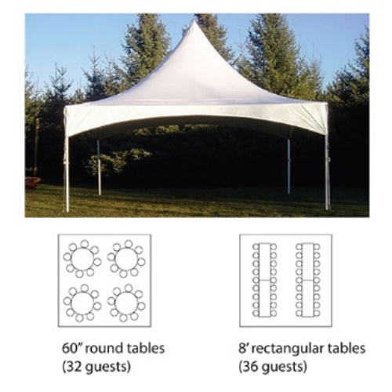
- 20x20 Tent- $400.00
- 20’x40’ Tent- $800.00
- Solid Tent Side- $50.00
- Door tent side- $50.00
- Window Tent Side- $50.00
- Halogen tent light- $30.00

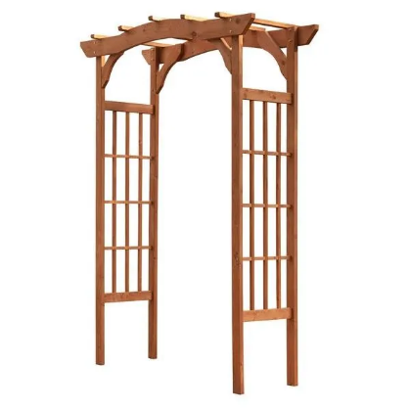
Wedding Archways
- Brass Arch- $30
- Nickel Arch- $30.00
- White Somerset Arch- $30.00
- Drapery Arch- $50.00
- Hexagon Arch- $75.00

Wedding Accessories
- White Stanchions with Chain- $4.00

- Chrome Stanchions- $5.00
- Mahogany Lectern- $20.00
- White Lattice podium- $15.00
- Wooden Easels $5.00
- Aluminum Easel- $5.00
- Coat Rack- - 15.00
- Chalk Board - $10.00
- Wooden signs- $5.00

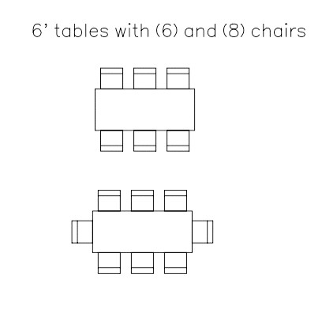
Chairs
- Brown Folding Chairs- $2.00 each
- Black Folding Chairs- $2.00 each *NEW!
- White Padded Folding Chairs- $4.00 each
- White Kids Chairs - $1.00 each
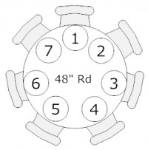
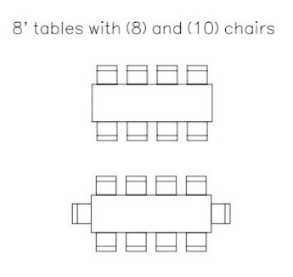
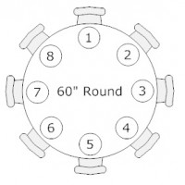

Tables
- Cocktail Tables (Either 42” Standing or 30” Sitting Height)
- 24” Round- $11.00
- 30” Round- $12.00
- 30” Square- $12.00
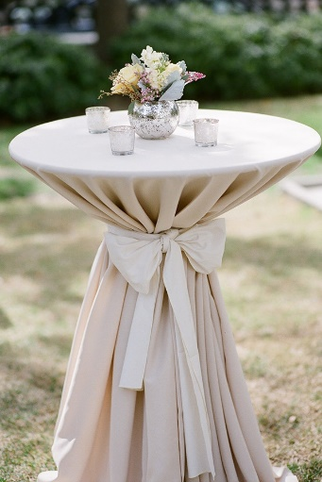
- 36” Round – 13.50
- Round Tables
- Half Round Table- $10.00 *Seats 2
- 5’ Heart Shape Table- $10.00 *Seats 6
- 3ft Round Table- $13.00 *Seats 2
- 4ft Round Table- $15.00 *Seats 6
- 5ft Round Table- $20.00 *Seats 8
- Rectangular Tables
- 6ft Rectangular Tables- $15.00 *Seats 6-8
- 8ft Rectangular Tables- $20.00 *Seats 8-10
- 6ft x 1½ Conference Tables- $10.00
- 6’ Kids Table - $10.00
- 8’ Kids Table - $10.00

Table Linens *This pricing is for solid colored polyester linens. Pricing will be higher for all other fabrics. Please visit our website to see our full linen selection.
- 20”x20” Napkins- $.80 each
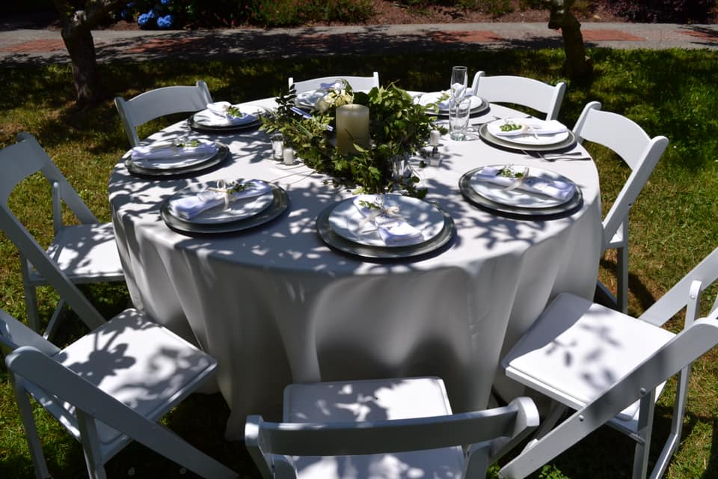
- 90”x132”- $25.00 each
- 90”x156”- $25.00 each
- 60”x120”- $11.00 each
- 90” Round- $12.50 each
- 108” Round- $15.00 each
- 120” Round- $17.25 each
- 54” Square- $7.25 each
- 72” Square- $8.50 each
- Table Skirts- 24.00 each
- Chair Covers Round or Square Back (Whi/Blk/Ivo)- $4.50
- Chair Sash- $3.50
We primarily sub-rent our linens. To do this, linen orders must be placed at least 2 weeks in advance of your event date. Standard shipping charges are included in the prices above, if any orders need to be rush shipped, additional charges will be added.



