ANNUAL REPORT 2023

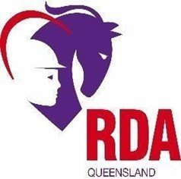

RIDING FOR THE DISABLED ASSOCIATION OF
QUEENSLAND INCORPORATED

Riding Develops Abilities

ABN: 985 824 305 76

MISSION

To support member centres to provide high quality,
safe, therapeutic equestrian activities to
people living with disability designed to improve quality of
life, develop life skills and attain personal goals.

VISION

RDAQ member centres across Queensland have the knowledge,
skills and resources they need to consistently provide high quality,
safe, therapeutic equestrian activities to
people living with disability in their community.

VALUES

Empowerment
Ongoing Improvement

Respect for Diversity

Inclusiveness

Quality services

Contents

Chair report to centres ……………………………………….… 3
About us …..………………………………………………………… 5
RDAQ Board Member ……………………………………….. 6
Our members ……………………………………….……………. 7
Our Volunteers …………………………………….……………… 8
Our Horses …………………………………………………….…… 9
Key Achievements …………………………………………….… 10
RDAQ State Championships ………………………………… 12
Financials …………………………………………………………… 14
Acknowledgements ……………………………………………. 15

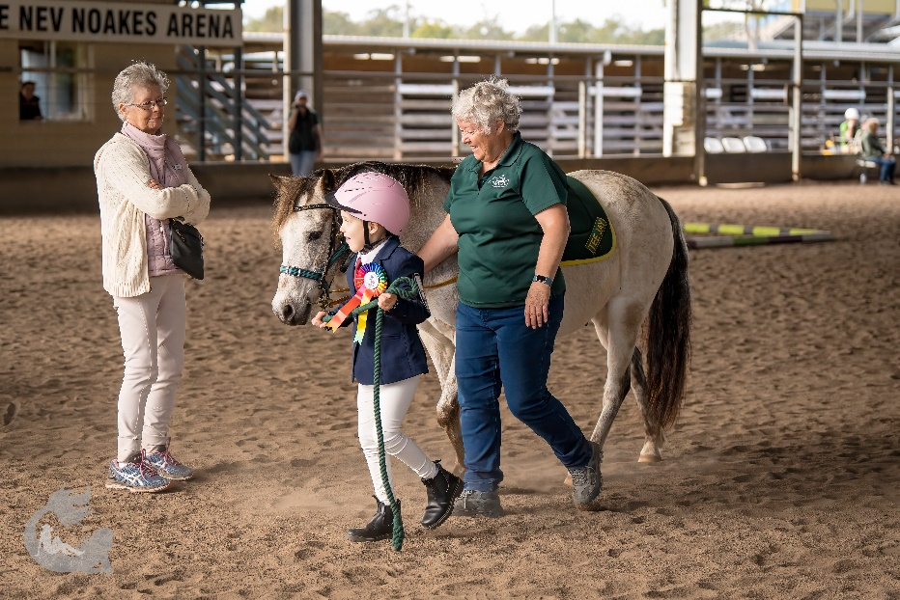
CHAIR REPORT TO CENTRES
Developing processes with the restructured RDAQ board to better meet the needs of affiliated member centres.
The board was re-structured 2 years ago so that individual Board Members are encouraged to deal more closely with issues and requests allied with their nominal position. This involves developing networks and finding resources for areas such as Riders (Talent Pathways etc), Coaches (Improving Accessibility to Coaching, answering Coaching Questions), Horse Welfare and Volunteers. This structure is working well.
Increased number of annual regional workshops to be more accessible to regional member centres

This year 3 Regional Workshops were held in Maryborough, Rockhampton and Gold Coast and all were well attended. These were attended by more volunteers and riders than in previous years which have generally been coach dominated.
Coordinated 6 Centre Accreditations and 11+ assessments

One of the major tasks of RDAQ is to coordinate the assessment of Coaches and to help Centres to achieve accreditation. Di and several Board members have spent considerable time in this last year helping centres to meet criteria and assisting them to deal with issues and conflicts as they arise.

RDAQ also acts as a conduit for information from the National RDAA and sometimes boosts information to RDAA from the Centres. 2023 has been a year of huge changes in RDAA. Board Members spend time trying to follow changes that are happening and helping Di to translate this to information and/or resources that we all can use. This has also necessitated the continuing development of database with increasing information for reporting to RDAA and other bodies.

Securing ongoing grant funding with timely reporting

Once again, significant Grant Funding has been secured for the next year to allow for the continuation and improvement of the processes listed above. To acquire this funding, reporting need to be detailed and documented so please, when Di asks for information, make sure she gets it.
Collection and categorisation of Policies and Procedures

This year has seen an audit of all Policies and Procedures so that these can be more easily correlated with changes made at National level or legislated.
Event planning and coordination of State Championships
Our First live Championships since 2019, which was very well attended, and which gave our riders a chance to interact with other centres and riders as well as seeing some high-level coaching in action.

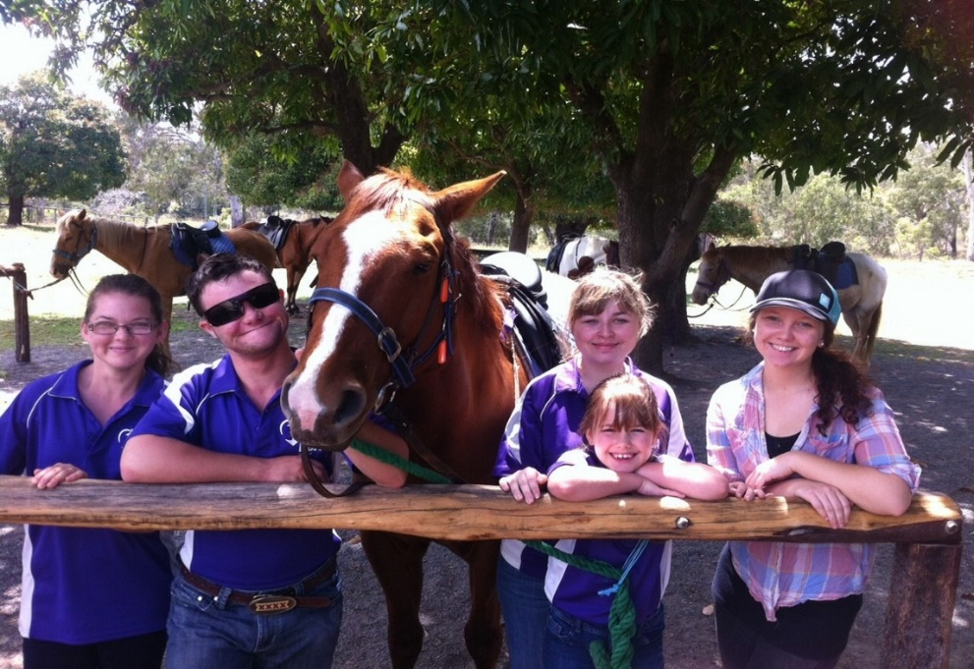

A BOUT US
RDAQ is a registered not for profit incorporated association and is registered as a disability sports charity. The organisation reports to, and is bound by the requirements of, the Australian Charities and Not-for-Profits Commission; the Queensland Office of Fair Trading; and the Riding for the Disabled Association of Australia (RDAA).

The RDAQ Board and State Office provide advocacy, leadership, professional Development, resources, competition, and training opportunities as well as accreditation and administrative support to all affiliated Riding for Disabled Associations (RDA) in Queensland (members). All RDAQ member centres, their coaches, and volunteers are covered by Public Liability insurance held by RDAA.
RDAQ works closely with the RDAA Executive to develop policies and procedures that reflect the changing needs of its members, their volunteers, and the people with disability who use their services. RDAQ advises its members on relevant national policies and accreditation standards for rider health and safety, horse welfare, coach and volunteer training, and centre management. RDAQ collaborates with government agencies and industry representatives to raise awareness of the work of RDAQ and to secure support for its members. RDAQ secures and reports on recurrent and one-off funding to achieve its objectives as detailed in the Rules of the Association.

The facilities, resources, and their coaches of all RDAQ members must continue to meet strict RDAA accreditation standards. All affiliated members deliver unique equine-assisted services designed to build self-esteem, confidence, skills and joy in people living with disability, aged from 3 years. Those who do not wish to ride may still benefit from time spent just being with one of the RDA specially selected horses. Horses can help build trust, joy, and a sense of calm. With a horse you can live in the moment! Disabilities can happen to anyone at any stage of life. The causes of disabilities are many. They include, but are not limited to, complications of pregnancy; congenital anomalies; injury or trauma; and mental illness and behavioral disorders.
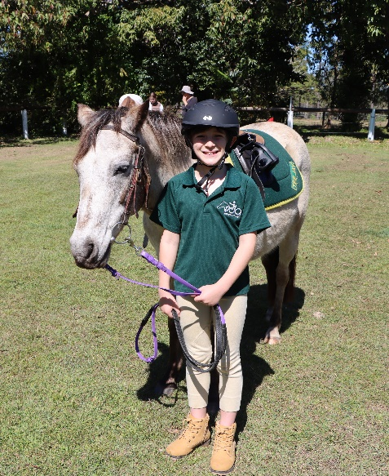
Seven per cent of children aged under 15 years, and fifteen per cent of people aged 15 to 64 years have one or more disability. One in three (32%) people with a disability have severe or profound disability.

Currently there are 270 children and adults living with disability benefiting from the services offered by RDAQ members.
RDAQ is focussed on removing barriers to grow this number and enable more disabled people to access accredited RDA services in their communities throughout Queensland.
RDAQ recognises a ‘Disability’ as ‘any condition that restricts a person’s mental, sensory and or mobility functions. It may be caused by accident, trauma, genetics or disease. A disability may be temporary or permanent, total or partial, lifelong or acquired, visible or invisible’.
RDAQ BOARD MEMBERS
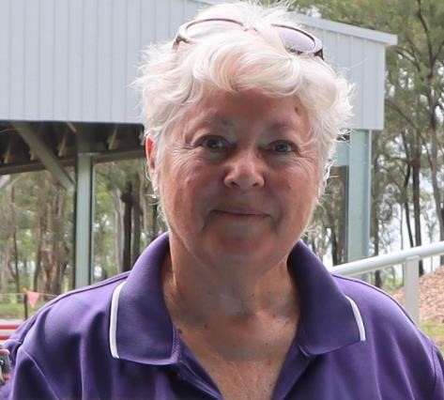
Robyn Mapp
Volunteer Representative
Robyn is an accredited Level 1 Coach and is Treasurer of the Hervey Bay RDA. In 2022, Robyn was awarded the RDAA Volunteer of the Year Award.
Robyn has extensive experience in supporting volunteers in the community
Maggie Rippey,
Coach Representative
Maggie is an accredited Level 1 Coach and Secretary of the Maryborough RDA. Maggie is an active member of the RDAA Program Development Committee
In 2021, Maggie was awarded the RDAA National Michael Field Memorial Award.
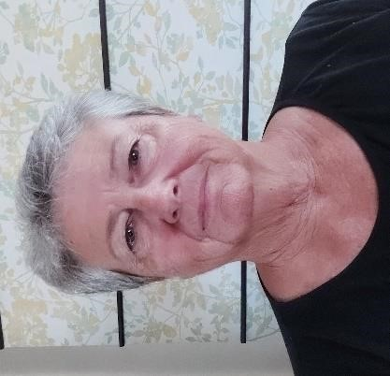
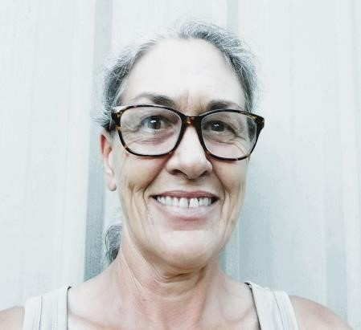
Kellie Davies
Horse Welfare Representative
Kellie is an accredited Level 1 Coach and is the Horse Manager at the Maryborough RDA.

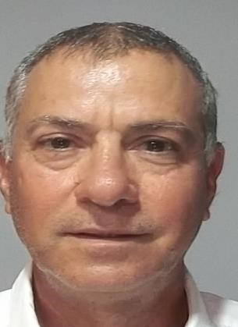
Boaz Bernstein
Consumer representative (Riding)
Boaz is an Assistant Coach and Vice President of the Hervey Bay RDA.
Boaz has international experience in management
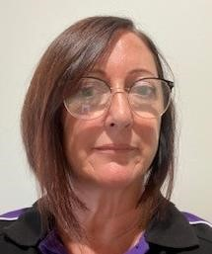
Diana Adderley
Governance representative

Diana is a non-voting member of the RDAQ Board. Diana holds a Certificate in Stable Management & Horse Riding (UK).
Diana also has worked for several years in business administration and management

OUR MEMBERS
There are 14 accredited Riding for the Disabled Associations registered as financial members of RDAQ.
They range from very small centres in remote locations to large multi-service organisations in metropolitan Brisbane. Most RDAQ members are independent, incorporated associations run by an elected management committee of local volunteers.
The majority depend on local sponsorship, fund-raising, donations, grant funding, and the incredible support of community members to keep fees as low as possible while ensuring safety and horse welfare standards are met. One has joined with a major disability support provider to offer a mixed funded model to clients.
NORTHERN QLD
GEMFIELDS
MACKAY
ROCKHAMPTON
TOWNSVILLE

CENTRAL AND WIDE BAY
BUNDABERG
HERVEY BAY
MARYBOROUGH
P.E.N.D.E.R.
SAMFORD
MARYBOROUGH
IDE BAY
BUNDABERG
HERVEY BAY
MARYBOROUGH
TOWNSVILLE

SOUTHERN QLD
LOCKYER VALLEY
TOOWOOMBA
WARWICK
CROWSON PARK
VALLEY

VALLEY
TOWNSVILLE

OUR COACHES

Volunteers at all RDAQ member centres must undertake comprehensive training and assessment to be registered as an RDA Centre Coach.
RDAA provides training to RDA coaches through an accredited training system in three progressive stages:
Level O
assistant Coach
Level 1
accredited coach
Level 2
Accredited Advanced Coach

RDA volunteers can apply to become an Assistant Coach from the age of 15 years and must be 16 years of age before completing the qualification.
The Assistant Coach course is designed to develop the skills and knowledge to support the RDA Centre Coach to deliver group lessons that are safe and free flowing in an enclosed area. It introduces teaching foundation riding skills, an awareness of adaptive coaching for people with disabilities and best practice horse handling and horse management skills.

The Centre Coach course is designed for candidates with a foundation knowledge of horse-riding skills, experience working safely around horses, an aptitude for coaching and for working with people with disabilities, and a demonstrated ability to work within and lead teams. Applicants for Centre Coach must be over 16 years of age and 18 years of age before completing the qualification. They must also be able to demonstrate horse riding skills at Walk, Trot and Canter.
RDAQ members can support people with disability to participate in a range of equestrian sports through the commitment and expertise

OUR VOLUNTEERS
During 2023, our members could offer a range of horse-assisted programs because of the dedication and support of 459 volunteers. To volunteer at an RDAQ member centre you must be aged over 12 years and hold a current Blue Card. Volunteers play a vital role in enabling centres to offer safe, affordable services. Duties and activities include record keeping and administration, facilities and pasture maintenance, rider preparation, media and marketing, public speaking and promotion, fund-raising, and assisting the coaches during lessons…..the list is long! Without volunteers the RDAQ members could not operate.
Many RDA volunteers go on to careers in the health, disability, education, and equestrian sectors. Some choose to undertake additional study to become a nationally accredited RDAA coach.

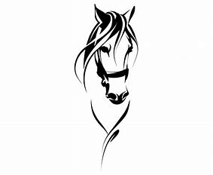
OUR HORSES

RDAQ centres have 85 horses with 5 supported by The Queensland Off-The-Track (QOTT) grants programme.

The Queensland Off-The-Track (QOTT) Grants Program supports not-for-profit organisations, charities and businesses that provide equine rehabilitation or retraining services, or second careers for retired racehorses, including as therapy horses.

QOTT Business Expansion Grant

The QOTT Program is committed to supporting Queensland equine businesses to expand the number of retired racehorses used to deliver core business services and increase the breadth of career options available for retired racehorses on a sustainable basis.

QOTT Therapy Horse Grant

The QOTT Program is committed to supporting not-for-profit organisations and charities that utilise retired racehorses as therapy aids for core service delivery.

Successful organisations are awarded funding to assist with increasing the number of retired racehorses used in their therapy programs and/or for costs associated with veterinary treatment, professional farrier services and/or feed for retired racehorses that are utilised as therapy aids to deliver core services for the organisation.

Successful RDAQ grant recipients for the “QOTT Therapy Horse Grant” in 2023:
- Riding For Disabled Association Hervey Bay
- Valley Riding Develops Abilities
- Gemfields Riding The Disabled

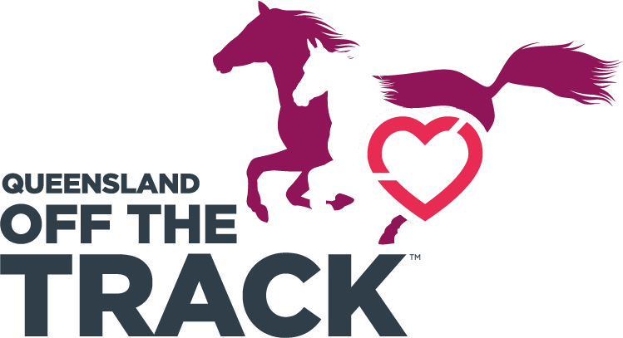

KEY ACHIEVEMENTS 2023
REGIONAL WORKSHOPS

In 2023 workshops were held in 3 Queensland regional locations: Valley RDA (Tallebudgera Pony Club), Maryborough (Maryborough Showgrounds) and Rockhampton (Rockhampton RDA) with a total of 87 participants. Volunteers, riders and coaches from 11 centres attended sessions on :
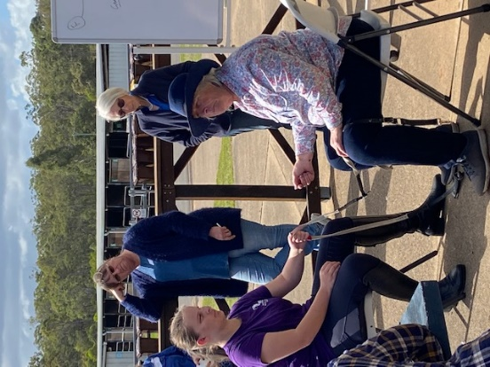
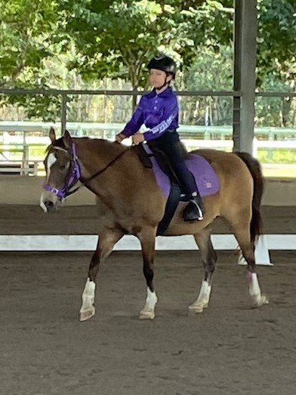
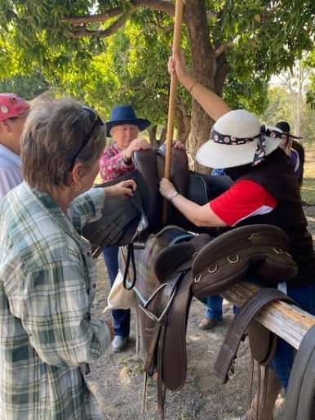
Fitting saddlery and horse health
How to train riders for
accuracy in dressage tests
The importance of Rein control

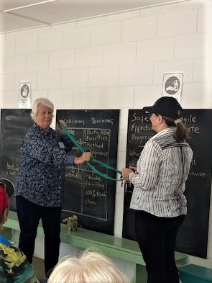
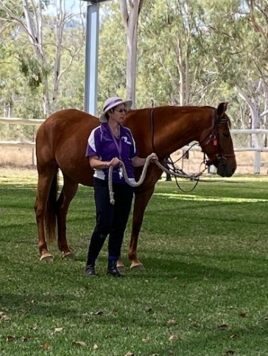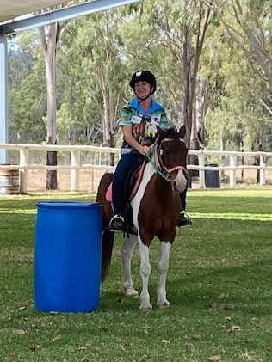
The Square of Teaching Leading a horse correctly ‘Riding with Joan’
and volunteer training

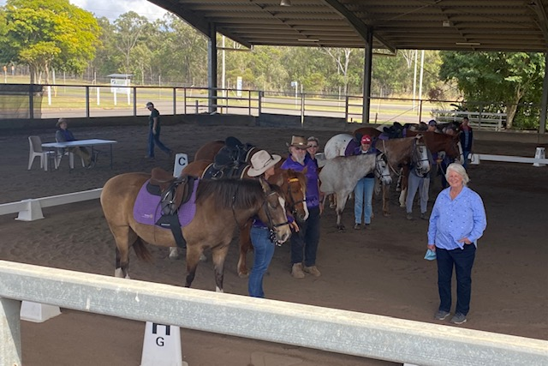
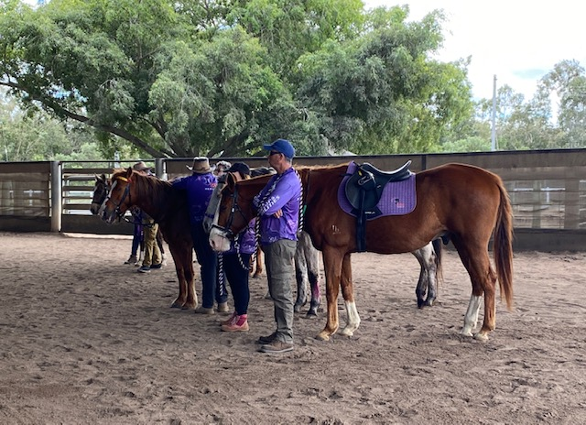Horses Health Developing rider’s goals and Lesson planning

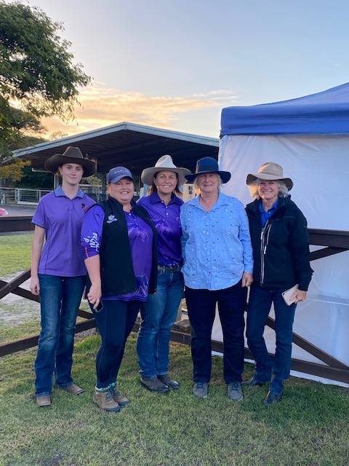

5 trainee coaches were accredited as level O coaches and are now working towards their Level 1 accreditation
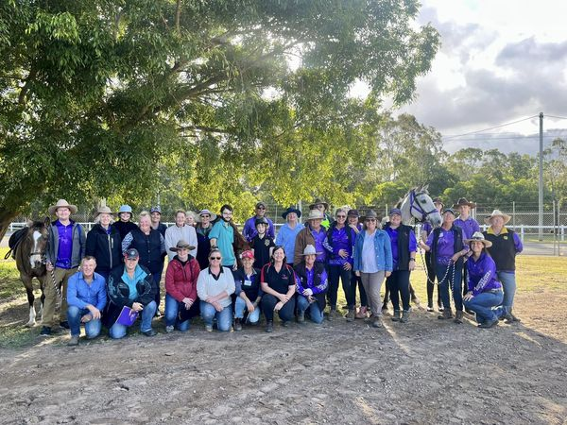
RDAQ STATE CHAMPIONSHIPS 2023
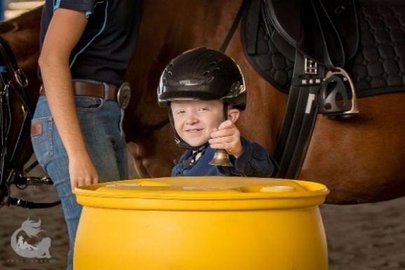
Thirty-two (32) riders from six (6) affiliated centres travelled to compete in the 2023 State Championships held at the Maryborough Showgrounds in early August.

The Championships are designed to enable riders and non-riders, from RDAQ member centres, to showcase their horsemanship abilities in a competitive and supportive environment. While the events are run under the RDAA Test Booklet 2015 and the Para Equestrian Test: Equestrian Australia Dressage Rules the focus was on inclusion participation, and fun! The championships were judged by international Judy Carsley and Beryl Burkhardt.

This free two-day event is the only state level competition designed specifically for disabled equestrians in Queensland. The event is one part of a multi-strategy approach by RDAQ and RDAA to create pathways for disabled riders to the Special Olympics and the Para Olympics. To enable as many athletes to participate as possible, RDAQ also provided financial support for those who had to travel from across Queensland.

Equestrians and their supporters from the Lockyer Valley, Rockhampton, Bundaberg, Mackay, Harvey Bay, and Maryborough all took the opportunity to participate in Dressage, Working Trails, Handy Pony Obstacle and Team Fancy Dress events. Both Riden and Led events were included in the program to ensure that all equestrians could be recognised for their champion abilities.

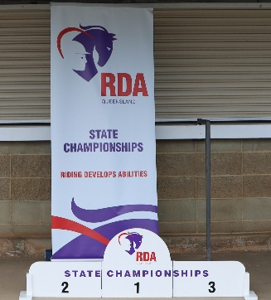
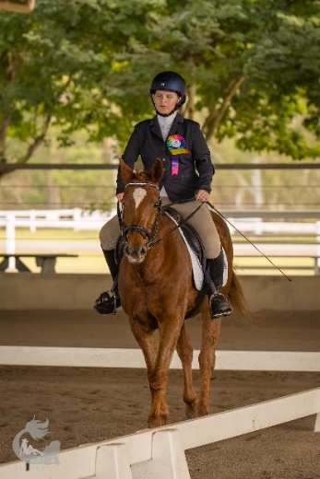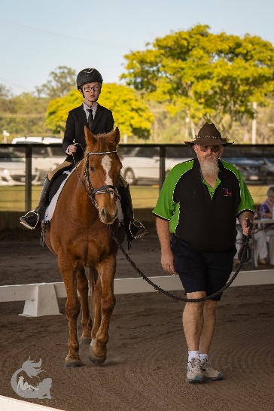

Competition Results
RDAQ/SHCQ Perpetual Trophy
1st place - Adria Edwards (Hervey Bay RDA) with a score of 75.75%
2nd place: Matt McLachlan (Rockhampton RDA) with a score of70.75%
3rd place: Sienna Cocks (Maryborough RDA) with a score of 69.18%
Horse and Rider Turnout – Dressage : The horse, rider, side walkers/leader deemed by the judges to be best in appearance (best turned out), as a team and following the dress code was awarded to
Chloe Black riding Carlie (Bundaberg RDA)
Horse and Rider Turnout - Working Trails: The horse, rider, side walkers/leader deemed by the judges to be best in appearance (best turned out), as a team and following the dress code, was awarded to Zachary Fairley on Teddy (Lockyer Valley RDA)

Golden Lead Rope Award : The horse leader deemed by the judges to be working in harmony with the horse and providing the rider with the opportunity to display their riding skills to the best of their ability was awarded to Terry Dingle from the Lockyer Valley RDA

Mary Longden award for the Most Giving Horse was awarded to Snow from the Maryborough RDA
Fancy Dress winners: Hervey Bay Hogwarts School of Witchcraft and Wizardry.

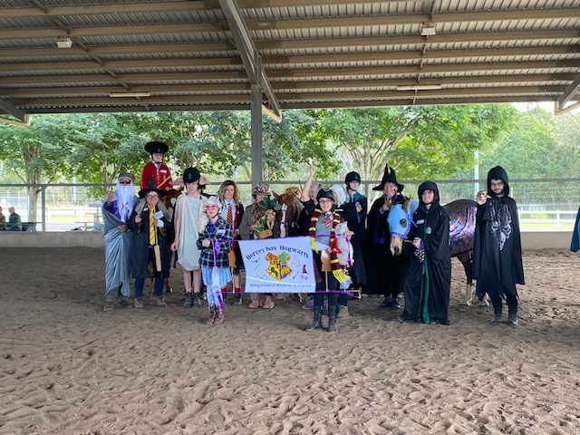

FINANCIALS

Revenue/receipts

Revenue from government including grants | $86,000
Donations and bequests | $20,694
Revenue from providing goods or services | $45,481
Revenue from investments | $0
Other revenue/receipts | $6,702
Total revenue/receipts | $158,877
Other income (for example, gains) | $0
Total income/receipts | $158,877

Expenses/Payments

Employee expenses/payments | $66,300
Grants and donations made for use in Australia | $0
Grants and donations made for use outside Australia | $0
Other expenses/payments | $118,581
Total expenses/payments | $184,881
Net surplus/(deficit) | -$26,004

Balance Sheet Extract

Total assets | $208,096
Total liabilities | $6,045
Net assets/liabilities | $202,051

ACKNOWLEDGEMENTS AND THANK YOU

Donors
Greg Grant Saddlery not only donates prizes es to the RDAQ State Championships, they also offer our affiliated members a substantial discount on all products and equipment throughout the year.
Kohnke’s Own provides our members with horse nutrition products and supplements and are a source of advice about the best nutrition regimen for the RDA herd.

Grants and funding
The Queensland Department of Sport and Recreation provides the funding that enables the Association to offer disabled children and adults access to equestrian sporting and recreational activities that are available to other members of the broader community.

HOW YOU CAN HELP
We would welcome an opportunity to discuss how you, or your organisation, can make a difference to the lives of children and adults living with disability in Queensland.
You could….
- Nominate to become an RDAQ Board member.
- Become a corporate partner.
- Offer our members a discount on horse products, equipment and or services (veterinary, farrier, saddler)
- Donate funding to support an activity of your choice.
- Leave a bequest.
- Sponsor a competition or talent development event.

Great things are done by a series of small things brought together. …great things are never done by one person. They're done by a team of people” Steve Jobs
To find out more about the rewarding work of RDAQ go to www.rdaq.org.au or contact us.

CONTACT DETAILS
Phone: (07) 3408 6942
Email: admin@rdaq.org.au
Postal Address: PO Box 1013, Bongaree, QLD, 4507

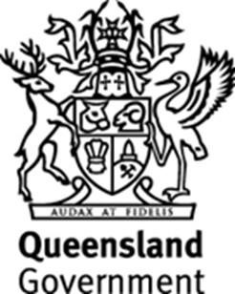


Equine Nutrition Supplements for Health

