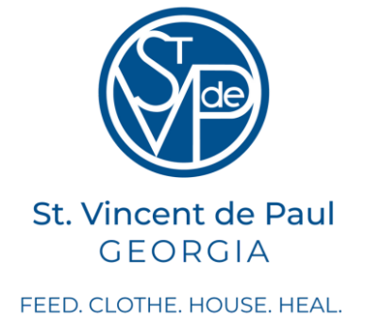
St. Vincent de Paul / St. Lawrence Conference
The Year for Help – 2024-2025
Fiscal Year: October 2024- September 2025 - Summary
SVdP helped over 700 Neighbors in need with 238 visits from our Vincentian members.
We received on average 250 calls/month of those who are desperately in need of financial help but also compassion, understanding, and prayers during their struggles in life. We sincerely wish that we were able to help each and every one.
Our Vincentian volunteers are truly the hands and feet of Christ sharing their love of God with our Neighbors while walking side by side in their troubles.
We serve single mothers, children, fathers, the elderly, homeless, medically fragile people and families who have lost a loved one and don’t know how to pay for the funeral. We help women dealing with catastrophic medical bills after treatment for cancer, fathers whose brakes went out leaving him unable get to work without repairs, mothers needing to pay for daycare so they can go to work to support their families, and seniors who live on a fixed income and can’t afford to buy their medications and also pay their rent. We help grandmas who are raising their grandchildren pay for food and clothes/shoes for school. We help families who are living without basic necessities such as gas, electric, and water while spending their only income on rent to keep a roof over their heads. We help a mother who is critically ill with major cardiac issues get medical treatment and receive medications from our SVdP pharmacy.
Each Neighbor receives individual care from a caseworker who helps the Neighbor. They truly help in so many ways: paying bills, giving additional resources for their help, and just being a compassionate friend who listens and prays with them.
We aren’t always able to help Neighbors financially, but we pray for all who do call the Help Line. This past year since we have gotten so many calls that we have been unable to call back all who call and complete a Help Line form. That is why we are in search of more parishioners who would like to join our ministry to help. Many times, people are afraid to join St. Vincent de Paul, thinking they have to be a caseworker, but we have many other jobs which can help all these Neighbors in need in our community.
You could work from home on your phone and answer the calls, sharing this vital job with other Vincentians. The only requirement for this job is to have a phone and a heart full of Jesus and be willing to listen and share with our Neighbors. You could help with our Angel Tree program each Christmas season, or help deliver food from the Lawrenceville CO-OP, Our Food Partner, to families without a car. If you don’t mind driving, you could pick up diapers, feminine products, and baby formula from Helping Momas and bring them back to church for the caseworkers to give out to our Neighbors. You could help Pat; our Resource Coordinator, update the list of resources available in Gwinnett and post updates to the Saintlaw.org website.
Our Mission is “A network of friends, inspired by Gospel values, growing in holiness and building a more just world through personal relationships with and service to people in need.” You may ask how does the Society of St. Vincent de Paul differ from other charitable organizations? We are composed of women and men who seek personal holiness through works of charity: “We don’t provide transactions; we create and nurture relationships.”
We are able to do this because our Vincentians have accepted the call from Jesus to care for the poor. St. Vincent de Paul said, “Go to the poor; you will find God.”
In our last fiscal year, the Parishioners of St. Lawrence provided our ministry funds for the Neighbors in Need in our community of Lawrenceville and Dacula. Over $143,000 donations helped pay for Direct Aide. This, coupled with funds from the SVdP Thrift Store and Community Service grants provided:
- Rental Assistance with Eviction Prevention: > $87,000
- Utilities: > $100,000
- Temporary Lodging: > $16,000
- Transportation (car payments, repairs, insurance): > $13,000
Our Conference Vincentians spent about 7000 hours and drove 3300 miles during the past year.
Know that you are invited to our monthly meetings, the second Monday of each month in Cogswell Hall. We first share food and socialize together and follow with a meeting to review our past month work and make plans for upcoming activities in our ministry.
Check out the bulletin, weekend slides at Mass, and the Narthex news each month.
Upcoming Event for St. Vincent de Paul / St. Lawrence
You all are invited to The Meet and Greet for SVdP!
Date: April 14
Time: 7pm
Place: Slow Pour Brewing Company, 407 N. Clayton St. Lawrenceville
Enjoy food, drinks, fun and get to know some of your fellow parishioners who are “Vincentians”

