St. Lawrence High School Youth Ministry Life Teen & Confirmation ~ 2025-26 Calendar Wednesdays ~ 6:00-7:30 PM
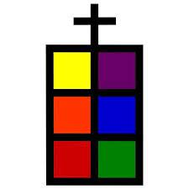

AUGUST
20 Parent and Teen Meeting
27 Session

SEPTEMBER
3 Session
10 Session/Year 2 Parent Meeting
17 Session
24 Session

OCTOBER
1 Session
8 No Session – Fall Break
15 Session/ Year 2 Parent Meeting
22 Session
24-26 Retreat for Year 2 Teens
29 Session

NOVEMBER
5 Session
12 Session/ Year 2 Parent Meeting
19 Session
26 No Session – Thanksgiving Break

DECEMBER
3 Session
10 Session/ Year 2 Parent Meeting
17 Advent Penance Service - 7pm 24/31 No Session – Christmas Break

JANUARY
7 Session
14 Session/ Year 2 Parent Meeting
21 Session
28 Session

FEBRUARY
4 Session
11 No Session - Winter Break
18 No Session - Ash Wednesday
25 Session

MARCH
4 Session
11 Session/ Year 2 Parent Meeting
18 Session
25 Session

APRIL
1 No Session – Holy Week
8 No Session – Spring Break
15 Session/ Year 2 Parent Meeting
22 Session
29 Last Session for Life Teen

MAY
- Rehearsal
- Holy Sacrament of Confirmation

Questions? Elizabeth Chinery, 770-963-8992 x 445, or echinery@saintlaw.org

Parent meetings are required for Year 2 Confirmation parents/guardians.

