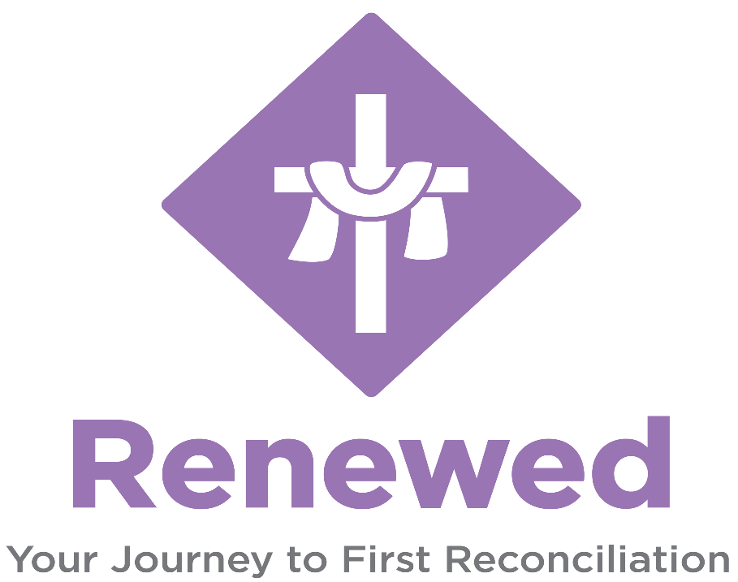
Fall 2026

August 23: Welcome back! Required Parent Meeting + Chapter 1.1
August 30: Chapter 1.2
September 6: Labor Day Weekend – NO CLASS
September 13: Chapter 2.1
September 20: Virtus Session/Chapter 2.2
September 27: Chapter 3.1 + 3.2
October 4: Chapter 4.1
October 11: Fall Break – NO CLASS
October 18: Family Prayer
October 25: Chapter 4.2
November 1: Chapter 5.1
November 8: Chapter 5.2
November 14: First Reconciliation Retreat 10AM-2PM
November 15: Family Prayer
November 22: Thanksgiving Break – NO CLASS
November 29: Thanksgiving Break – NO CLASS
December 5: First Reconciliation Day 1PM
December 6: Chapter 6.1
December 13: Chapter 6.2
December 20: Christmas Break – NO CLASS
December 27: Christmas Break – NO CLASS

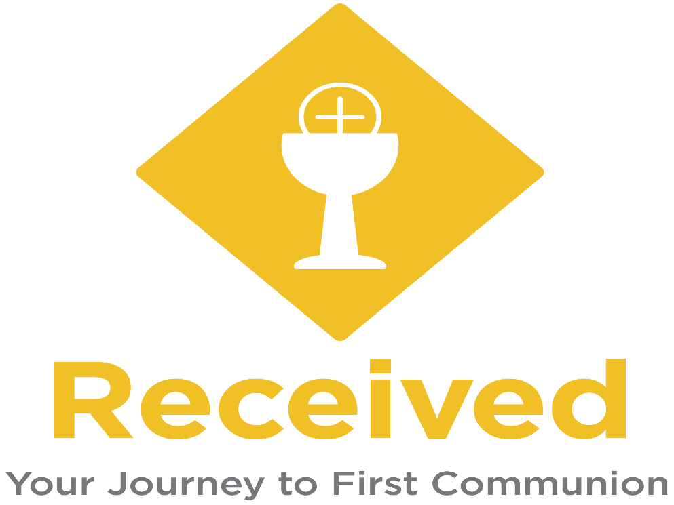
Spring 2027

January 3: Christmas Break - NO CLASS
January 10: Family Prayer
January 17: MLK – NO CLASS
January 24: Chapter 1.1 + 1.2
January 31: Chapter 2.1
February 7: Chapter 2.2
February 14: President’s Day – NO CLASS
February 21: Family Prayer
February 28: Chapter 3.1
March 7: Chapter 3.2
March 13: First Communion Retreat 10AM-2PM
March 14: Chapter 4.1 + 4.2
March 21: Palm Sunday – NO CLASS
March 28: Easter Sunday – NO CLASS
April 4: Spring Break – NO CLASS
April 11: 5.1 + 5.2
April 14: First Communion Rehearsal (Time TBD)
April 17: First Communion Day!
April 18: Chapter 6.1
April 25: Chapter 6.2

