


OD Agenda
COPE Approved CE
Wednesday, July 15, 2026
12:30pm Registration table open

1:00-2:00pm “9 KPIs for a Comprehensive Practice” COPE#104013-PM
Dr. Chris Wolfe

2:00-3:00pm “4 Billing and Coding Changes You Can Make Tomorrow to Improve Your KPIs” COPE#104014-PM
Dr. Chris Wolfe

3:00-3:30pm Break

3:30-4:30pm “Worried About Audits? You Should Be but Not for the Reason You Are” COPE#104015-EJ
Dr. Chris Wolfe

4:30-5:30pm “Practical Implementation of ERG into a Comprehensive Practice” COPE#99023-GO
Dr. Chris Wolfe

6:00-9:00pm Night at the Museum sponsored by InMode
Enjoy light refreshments and time to explore the Buffalo Bill Center of the West

Thursday, July 16, 2026
7:00am Registration table open

8:00-9:00am “Cranial Nerve Palsy Update for the Primary Care OD” COPE#104044-NO
Dr. Chris Wolfe

9:00-11:00am “Neuro-Ophthalmic Update for the Primary Care OD” COPE#104046-NO
Dr. Chris Wolfe

11:00-12:00pm “Ocular Surface Disease: A Differential Diagnosis” COPE#104045-TD
Dr. Chris Wolfe

12:00-1:30pm Lunch on own or WOA membership meeting

1:30-2:30pm “Nutrition for the Young and the Not So Young” COPE#102566-PH
Dr. Pinakin Davey

2:30-3:30pm “Cool Things About Carotenoids and Ocular Nutrition” COPE#104316-PH
Dr. Pinakin Davey

3:30-4:30pm “Glaucoma: When the Angle is Not Wide Open”. COPE#101662-TD

4:30-7:00pm Exhibit Hall-Appetizers and Drinks

Friday, July 17, 2026
7:00am Registration table open

7:00am Breakfast sponsored by Lenz

8:00-10:00am “Glaucoma- Advances and Updates” COPE#104069-GL
Dr. Pinakin Davey

10:00-11:00am “Glaucoma Medical Management” COPE#102570-GL
Dr. Pinakin Davey

11:00-12:00pm “Glaucoma Surgical Management” COPE#102571-GL
Dr. Pinakin Davey

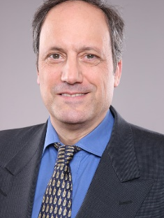
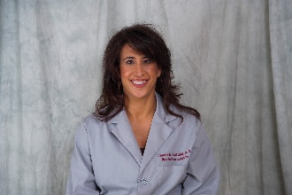
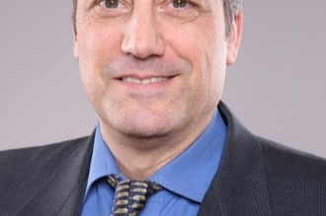
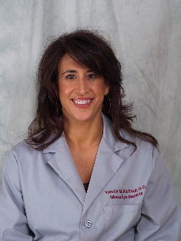
12:00-12:30pm AOA

12:30-2:00pm Exhibit Hall-Lunch

2:00-4:00pm “Modern Day Diabetes” COPE#101692-SD
Dr. Jeffry Gerson

4:00-5:00pm “The Art of Optometry” COPE#101696-GO
Dr. Jeffry Gerson

Saturday, July 18, 2026
7:00am Registration table open

8:00-10:00am “AMD: Charting a Better Patient Experience” COPE#101694-TD
Dr. Jeffry Gerson

10:00-12:00pm “Retinal Findings with Systemic Disease” COPE# Pending
Dr. Jeffry Gerson

