Sponsorship & Exhibit Opportunities
Exhibit Hall Booth- $1000
- Skirted table & Electricity
- Booth registration for 2 company representatives
Exclusive Name Badge Sponsor with Company Logo- $1000
- Company logo on all attendee name badges
Exclusive Lanyard Sponsor with Company Logo- $1000
- Company logo on all attendee lanyards
Exclusive Tote Bag Sponsor with Company Logo- $2000
- Company logo on all attendee tote bags
Attendee bag stuffers-$250
- Company materials or swag for all attendee tote bags
Exclusive Coffee Break Sponsor- $2000
- Company logo on event sponsor sign during all breaks
- Company logo on event promotion materials
- Company logo on disposable cup collars on all breaks
Snack Break Sponsor-$2000
- Company logo on event sponsor sign during all breaks
- Company logo on event promotion materials
- Company recognition from the podium prior to the break
Breakfast Buffet Sponsor-$3000
- 10 minutes of promotional speaking time to all attendees prior to breakfast
- Company logo on event sponsor sign during breakfast
- Company logo on event promotional materials
Advertising in Promotional Conference Program
- Full page color inside Ad- $500
- Half page color inside Ad- $250

BOOTH SET-UP & BREAK DOWN
You will be responsible for the set up and break down of your booth and all materials. NROC and the Holiday Inn will be onsite to assist in providing directions for booth locations and answer questions. You will receive a map with booth assignments when you arrive. NROC or the Holiday Inn will not be responsible to help load in or out your booth materials or equipment. If you have materials shipped or concerns about heavy equipment please make arrangements directly with the Holiday Inn.
EXHIBIT STORAGE
If you will require assistance with transportation and/or storage of freight, you are responsible for making the necessary arrangements through the Holiday Inn. NROC will not be responsible for your materials or equipment while exhibiting during our Convention.
To make shipping, set up, or storage arrangements:
Holiday Inn
C/O Cheyenne
1701 Sheridan Avenue
Cody, WY 82414
307-587-5555

Exhibit Hall Times
Thursday, July 16, 2026
1:00 pm- 3:30 pm Set Up
4:30pm- 7:00pm Exhibit Hall Open

Friday, July 17, 2026
12:00pm-2:00pm Exhibit Hall Open

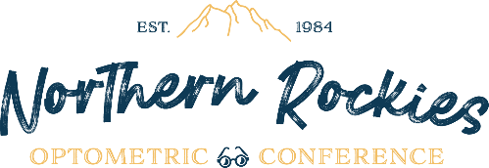
Questions? Please reach out to:
Kari Cline
Executive Director, Northern Rockies Optometric Conference
director@nrocmeeting.com

