T R I N I T Y E P I S C O P A L C H U R C H
B A T O N R O U G E , L O U I S I A N A

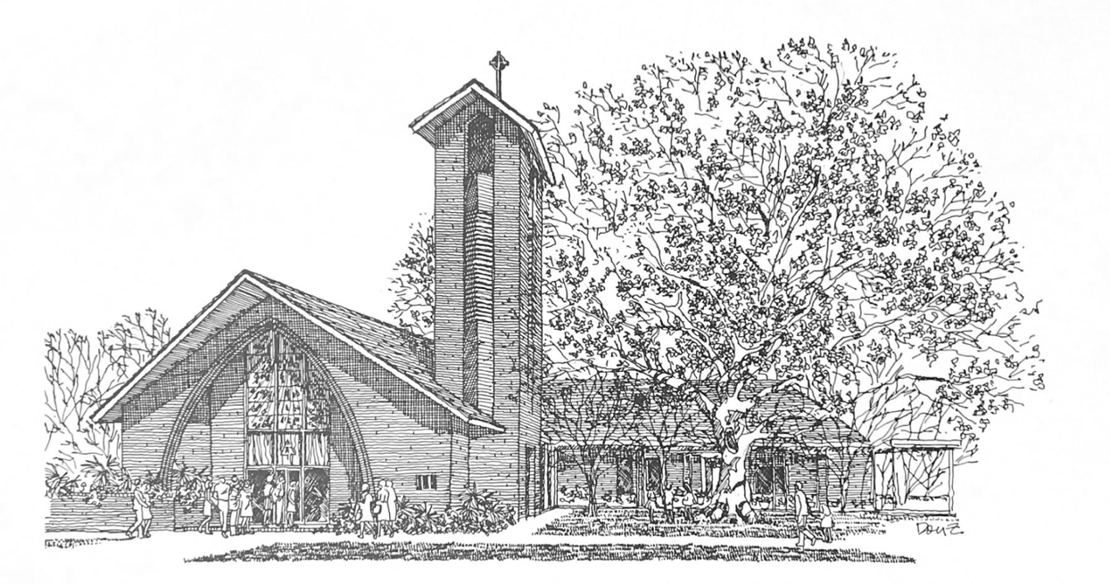


T w e n t y - S e c o n d S u n d a y
a f t e r P e n t e c o s t

O c t o b e r 2 5 , 2 0 2 6
8 A M & 1 0 A M

H O L Y E U C H A R I S T R I T E I I

T h e L i t u r g y o f t h e W o r d
Hymn 450 All hail the power of Jesus’ name!
Opening Acclamation BCP 355
Gloria in Excelsis BCP 356 | Hymn 402
The Collect of the Day
Almighty and everlasting God, increase in us the gifts of faith, hope, and charity; and, that we may obtain what you promise, make us love what you command; through Jesus Christ our Lord, who lives and reigns with you and the Holy Spirit, one God, for ever and ever
People: Amen.
The congregation may be seated.
_____________________________________________________
Children's Moment
At the 10AM service, Children 5th grade and lower are invited to come to the chancel steps for a brief lesson on the day’s readings

_____________________________________________________First Reading Deuteronomy 34:1-12
Moses went up from the plains of Moab to Mount Nebo, to the top of Pisgah, which is opposite Jericho, and the Lord showed him the whole land: Gilead as far as Dan, all Naphtali, the land of Ephraim and Manasseh, all the land of Judah as far as the Western Sea, the Negeb, and the Plain—that is, the valley of Jericho, the city of palm trees—as far as Zoar. The Lord said to him, “This is the land of which I swore to Abraham, to Isaac, and to Jacob, saying, ‘I will give it to your descendants’; I have let you see it with your eyes, but you shall not cross over there.” Then Moses, the servant of the Lord, died there in the land of Moab, at the Lord’s command. He was buried in a valley in the land of Moab, opposite Beth-peor, but no one knows his burial place to this day. Moses was one hundred twenty years old when he died; his sight was unimpaired and his vigor had not abated. The Israelites wept for Moses in the plains of Moab thirty days; then the period of mourning for Moses was ended. Joshua son of Nun was full of the spirit of wisdom, because Moses had laid his hands on him; and the Israelites obeyed him, doing as the Lord had commanded Moses. Never since has there arisen a prophet in Israel like Moses, whom the Lord knew face to face. He was unequaled for all the signs and wonders that the Lord sent him to perform in the land of Egypt, against Pharaoh and all his servants and his entire land, and for all the mighty deeds and all the terrifying displays of power that Moses performed in the sight of all Israel.

Reader: The Word of the Lord.
People: Thanks be to God.

_____________________________________________________
Psalm 90:1-6, 13-17 Domine, refugium
Read in unison at the 8AM service, sung at the 10AM service.
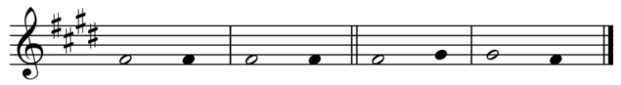
Setting by Sam Kohler
1 Lord, you have been our | refuge *
from one generation to a | nother.
2 Before the mountains were brought forth,
or the land and the earth were | born, *
from age to age you are | God.
3 You turn us back to the dust and | say, *
"Go back, O child of | earth."
4 For a thousand years in your sight are like yesterday when it is | past *
and like a watch in the | night.
5 You sweep us away like a | dream; *
we fade away suddenly like the | grass.
6 In the morning it is green and | flourishes; *
in the evening it is dried up and | withered.
13 Return, O Lord; how long will you | tarry? *
be gracious to your | servants.
14 Satisfy us by your loving-kindness in the | morning; *
so shall we rejoice and be glad all the days of our | life.
15 Make us glad by the measure of the days that you a | fflicted us *
and the years in which we suffered ad | versity.
16 Show your servants your | works *
and your splendor to their | children.
17 May the graciousness of the Lord our God be u | pon us; *
prosper the work of our hands;
prosper our | handiwork.

____________________________________________________

Second Reading 1 Thessalonians 2:1-8
Read at the 10AM service.
You yourselves know, brothers and sisters, that our coming to you was not in vain, but though we had already suffered and been shamefully mistreated at Philippi, as you know, we had courage in our God to declare to you the gospel of God in spite of great opposition. For our appeal does not spring from deceit or impure motives or trickery, but just as we have been approved by God to be entrusted with the message of the gospel, even so we speak, not to please mortals, but to please God who tests our hearts. As you know and as God is our witness, we never came with words of flattery or with a pretext for greed; nor did we seek praise from mortals, whether from you or from others, though we might have made demands as apostles of Christ. But we were gentle among you, like a nurse tenderly caring for her own children. So deeply do we care for you that we are determined to share with you not only the gospel of God but also our own selves, because you have become very dear to us.
Reader: The Word of the Lord.
People: Thanks be to God.
_____________________________________________________
Hymn 517 How lovely is thy dwelling-place _____________________________________________________

Gospel Reading Matthew 22:34-46
Celebrant: The Holy Gospel of our Lord Jesus Christ
according to Matthew.
People: Glory to you, Lord Christ.
When the Pharisees heard that Jesus had silenced the Sadducees, they gathered together, and one of them, a lawyer, asked him a question to test him. “Teacher, which commandment in the law is the greatest?” He said to him, “’You shall love the Lord your God with all your heart, and with all your soul, and with all your mind.’ This is the greatest and first commandment. And a second is like it: ‘You shall love your neighbor as yourself.’ On these two commandments hang all the law and the prophets.” Now while the Pharisees were gathered together, Jesus asked them this question: “What do you think of the Messiah? Whose son is he?” They said to him, “The son of David.” He said to them, “How is it then that David by the Spirit calls him Lord, saying, ‘The Lord said to my Lord, “Sit at my right hand, until I put your enemies under your feet”’? If David thus calls him Lord, how can he be his son?” No one was able to give him an answer, nor from that day did anyone dare to ask him any more questions.
Celebrant: The Gospel of the Lord.
People: Praise to you, Lord Christ.
The congregation may be seated.
The Sermon The Rev. Peter R. Wong
The Nicene Creed BCP 358
The Prayers of the People (Form VI) BCP 392
Confession of Sin BCP 360
The Peace
Celebrant: The peace of the Lord be always with you.
People: And also with you.
The peace is then exchanged.
Announcements
Offertory Anthem We will extol you, ever blessed Lord
Words: J. Nichol Grieve, from Psalm 145 Music: Old 124th (1551), arr. Charles Winfred Douglas
Doxology Hymn 380, vs. 3
T h e L i t u r g y o f t h e T a b l e
Please stand as you are able.
Eucharistic Prayer A BCP 361
Sanctus BCP 362 | S-129
The Lord’s Prayer, Fraction, & Invitation BCP 364
If you are a guest with us today, the Episcopal Church welcomes all baptized persons to receive Holy Communion. If you prefer not to, you may either come to the altar and cross your arms over your chest to receive a blessing from the priest, or you may remain in your pew.
Communion Music
Hymn 575 Before thy throne, O God, we kneel
Please kneel as you are able.
Prayer of Commissioning BCP 365
The Blessing
Hymn 423 Immortal, invisible, God only wise
The Dismissal
Celebrant: Let us go forth in the name of Christ. Alleluia, alleluia.
People: Thanks be to God. Alleluia, alleluia.
Flowers on the altar are given to the Glory of God and in
Celebration of Margaret’s birthday by Kelly, Kyle, & Abigail Viator.

P a r i s h A n n o u n c e m e n t s
A special thank you to Dot Alford who stepped in last minute as organist last Sunday!
Wednesday Newsletter
Our weekly online newsletter is published every Wednesday.
Contact the parish office or sign-up at trinitybr.org/newsletter
GBR Food Bank Volunteering
Wednesday, October 28, 9:30-11:30AM
and last Wednesday monthly
Greater Baton Rouge Food Bank, 10600 S. Choctaw Drive
For more information, contact Ruth Barnes
ruthsb2000@gmail.com | 225-333-0487 | brfoodbank.org
A donation box for non-perishable items is in the narthex
All Saints’ Remembrances
If you have someone you would like to be included in our memorial on All Saints’ Sunday (November 1), send it to the parish office online at trinitybr.org or call 225-387-0396
Music at Trinity
Sunday, November 15, 3PM BR Conservatory Student Recital
Saturday, November 21, 7PM Les Sirènes Louisianais Choir
Tuesday, December 1, 7:30PM LSU Chamber Singers

_____________________________________________________
Parish Staff
Bishop The Rt. Rev. Shannon Duckworth
Rector The Rev. Peter R. Wong
Music Director Sam Kohler
Business Manager Aminta Dupuy
Parish Secretary Irma Stephens
Head of School Elena McPeak
Youth Ministry Darren & Alisha Hudman
Children’s Ministry Katie Huelsbeck
Ministers of the Service
Acolytes Olive Coker, Graham Landry, Brooke Olinde, Drew Olinde, Lila Wong
Lay Eucharist Minister Jeanne Hurlbert
Ushers David Carnes, Lucius Butts
Flower Guild Renee Renegar, Abigail Viator, Kelly Viator Lectors Carol Young, Gloria Wilkins Livestream Heath Böddie, Jennifer Johnson Cantors Trisha Thatai, Joshua Ford

W E L C O M E T O T R I N I T Y
If you are a guest with us today, please fill out a card and place it in the offering plate so we know you were here. We would love to hear from you, and hope you will join us following the service for coffee and refreshments in the Common Room!
Join us for Bible Study
Monday: Bible Study 6PM | Compline Service 7PM | For all ages!
Tuesday: Men’s Group 7AM | Women’s Group 8:30AM
Promise Fund Week
Support Trinity Day School with a donation to the Promise Fund!

Online Giving

Contribute to our ministry here:

Happening at Trinity

October
28 Food Bank Volunteer 9:30AM
November
1 All Saints’ Sunday Jazz Brunch
3 Federal Elections
15 BRC Student Recital 3PM
21 Les Sirènes Louisianais 7PM

III
I

TRINITY

EPISCOPAL CHURCH

3 5 5 2 M o r n i n g G l o r y A v e.
B a t o n R o u g e , L o u i s i a n a
w w w. t r i n i t y b r. o r g ( 2 2 5 ) 3 8 7 0 3 9 6

