T R I N I T Y E P I S C O P A L C H U R C H
B A T O N R O U G E , L O U I S I A N A

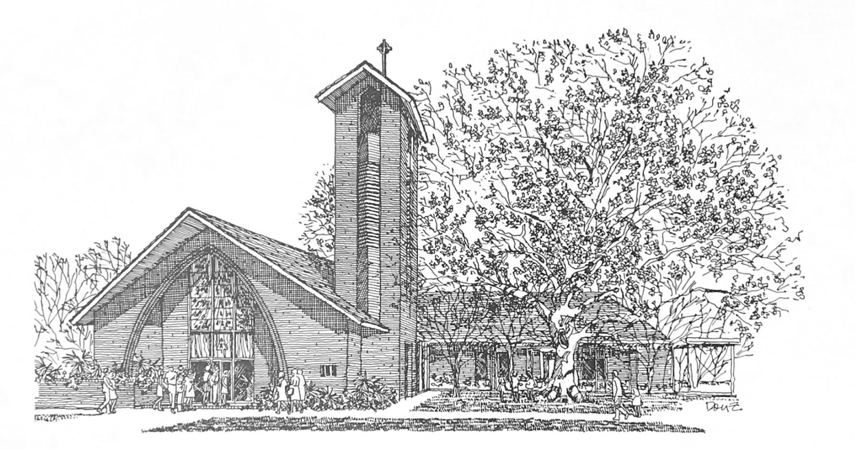


T w e n t y - F o u r t h S u n d a y
a f t e r P e n t e c o s t

N o v e m b e r 8 , 2 0 2 6
1 0 A M

H O L Y E U C H A R I S T R I T E I I

T h e L i t u r g y o f t h e W o r d
Prelude Holy and Anointed One
Processional Hymn Thy Word
Chorus Thy Word is a lamp unto my feet
And a light unto my path
Verse 1 When I feel afraid
And I think I've lost my way
Still You're there right beside me
Nothing will I fear
As long as You are near
Please be near me to the end
Verse 2 I will not forget
Your love for me and yet
My heart forever is wandering
Jesus be my guide
And hold me to Your side
I will love You to the end

Opening Acclamation BCP 355
Hymn of Praise Glory to the Father
Music by Rev. Charles deGravelles
Refrain Glory to the Father, Son, and Holy Spirit
As it was in the beginning, is now, and ever shall be
Verse Father, creator, sustainer of all
Splendid in all of your might
Holy of holies, you show us the way
From darkness into the light (Refrain)
Lord Jesus Christ you are king above all
Savior of all the earth
With Father and Spirit before you we fall
Give us the gift of new birth (Refrain)

Come, Holy Spirit and enter us now
Make each of us one of your own
We give ourselves gladly, come live within us
Make our spirits your home (Final Refrain)
The Collect of the Day
O God, whose blessed Son came into the world that he might destroy the works of the devil and make us children of God and heirs of eternal life: Grant that, having this hope, we may purify ourselves as he is pure; that, when he comes again with power and great glory, we may be made like him in his eternal and glorious kingdom; where he lives and reigns with you and the Holy Spirit, one God, for ever and ever.
People: Amen.
The congregation may be seated.
_____________________________________________________
Children's Moment
Children 5th grade and lower are invited to come to the chancel steps for a brief lesson on the day’s readings
_____________________________________________________ First Reading Joshua 24:1-3a, 14-25
Joshua gathered all the tribes of Israel to Shechem, and summoned the elders, the heads, the judges, and the officers of Israel; and they presented themselves before God. And Joshua said to all the people, “Thus says the Lord, the God of Israel: Long ago your ancestors—Terah and his sons Abraham and Nahor—lived beyond the Euphrates and served other gods. Then I took your father Abraham from beyond the River and led him through all the land of Canaan and made his offspring many.
“Now therefore revere the Lord, and serve him in sincerity and in faithfulness; put away the gods that your ancestors served beyond the River and in Egypt, and serve the Lord. Now if you are unwilling to serve the Lord, choose this day whom you will serve, whether the gods your ancestors served in the region beyond the River or the gods of the Amorites in whose land you are living; but as for me and my household, we will serve the Lord.”
Then the people answered, “Far be it from us that we should forsake the Lord to serve other gods; for it is the Lord our God who brought us and our ancestors up from the land of Egypt, out of the house of slavery, and who did those great signs in our sight. He protected us along all the way that we went, and among all the peoples through whom we passed; and the Lord drove out before us all the peoples, the Amorites who lived in the land. Therefore we also will serve the Lord, for he is our God.” But Joshua said to the people, “You cannot serve the Lord, for he is a holy God. He is a jealous God; he will not forgive your transgressions or your sins. If you forsake the Lord and serve foreign gods, then he will turn and do you harm, and consume you, after having done you good.” And the people said to Joshua, “No, we will serve the Lord!” Then Joshua said to the people, “You are witnesses against yourselves that you have chosen the Lord, to serve him.” And they said, “We are witnesses.” He said, “Then put away the foreign gods that are among you, and incline your hearts to the Lord, the God of Israel.” The people said to Joshua, “The Lord our God we will serve, and him we will obey.” So Joshua made a covenant with the people that day, and made statutes and ordinances for them at Shechem.

Reader: The Word of the Lord.
People: Thanks be to God.

_____________________________________________________
Psalm 78: 1-7 Attendite, popule
Read in unison.
1 Hear my teaching, O my people; *
incline your ears to the words of my mouth.
2 I will open my mouth in a parable; *
I will declare the mysteries of ancient times.
3 That which we have heard and known,
and what our forefathers have told us, *
we will not hide from their children.
4 We will recount to generations to come
the praiseworthy deeds and the power of the Lord, *
and the wonderful works he has done.
5 He gave his decrees to Jacob
and established a law for Israel, *
which he commanded them to teach their children;
6 That the generations to come might know,
and the children yet unborn; *
that they in their turn might tell it to their children;
7 So that they might put their trust in God, *
and not forget the deeds of God,
but keep his commandments.
_____________________________________________________
Second Reading 1 Thessalonians 4:13-18
We do not want you to be uninformed, brothers and sisters, about those who have died, so that you may not grieve as others do who have no hope. For since we believe that Jesus died and rose again, even so, through Jesus, God will bring with him those who have died. For this we declare to you by the word of the Lord, that we who are alive, who are left until the coming of the Lord, will by no means precede those who have died. For the Lord himself, with a cry of command, with the archangel's call and with the sound of God's trumpet, will descend from heaven, and the dead in Christ will rise first. Then we who are alive, who are left, will be caught up in the clouds together with them to meet the Lord in the air; and so we will be with the Lord forever. Therefore encourage one another with these words.

Reader: The Word of the Lord.
People: Thanks be to God.
_____________________________________________________
Gospel Hymn Keep your lamps trimmed and burning

Verse 1 Keep your lamps trimmed and burning (3x)
for the time is drawing nigh
Refrain Sisters don’t grow weary, brothers don’t grow weary, children don’t grow weary,
for the time is drawing nigh.
Verse 2 It’s our faith makes us happy (3x)
for the time is drawing nigh (Refrain)
Verse 3 We are climbing Jacob’s ladder (3x)
for the time is drawing nigh (Refrain)
Verse 4 Every round goes higher, higher (3x)
for the time is drawing nigh (Refrain)
_____________________________________________________Gospel Reading Matthew 25:1-13
Celebrant: The Holy Gospel of our Lord Jesus Christ
according to Matthew.
People: Glory to you, Lord Christ.
Jesus said, “Then the kingdom of heaven will be like this. Ten bridesmaids took their lamps and went to meet the bridegroom. Five of them were foolish, and five were wise. When the foolish took their lamps, they took no oil with them; but the wise took flasks of oil with their lamps. As the bridegroom was delayed, all of them became drowsy and slept. But at midnight there was a shout, ‘Look! Here is the bridegroom! Come out to meet him.’ Then all those bridesmaids got up and trimmed their lamps. The foolish said to the wise, ‘Give us some of your oil, for our lamps are going out.’ But the wise replied, ‘No! there will not be enough for you and for us; you had better go to the dealers and buy some for yourselves.’ And while they went to buy it, the bridegroom came, and those who were ready went with him into the wedding banquet; and the door was shut. Later the other bridesmaids came also, saying, ‘Lord, lord, open to us.’ But he replied, ‘Truly I tell you, I do not know you.’ Keep awake therefore, for you know neither the day nor the hour.”

Celebrant: The Gospel of the Lord.
People: Praise to you, Lord Christ.
The congregation may be seated.
The Sermon The Rev. Peter R. Wong
The Nicene Creed BCP 358
Confession of Sin BCP 360
The Peace
Celebrant: The peace of the Lord be always with you.
People: And also with you.
The peace is then exchanged.
Announcements
Offertory Hymn All that we have
T h e L i t u r g y o f t h e T a b l e
Please stand as you are able.
Eucharistic Prayer D BCP 372
Sanctus Slater Armstrong
The Lord’s Prayer, Fraction, & Invitation BCP 364
If you are a guest with us today, the Episcopal Church welcomes all baptized persons to receive Holy Communion. If you prefer not to, you may either come to the altar and cross your arms over your chest to receive a blessing from the priest, or you may remain in your pew.
Communion Music
All who are thirsty
Come as you are
Be unto Your name

Please kneel as you are able.
Prayer of Commissioning BCP 365
The Blessing
Recessional Hymn Love the Lord
Verse 1 Love the Lord your God with all your heart
With all your soul with all your mind
And with all your strength
Chorus With all your heart with all your soul
With all your mind with all your strength
Love the Lord your God with all your heart
With all your soul with all your mind
And with all your strength
Verse 2 I will serve the Lord
With all my heart with all my soul
With all my mind and with all my strength
Chorus
Bridge I will love You (I will love You)
I will praise You (I will praise You)
I will serve You (I will serve You)
I will trust You Lord (I will trust You)
Chorus
The Dismissal
Celebrant: Let us go forth in the name of Christ. Alleluia, alleluia.
People: Thanks be to God. Alleluia, alleluia.
_____________________________________________________

“Holy and Anointed One” John Barnett © 1988 Mercy / Vineyard Publishing | “Thy Word” Amy Grant | Michael W. Smith © 1984 Meadowgreen Music Company; Vinny Mae's Girl | “All that we have” Gary Ault © 1969 F.E.L. Publications (WORLD - admin. by Music Services obo Lorenz Corporation ) | “All who are thirsty” Brenton Brown | Glenn Robertson © 1998 Vineyard Songs (UK/Eire) | “Come as you are” Ben Glover | David Crowder | Matt Maher © 2014 Ariose Music; sixsteps Music; Thankyou Music Ltd; Valley Of Songs Music; worshiptogether.com songs | “Be unto your name” Gary Sadler | Lynn DeShazo © 1998 Integrity's Hosanna! Music; Lynn DeShazo Music; Paintbrush Music “Love the Lord” Lincoln Brewster © 2005 Integrity's Praise! Music

All words & music printed and streamed with permission.
CCLI Copyright License #22594791
CCLI Streaming License #22594801

W E L C O M E T O T R I N I T Y

Online Giving

Contribute to our ministry here:
Happening at Trinity

November
9-17 No Bible Study
12 Fall Soiree 6:30PM
15 BRC Student Recital 3PM
21 Les Sirènes Louisianais 7PM

