T R I N I T Y E P I S C O P A L C H U R C H
B A T O N R O U G E , L O U I S I A N A

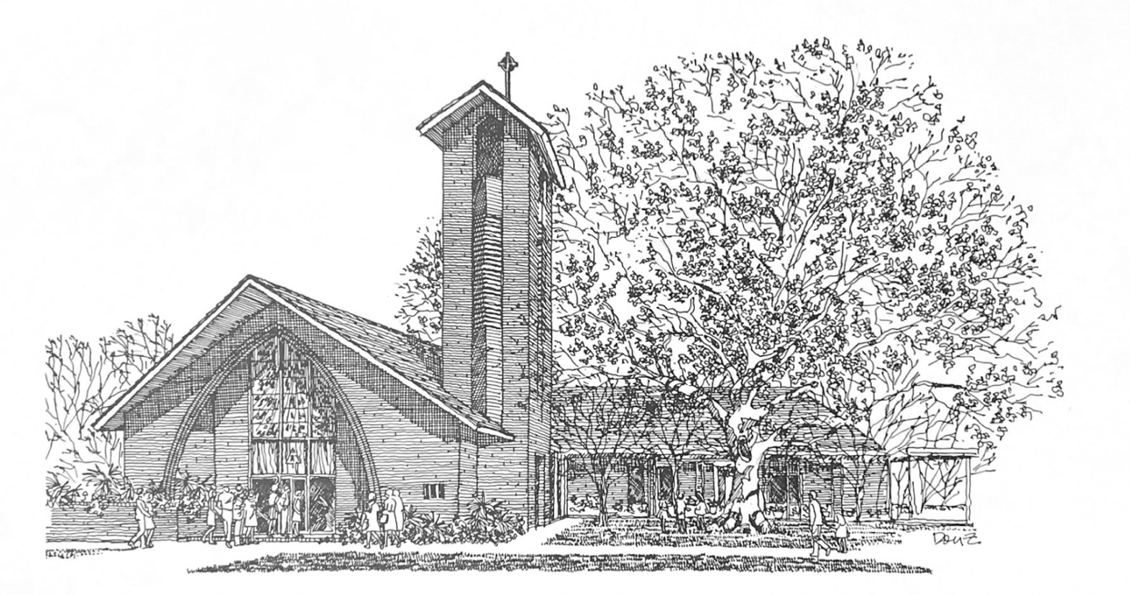

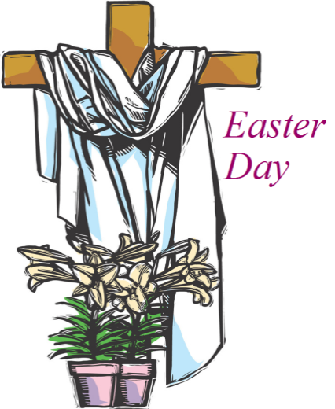
T h i r t e e n t h S u n d a y
a f t e r P e n t e c o s t

A u g u s t 2 3 , 2 0 2 6
8 A M & 1 0 A M

H O L Y E U C H A R I S T R I T E I I
T h e L i t u r g y o f t h e W o r d
Hymn 522 Glorious things of thee are spoken
Opening Acclamation BCP 355
Gloria in Excelsis BCP 356 | S-280
The Collect of the Day
Grant, O merciful God, that your Church, being gathered together in unity by your Holy Spirit, may show forth your power among all peoples, to the glory of your Name; through Jesus Christ our Lord, who lives and reigns with you and the Holy Spirit, one God, for ever and ever.
People: Amen.
The congregation may be seated.
_____________________________________________________
Children's Moment
At the 10AM service, children 5th grade and lower are invited to come to the chancel steps for a brief lesson on the day’s readings

_____________________________________________________First Reading Exodus 1:8-2:10
Now a new king arose over Egypt, who did not know Joseph. He said to his people, “Look, the Israelite people are more numerous and more powerful than we. Come, let us deal shrewdly with them, or they will increase and, in the event of war, join our enemies and fight against us and escape from the land.” Therefore they set taskmasters over them to oppress them with forced labor. They built supply cities, Pithom and Rameses, for Pharaoh. But the more they were oppressed, the more they multiplied and spread, so that the Egyptians came to dread the Israelites. The Egyptians became ruthless in imposing tasks on the Israelites, and made their lives bitter with hard service in mortar and brick and in every kind of field labor. They were ruthless in all the tasks that they imposed on them.
The king of Egypt said to the Hebrew midwives, one of whom was named Shiphrah and the other Puah, “When you act as midwives to the Hebrew women, and see them on the birthstool, if it is a boy, kill him; but if it is a girl, she shall live.” But the midwives feared God; they did not do as the king of Egypt commanded them, but they let the boys live. So the king of Egypt summoned the midwives and said to them, “Why have you done this, and allowed the boys to live?” The midwives said to Pharaoh, “Because the Hebrew women are not like the Egyptian women; for they are vigorous and give birth before the midwife comes to them.” So God dealt well with the midwives; and the people multiplied and became very strong. And because the midwives feared God, he gave them families. Then Pharaoh commanded all his people, “Every boy that is born to the Hebrews you shall throw into the Nile, but you shall let every girl live.”
Now a man from the house of Levi went and married a Levite woman. The woman conceived and bore a son; and when she saw that he was a fine baby, she hid him three months. When she could hide him no longer she got a papyrus basket for him, and plastered it with bitumen and pitch; she put the child in it and placed it among the reeds on the bank of the river. His sister stood at a distance, to see what would happen to him. The daughter of Pharaoh came down to bathe at the river, while her attendants walked beside the river. She saw the basket among the reeds and sent her maid to bring it. When she opened it, she saw the child. He was crying, and she took pity on him, “This must be one of the Hebrews’ children,” she said. Then his sister said to Pharaoh’s daughter, “Shall I go and get you a nurse from the Hebrew women to nurse the child for you?” Pharaoh’s daughter said to her, “Yes.” So the girl went and called the child’s mother. Pharaoh’s daughter said to her, “Take this child and nurse it for me, and I will give you your wages.” So the woman took the child and nursed it. When the child grew up, she brought him to Pharaoh’s daughter, and she took him as her son. She named him Moses, “because,” she said, “I drew him out of the water.”

Reader: The Word of the Lord.
People: Thanks be to God
Psalm 124 Nisi quia Dominus
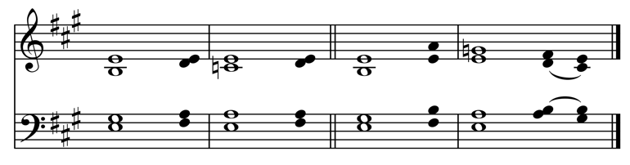
Read in unison at the 8AM service, sung at the 10AM service.
Setting by Sam Kohler

1 If the Lord had not been on our | side, *
let Israel now | say;
2 If the Lord had not been on our | side, *
when enemies rose up a | gainst us;
3 Then would they have swallowed us up a | live *
in their fierce anger toward | us;
4 Then would the waters have overwhelmed | us *
and the torrent gone over | us;
5 Then would the raging | waters *
have gone right | over us.
6 Blessed be the | Lord! *
he has not given us over to be a prey for their | teeth.
7 We have escaped like a bird from the snare of the | fowler; *
the snare is broken, and we have | escaped.
8 Our help is in the Name of the | Lord, *
the maker of heaven and | earth.
_____________________________________________________

Second Reading Romans 12:1-8
Read at the 10AM service.
I appeal to you therefore, brothers and sisters, by the mercies of God, to present your bodies as a living sacrifice, holy and acceptable to God, which is your spiritual worship. Do not be conformed to this world, but be transformed by the renewing of your minds, so that you may discern what is the will of God-- what is good and acceptable and perfect. For by the grace given to me I say to everyone among you not to think of yourself more highly than you ought to think, but to think with sober judgment, each according to the measure of faith that God has assigned. For as in one body we have many members, and not all the members have the same function, so we, who are many, are one body in Christ, and individually we are members one of another. We have gifts that differ according to the grace given to us: prophecy, in proportion to faith; ministry, in ministering; the teacher, in teaching; the exhorter, in exhortation; the giver, in generosity; the leader, in diligence; the compassionate, in cheerfulness.

Reader: The Word of the Lord.
People: Thanks be to God.
_____________________________________________________
Hymn 304 I come with joy to meet the Lord
Sung at the 10AM service.
_____________________________________________________

Gospel Reading Matthew 16:13-20
Celebrant: The Holy Gospel of our Lord Jesus Christ
according to Matthew.
People: Glory to you, Lord Christ.
When Jesus came into the district of Caesarea Philippi, he asked his disciples, “Who do people say that the Son of Man is?” And they said, “Some say John the Baptist, but others Elijah, and still others Jeremiah or one of the prophets.” He said to them, “But who do you say that I am?” Simon Peter answered, “You are the Messiah, the Son of the living God.” And Jesus answered him, “Blessed are you, Simon son of Jonah! For flesh and blood has not revealed this to you, but my Father in heaven. And I tell you, you are Peter, and on this rock I will build my church, and the gates of Hades will not prevail against it. I will give you the keys of the kingdom of heaven, and whatever you bind on earth will be bound in heaven, and whatever you loose on earth will be loosed in heaven.” Then he sternly ordered the disciples not to tell anyone that he was the Messiah.
Celebrant: The Gospel of the Lord.
People: Praise to you, Lord Christ.
The congregation may be seated.
_____________________________________________________
The Sermon The Rev. Peter R. Wong
Please stand as you are able.
The Nicene Creed BCP 358
The Prayers of the People (Form I) BCP 383
Confession of Sin BCP 360
The Peace
Celebrant: The peace of the Lord be always with you.
People: And also with you.
The peace is then exchanged.
Announcements
Offertory Organ Voluntary
Doxology Hymn 380, vs. 3
T h e L i t u r g y o f t h e T a b l e
Please stand as you are able.
Eucharistic Prayer B BCP 367
Sanctus BCP 367 | S-129
The Lord’s Prayer, Fraction, & Invitation BCP 364
If you are a guest with us today, the Episcopal Church welcomes all baptized persons to receive Holy Communion. If you prefer not to, you may either come to the altar and cross your arms over your chest to receive a blessing from the priest, or you may remain in your pew.
Communion Music
Hymn 302 Father, we thank thee who hast planted
Please kneel as you are able.
Prayer of Commissioning BCP 365
The Blessing
Hymn 427 When morning gilds the skies
The Dismissal
Celebrant: Let us go forth in the name of Christ. Alleluia, alleluia.
People: Thanks be to God. Alleluia, alleluia.
P a r i s h A n n o u n c e m e n t s
Fellowship After Church
Join us following the service for coffee and refreshments in the Common Room.
TODAY: Baton Rouge Conservatory Concert
Join us this afternoon at 4PM for the Baton Rouge Conservatory Faculty Concert!
GBR Food Bank Volunteering
NOTE: This month we will meet on Tuesday!
Tuesday, August 25, 9:30-11:30AM
Greater Baton Rouge Food Bank, 10600 S. Choctaw Drive
For more information, contact Ruth Barnes
ruthsb2000@gmail.com | 225-333-0487 | brfoodbank.org

Monday Evening Bible Study & Compline
Beginning Monday, August 24, 6PM & 7PM
Bible Study at 6PM, Compline Service at 7PM
Wednesday Newsletter
Our weekly online newsletter is published every Wednesday. Contact the parish office or sign-up at trinitybr.org/newsletter
W E L C O M E T O T R I N I T Y
If you are a guest today, we warmly welcome you.
Please fill out a card and place it in the offering plate so we know you were here. We would love to hear from you.

Online Giving

You can contribute to the ministry at Trinity here:


Upcoming at Trinity

August

25 GBR Foodbank 9:30AM
30 TEYC Hangout

September

7 Parish Office Closed
10 Finance Meeting Noon
15 Vestry 5:30PM
24 TEDS Mahjong Fundraiser 6PM

III
I
TRINITY

EPISCOPAL CHURCH

3 5 5 2 M o r n i n g G l o r y A v e.
B a t o n R o u g e , L o u i s i a n a
w w w. t r i n i t y b r. o r g ( 2 2 5 ) 3 8 7 0 3 9 6

