T R I N I T Y E P I S C O P A L C H U R C H
B A T O N R O U G E , L O U I S I A N A

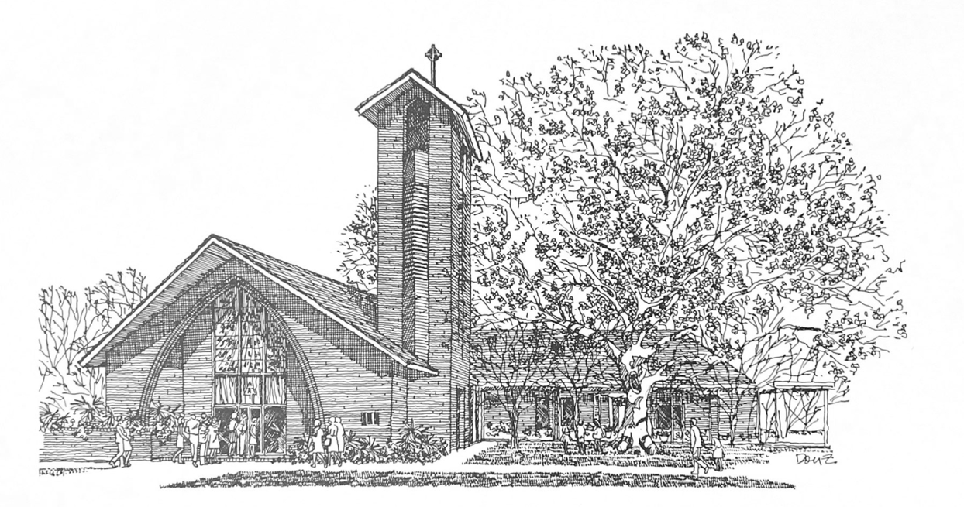

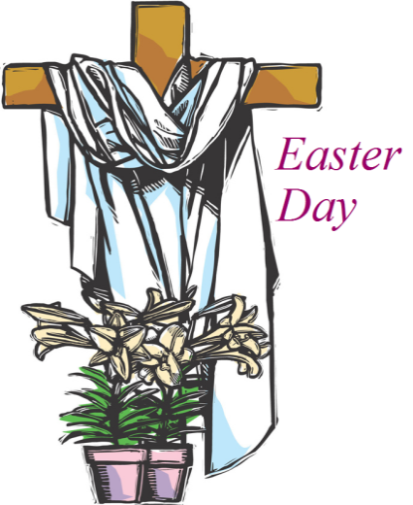
S I X T H S U N D A Y
O F E A S T E R

M A Y 1 0 , 2 0 2 6
1 0 A M

H O L Y E U C H A R I S T R I T E I I
T h e L i t u r g y o f t h e W o r d

Prelude Healing is in your hands
Opening Hymn Shout to the Lord
Verse My Jesus, my Saviour
Lord there is none like You
All of my days I want to praise
The wonders of Your mighty love
My comfort, my shelter
Tower of refuge and strength
Let every breath, all that I am
Never cease to worship You

Chorus Shout to the Lord all the Earth, let us sing
Power and majesty, praise to the King
Mountains bow down and the seas will roar
At the sound of Your name
I sing for joy at the work of Your hands
Forever I'll love You, forever I'll stand
Nothing compares to the promise I have In You
Repeat Verse
Repeat Chorus 2x
Opening Acclamation BCP 355
Song of Praise Hymn 376 (vs. 1 & 3)
The Collect of the Day
O God, you have prepared for those who love you such good things as surpass our understanding: Pour into our hearts such love towards you, that we, loving you in all things and above all things, may obtain your promises, which exceed all that we can desire; through Jesus Christ our Lord, who lives and reigns with you and the Holy Spirit, one God, for ever and ever.
People: Amen.
_____________________________________________________
Children's Moment
Children 5th grade and lower are invited to come to the chancel steps for a brief lesson on the day’s readings

_____________________________________________________

First Reading Acts 17:22-31
Paul stood in front of the Areopagus and said, “Athenians, I see how extremely religious you are in every way. For as I went through the city and looked carefully at the objects of your worship, I found among them an altar with the inscription, ‘To an unknown god.’ What therefore you worship as unknown, this I proclaim to you. The God who made the world and everything in it, he who is Lord of heaven and earth, does not live in shrines made by human hands, nor is he served by human hands, as though he needed anything, since he himself gives to all mortals life and breath and all things. From one ancestor he made all nations to inhabit the whole earth, and he allotted the times of their existence and the boundaries of the places where they would live, so that they would search for God and perhaps grope for him and find him—though indeed he is not far from each one of us. For ‘In him we live and move and have our being’; as even some of your own poets have said,
‘For we too are his offspring.’
Since we are God’s offspring, we ought not to think that the deity is like gold, or silver, or stone, an image formed by the art and imagination of mortals. While God has overlooked the times of human ignorance, now he commands all people everywhere to repent, because he has fixed a day on which he will have the world judged in righteousness by a man whom he has appointed, and of this he has given assurance to all by raising him from the dead.”

Reader: The Word of the Lord.
People: Thanks be to God
Psalm 66:7-18 Jubilate Deo
Spoken in unison.
7 Bless our God, you peoples; *
make the voice of his praise to be heard;
8 Who holds our souls in life, *
and will not allow our feet to slip.
9 For you, O God, have proved us; *
you have tried us just as silver is tried.
10 You brought us into the snare; *
you laid heavy burdens upon our backs.
11 You let enemies ride over our heads;
we went through fire and water; *
but you brought us out into a place of refreshment.
12 I will enter your house with burnt-offerings
and will pay you my vows, *
which I promised with my lips
and spoke with my mouth when I was in trouble.
13 I will offer you sacrifices of fat beasts
with the smoke of rams; *
I will give you oxen and goats.
14 Come and listen, all you who fear God, *
and I will tell you what he has done for me.
15 I called out to him with my mouth, *
and his praise was on my tongue.
16 If I had found evil in my heart, *
the Lord would not have heard me;
17 But in truth God has heard me; *
he has attended to the voice of my prayer.
18 Blessed be God, who has not rejected my prayer, *
nor withheld his love from me.

Second Reading 1 Peter 3:13-22
Now who will harm you if you are eager to do what is good? But even if you do suffer for doing what is right, you are blessed. Do not fear what they fear, and do not be intimidated, but in your hearts sanctify Christ as Lord. Always be ready to make your defense to anyone who demands from you an accounting for the hope that is in you; yet do it with gentleness and reverence. Keep your conscience clear, so that, when you are maligned, those who abuse you for your good conduct in Christ may be put to shame. For it is better to suffer for doing good, if suffering should be God's will, than to suffer for doing evil. For Christ also suffered for sins once for all, the righteous for the unrighteous, in order to bring you to God. He was put to death in the flesh, but made alive in the spirit, in which also he went and made a proclamation to the spirits in prison, who in former times did not obey, when God waited patiently in the days of Noah, during the building of the ark, in which a few, that is, eight persons, were saved through water. And baptism, which this prefigured, now saves you-- not as a removal of dirt from the body, but as an appeal to God for a good conscience, through the resurrection of Jesus Christ, who has gone into heaven and is at the right hand of God, with angels, authorities, and powers made subject to him.
Reader: The Word of the Lord.
People: Thanks be to God.
_____________________________________________________
Hymn 488 Be thou my vision, O Lord of my heart _____________________________________________________

Gospel Reading John 14:15-21
Celebrant: The Holy Gospel of our Lord Jesus Christ
according to John.
People: Glory to you, Lord Christ.
Jesus said, ”If you love me, you will keep my commandments. And I will ask the Father, and he will give you another Advocate, to be with you forever. This is the Spirit of truth, whom the world cannot receive, because it neither sees him nor knows him. You know him, because he abides with you, and he will be in you.
”I will not leave you orphaned; I am coming to you. In a little while the world will no longer see me, but you will see me; because I live, you also will live. On that day you will know that I am in my Father, and you in me, and I in you. They who have my commandments and keep them are those who love me; and those who love me will be loved by my Father, and I will love them and reveal myself to them.”

Celebrant: The Gospel of the Lord.
People: Praise to you, Lord Christ.
_____________________________________________________
The Sermon The Rev. Peter R. Wong
The Nicene Creed BCP 358
The Prayers of the People (Form III) BCP 387
Celebrant: The peace of the Lord be always with you.
People: And also with you.
The peace is then exchanged.
Announcements

Offertory Hymn Lord you have my heart
Verse Lord, You have my heart
And I will search for Yours
Jesus, take my life and lead me on
Oh Lord, You have my heart
And I will search for Yours
Let me be to You a sacrifice
Chorus And I will praise You, Lord
And I will sing of love come down
And as You show Your face
We'll see Your glory here
Repeat Verse, Repeat Chorus

T h e L i t u r g y o f t h e T a b l e
Eucharistic Prayer A (standing) BCP 361
Sanctus Dubay
The Lord’s Prayer, Fraction, & Invitation BCP 364

The Episcopal Church welcomes all baptized persons
to receive Holy Communion; you may also cross your arms across your chest to receive a blessing from the priest instead of receiving.

Communion Music
Thy word
The Heart of Worship
One bread, one body
_____________________________________________________
Prayer of Commissioning (kneeling) BCP 365
The Blessing

Recessional Hymn Blessed be your name
Verse 1 Blessed be Your Name, in the land that is plentiful
Where Your streams of abundance flow
Blessed be Your name
And, blessed be Your name
when I’m found in the desert place
Though I walk through the wilderness
Blessed be Your name
Chorus Every blessing You pour out,
I’ll turn back to praise
When the darkness closes in, Lord, still I will say
Blessed be the name of the Lord,
Blessed be Your name
Blessed be the name of the Lord,
Blessed be Your glorious name
Verse 2 Blessed be your name,
when the sun’s shining down on me
When the world’s all as it should be,
blessed be your name
And, bless-ed be your name
on the road marked with suffering
Though there’s pain in the offering
blessed be your name
Chorus
Bridge You give and take away, you give and take away
My heart will choose to say,
lord, blessed be your name
You give and take away, you give and take away
My heart will choose to say,
lord, blessed be your name
Final Chorus
The Dismissal
Celebrant: Let us go forth in the name of Christ,
Alleluia, Alleluia
People: Thanks be to God. Alleluia, alleluia.

Flowers on the altar are given in the Glory of God and in Loving memory of Myron Falk & Roberta Falk by Libby, Roger, Rafe & Gil Jones.

Parish Staff

Bishop The Rt. Rev. Shannon Duckworth
Rector The Rev. Peter R. Wong
Music Director Sam Kohler
Business Manager Aminta Dupuy
Interim Head of School Elena McPeak
Plant Manager Yeika Williams
Parish Secretary Irma Stephens
Social Media Daniela Latil
Children’s Ministry Katie Huelsbeck

Ministers of the Service

Acolytes David Chauvin, Aedan Hudman, Jude Hudman, Lila Morton, William Morton
Lector Alisha Hudman
Altar Guild Anne Tillman, Nicole Chauvin
Flower Guild Renee Renegar, Abigail Viator, Kelly Viator
Livestream Heath Böddie, Jennifer Johnson
Ushers Lucius Butts, David Carnes
Morning Glory Coordinator Susan Brewer
Piano Damaris Dupuertis
Guitar Tom Guidry

“Healing is in your hands” Muisc & Words by Chris Tomlin, Christy Nockels, Daniel Carson, Matt Redman, Nathan Nockels Copyright © 2010 Rising Springs Music (Admin. by Capitol CMG Publishing) Sweater Weather Music (Admin. by Capitol CMG Publishing)Thankyou Music Ltd (Admin. by Capitol CMG Publishing) Vamos Publishing (Admin. by Capitol CMG Publishing) worshiptogether.com songs (Admin. by Capitol CMG Publishing) | “Shout to the Lord” Muisc & Words by Darlene Zschech Copyright © 1993 Wondrous Worship (Admin. by Reservoir Media Management, Inc.) | “Lord you have my heart” Music & Words by Martin Smith Copyright © 1992 Thankyou Music Ltd (Admin. by Capitol CMG Publishing) | “Thy Word” Music & Words by Amy Grant, Michael W. Smith Copyright © 1984 Meadowgreen Music Company (Admin. by Capitol CMG Publishing) Vinny Mae's Girl (Admin. by ClearBox Rights, LLC) | “The Heart of Worship” Music & Words by Matt Redman Copyright © 1999 Thankyou Music Ltd (Admin. by Capitol CMG Publishing) | “Blessed by your name” Music & Words by Beth Redman, Matt Redman Copyright © 2002 Thankyou Music Ltd (Admin. by Capitol CMG Publishing)

All words & music printed and streamed with permission.
CCLI Copyright License #22594791
CCLI Streaming License #22594801

Parish Announcements
Fellowship After Church
Please join us following the 10AM service for coffee and snacks in the common room.
Wednesday Newsletter
Our weekly online newsletter is published every Wednesday. Contact the parish office to receive it by email, or sign-up at trinitybr.org/newsletter
GBR Food Bank Volunteering
Wednesday, May 27, 9:30-11:30AM
Last wednesday of every month
Greater Baton Rouge Food Bank, 10600 S. Choctaw Drive
To register contact Ruth Barnes
ruthsb2000@gmail.com | 225-333-0487
Donate at brfoodbank.org

A donation box for non-perishable items is in the narthex

“Two Birds with One Stone” Clean-Up Day
Saturday, May 30 9AM
Join us in raking leaves along Stanford and Cherrydale, as well as cleaning out the “Red House” garage!

TRINITY CHOIR
Participation in the Trinity Choir is open to all.
No previous music experience necessary.
The choir meets 7:30PM Wednesdays and 9AM Sundays.
Tuesday Bible Study
Men’s Group 7AM | Women’s Group 8:30AM
Open to all, meets in the Common Room.
W E L C O M E T O T R I N I T Y
If you are a guest today, we warmly welcome you.
Please fill out a card and place it in the offering plate so we know you were here. We would love to hear from you.

Online Giving

You can contribute to our ministry here:


Upcoming Events

May

14 Finance Committee Noon
16 State & Municipal Election
18 OPUS 1:30PM
19 Vestry Meeting 5:30PM
21 TEDS Graduation 8:30AM
24 Jazz Eucharist 10AM
25 Parish office closed
27 GBRFB Volunteer 9:30AM
Camp Theodore Begins
30 “Two Birds with One Stone” Clean-up Day 9AM

III
I
TRINITY

EPISCOPAL CHURCH

3 5 5 2 M o r n i n g G l o r y A v e.
B a t o n R o u g e , L o u i s i a n a
w w w. t r i n i t y b r. o r g ( 2 2 5 ) 3 8 7 0 3 9 6

