T R I N I T Y E P I S C O P A L C H U R C H
B A T O N R O U G E , L O U I S I A N A

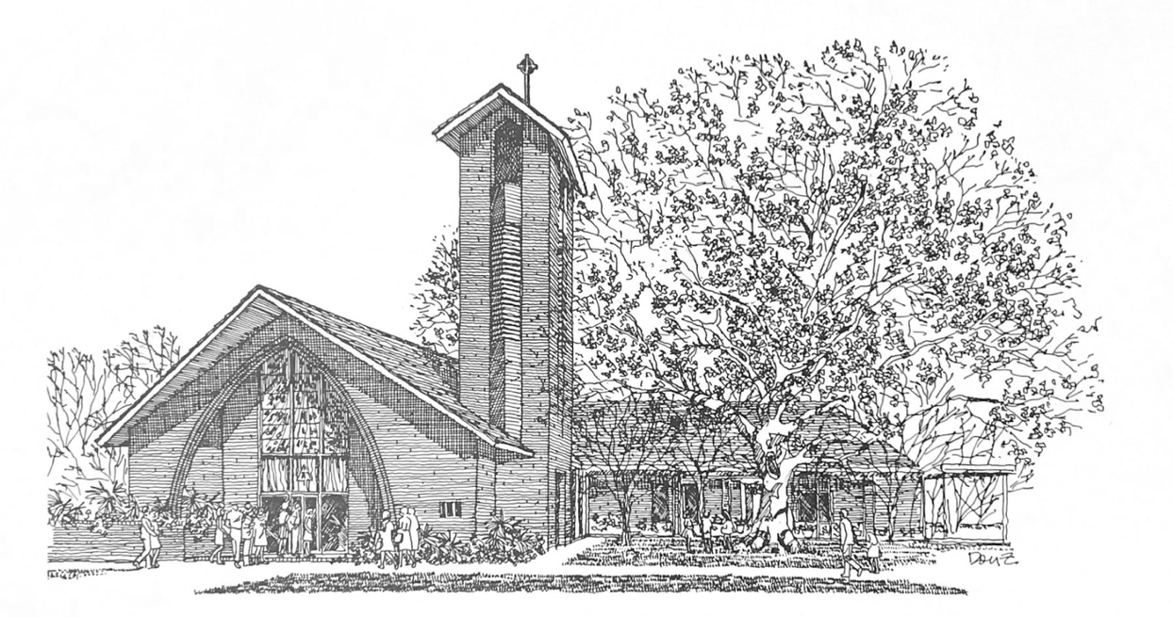


S i x t e e n t h S u n d a y
a f t e r P e n t e c o s t

S e p t e m b e r 1 3 , 2 0 2 6
1 0 A M

H O L Y E U C H A R I S T R I T E I I
T h e L i t u r g y o f t h e W o r d
Hymn 390 Praise to the Lord, the Almighty
Opening Acclamation BCP 299
The Collect of the Day
O God, because without you we are not able to please you, mercifully grant that your Holy Spirit may in all things direct and rule our hearts; through Jesus Christ our Lord, who lives and reigns with you and the Holy Spirit, one God, now and for ever.
People: Amen.
The congregation may be seated.
_____________________________________________________
Children's Moment
Children 5th grade and lower are invited to come to the chancel steps for a brief lesson on the day’s readings

_____________________________________________________First Reading Exodus 14:19-31
The angel of God who was going before the Israelite army moved and went behind them; and the pillar of cloud moved from in front of them and took its place behind them. It came between the army of Egypt and the army of Israel. And so the cloud was there with the darkness, and it lit up the night; one did not come near the other all night. Then Moses stretched out his hand over the sea. The Lord drove the sea back by a strong east wind all night, and turned the sea into dry land; and the waters were divided. The Israelites went into the sea on dry ground, the waters forming a wall for them on their right and on their left. The Egyptians pursued, and went into the sea after them, all of Pharaoh’s horses, chariots, and chariot drivers. At the morning watch the Lord in the pillar of fire and cloud looked down upon the Egyptian army, and threw the Egyptian army into panic. He clogged their chariot wheels so that they turned with difficulty. The Egyptians said, “Let us flee from the Israelites, for the Lord is fighting for them against Egypt.” Then the Lord said to Moses, “Stretch out your hand over the sea, so that the water may come back upon the Egyptians, upon their chariots and chariot drivers.” So Moses stretched out his hand over the sea, and at dawn the sea returned to its normal depth. As the Egyptians fled before it, the Lord tossed the Egyptians into the sea. The waters returned and covered the chariots and the chariot drivers, the entire army of Pharaoh that had followed them into the sea; not one of them remained. But the Israelites walked on dry ground through the sea, the waters forming a wall for them on their right and on their left. Thus the Lord saved Israel that day from the Egyptians; and Israel saw the Egyptians dead on the seashore. Israel saw the great work that the Lord did against the Egyptians. So the people feared the Lord and believed in the Lord and in his servant Moses.

Reader: The Word of the Lord.
People: Thanks be to God.

_____________________________________________________
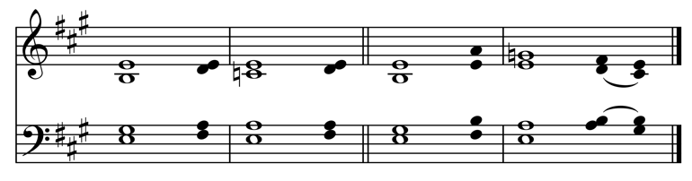
Psalm 114 In exitu Israel
Setting by Sam Kohler
1 Hallelujah!
When Israel came out of | Egypt, *
the house of Jacob from a people of strange | speech,
2 Judah became God's | sanctuary *
and Israel his do - | minion.
3 The sea beheld it and | fled; *
Jordan turned and went | back.
4 The mountains skipped like | rams, *
and the little hills like young | sheep.
5 What ailed you, O sea, that you | fled? *
O Jordan, that you turned | back?
6 You mountains, that you skipped like | rams? *
you little hills like young | sheep?
7 Tremble, O earth, at the presence of the | Lord, *
at the presence of the God of | Jacob,
8 Who turned the hard rock into a pool of | water *
and flint-stone into a flowing | spring.
_____________________________________________________

Second Reading Romans 14:1-12
Welcome those who are weak in faith, but not for the purpose of quarreling over opinions. Some believe in eating anything, while the weak eat only vegetables. Those who eat must not despise those who abstain, and those who abstain must not pass judgment on those who eat; for God has welcomed them. Who are you to pass judgment on servants of another? It is before their own lord that they stand or fall. And they will be upheld, for the Lord is able to make them stand. Some judge one day to be better than another, while others judge all days to be alike. Let all be fully convinced in their own minds. Those who observe the day, observe it in honor of the Lord. Also those who eat, eat in honor of the Lord, since they give thanks to God; while those who abstain, abstain in honor of the Lord and give thanks to God.
We do not live to ourselves, and we do not die to ourselves. If we live, we live to the Lord, and if we die, we die to the Lord; so then, whether we live or whether we die, we are the Lord's. For to this end Christ died and lived again, so that he might be Lord of both the dead and the living. Why do you pass judgment on your brother or sister? Or you, why do you despise your brother or sister? For we will all stand before the judgment seat of God. For it is written, "As I live, says the Lord, every knee shall bow to me,
and every tongue shall give praise to God." So then, each of us will be accountable to God.
Reader: The Word of the Lord.
People: Thanks be to God.
_____________________________________________________
Hymn 516 Come down, O Love divine

Gospel Reading Matthew 18:21-35
Celebrant: The Holy Gospel of our Lord Jesus Christ
according to Matthew.
People: Glory to you, Lord Christ.
Peter came and said to Jesus, “Lord, if another member of the church sins against me, how often should I forgive? As many as seven times?” Jesus said to him, “Not seven times, but, I tell you, seventy-seven times. For this reason the kingdom of heaven may be compared to a king who wished to settle accounts with his slaves. When he began the reckoning, one who owed him ten thousand talents was brought to him; and, as he could not pay, his lord ordered him to be sold, together with his wife and children and all his possessions, and payment to be made. So the slave fell on his knees before him, saying, ‘Have patience with me, and I will pay you everything.’ And out of pity for him, the lord of that slave released him and forgave him the debt. But that same slave, as he went out, came upon one of his fellow slaves who owed him a hundred denarii; and seizing him by the throat, he said, ‘Pay what you owe.’ Then his fellow slave fell down and pleaded with him, ‘Have patience with me, and I will pay you.’ But he refused; then he went and threw him into prison until he would pay the debt. When his fellow slaves saw what had happened, they were greatly distressed, and they went and reported to their lord all that had taken place. Then his lord summoned him and said to him, ‘You wicked slave! I forgave you all that debt because you pleaded with me. Should you not have had mercy on your fellow slave, as I had mercy on you?’ And in anger his lord handed him over to be tortured until he would pay his entire debt. So my heavenly Father will also do to every one of you, if you do not forgive your brother or sister from your heart.”
Celebrant: The Gospel of the Lord.
People: Praise to you, Lord Christ.
The congregation may be seated.
The Sermon The Rev. Peter R. Wong

T h e B a p t i s m o f
L u c y M c K u t c h e o n F i e l d
The Presentation & Examination BCP 301
The Baptismal Covenant BCP 304
The Prayers for the Candidates BCP 305
Baptism BCP 306
The Peace
Celebrant: The peace of the Lord be always with you.
People: And also with you.
The peace is then exchanged.
Announcements
Offertory Anthem Lord, thou hast searched me
Words: from Psalm 139
Music: Tender Thought, arr. Alice Parker
LORD, Thou hast searched me, and dost know where'er I rest, where'er I go; Thou knowest all that I have planned, and all my ways are in Thy hands. My words from Thee I cannot hide, I feel Thy pow'r on ev'ry side; O wondrous knowledge, awful might, unfathomed depth, unmeasured height! If I the wings of morning take, and far away my dwelling make, the hand that leadeth me is Thine, and my support Thy pow'r divine. If deepest darkness cover me, the darkness hideth not from Thee; to Thee both night and day are bright, the darkness shineth as the light.
Doxology Hymn 380, vs. 3
T h e L i t u r g y o f t h e T a b l e
Please stand as you are able.
Eucharistic Prayer C BCP 369
Sanctus S-129
The Lord’s Prayer, Fraction, & Invitation BCP 364
If you are a guest with us today, the Episcopal Church welcomes all baptized persons to receive Holy Communion. If you prefer not to, you may either come to the altar and cross your arms over your chest to receive a blessing from the priest, or you may remain in your pew.
Communion Music
Hymn 336 Come with us, O blessed Jesus

Please kneel as you are able.
Prayer of Commissioning BCP 365
The Blessing
Hymn 397 Now thank we all our God
The Dismissal
Celebrant: Let us go forth in the name of Christ. Alleluia, alleluia.
People: Thanks be to God. Alleluia, alleluia.
Flowers on the altar are given to the Glory of God and in
Loving Memory of Mildred Alford by Joe & Dot Alford

P a r i s h A n n o u n c e m e n t s
Join us for Bible Study
Monday: Bible Study 6PM | Compline Service 7PM | For all ages!
Tuesday: Men’s Group 7AM | Women’s Group 8:30AM
Promise Fund Week - Begins Tomorrow
Support Trinity Day School with a donation to the Promise Fund!
Thursday, September 24 6PM Trinity & Tiles Mahjong Night
Interfaith Federation Anniversary Events
Today 2 - 4PM Prayer Vigil, Shiloh Missionary Baptist Church
Wednesday, September 16, Noon Luncheon at Holy Grill
Thursday, September 17, 7AM Prayer Breakfast at Boudreaux's
W E L C O M E T O T R I N I T Y
If you are a guest today, we warmly welcome you.
Please fill out a card and place it in the offering plate so we know you were here. We would love to hear from you, and hope you will join us following the service for coffee and refreshments in the Common Room!

Online Giving

Contribute to our ministry here:


This Month at Trinity

September

13 Interfaith Prayer Vigil
at Shiloh Missionary Baptist
14 Promise Fund Week Kickoff
15 Vestry 5:30PM
17 Interfaith Breakfast 7AM
at Boudreaux’s
24 Trinity & Tiles 6PM
30 GBR Food Bank Volunteering 9:30AM

III
I
TRINITY

EPISCOPAL CHURCH

3 5 5 2 M o r n i n g G l o r y A v e.
B a t o n R o u g e , L o u i s i a n a
w w w. t r i n i t y b r. o r g ( 2 2 5 ) 3 8 7 0 3 9 6

