T R I N I T Y E P I S C O P A L C H U R C H
B A T O N R O U G E , L O U I S I A N A

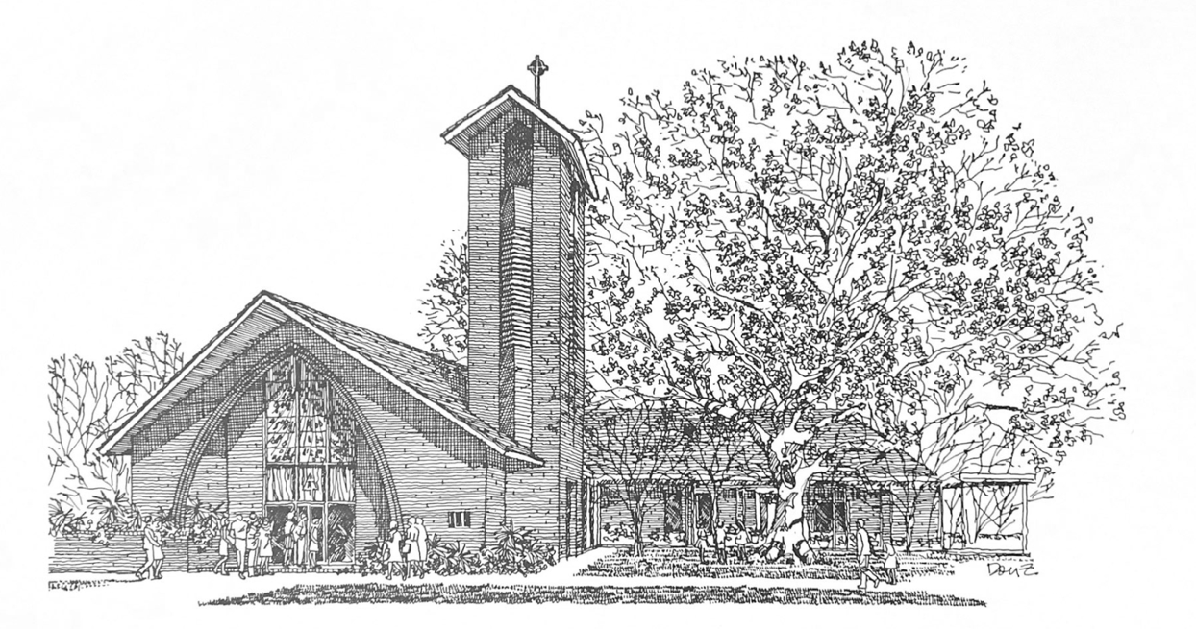


S E V E N T H S U N D A Y
O F E A S T E R

M A Y 1 7 , 2 0 2 6
8 A M & 1 0 A M

H O L Y E U C H A R I S T R I T E I I
At the 8AM Service, only the first and last verses of the opening and closing hymns are sung. The Gospel Hymn is omitted and all other responses are spoken.
T h e L i t u r g y o f t h e W o r d
Hymn 494 Crown him with many crowns
Opening Acclamation BCP 355
Song of Praise Hymn 376 (vs. 1 & 3)
The Collect of the Day
O God, the King of glory, you have exalted your only Son Jesus Christ with great triumph to your kingdom in heaven: Do not leave us comfortless, but send us your Holy Spirit to strengthen us, and exalt us to that place where our Savior Christ has gone before; who lives and reigns with you and the Holy Spirit, one God, in glory everlasting.
People: Amen.
_____________________________________________________
Children's Moment (at 10am Service)
Children 5th grade and lower are invited to come to the chancel steps for a brief lesson on the day’s readings

_____________________________________________________

First Reading Acts 1:6-14
When the apostles had come together, they asked Jesus, “Lord, is this the time when you will restore the kingdom to Israel?” He replied, “It is not for you to know the times or periods that the Father has set by his own authority. But you will receive power when the Holy Spirit has come upon you; and you will be my witnesses in Jerusalem, in all Judea and Samaria, and to the ends of the earth.” When he had said this, as they were watching, he was lifted up, and a cloud took him out of their sight. While he was going and they were gazing up toward heaven, suddenly two men in white robes stood by them. They said, “Men of Galilee, why do you stand looking up toward heaven? This Jesus, who has been taken up from you into heaven, will come in the same way as you saw him go into heaven.” Then they returned to Jerusalem from the mount called Olivet, which is near Jerusalem, a sabbath day’s journey away. When they had entered the city, they went to the room upstairs where they were staying, Peter, and John, and James, and Andrew, Philip and Thomas, Bartholomew and Matthew, James son of Alphaeus, and Simon the Zealot, and Judas son of James. All these were constantly devoting themselves to prayer, together with certain women, including Mary the mother of Jesus, as well as his brothers.
Reader: The Word of the Lord.
People: Thanks be to God
_____________________________________________________
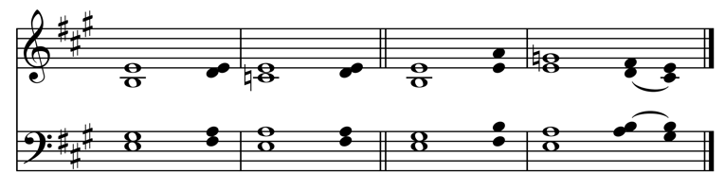
Psalm 68:1-10, 33-36 Exsurgat Deus
1 Let God arise, and let his enemies be | scattered; *
let those who hate him flee before | him.
2 Let them vanish like smoke when the wind drives it a | way; *
as the wax melts at the fire, so let the wicked perish at the presence of | God.
3 But let the righteous be glad and rejoice before | God; *
let them also be merry and | joyful.
4 Sing to God, sing praises to his Name;
exalt him who rides upon the | heavens; *
YAHWEH is his Name, rejoice before | him!
5 Father of orphans, defender of | widows, *
God in his holy habi | tation!
6 God gives the solitary a home
and brings forth prisoners into | freedom; *
but the rebels shall live in dry | places.
7 O God, when you went forth before your | people, *
when you marched through the | wilderness,
8 The earth shook, and the skies poured down rain,
at the presence of God, the God of | Sinai, *
at the presence of God, the God of | Israel.
9 You sent a gracious rain, O God, upon your in | heritance; *
you refreshed the land when it was | weary.
10 Your people found their home in | it; *
in your goodness, O God,
you have made provision for the | poor.
33 Sing to God, O kingdoms of the | earth; *
sing praises to the | Lord.
34 He rides in the heavens, the ancient | heavens; *
he sends forth his voice, his mighty | voice.
35 Ascribe power to | God; *
his majesty is over Israel; his strength is in the | skies.
36 How wonderful is God in his holy | places! *
the God of Israel giving strength and power to his people! Blessed be | God!
_____________________________________________________

Second Reading (at 10am Service) 1 Peter 4:12-14; 5:6-11
Beloved, do not be surprised at the fiery ordeal that is taking place among you to test you, as though something strange were happening to you. But rejoice insofar as you are sharing Christ's sufferings, so that you may also be glad and shout for joy when his glory is revealed. If you are reviled for the name of Christ, you are blessed, because the spirit of glory, which is the Spirit of God, is resting on you. Humble yourselves therefore under the mighty hand of God, so that he may exalt you in due time. Cast all your anxiety on him, because he cares for you. Discipline yourselves, keep alert. Like a roaring lion your adversary the devil prowls around, looking for someone to devour. Resist him, steadfast in your faith, for you know that your brothers and sisters in all the world are undergoing the same kinds of suffering. And after you have suffered for a little while, the God of all grace, who has called you to his eternal glory in Christ, will himself restore, support, strengthen, and establish you. To him be the power forever and ever. Amen.
Reader: The Word of the Lord.
People: Thanks be to God.
_____________________________________________________
Hymn 460 Alleluia! sing to Jesus _____________________________________________________

Gospel Reading John 17:1-11
Celebrant: The Holy Gospel of our Lord Jesus Christ
according to John.
People: Glory to you, Lord Christ.
Jesus looked up to heaven and said, “Father, the hour has come; glorify your Son so that the Son may glorify you, since you have given him authority over all people, to give eternal life to all whom you have given him. And this is eternal life, that they may know you, the only true God, and Jesus Christ whom you have sent. I glorified you on earth by finishing the work that you gave me to do. So now, Father, glorify me in your own presence with the glory that I had in your presence before the world existed. “I have made your name known to those whom you gave me from the world. They were yours, and you gave them to me, and they have kept your word. Now they know that everything you have given me is from you; for the words that you gave to me I have given to them, and they have received them and know in truth that I came from you; and they have believed that you sent me. I am asking on their behalf; I am not asking on behalf of the world, but on behalf of those whom you gave me, because they are yours. All mine are yours, and yours are mine; and I have been glorified in them. And now I am no longer in the world, but they are in the world, and I am coming to you. Holy Father, protect them in your name that you have given me, so that they may be one, as we are one.”
Celebrant: The Gospel of the Lord.
People: Praise to you, Lord Christ.
The Sermon The Rev. Peter R. Wong
The Nicene Creed BCP 358
The Prayers of the People (Form III) BCP 387
The Peace BCP 360
Offertory
Doxology Hymn 380, vs. 3
_____________________________________________________
T h e L i t u r g y o f t h e T a b l e
Eucharistic Prayer A (standing) BCP 361
Sanctus BCP 362 | S-130
The Lord’s Prayer, Fraction, & Invitation BCP 364

The Episcopal Church welcomes all baptized persons
to receive Holy Communion; you may also cross your arms across your chest to receive a blessing from the priest instead of receiving.

Communion Music
Hymn 315 Thou, who at thy first Eucharist didst pray
Prayer of Commissioning (kneeling) BCP 365
The Blessing
Hymn 544 Jesus shall reign where’er the sun
The Dismissal

Parish Staff

Bishop The Rt. Rev. Shannon Duckworth
Rector The Rev. Peter R. Wong
Music Director Sam Kohler
Business Manager Aminta Dupuy
Interim Head of School Elena McPeak
Plant Manager Yeika Williams
Parish Secretary Irma Stephens
Social Media Daniela Latil
Youth Ministry Darren & Alisha Hudman
Katie Huelsbeck
Ministers of the Service

Acolytes Olive Coker, Ruby Menou,
Brooke Olinde, Drew Olinde, Lila Wong
Lectors Carol Young, Mike McKay
Ushers Ed Stauss, Victor Stater
Altar Guild Courtney Dampf, Cooper Knecht
Flower Guild Liz Alexius, Ashley Coker, Sydnee Menou
Livestream Heath Böddie, Jennifer Johnson
Coffee Heath Böddie, Christine Appolonis
Cantor Sam Bubenzer

Parish Announcements

Fellowship After Church
Please join us following the 10AM service for coffee and snacks in the common room.
Wednesday Newsletter
Our weekly online newsletter is published every Wednesday. Contact the parish office to receive it by email, or sign-up at trinitybr.org/newsletter
GBR Food Bank Volunteering
Wednesday, May 27, 9:30-11:30AM, Last Wednesday of every month, Greater Baton Rouge Food Bank, 10600 S. Choctaw Drive
For more information, contact Ruth Barnes
ruthsb2000@gmail.com | 225-333-0487
Donate at brfoodbank.org
A donation box for non-perishable items is in the narthex

“Two Birds with One Stone” Clean-Up Day
Saturday, May 30 9AM
Join us in raking leaves along Stanford and Cherrydale, as well as cleaning out the “Red House” garage!

TRINITY CHOIR
Participation in the Trinity Choir is open to all.
No previous music experience necessary.
The choir meets 7:30PM Wednesdays and 9AM Sundays.
Tuesday Bible Study
Men’s Group 7AM | Women’s Group 8:30AM
Open to all, meets in the Common Room.
W E L C O M E T O T R I N I T Y
If you are a guest today, we warmly welcome you.
Please fill out a card and place it in the offering plate so we know you were here. We would love to hear from you.

Online Giving

You can contribute to our ministry here:


Upcoming Events

May

18 OPUS 1:30PM
19 Vestry Meeting 5:30PM
21 TEDS Graduation 8:30AM
24 Jazz Eucharist 10AM
25 Parish office closed
27 GBRFB Volunteer 9:30AM
Camp Theodore Begins
30 “Two Birds with One Stone” Clean-up Day 9AM

III
I
TRINITY

EPISCOPAL CHURCH

3 5 5 2 M o r n i n g G l o r y A v e.
B a t o n R o u g e , L o u i s i a n a
w w w. t r i n i t y b r. o r g ( 2 2 5 ) 3 8 7 0 3 9 6

