T R I N I T Y E P I S C O P A L C H U R C H
B A T O N R O U G E , L O U I S I A N A

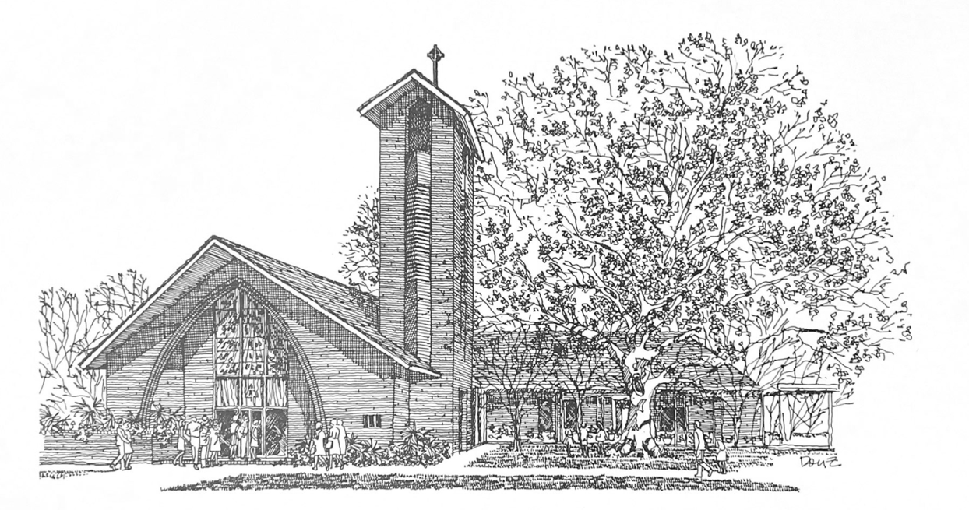


S E C O N D S U N D AY
I N L E N T

M A R C H 1 , 2 0 2 6
8 A M & 1 0 A M

H O L Y E U C H A R I S T R I T E I

At the 8AM Service, only the first and last verses of the opening and closing hymns are sung. The Gospel Hymn is omitted and all other responses are spoken.

T h e L i t u r g y o f t h e W o r d

Hymn 636 How firm a foundation
The Penitential Order & Decalogue BCP 319
The Confession & Absolution BCP 320
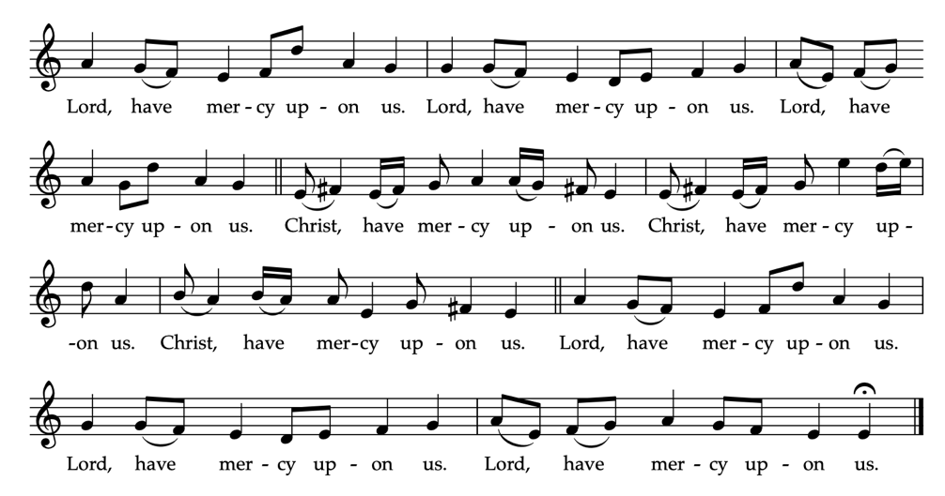
Kyrie Eleison BCP 324/10AM See below

_____________________________________________________
The Collect of the Day
O God, whose glory it is always to have mercy: Be gracious
to all who have gone astray from thy ways, and bring them
again with penitent hearts and steadfast faith to embrace and
hold fast the unchangeable truth of thy Word, Jesus Christ thy Son; who with thee and the Holy Spirit liveth and reigneth, one God, for ever and ever.
People: Amen.

Children's Moment (at 10am Service)
Children 5th grade and lower are invited to come to the chancel steps for a brief lesson on the day’s readings
_____________________________________________________First Reading Genesis 12:1-4a
The Lord said to Abram, “Go from your country and your kindred and your father’s house to the land that I will show you. I will make of you a great nation, and I will bless you, and make your name great, so that you will be a blessing. I will bless those who bless you, and the one who curses you I will curse; and in you all the families of the earth shall be blessed.”
So Abram went, as the Lord had told him; and Lot went with him.

Reader: The Word of the Lord.
People: Thanks be to God
_____________________________________________________
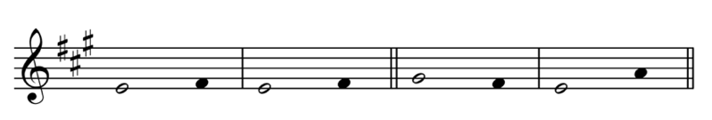
Psalm 121 Levavi oculos

1 I lift up my eyes to the | hills; *
from where is my help to | come?
2 My help comes from the | Lord, *
the maker of heaven and | earth.
3 He will not let your foot be | moved *
and he who watches over you will not fall a - | sleep.
4 Behold, he who keeps watch over | Israel *
shall neither slumber nor | sleep;
5 The Lord himself watches over | you; *
the Lord is your shade at your right | hand,
6 So that the sun shall not strike you by | day, *
nor the moon by | night.
7 The Lord shall preserve you from all | evil; *
it is he who shall keep you | safe.
8 The Lord shall watch over your going out and your coming |in,*
from this time forth for ever - | more.
Second Reading (at 10am Service) Romans 4:1-5, 13-17
What then are we to say was gained by Abraham, our ancestor according to the flesh? For if Abraham was justified by works, he has something to boast about, but not before God. For what does the scripture say? “Abraham believed God, and it was reckoned to him as righteousness.” Now to one who works, wages are not reckoned as a gift but as something due. But to one who without works trusts him who justifies the ungodly, such faith is reckoned as righteousness. For the promise that he would inherit the world did not come to Abraham or to his descendants through the law but through the righteousness of faith. If it is the adherents of the law who are to be the heirs, faith is null and the promise is void. For the law brings wrath; but where there is no law, neither is there violation. For this reason it depends on faith, in order that the promise may rest on grace and be guaranteed to all his descendants, not only to the adherents of the law but also to those who share the faith of Abraham (for he is the father of all of us, as it is written, “I have made you the father of many nations”) —in the presence of the God in whom he believed, who gives life to the dead and calls into existence the things that do not exist.

Reader: The Word of the Lord.
People: Thanks be to God.
_____________________________________________________
Hymn 401 The God of Abraham praise
_____________________________________________________
Gospel Reading John 3:1-17
Celebrant: The Holy Gospel of our Lord Jesus Christ
according to John.
People: Glory be to thee, O Lord.
There was a Pharisee named Nicodemus, a leader of the Jews. He came to Jesus by night and said to him, “Rabbi, we know that you are a teacher who has come from God; for no one can do these signs that you do apart from the presence of God.” Jesus answered him, “Very truly, I tell you, no one can see the kingdom of God without being born from above.” Nicodemus said to him, “How can anyone be born after having grown old? Can one enter a second time into the mother’s womb and be born?” Jesus answered, “Very truly, I tell you, no one can enter the kingdom of God without being born of water and Spirit. What is born of the flesh is flesh, and what is born of the Spirit is spirit. Do not be astonished that I said to you, ‘You must be born from above.’ The wind blows where it chooses, and you hear the sound of it, but you do not know where it comes from or where it goes. So it is with everyone who is born of the Spirit.” Nicodemus said to him, “How can these things be?” Jesus answered him, “Are you a teacher of Israel, and yet you do not understand these things?
“Very truly, I tell you, we speak of what we know and testify to what we have seen; yet you do not receive our testimony. If I have told you about earthly things and you do not believe, how can you believe if I tell you about heavenly things? No one has ascended into heaven except the one who descended from heaven, the Son of Man. And just as Moses lifted up the serpent in the wilderness, so must the Son of Man be lifted up, that whoever believes in him may have eternal life.
“For God so loved the world that he gave his only Son, so that everyone who believes in him may not perish but may have eternal life. “Indeed, God did not send the Son into the world to condemn the world, but in order that the world might be saved through him.”

Celebrant: The Gospel of the Lord.
People: Praise be to thee, O Christ.
_____________________________________________________
The Sermon The Rev. Peter R. Wong
The Nicene Creed BCP 326
The Prayers of the People BCP 328
The Peace BCP 332
Offertory God be in my head A. Carter
T h e L i t u r g y o f t h e T a b l e
Eucharistic Prayer I (standing) BCP 333
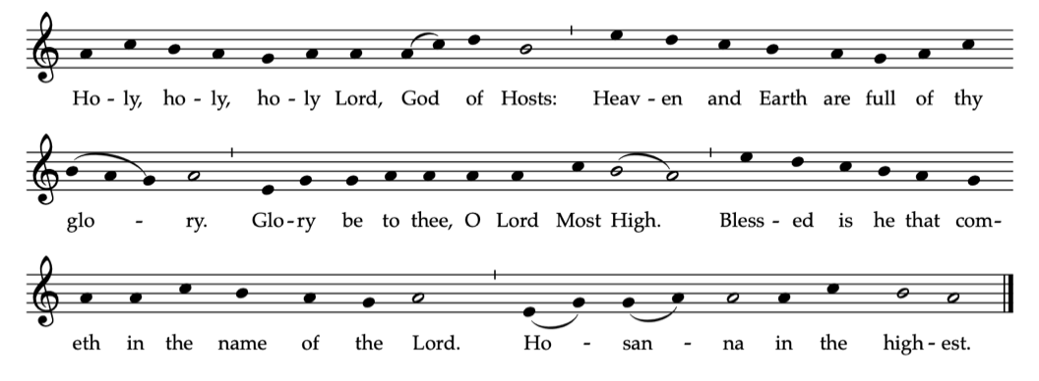
Sanctus BCP 334

The Lord’s Prayer BCP 336
The Fraction BCP 337
The Invitation BCP 338
_____________________________________________________
Communion Music
Aria F. Peters
Hymn 151 From deepest woe I cry to thee
Hymn 152 Kind maker of the world, O hear

The Episcopal Church welcomes all baptized persons
to receive Holy Communion; you may also cross your arms across your chest to receive a blessing from the priest instead of receiving.
_____________________________________________________
Prayer of Commissioning & Blessing (kneeling) BCP 339
_____________________________________________________
Hymn 495 Hail Thou, once despised Jesus!
_____________________________________________________
The Dismissal
Celebrant: Let us bless the Lord.
People: Thanks be to God.
Bishop The Rt. Rev. Shannon Rogers Duckworth | Rector The Rev. Peter R. Wong | Music Director Sam Kohler | Business Manager Aminta Dupuy | Interim Head of School Elena McPeak | Plant Manager Yeika Williams | Parish Secretary Irma Stephens | Acolytes David Chauvin, Aedan Hudman, Jude Hudman, Lila Morton, William Morton | Altar Guild Cooper Knecht, Mary Hoy | Lectors JoAnn Anderson (8AM), Owen Carmichael (10AM) | Lay Eucharist Minister Norma Rutledge | Ushers Owen Carmichael, Tom Newman, Andrew Olinde | Livestream Heath Böddie, Jennifer Johnson | Cantor Sam Bubenzer
Lenten & Holy Week Services

Every Wednesday Evening Prayer 6PM
& Lenten program
March 29 Palm Sunday 8AM and 10AM
April 2 Maundy Thursday 6PM
April 3 Good Friday Noon and 6PM
April 5 Easter Sunday 8AM and 10AM

Fellowship After Church
Please join us in the Common Room after the 10AM service for coffee and light refreshments.
Annual Parish Report
The 2026 Annual Report is available in the parish office.
Wednesday Evening Prayer
Throughout Lent this year, we will offer a brief Evening Prayer service at 6PM every Wednesday. It will include music with special guests and will be followed by soup and salad in the activities buidling.
Wednesday Newsletter
Our weekly online newsletter is published every Wednesday. Contact the church office to receive it by email, or sign-up at trinitybr.org/newsletter
W E L C O M E T O T R I N I T Y
If you are a guest today, we warmly welcome you.
Please fill out a card and place it in the offering plate so we know you were here.
We would love to hear from you.

Online Giving

You can contribute to our ministry here:


Upcoming Events

March
4 Lenten Program II 6PM
11 Lenten Program III 6PM
17 Vestry 5:30 (CR)
18 Lenten Program IV 6PM
22 LSU Choir 7:30PM
25 Lenten Program V 6PM

April
2 Maundy Thursday 6PM
3 Good Friday
Noon and 6PM

III
I
TRINITY

EPISCOPAL CHURCH

3 5 5 2 M o r n i n g G l o r y A v e.
B a t o n R o u g e , L o u i s i a n a
w w w. t r i n i t y b r. o r g ( 2 2 5 ) 3 8 7 0 3 9 6

