T R I N I T Y E P I S C O P A L C H U R C H
B A T O N R O U G E , L O U I S I A N A

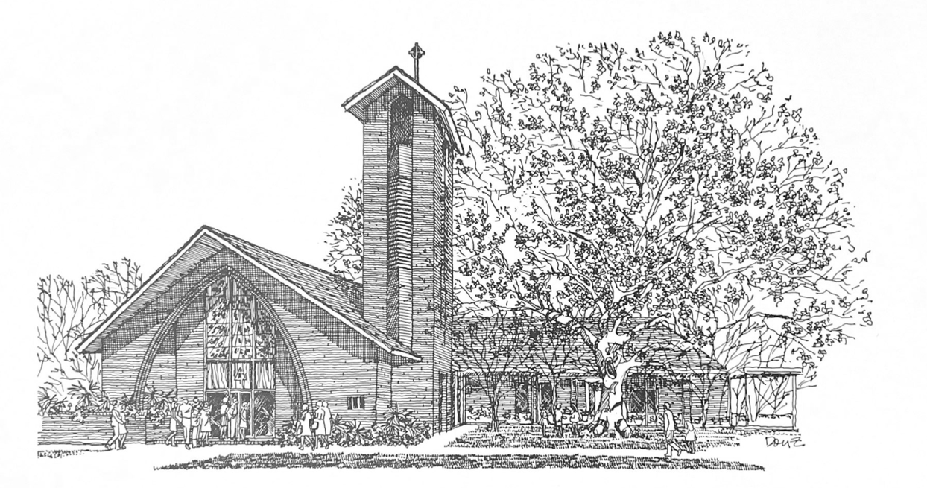

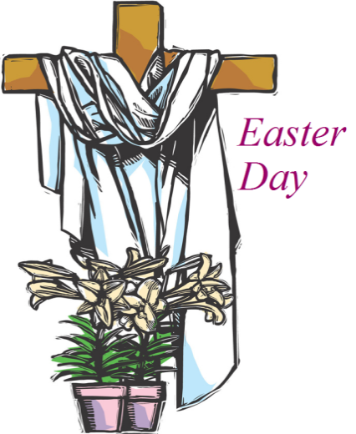
P E N T E C O S T
S U N D A Y

M A Y 2 4 , 2 0 2 6
1 0 A M

H O L Y E U C H A R I S T R I T E I I
T h e L i t u r g y o f t h e W o r d
Hymn 686 Come thou fount of every blessing
Opening Acclamation BCP 355
Song of Praise John Coltrane
The Collect of the Day
Almighty God, on this day you opened the way of eternal life to every race and nation by the promised gift of your Holy Spirit: Shed abroad this gift throughout the world by the preaching of the Gospel, that it may reach to the ends of the earth; through Jesus Christ our Lord, who lives and reigns with you, in the unity of the Holy Spirit, one God, for ever and ever.
People: Amen.
_____________________________________________________
Children's Moment
Children 5th grade and lower are invited to come to the chancel steps for a brief lesson on the day’s readings

_____________________________________________________First Reading Numbers 11:24-30
Moses went out and told the people the words of the Lord; and he gathered seventy elders of the people, and placed them all around the tent. Then the Lord came down in the cloud and spoke to him, and took some of the spirit that was on him and put it on the seventy elders; and when the spirit rested upon them, they prophesied. But they did not do so again. Two men remained in the camp, one named Eldad, and the other named Medad, and the spirit rested on them; they were among those registered, but they had not gone out to the tent, and so they prophesied in the camp. And a young man ran and told Moses, "Eldad and Medad are prophesying in the camp." And Joshua son of Nun, the assistant of Moses, one of his chosen men, said, "My lord Moses, stop them!" But Moses said to him, "Are you jealous for my sake? Would that all the Lord's people were prophets, and that the Lord would put his spirit on them!" And Moses and the elders of Israel returned to the camp.
Reader: The Word of the Lord.
People: Thanks be to God

Psalm 104:25-35, 37 Benedic, anima mea BCP 736

Second Reading Acts 2:1-21
When the day of Pentecost had come, the disciples were all together in one place. And suddenly from heaven there came a sound like the rush of a violent wind, and it filled the entire house where they were sitting. Divided tongues, as of fire, appeared among them, and a tongue rested on each of them. All of them were filled with the Holy Spirit and began to speak in other languages, as the Spirit gave them ability. Now there were devout Jews from every nation under heaven living in Jerusalem. And at this sound the crowd gathered and was bewildered, because each one heard them speaking in the native language of each. Amazed and astonished, they asked, "Are not all these who are speaking Galileans? And how is it that we hear, each of us, in our own native language? Parthians, Medes, Elamites, and residents of Mesopotamia, Judea and Cappadocia, Pontus and Asia, Phrygia and Pamphylia, Egypt and the parts of Libya belonging to Cyrene, and visitors from Rome, both Jews and proselytes, Cretans and Arabs-- in our own languages we hear them speaking about God's deeds of power." All were amazed and perplexed, saying to one another, "What does this mean?" But others sneered and said, "They are filled with new wine." But Peter, standing with the eleven, raised his voice and addressed them, "Men of Judea and all who live in Jerusalem, let this be known to you, and listen to what I say. Indeed, these are not drunk, as you suppose, for it is only nine o'clock in the morning. No, this is what was spoken through the prophet Joel:
`In the last days it will be, God declares, that I will pour out my Spirit upon all flesh, and your sons and your daughters shall prophesy, and your young men shall see visions, and your old men shall dream dreams. Even upon my slaves, both men and women, in those days I will pour out my Spirit; and they shall prophesy. And I will show portents in the heaven above and signs on the earth below, blood, and fire, and smoky mist. The sun shall be turned to darkness and the moon to blood, before the coming of the Lord's great and glorious day. Then everyone who calls on the name of the Lord shall be saved.' "
Reader: The Word of the Lord.
People: Thanks be to God.
_____________________________________________________
Hymn 516 Come down O Love Divine _____________________________________________________

Gospel Reading John 7:37-39
Celebrant: The Holy Gospel of our Lord Jesus Christ
according to John.
People: Glory to you, Lord Christ.
On the last day of the festival, the great day, while Jesus was standing there, he cried out, “Let anyone who is thirsty come to me, and let the one who believes in me drink. As the scripture has said, ‘Out of the believer’s heart shall flow rivers of living water.’” Now he said this about the Spirit, which believers in him were to receive; for as yet there was no Spirit, because Jesus was not yet glorified.
Celebrant: The Gospel of the Lord.
People: Praise to you, Lord Christ.
The Sermon The Rev. Peter R. Wong
The Nicene Creed BCP 358
The Prayers of the People (Form III) BCP 387
Celebrant: The peace of the Lord be always with you.
People: And also with you.
Announcements
Offertory Music
T h e L i t u r g y o f t h e T a b l e
Eucharistic Prayer A (standing) BCP 361
Sanctus S-129
The Lord’s Prayer, Fraction, & Invitation BCP 364

The Episcopal Church welcomes all baptized persons
to receive Holy Communion; you may also cross your arms across your chest to receive a blessing from the priest instead of receiving.

Communion Music
Hymn 325 Let us break bread together
Prayer of Commissioning (kneeling) BCP 365
The Blessing
Recessional Hymn When the saints go marching in
Verse 1 O, when the saints go marching in,
O, when the saints go marching in.
Lord, I want to be in that number
when the saints go marching in.
Verse 2 O when the sun refused to shine,
O when the sun refused to shine,
Lord, I want to be in that number
when the sun refused to shine.
Verse 3 O when they gather 'round the throne,
O when they gather 'round the throne,
Lord, I want to be in that number
when they gather 'round the throne.
Verse 4 O when they crown Him Lord of all,
O when they crown Him Lord of all,
Lord, I want to be in that number
when they crown Him Lord of all.
The Dismissal
Flowers on the altar are given to the Glory of God and in Loving Memory of Jinas Heath by Joe & Dot Alford
About the Music in Today’s Worship

The uniquely American improvised music known as “jazz” emerged in New Orleans at the turn of the 20th century from a confluence of blues, Spanish-Cuban, and African musical practices. Though it is known in the broader culture as a secular music, it has always had sacred roots.

Today’s music features mostly original compositions, some composed especially for this service. One of our songs was composed by Rev. Charles deGravelles, who served as a deacon at Trinity for about three decades.

Today’s worship also features music by John Coltrane (1926-67), who first achieved fame as a member of the Miles Davis Quintet in the mid-1950s. He experienced a divine revelation in 1957 that caused him to recover from addiction and inspired his greatest works, including A Love Supreme (1965). He is widely considered one of the most important musical figures of the 20th century, and in 1982 he was canonized as a saint by the African Orthodox Church.

Some other notable works of sacred improvised music include Duke Ellington Black, Brown, & Beige, Mary Lou Williams Mary Lou’s Mass, Alice Coltrane A Monastic Trio, John McLaughlin My Goal’s Beyond, and the works of Pharoah Sanders and Albert Ayler.

Parish Staff

Bishop The Rt. Rev. Shannon Duckworth
Rector The Rev. Peter R. Wong
Music Director Sam Kohler
Business Manager Aminta Dupuy
Head of School Elena McPeak
Plant Manager Yeika Williams
Parish Secretary Irma Stephens
Social Media Daniela Latil
Youth Ministry Darren & Alisha Hudman
Children’s Ministry Katie Huelsbeck

Ministers of the Service

Acolytes Paul Carmichael, Ben Menou, Gwen Hudman, Peter Hudman, Bradley Tirone
Lay Eucharist Minister Jeanne Hurlbert
Lector Kevin Portz
Ushers Owen Carmichael, Tom Newman, Andrew Olinde
Altar Elizabeth Fitzgerald, Norma Rutledge
Flowers Arlene Earhart, Laura Kurtz, Carol Matthews, Emily Wilbert
Livestream Heath Böddie, Jennifer Johnson
Musicians Jacob Peffer, DJ Shelton, Dane Harter, Jacob Gartenstein
Parish Announcements

Fellowship After Church
Please join us following the 10AM service for a light brunch in the common room.
Parish Office Closed
The parish office will be closed Monday May 25.
Wednesday Newsletter
Our weekly online newsletter is published every Wednesday. Contact the parish office to receive it by email, or sign-up at trinitybr.org/newsletter
GBR Food Bank Volunteering
Wednesday, May 27, 9:30-11:30AM
and last Wednesday of every month
Greater Baton Rouge Food Bank, 10600 S. Choctaw Drive
For more information, contact Ruth Barnes
ruthsb2000@gmail.com | 225-333-0487
Donate at brfoodbank.org
A donation box for non-perishable items is in the narthex

“Two Birds with One Stone” Clean-Up Day
Saturday, May 30 9AM
Join us in raking leaves along Stanford and Cherrydale, as well as cleaning out the “Red House” garage!

TRINITY CHOIR
Participation in the Trinity Choir is open to all.
No previous music experience necessary.
During the summer the choir meets 9AM Sundays.
Tuesday Bible Study
Men’s Group 7AM | Women’s Group 8:30AM
Open to all, meets in the Common Room.
Bible Study will not meet on May 26, June 23, June 30, or July 21
W E L C O M E T O T R I N I T Y
If you are a guest today, we warmly welcome you.
Please fill out a card and place it in the offering plate so we know you were here. We would love to hear from you.

Online Giving

You can contribute to our ministry here:


Upcoming Events

May

25 Parish office closed
26 No Bible study
27 GBRFB Volunteer 9:30AM
Camp Theodore Begins
30 “Two Birds with One Stone” Clean-up Day 9AM

III
I
TRINITY

EPISCOPAL CHURCH

3 5 5 2 M o r n i n g G l o r y A v e.
B a t o n R o u g e , L o u i s i a n a
w w w. t r i n i t y b r. o r g ( 2 2 5 ) 3 8 7 0 3 9 6

