T R I N I T Y E P I S C O P A L C H U R C H
B A T O N R O U G E , L O U I S I A N A

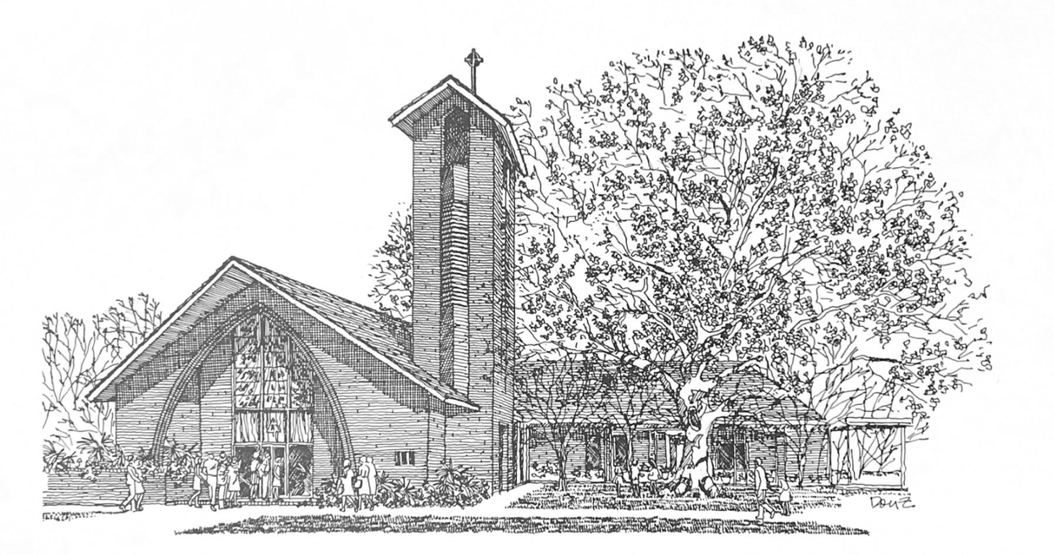

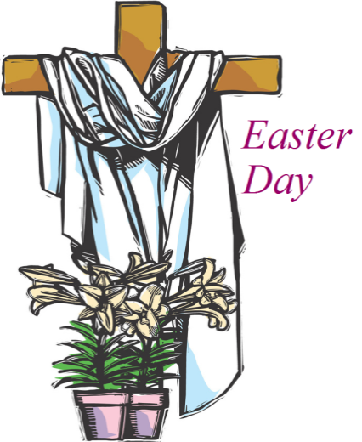
n i n e t e e n t h S u n d a y
a f t e r P e n t e c o s t

D a y S c h o o l S u n day

O c t o b e r 4 , 2 0 2 6
1 0 A M

H O L Y E U C H A R I S T R I T E I I
T h e L i t u r g y o f t h e W o r d
Throughout the service, responses can be found on the corresponding page of your red Book of Common Prayer (BCP) found in your pew.

Hymn 362 Holy, holy, Holy Lord God Almighty
Opening Acclamation
Celebrant: Blessed be God: Father, Son, and Holy Spirit.
People: And blessed be his kingdom, now and for ever. Amen.
Celebrant: Almighty God, to you all hearts are open, all desires known, and from you no secrets are hid: Cleanse the thoughts of our hearts by the inspiration of your Holy Spirit, that we may perfectly love you, and worthily magnify your holy Name, through Christ our Lord.
People: Amen.
Hymn of Praise Hymn 376 Joyful, joyful we adore thee
The Collect of the Day
Almighty and everlasting God, you are always more ready to hear than we to pray, and to give more than we either desire or deserve: Pour upon us the abundance of your mercy, forgiving us those things of which our conscience is afraid, and giving us those good things for which we are not worthy to ask, except through the merits and mediation of Jesus Christ our Savior; who lives and reigns with you and the Holy Spirit, one God, for ever and ever.

People: Amen.
The congregation may be seated.
_____________________________________________________
Children's Moment
Children 5th grade and lower are invited to come to the chancel steps for a brief lesson on the day’s readings

The Readings

Read by Trinity Day School Students

A Reading from Exodus

Reader: The Word of the Lord.
People: Thanks be to God.

A reading from Psalm 19

A reading from Philippians
Reader: The Word of the Lord.
People: Thanks be to God.
_____________________________________________________
Hymn 711 Seek Ye First _____________________________________________________

Gospel Reading Matthew 21:33-46
Celebrant: The Holy Gospel of our Lord Jesus Christ
according to Matthew.
People: Glory to you, Lord Christ.
Jesus said, “Listen to another parable. There was a landowner who planted a vineyard, put a fence around it, dug a wine press in it, and built a watchtower. Then he leased it to tenants and went to another country. When the harvest time had come, he sent his slaves to the tenants to collect his produce. But the tenants seized his slaves and beat one, killed another, and stoned another. Again he sent other slaves, more than the first; and they treated them in the same way. Finally he sent his son to them, saying, ‘They will respect my son.’ But when the tenants saw the son, they said to themselves, ‘This is the heir; come, let us kill him and get his inheritance.’ So they seized him, threw him out of the vineyard, and killed him. Now when the owner of the vineyard comes, what will he do to those tenants?” They said to him, “He will put those wretches to a miserable death, and lease the vineyard to other tenants who will give him the produce at the harvest time.”
Jesus said to them, “Have you never read in the scriptures:
‘The stone that the builders rejected has become the cornerstone;
this was the Lord’s doing, and it is amazing in our eyes’?
Therefore I tell you, the kingdom of God will be taken away from you and given to a people that produces the fruits of the kingdom. The one who falls on this stone will be broken to pieces; and it will crush anyone on whom it falls.” When the chief priests and the Pharisees heard his parables, they realized that he was speaking about them. They wanted to arrest him, but they feared the crowds, because they regarded him as a prophet.
Celebrant: The Gospel of the Lord.
People: Praise to you, Lord Christ.
The congregation may be seated.
The Sermon The Rev. Peter R. Wong _____________________________________________________
The Nicene Creed BCP 358
Read in unison.
The Prayers of the People (Form VI) BCP 392
The Absolution
The Peace
Celebrant: The peace of the Lord be always with you.
People: And also with you.
The peace is then exchanged.
Announcements
Offertory Anthem Here I am, Lord
Words and music by Dan Schutte
Presented by Trinity Children’s Choir Callie Ancelet, director
I, the Lord of sea and sky, I have heard my people cry. All who dwell in dark and sin, My hand will save. I, who made the stars of night, I will make their darkness bright. Who will bear my light to them? Whom shall I send? Here I am, Lord. Is it I, Lord? I have heard you calling in the night. I will go, Lord, if you lead me. I will hold your people in my heart.
Doxology Hymn 380, vs. 3
T h e L i t u r g y o f t h e T a b l e
Please stand as you are able.
Eucharistic Prayer A BCP 361
Celebrant: | The Lord be with you.
People: | And also with you.
Celebrant: | Lift up your hearts.
People: | We lift them to the Lord.
Celebrant: | Let us give thanks to the Lord our God.
People: | It is right to give him thanks and praise.
Celebrant: It is right. . . to proclaim the glory of your Name:
Sanctus S-130
Found in front section of the blue hymnal
Holy and gracious Father. . .Therefore we proclaim the mystery of faith:
People: Christ has died.
Christ is risen.
Christ will come again.
We celebrate the memorial of our redemption. . . all honor
and glory is yours, Almighty Father, now and for ever.
People: Amen.
The Lord’s Prayer, Fraction, & Invitation BCP 364
If you are a guest with us today, the Episcopal Church welcomes all baptized persons to receive Holy Communion. If you prefer not to, you may either come to the altar and cross your arms over your chest to receive a blessing from the priest, or you may remain in your pew.

Communion Music
Trinity Day School Students
Hymn 325 Let us break bread together
Bless the Lord, O my Soul M. Ippolitof-Ivanov
Tender Thought Traditional, Arr. Alice Parker

Please kneel as you are able.
Prayer of Commissioning BCP 365
The Blessing
Hymn 686 Come thou fount of every blessing
The Dismissal
Celebrant: Let us go forth in the name of Christ. Alleluia, alleluia.
People: Thanks be to God. Alleluia, alleluia.
Flowers on the altar are given to the Glory of God and in
Loving Memory of Lawerence Lovell by Anne Tillman.
P a r i s h A n n o u n c e m e n t s
A special thanks to the Trinity Day School faculty, in particular those who helped coordinate today’s service: Amy McRae, Callie Ancelet, and Elena McPeak.
Wednesday Newsletter
Our weekly online newsletter is published every Wednesday. The newsletter features articles written by staff and parishioners, updates on parish events, and a calendar of local happenings. Contact the parish office or sign-up at trinitybr.org/newsletter
Music at Trinity Fall 2026 Events
October 22, 7:30PM: LSU Chamber Singers
December 1, 7:30PM: LSU Chamber Singers
Free and open to the public, join us for presentations of sacred music in our beautiful space.

Trinity Choir
Participation in the Trinity Choir is open to all!
No previous music experience necessary.
The choir meets 7PM Wednesdays and 9AM Sundays.
GBR Food Bank Volunteering
Wednesday, October 28, 9:30-11:30AM
and last Wednesday monthly
Greater Baton Rouge Food Bank, 10600 S. Choctaw Drive
For more information, contact Ruth Barnes
ruthsb2000@gmail.com | 225-333-0487 | brfoodbank.org
A donation box for non-perishable items is in the narthex

W E L C O M E T O T R I N I T Y
If you are a guest with us today, please fill out a card and place it in the offering plate so we know you were here. We would love to hear from you, and hope you will join us following the service for a reception provided by Trinity Day School!
Join us for Bible Study
Note: Bible Study will not meet this week
Monday: Bible Study 6PM | Compline Service 7PM | For all ages!
Tuesday: Men’s Group 7AM | Women’s Group 8:30AM
Promise Fund
Support Trinity Day School with a donation to the Promise Fund!

Online Giving

Contribute to our ministry here:
Happening at Trinity

October
5-6 No Bible study
15 Cookout 5:30PM
22 LSU Chamber Singers 7:30PM
23 Trunk-or-treat

III
I

TRINITY

EPISCOPAL CHURCH

3 5 5 2 M o r n i n g G l o r y A v e.
B a t o n R o u g e , L o u i s i a n a
w w w. t r i n i t y b r. o r g ( 2 2 5 ) 3 8 7 0 3 9 6

