T R I N I T Y E P I S C O P A L C H U R C H
B A T O N R O U G E , L O U I S I A N A

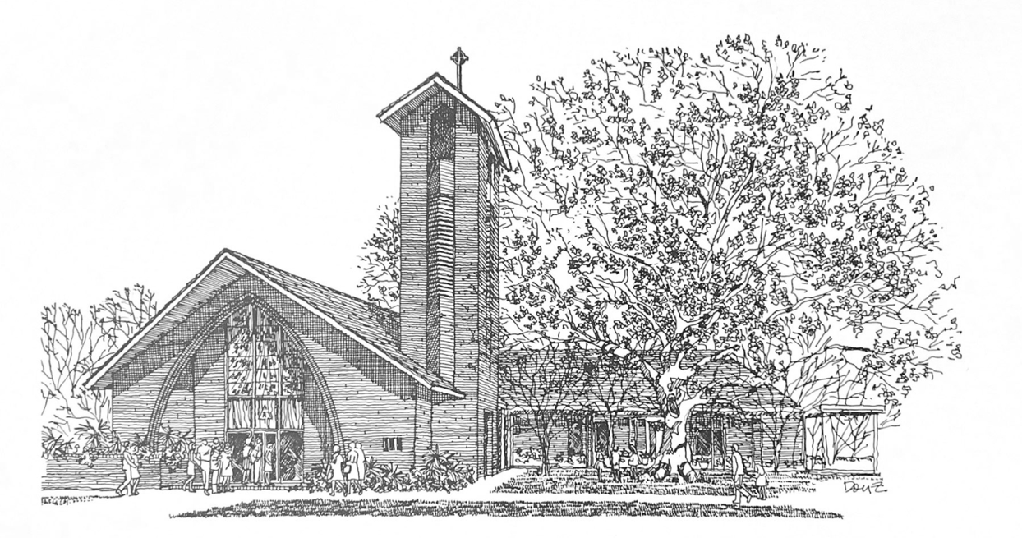


F i r s t S u n d a y
i n L e n t

F E B R U A R Y 2 2 , 2 0 2 6
8 A M & 1 0 A M

H O L Y E U C H A R I S T R I T E I

At the 8AM Service, only the first and last verses of the opening and closing hymns are sung. The Gospel Hymn is omitted and all other responses are spoken.

T h e L i t u r g y o f t h e W o r d

Hymn 681 Our God to whom we turn
The Penitential Order & Decalogue BCP 319
The Confession & Absolution BCP 320
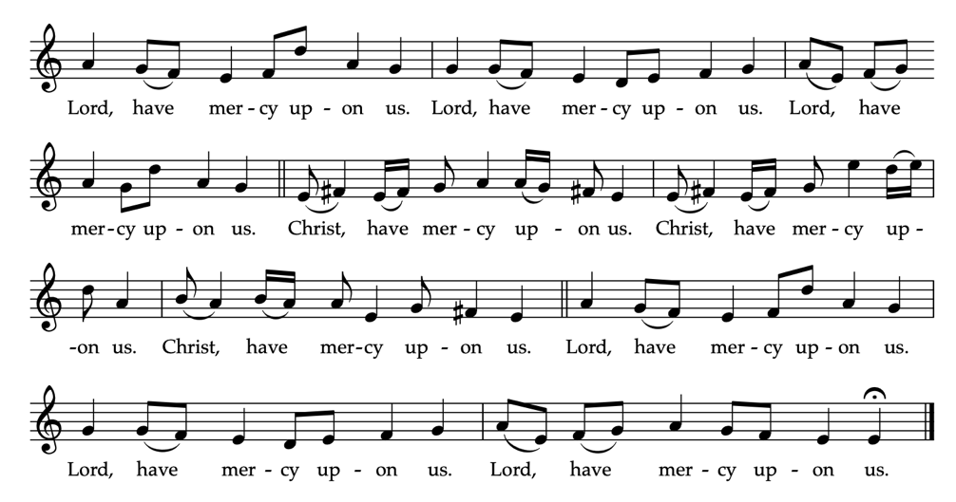
Kyrie Eleison BCP 324

_____________________________________________________
The Collect of the Day
Almighty God, whose blessed Son was led by the Spirit to be tempted by Satan: Come quickly to help us who are assaulted by many temptations; and, as you know the weaknesses of each of us, let each one find you mighty to save; through Jesus Christ your Son our Lord, who lives and reigns with you and the Holy Spirit, one God, now and for ever.
People: Amen.

Children's Moment (at 10am Service)
Children 5th grade and lower are invited to come to the chancel steps for a brief lesson on the day’s readings
_____________________________________________________First Reading Genesis 2:15-17; 3:1-7
The Lord God took the man and put him in the garden of Eden to till it and keep it. And the Lord God commanded the man, “You may freely eat of every tree of the garden; but of the tree of the knowledge of good and evil you shall not eat, for in the day that you eat of it you shall die.”
Now the serpent was more crafty than any other wild animal that the Lord God had made. He said to the woman, “Did God say, ‘You shall not eat from any tree in the garden’?” The woman said to the serpent, “We may eat of the fruit of the trees in the garden; but God said, ‘You shall not eat of the fruit of the tree that is in the middle of the garden, nor shall you touch it, or you shall die.’“ But the serpent said to the woman, “You will not die; for God knows that when you eat of it your eyes will be opened, and you will be like God, knowing good and evil.” So when the woman saw that the tree was good for food, and that it was a delight to the eyes, and that the tree was to be desired to make one wise, she took of its fruit and ate; and she also gave some to her husband, who was with her, and he ate. Then the eyes of both were opened, and they knew that they were naked; and they sewed fig leaves together and made loincloths for themselves.

Reader: The Word of the Lord.
People: Thanks be to God
_____________________________________________________
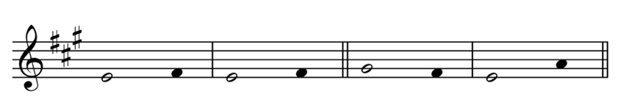
Psalm 32 Beati quorum

1 Happy are they whose transgressions are for | given, *
and whose sin is put a | way!
2 Happy are they to whom the Lord imputes no | guilt, *
and in whose spirit there is no | guile!
3 While I held my tongue, my bones withered a | way, *
because of my groaning all day | long.
4 For your hand was heavy upon me day and | night; *
my moisture was dried up as in the heat of | summer.
5 Then I acknowledged my sin to | you, *
and did not conceal my | guilt.
6 I said, "I will confess my transgressions to the | Lord." *
Then you forgave me the guilt of my | sin.
7 Therefore all the faithful will make their prayers
to you in time of | trouble; *
when the great waters overflow, they shall not reach | them.
8 You are my hiding-place;
you preserve me from | trouble; *
you surround me with shouts of de | liverance.
9 "I will instruct you and teach you in the way
that you should | go;*
I will guide you with my | eye.
10 Do not be like horse or mule, which have no under |standing; *
who must be fitted with bit and bridle,
or else they will not stay | near you."
11 Great are the tribulations of the | wicked; *
but mercy embraces those who trust in the | Lord.
12 Be glad, you righteous, and rejoice in the | Lord; *
shout for joy, all who are true of | heart.
_____________________________________________________
Second Reading (at 10am Service) Romans 5:12-19
As sin came into the world through one man, and death came through sin, and so death spread to all because all have sinned-- sin was indeed in the world before the law, but sin is not reckoned when there is no law. Yet death exercised dominion from Adam to Moses, even over those whose sins were not like the transgression of Adam, who is a type of the one who was to come. But the free gift is not like the trespass. For if the many died through the one man's trespass, much more surely have the grace of God and the free gift in the grace of the one man, Jesus Christ, abounded for the many. And the free gift is not like the effect of the one man's sin. For the judgment following one trespass brought condemnation, but the free gift following many trespasses brings justification. If, because of the one man's trespass, death exercised dominion through that one, much more surely will those who receive the abundance of grace and the free gift of righteousness exercise dominion in life through the one man, Jesus Christ. Therefore just as one man's trespass led to condemnation for all, so one man's act of righteousness leads to justification and life for all. For just as by the one man's disobedience the many were made sinners, so by the one man's obedience the many will be made righteous.

Reader: The Word of the Lord.
People: Thanks be to God.
_____________________________________________________
Hymn 150 Forty days and forty nights
_____________________________________________________
Gospel Reading Matthew 4:1-11
Celebrant: The Holy Gospel of our Lord Jesus Christ
according to Matthew.
People: Glory to you, Lord Christ.
Jesus was led up by the Spirit into the wilderness to be tempted by the devil. He fasted forty days and forty nights, and afterwards he was famished. The tempter came and said to him, “If you are the Son of God, command these stones to become loaves of bread.” But he answered, “It is written, ‘One does not live by bread alone, but by every word that comes from the mouth of God.’” Then the devil took him to the holy city and placed him on the pinnacle of the temple, saying to him, “If you are the Son of God, throw yourself down; for it is written, ‘He will command his angels concerning you,’ and ‘On their hands they will bear you up, so that you will not dash your foot against a stone.’” Jesus said to him, “Again it is written, ‘Do not put the Lord your God to the test.’” Again, the devil took him to a very high mountain and showed him all the kingdoms of the world and their splendor; and he said to him, “All these I will give you, if you will fall down and worship me.” Jesus said to him, “Away with you, Satan! for it is written, ‘Worship the Lord your God, and serve only him.’” Then the devil left him, and suddenly angels came and waited on him.

Celebrant: The Gospel of the Lord.
People: Praise to you, Lord Christ.
_____________________________________________________
The Sermon The Rev. Peter R. Wong
The Nicene Creed BCP 326
The Prayers of the People BCP 328
The Peace BCP 332
Offertory Ave Verum Corpus E. Elgar
During the season of Lent, the Doxology is omitted.
_____________________________________________________
T h e L i t u r g y o f t h e T a b l e
Eucharistic Prayer I (standing) BCP 333
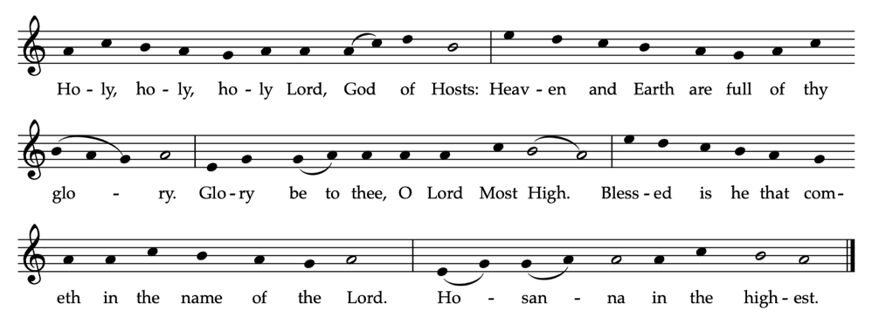
Sanctus BCP 334

The Lord’s Prayer BCP 336
The Fraction BCP 337
The Invitation BCP 338

Communion Music
Erbarm dich mein, o Herre Gott, BWV 721 J.S. Bach
Hymn 149 Eternal Lord of love
Hymn 635 If thou but trust in God to guide thee
The Episcopal Church welcomes all baptized persons
to receive Holy Communion; you may also cross your arms across your chest to receive a blessing from the priest instead of receiving.
_____________________________________________________
Prayer of Commissioning (kneeling) BCP 339
The Blessing
_____________________________________________________
Hymn 687 A mighty fortress is our God
_____________________________________________________
The Dismissal

Celebrant: Let us go forth in the name of Christ,
Alleluia, Alleluia
People: Thanks be to God. Alleluia, alleluia.
_____________________________________________________
Bishop The Rt. Rev. Shannon Rogers Duckworth | Rector The Rev. Peter R. Wong | Music Director Sam Kohler | Business Manager Aminta Dupuy | Interim Head of School Elena McPeak | Plant Manager Yeika Williams | Parish Secretary Irma Stephens | Acolytes Locke Brackin, Ben Heinlein, Caleb Heinlein, Annie Higgins, James Peter Wong | Altar Guild Elizabeth Fitzgerald, Renee Renegar | Lectors Carol Young (8AM), Mary Olinde (10AM) | Lay Eucharist Minister Kelly Viator | Ushers Ed Stauss, Victor Stater | Livestream Heath Böddie, Jennifer Johnson | Cantor Sam Bubenzer

Lenten Services

Every Wednesday Evening Prayer 6PM
March 29 Palm Sunday 8AM and 10AM
April 2 Maundy Thursday 6PM
April 3 Good Friday Noon and 6PM
April 5 Easter Sunday 8AM and 10AM

W E L C O M E T O T R I N I T Y
If you are a guest today, we warmly welcome you.
Please fill out a card and place it in the offering plate so we know you were here.
We would love to hear from you.

Online Giving

You can contribute to our ministry here:


Upcoming Events

February
24 Vestry 5:30PM (CR)
25 Evening Prayer 6PM

March
4 Evening Prayer 6PM
11 Evening Prayer 6PM
18 Evening Prayer 6PM
22 LSU Choir 7:30PM
25 Evening Prayer 6PM

April
2 Maundy Thursday 6PM
3 Good Friday
Noon and 6PM

III
I
TRINITY

EPISCOPAL CHURCH

3 5 5 2 M o r n i n g G l o r y A v e.
B a t o n R o u g e , L o u i s i a n a
w w w. t r i n i t y b r. o r g ( 2 2 5 ) 3 8 7 0 3 9 6

