T R I N I T Y E P I S C O P A L C H U R C H
B A T O N R O U G E , L O U I S I A N A

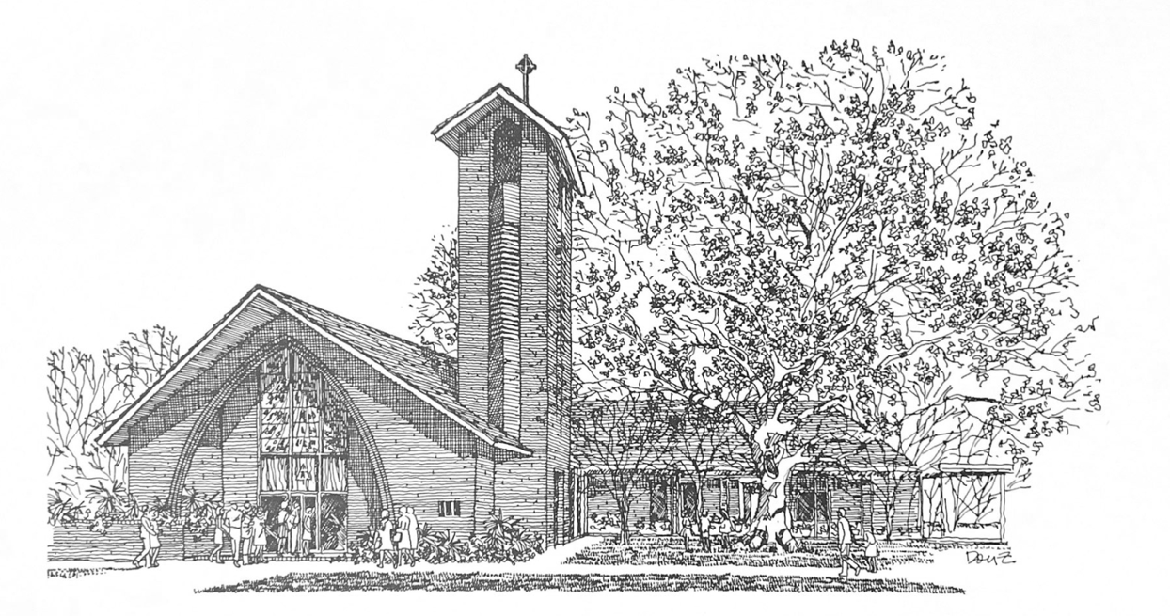


F I F T H S U N D AY
I N L E N T

M A R C H 2 2 , 2 0 2 6
8 A M & 1 0 A M

H O L Y E U C H A R I S T R I T E I

At the 8AM Service, only the first and last verses of the opening and closing hymns are sung. The Gospel Hymn is omitted and all other responses are spoken.
T h e L i t u r g y o f t h e W o r d
Hymn 547 Awake, O sleeper, rise from death
The Penitential Order & Decalogue BCP 319
The Confession & Absolution BCP 320
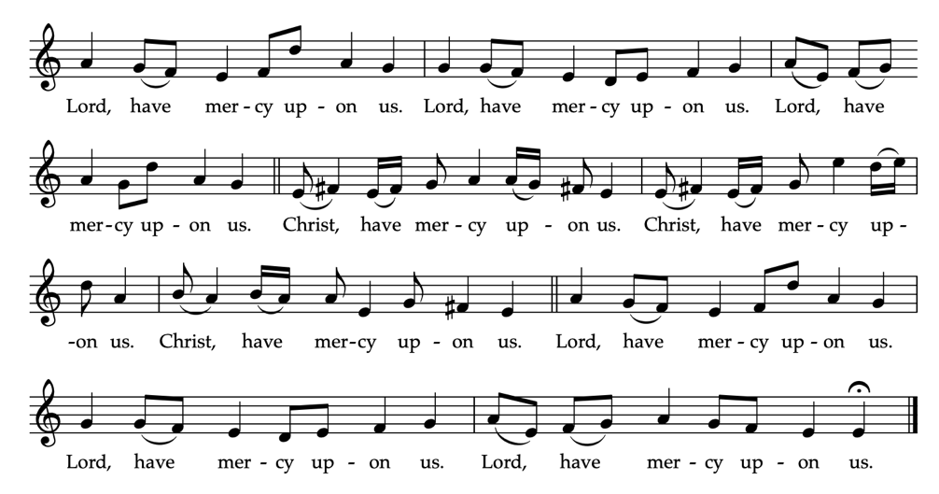
Kyrie Eleison BCP 324 | See Below

_____________________________________________________
The Collect of the Day
O Almighty God, who alone canst order the unruly wills and
affections of sinful men: Grant unto thy people that they may
love the thing which thou commandest, and desire that
which thou dost promise; that so, among the sundry and
manifold changes of the world, our hearts may surely there
be fixed where true joys are to be found; through Jesus
Christ our Lord, who liveth and reigneth with thee and the
Holy Spirit, one God, now and for ever.
People: Amen.
_____________________________________________________

Children's Moment (at 10am Service)
Children 5th grade and lower are invited to come to the chancel steps for a brief lesson on the day’s readings
_____________________________________________________
First Reading Ezekiel 37:1-14
The hand of the Lord came upon me, and he brought me out by the spirit of the Lord and set me down in the middle of a valley; it was full of bones. He led me all around them; there were very many lying in the valley, and they were very dry. He said to me, “Mortal, can these bones live?” I answered, “O Lord God, you know.” Then he said to me, “Prophesy to these bones, and say to them: O dry bones, hear the word of the Lord. Thus says the Lord God to these bones: I will cause breath to enter you, and you shall live. I will lay sinews on you, and will cause flesh to come upon you, and cover you with skin, and put breath in you, and you shall live; and you shall know that I am the Lord.”
So I prophesied as I had been commanded; and as I prophesied, suddenly there was a noise, a rattling, and the bones came together, bone to its bone. I looked, and there were sinews on them, and flesh had come upon them, and skin had covered them; but there was no breath in them. Then he said to me, “Prophesy to the breath, prophesy, mortal, and say to the breath: Thus says the Lord God: Come from the four winds, O breath, and breathe upon these slain, that they may live.” I prophesied as he commanded me, and the breath came into them, and they lived, and stood on their feet, a vast multitude.
Then he said to me, “Mortal, these bones are the whole house of Israel. They say, ‘Our bones are dried up, and our hope is lost; we are cut off completely.’ Therefore prophesy, and say to them, Thus says the Lord God: I am going to open your graves, and bring you up from your graves, O my people; and I will bring you back to the land of Israel. And you shall know that I am the Lord, when I open your graves, and bring you up from your graves, O my people. I will put my spirit within you, and you shall live, and I will place you on your own soil; then you shall know that I, the Lord, have spoken and will act,” says the Lord.

Reader: The Word of the Lord.
People: Thanks be to God
_____________________________________________________
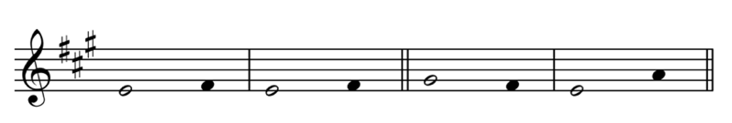
Psalm 130 De profundis

1 Out of the depths have I called to you, O Lord;
Lord, hear my | voice; *
let your ears consider well the voice of my suppli- | cation.
2 If you, Lord, were to note what is done a - | miss, *
O Lord, who could | stand?
3 For there is forgiveness with | you; *
therefore you shall be | feared.
4 I wait for the Lord; my soul waits for | him; *
in his word is my | hope.
5 My soul waits for the Lord,
more than watchmen for the | morning, *
more than watchmen for the | morning.
6 O Israel, wait for the | Lord, *
for with the Lord there is | mercy;
7 With him there is plenteous re - | demption, *
and he shall redeem Israel from all their | sins.
_____________________________________________________
Second Reading (at 10am Service) Romans 8:6-11
To set the mind on the flesh is death, but to set the mind on the Spirit is life and peace. For this reason the mind that is set on the flesh is hostile to God; it does not submit to God's law-- indeed it cannot, and those who are in the flesh cannot please God.
But you are not in the flesh; you are in the Spirit, since the Spirit of God dwells in you. Anyone who does not have the Spirit of Christ does not belong to him. But if Christ is in you, though the body is dead because of sin, the Spirit is life because of righteousness. If the Spirit of him who raised Jesus from the dead dwells in you, he who raised Christ from the dead will give life to your mortal bodies also through his Spirit that dwells in you.

Reader: The Word of the Lord.
People: Thanks be to God.
_____________________________________________________
Hymn 508 Breathe on me, breath of God
_____________________________________________________
Gospel Reading John 11:1-45
Celebrant: The Holy Gospel of our Lord Jesus Christ
according to John.
People: Glory be to thee, O Lord.
Now a certain man was ill, Lazarus of Bethany, the village of Mary and her sister Martha. Mary was the one who anointed the Lord with perfume and wiped his feet with her hair; her brother Lazarus was ill. So the sisters sent a message to Jesus, “Lord, he whom you love is ill.” But when Jesus heard it, he said, “This illness does not lead to death; rather it is for God’s glory, so that the Son of God may be glorified through it.” Accordingly, though Jesus loved Martha and her sister and Lazarus, after having heard that Lazarus was ill, he stayed two days longer in the place where he was.
Then after this he said to the disciples, “Let us go to Judea again.” The disciples said to him, “Rabbi, the Jews were just now trying to stone you, and are you going there again?” Jesus answered, “Are there not twelve hours of daylight? Those who walk during the day do not stumble, because they see the light of this world. But those who walk at night stumble, because the light is not in them.” After saying this, he told them, “Our friend Lazarus has fallen asleep, but I am going there to awaken him.” The disciples said to him, “Lord, if he has fallen asleep, he will be all right.” Jesus, however, had been speaking about his death, but they thought that he was referring merely to sleep. Then Jesus told them plainly, “Lazarus is dead. For your sake I am glad I was not there, so that you may believe. But let us go to him.” Thomas, who was called the Twin, said to his fellow disciples, “Let us also go, that we may die with him.” When Jesus arrived, he found that Lazarus had already been in the tomb four days. Now Bethany was near Jerusalem, some two miles away, and many of the Jews had come to Martha and Mary to console them about their brother. When Martha heard that Jesus was coming, she went and met him, while Mary stayed at home. Martha said to Jesus, “Lord, if you had been here, my brother would not have died. But even now I know that God will give you whatever you ask of him.” Jesus said to her, “Your brother will rise again.” Martha said to him, “I know that he will rise again in the resurrection on the last day.” Jesus said to her, “I am the resurrection and the life. Those who believe in me, even though they die, will live, and everyone who lives and believes in me will never die. Do you believe this?” She said to him, “Yes, Lord, I believe that you are the Messiah, the Son of God, the one coming into the world.” When she had said this, she went back and called her sister Mary, and told her privately, “The Teacher is here and is calling for you.” And when she heard it, she got up quickly and went to him. Now Jesus had not yet come to the village, but was still at the place where Martha had met him. The Jews who were with her in the house, consoling her, saw Mary get up quickly and go out. They followed her because they thought that she was going to the tomb to weep there. When Mary came where Jesus was and saw him, she knelt at his feet and said to him, “Lord, if you had been here, my brother would not have died.” When Jesus saw her weeping, and the Jews who came with her also weeping, he was greatly disturbed in spirit and deeply moved. He said, “Where have you laid him?” They said to him, “Lord, come and see.” Jesus began to weep. So the Jews said, “See how he loved him!” But some of them said, “Could not he who opened the eyes of the blind man have kept this man from dying?”Then Jesus, again greatly disturbed, came to the tomb. It was a cave, and a stone was lying against it. Jesus said, “Take away the stone.” Martha, the sister of the dead man, said to him, “Lord, already there is a stench because he has been dead four days.” Jesus said to her, “Did I not tell you that if you believed, you would see the glory of God?” So they took away the stone. And Jesus looked upward and said, “Father, I thank you for having heard me. I knew that you always hear me, but I have said this for the sake of the crowd standing here, so that they may believe that you sent me.” When he had said this, he cried with a loud voice, “Lazarus, come out!” The dead man came out, his hands and feet bound with strips of cloth, and his face wrapped in a cloth. Jesus said to them, “Unbind him, and let him go.” Many of the Jews therefore, who had come with Mary and had seen what Jesus did, believed in him.

Celebrant: The Gospel of the Lord.
People: Praise be to thee, O Christ.
_____________________________________________________
The Sermon The Rev. Peter R. Wong
The Nicene Creed BCP 326
The Prayers of the People BCP 328
The Peace BCP 332
Offertory Irish Blessing S. Bubenzer
_____________________________________________________
T h e L i t u r g y o f t h e T a b l e
Eucharistic Prayer I (standing) BCP 333
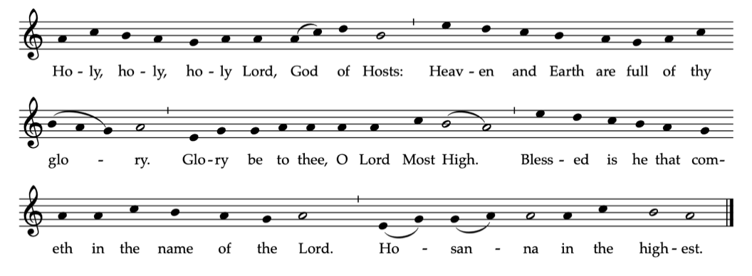
Sanctus BCP 334 | See Below

The Lord’s Prayer BCP 336
The Fraction & Invitation BCP 337 & 338
Communion Music
Elevation from Messes des Convenants F. Couperin
Hymn 151 From deepest woe I cry to thee

The Episcopal Church welcomes all baptized persons
to receive Holy Communion; you may also cross your arms across your chest to receive a blessing from the priest instead of receiving.
_____________________________________________________
Prayer of Commissioning & Blessing (kneeling) BCP 339
Hymn 511 Holy Spirit, every living
_____________________________________________________
The Dismissal
Celebrant: Let us bless the Lord.
People: Thanks be to God.
_____________________________________________________
W E L C O M E T O T R I N I T Y

Online Giving

You can contribute here:

____________________
GBR Food Bank
Volunteer at the Food Bank
Last Wednesday each month,
9:30AM-11:30AM
Donation box in the narthex
Ruth Barnes, coordinator brfoodbank.org
III
Upcoming Events
March
TONIGHT LSU Choir 8PM
25 Food Bank 9:30AM
Lenten Program V 6PM
April
2 Maundy Thursday 6PM
3 Good Friday Noon
Stations of the Cross 6PM
3-7 Parish office closed
I
EPISCOPAL CHURCH

TRINITY

