T R I N I T Y E P I S C O P A L C H U R C H
B A T O N R O U G E , L O U I S I A N A

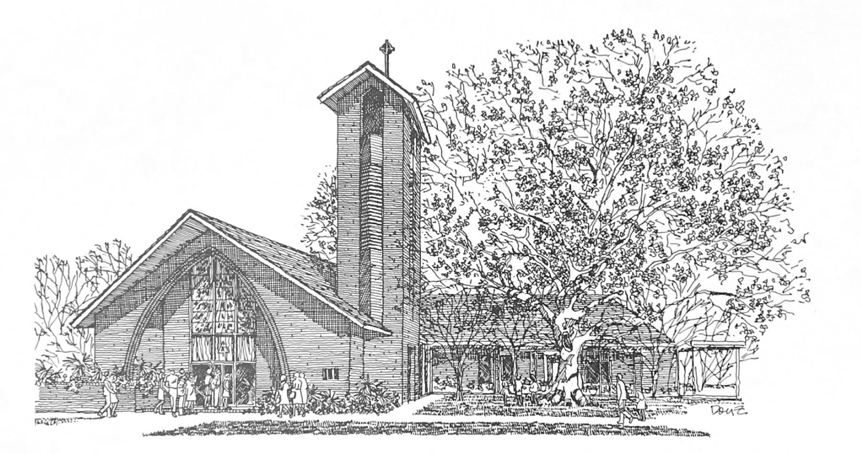

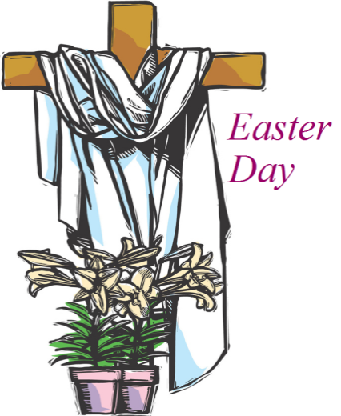
E i g h t e e n t h S u n d a y
a f t e r P e n t e c o s t

S e p t e m b e r 2 7 , 2 0 2 6
8 A M & 1 0 A M

H O L Y E U C H A R I S T R I T E I I
T h e L i t u r g y o f t h e W o r d
Hymn 492 Sing, ye faithful, sing with gladness
Opening Acclamation BCP 355
Gloria in Excelsis BCP 356 | S-280
The Collect of the Day
O God, you declare your almighty power chiefly in showing mercy and pity: Grant us the fullness of your grace, that we, running to obtain your promises, may become partakers of your heavenly treasure; through Jesus Christ our Lord, who lives and reigns with you and the Holy Spirit, one God, for ever and ever
People: Amen.
The congregation may be seated.
_____________________________________________________
Children's Moment
At the 10AM service, Children 5th grade and lower are invited to come to the chancel steps for a brief lesson on the day’s readings

_____________________________________________________First Reading Exodus 17:1-7
From the wilderness of Sin the whole congregation of the Israelites journeyed by stages, as the Lord commanded. They camped at Rephidim, but there was no water for the people to drink. The people quarreled with Moses, and said, “Give us water to drink.” Moses said to them, “Why do you quarrel with me? Why do you test the Lord?” But the people thirsted there for water; and the people complained against Moses and said, “Why did you bring us out of Egypt, to kill us and our children and livestock with thirst?” So Moses cried out to the Lord, “What shall I do with this people? They are almost ready to stone me.” The Lord said to Moses, “Go on ahead of the people, and take some of the elders of Israel with you; take in your hand the staff with which you struck the Nile, and go. I will be standing there in front of you on the rock at Horeb. Strike the rock, and water will come out of it, so that the people may drink.” Moses did so, in the sight of the elders of Israel. He called the place Massah and Meribah, because the Israelites quarreled and tested the Lord, saying, “Is the Lord among us or not?”

Reader: The Word of the Lord.
People: Thanks be to God.

_____________________________________________________
Psalm 78:1-4,12-16 Attendite, popule
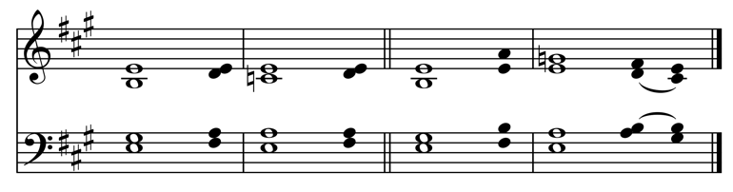
Read in unison at the 8AM service, sung at the 10AM service.
Setting by Sam Kohler
1 Hear my teaching, O my | people; *
incline your ears to the words of my | mouth.
2 I will open my mouth in a | parable; *
I will declare the mysteries of ancient | times.
3 That which we have heard and | known,
and what our forefathers have | told us, *
we will not hide from their | children.
4 We will recount to generations to | come
the praiseworthy deeds and the power of the | Lord, *
and the wonderful works he has | done.
12 He worked marvels in the sight of their | forefathers, *
in the land of Egypt, in the field of | Zoan.
13 He split open the sea and let them pass | through; *
he made the waters stand up like | walls.
14 He led them with a cloud by | day, *
and all the night through with a glow of | fire.
15 He split the hard rocks in the | wilderness *
and gave them drink as from the great | deep.
16 He brought streams out of the | cliff, *
and the waters gushed out like | rivers.

Second Reading Philippians 2:1-13
Read at the 10AM service.
If then there is any encouragement in Christ, any consolation from love, any sharing in the Spirit, any compassion and sympathy, make my joy complete: be of the same mind, having the same love, being in full accord and of one mind. Do nothing from selfish ambition or conceit, but in humility regard others as better than yourselves. Let each of you look not to your own interests, but to the interests of others. Let the same mind be in you that was in Christ Jesus, who, though he was in the form of God, did not regard equality with God as something to be exploited, but emptied himself, taking the form of a slave, being born in human likeness. And being found in human form, he humbled himself
and became obedient to the point of death -- even death on a cross. Therefore God also highly exalted him and gave him the name that is above every name, so that at the name of Jesus
every knee should bend, in heaven and on earth and under the earth, and every tongue should confess that Jesus Christ is Lord,
to the glory of God the Father. Therefore, my beloved, just as you have always obeyed me, not only in my presence, but much more now in my absence, work out your own salvation with fear and trembling; for it is God who is at work in you, enabling you both to will and to work for his good pleasure.
Reader: The Word of the Lord.
People: Thanks be to God.
_____________________________________________________
Hymn 435 At the name of Jesus _____________________________________________________

Gospel Reading Matthew 21:23-32
Celebrant: The Holy Gospel of our Lord Jesus Christ
according to Matthew.
People: Glory to you, Lord Christ.
When Jesus entered the temple, the chief priests and the elders of the people came to him as he was teaching, and said, “By what authority are you doing these things, and who gave you this authority?” Jesus said to them, “I will also ask you one question; if you tell me the answer, then I will also tell you by what authority I do these things. Did the baptism of John come from heaven, or was it of human origin?” And they argued with one another, “If we say, ‘From heaven,’ he will say to us, ‘Why then did you not believe him?’ But if we say, ‘Of human origin,’ we are afraid of the crowd; for all regard John as a prophet.” So they answered Jesus, “We do not know.” And he said to them, “Neither will I tell you by what authority I am doing these things.
“What do you think? A man had two sons; he went to the first and said, ‘Son, go and work in the vineyard today.’ He answered, ‘I will not’; but later he changed his mind and went. The father went to the second and said the same; and he answered, ‘I go, sir’; but he did not go. Which of the two did the will of his father?” They said, “The first.” Jesus said to them, “Truly I tell you, the tax collectors and the prostitutes are going into the kingdom of God ahead of you. For John came to you in the way of righteousness and you did not believe him, but the tax collectors and the prostitutes believed him; and even after you saw it, you did not change your minds and believe him.”
Celebrant: The Gospel of the Lord.
People: Praise to you, Lord Christ.
The congregation may be seated.
The Sermon The Rev. Peter R. Wong
The Nicene Creed BCP 358
The Prayers of the People (Form IV) BCP 388
Confession of Sin BCP 360
The Peace
Celebrant: The peace of the Lord be always with you.
People: And also with you.
The peace is then exchanged.
Announcements
Offertory Anthem I call on thee, Jesus Christ
Words: Miles Coverdale (1487-1568)
Music: Ich ruf zu dir (16th century)
I call on thee, Lord Jesus Christ, I have none other help but thee.
My heart is never set at rest till thy sweet word have comforted me. And steadfast faith grant me therefore, to hold by thy word evermore, above all thing, never resisting but to increase in faith more and more.
Doxology Hymn 380, vs. 3
T h e L i t u r g y o f t h e T a b l e
Please stand as you are able.
Eucharistic Prayer C BCP 369
Sanctus BCP 371 | S-129
The Lord’s Prayer, Fraction, & Invitation BCP 364
If you are a guest with us today, the Episcopal Church welcomes all baptized persons to receive Holy Communion. If you prefer not to, you may either come to the altar and cross your arms over your chest to receive a blessing from the priest, or you may remain in your pew.
Communion Music
Hymn 308 O food, to pilgrims given

Please kneel as you are able.
Prayer of Commissioning BCP 365
The Blessing
Hymn 477 All praise to thee, for thou, o King divine
The Dismissal
Celebrant: Let us go forth in the name of Christ. Alleluia, alleluia.
People: Thanks be to God. Alleluia, alleluia.
Flowers on the altar are given to the Glory of God and in
Loving Memory of Larry Luster by Jane Nell Luster.
P a r i s h A n n o u n c e m e n t s
GBR Food Bank Volunteering
Wednesday, September 30, 9:30-11:30AM
and last Wednesday monthly
Greater Baton Rouge Food Bank, 10600 S. Choctaw Drive
For more information, contact Ruth Barnes
ruthsb2000@gmail.com | 225-333-0487 | brfoodbank.org
A donation box for non-perishable items is in the narthex
Day School Sunday, October 4
Next Sunday, on October 4th, we will celebrate the ministry of Trinity Day School. Students and alumni will be present to minister different parts of the 10AM service. Our new children’s choir offered at the school will join the Trinity Choir and present a special song at the offertory. The school will provide a reception after. We hope you will join us!
Wednesday Newsletter
Our weekly online newsletter is published every Wednesday. Contact the parish office or sign-up at trinitybr.org/newsletter
Music at Trinity Fall 2026 Events
October 22, 7:30PM: LSU Chamber Singers
December 1, 7:30PM: LSU Chamber Singers
Free and open to the public, join us for presentations of sacred music in our beautiful space.

Trinity Choir
Participation in the Trinity Choir is open to all!
No previous music experience necessary.
The choir meets 7PM Wednesdays and 9AM Sundays.

W E L C O M E T O T R I N I T Y
If you are a guest with us today, please fill out a card and place it in the offering plate so we know you were here. We would love to hear from you, and hope you will join us following the service for coffee and refreshments in the Common Room!
Join us for Bible Study
Monday: Bible Study 6PM | Compline Service 7PM | For all ages!
Tuesday: Men’s Group 7AM | Women’s Group 8:30AM
Promise Fund Week
Support Trinity Day School with a donation to the Promise Fund!

Online Giving

Contribute to our ministry here:

Happening at Trinity

September
30 GBRFB Volunteer 9:30AM

October
4 Day School Sunday
15 Cookout 5:30PM
22 LSU Chamber Singers 7:30PM
23 Trunk-or-treat

III
I

TRINITY

EPISCOPAL CHURCH

3 5 5 2 M o r n i n g G l o r y A v e.
B a t o n R o u g e , L o u i s i a n a
w w w. t r i n i t y b r. o r g ( 2 2 5 ) 3 8 7 0 3 9 6

