T R I N I T Y E P I S C O P A L C H U R C H
B A T O N R O U G E , L O U I S I A N A

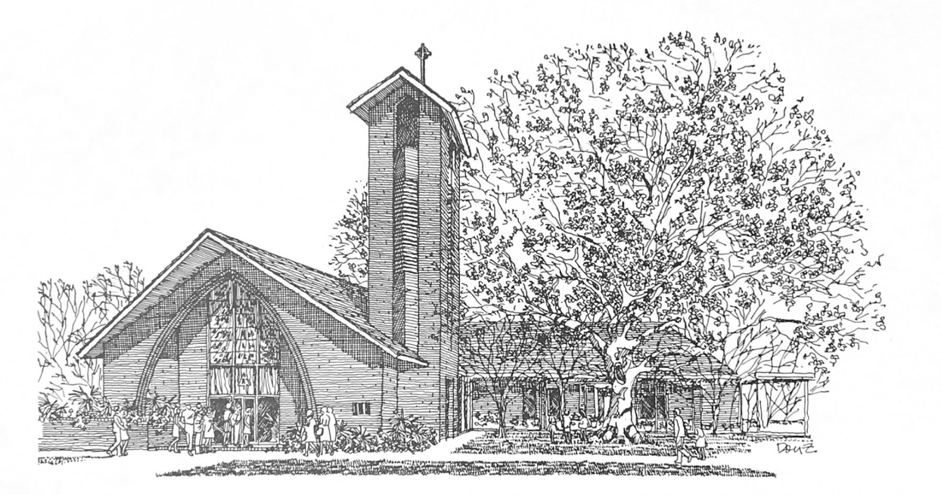

A L L S A I N T S ’ S U N D A Y

N o v e m b e r 1 , 2 0 2 6
8 A M & 1 0 A M

H O L Y E U C H A R I S T R I T E I I

T h e L i t u r g y o f t h e W o r d
Hymn 287 For all the saints (vs. 1-4, 8)
Opening Acclamation BCP 355
Gloria in Excelsis BCP 356 | Hymn 402
The Collect of the Day
Almighty God, you have knit together your elect in one communion and fellowship in the mystical body of your Son Christ our Lord: Give us grace so to follow your blessed saints in all virtuous and godly living, that we may come to those ineffable joys that you have prepared for those who truly love you; through Jesus Christ our Lord, who with you and the Holy Spirit lives and reigns, one God, in glory everlasting.
People: Amen.
The congregation may be seated.
_____________________________________________________
Children's Moment
At the 10AM service, Children 5th grade and lower are invited to come to the chancel steps for a brief lesson on the day’s readings
_____________________________________________________ First Reading Revelation 7:9-17
After this I, John, looked, and there was a great multitude that no one could count, from every nation, from all tribes and peoples and languages, standing before the throne and before the Lamb, robed in white, with palm branches in their hands. They cried out in a loud voice, saying, "Salvation belongs to our God who is seated on the throne, and to the Lamb!" And all the angels stood around the throne and around the elders and the four living creatures, and they fell on their faces before the throne and worshiped God, singing, "Amen! Blessing and glory and wisdom
and thanksgiving and honor and power and might be to our God forever and ever! Amen." Then one of the elders addressed me, saying, "Who are these, robed in white, and where have they come from?" I said to him, "Sir, you are the one that knows." Then he said to me, "These are they who have come out of the great ordeal; they have washed their robes and made them white in the blood of the Lamb. "For this reason they are before the throne of God, and worship him day and night within his temple,
and the one who is seated on the throne will shelter them.
They will hunger no more, and thirst no more; the sun will not strike them, nor any scorching heat; for the Lamb at the center of the throne will be their shepherd, and he will guide them to springs of the water of life, and God will wipe away every tear from their eyes."

Reader: The Word of the Lord.
People: Thanks be to God.

_____________________________________________________
Psalm 34:1-10,22 Benedicam Dominum
Read in unison at the 8AM service, sung at the 10AM service.
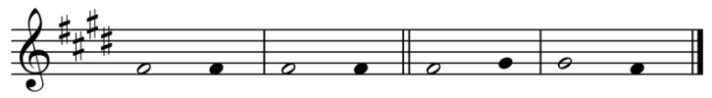
Setting by Sam Kohler
1 I will bless the Lord at all times; *
his praise shall ever be in my mouth.
2 I will glory in the Lord; *
let the humble hear and rejoice.
3 Proclaim with me the greatness of the Lord; *
let us exalt his Name together.
4 I sought the Lord, and he answered me *
and delivered me out of all my terror.
5 Look upon him and be radiant, *
and let not your faces be ashamed.
6 I called in my affliction and the Lord heard me *
and saved me from all my troubles.
7 The angel of the Lord encompasses those who fear him, *
and he will deliver them.
8 Taste and see that the Lord is good; *
happy are they who trust in him!
9 Fear the Lord, you that are his saints, *
for those who fear him lack nothing.
10 The young lions lack and suffer hunger, *
but those who seek the Lord lack nothing that is good.
22 The Lord ransoms the life of his servants, *
and none will be punished who trust in him.

____________________________________________________
Second Reading 1 John 3:1-3
Read at the 10AM service.
See what love the Father has given us, that we should be called children of God; and that is what we are. The reason the world does not know us is that it did not know him. Beloved, we are God's children now; what we will be has not yet been revealed. What we do know is this: when he is revealed, we will be like him, for we will see him as he is. And all who have this hope in him purify themselves, just as he is pure.
Reader: The Word of the Lord.
People: Thanks be to God.
_____________________________________________________
Hymn 618 Ye watchers and ye holy ones _____________________________________________________

Gospel Reading Matthew 5:1-12
Celebrant: The Holy Gospel of our Lord Jesus Christ
according to Matthew.
People: Glory to you, Lord Christ.
When Jesus saw the crowds, he went up the mountain; and after he sat down, his disciples came to him. Then he began to speak, and taught them, saying: "Blessed are the poor in spirit, for theirs is the kingdom of heaven. Blessed are those who mourn, for they will be comforted. Blessed are the meek, for they will inherit the earth. Blessed are those who hunger and thirst for righteousness, for they will be filled. Blessed are the merciful, for they will receive mercy. Blessed are the pure in heart, for they will see God. Blessed are the peacemakers, for they will be called children of God. Blessed are those who are persecuted for righteousness' sake, for theirs is the kingdom of heaven. Blessed are you when people revile you and persecute you and utter all kinds of evil against you falsely on my account. Rejoice and be glad, for your reward is great in heaven, for in the same way they persecuted the prophets who were before you."

Celebrant: The Gospel of the Lord.
People: Praise to you, Lord Christ.
The congregation may be seated.
The Sermon The Rev. Peter R. Wong
The Nicene Creed BCP 358
Confession of Sin BCP 360
The Peace
Celebrant: The peace of the Lord be always with you.
People: And also with you.
The peace is then exchanged.
Announcements
Offertory Anthem Lord, for thy tender mercy's sake
Music: Attr. Richard Farrant (16th century)
Lord, for thy tender mercy's sake, lay not our sins to our charge,
but forgive that is past, and give us grace to amend our sinful lives. To decline from sin and incline to virtue, that we may walk with an upright heart before thee, now and evermore. Amen.
Doxology Hymn 380, vs. 3
T h e L i t u r g y o f t h e T a b l e
Please stand as you are able.
Eucharistic Prayer D BCP 372
Sanctus BCP 373 | S-130
The Lord’s Prayer, Fraction, & Invitation BCP 364
If you are a guest with us today, the Episcopal Church welcomes all baptized persons to receive Holy Communion. If you prefer not to, you may either come to the altar and cross your arms over your chest to receive a blessing from the priest, or you may remain in your pew.
Communion Music
Hymn 623 O what their joy and their glory must be
Please kneel as you are able.
Prayer of Commissioning BCP 365
The Blessing
Hymn 625 Ye holy angels bright
The Dismissal
Celebrant: Let us go forth in the name of Christ. Alleluia, alleluia.
People: Thanks be to God. Alleluia, alleluia.
______________________________________
R e m e m b r a n c e s

Paul Adams
Isabel Addison
Oscar Albritton
Nancy Albritton
Paulsen Armstrong
Gerry Beggs
Helen Beggs
Jack Beggs
John Beggs
Coyle William Bossier
Frankie S. Ott-Bossier
Ihleene Brown
Kay Frances Brown
Lewis Brown
Lewis R. Brown
Robert Brown
William Francis Bruce
Kelsey Bruser
May Bruser
Beulah Burnett
Beatrice Bybee
Buford N. Bybee
Jonathan Cabrera
Aline Carnley
Dot & Howard Clampffer
Jeff Coker
Sonny Coker
Genevieve Cox Collins
Frank Collins, Jr.
Rev. David J. Coughlin, Jr.
Jean Coughlin
Curtis Crosby
Pearl DeSoto
Beth Dupaquier
Jack Dupaquier
John Dupaquier
Herbert Dyer
Rosalyn Fagan
Girard Golden
Lydia “Diane” Grant
Mildred Greenhalgh
Tony & Barbara Gremillion
Ann C. “Happy” Harris
Katerine M. Harris
Sallie L. Harris
Samuel (Sam) Harris, Jr.
Rev Terrence M. Harris
David Hartman
Eugenia Hartman
Laura H. Hays
Robert D. Hays
Fred Hochenedel
Shirley Hochenedel
Austin Hurlbert
Lucy Hurlbert
Charlie Huelsbeck
“Mr. Pete” & Jeanette Huelsbeck
S. Huston
Margaret Hutson
Bruce Johnson
Cheney C. Joseph, Jr.
Cheney C. Joseph, M.D.
Henry J. Landry, Jr.
Lainey Anne Landry
Rev. Alfred Stratton Lawrence, Jr.
Lawson C. Lott, Jr.
Lindsay McKee
Missie McKee
Harlan Moore
Jimmy Moore
Larry Moore
Vivian Moore
Margie Montgomery
Lisa Musgrove
Joseph Allen Nadler
Katherine (Kappy) Nadler
Scott Nadler
Dot Oubre
Joe Oubre
Kate Oubre
Lloyd Oubre, Jr.
Drew Peters
Mary Gertrude Querbes
Randolph A. Querbes
Marie Reece
Arville Roberts
Solange Roberts
June Rudd
Chuck Schwing
Loved ones of Skip & Judy Smart
Barbara H. Stackhouse
Ann Dowdell Stauss
Edward F. Stauss, Jr.
Doyle J. Suarez, Jr.
Frank Supetcinski
John S. Terrell
Randolph Querbes Terrell
Tetine Querbes Terrell
Stephen Paul Tuuri
Cy Steiner
Nancy Steiner
Cliff Viator
Emily Kay Viator
Grayson Ward
Bill Wilson
Jim A. Wilson
Margaret Wilson
Francis B. Williams
Lloyd F. Williams
Lloyd R. Williams
Patsy Wolfe
Rev. Camille Wood
Natalie Woods
Casey Wright
James Wright
Jenny Wright
Henrietta Joseph Yoder

W E L C O M E T O T R I N I T Y
Jazz Brunch
Please join us in the Common Room following the 10:00AM service for a Jazz brunch featuring musicians from New Orleans
Wednesday Newsletter
Our weekly online newsletter is published every Wednesday. Contact the parish office or sign-up at trinitybr.org/newsletter
Join us for Bible Study
Monday: Bible Study 6PM | Compline Service 7PM | For all ages! Tuesday: Men’s Group 7AM | Women’s Group 8:30AM
NOTE: Tuesday Bible Study will meet
in the Coughlin Library this week
Promise Fund Week
Support Trinity Day School with a donation to the Promise Fund!

Online Giving

Contribute to our ministry here:
Happening at Trinity

November
3 Federal Elections
9-17 No Bible Study
12 Fall Soiree 6:30PM
15 BRC Student Recital 3PM
21 Les Sirènes Louisianais 7P
III
I

TRINITY

EPISCOPAL CHURCH

3 5 5 2 M o r n i n g G l o r y A v e.
B a t o n R o u g e , L o u i s i a n a
w w w. t r i n i t y b r. o r g ( 2 2 5 ) 3 8 7 0 3 9 6

