Funerals at Trinity Episcopal Church

The family of Trinity Episcopal Church grieves with you at the loss of your loved one. While we recognize and proclaim the power of Christ’s resurrection even as we mourn the death of those whom we love but see no longer, we know that it is a difficult time for families. This guide is meant to help you plan and prepare for services to remember your beloved, to frame and to understand the traditions and practices of burial services at Trinity as we gather to remember the promises of Jesus in our loss.
The service for burial is an Easter liturgy. The worship is crafted to recall that central tenet of our faith. The prayers and practices recall to us that just as God fashioned each one of us, God redeems us all and every child of God is welcomed back home into the loving embrace of God. The music and readings (which may be found as an appendix to this guide) suggested are not exhaustive. If you prefer to hear another piece of the scriptures, another hymn, this is a matter which can be discussed and arranged with the clergy as you prepare for the service.
This guide with photos will help you visualize the funeral traditions of Trinity Episcopal Church.
Cremains
If there are cremated remains which will be a part of the service, the church will provide a skirted table with a brocade runner and a pall (cover) for the urn. If the remains are to be interred in the columbarium following the service, they may be processed from the front of the church to the columbarium at the end of the liturgy where the graveside prayers will follow. If the burial is to take place somewhere else, then the remains may either stay in place or be processed out with the family as you transport them to their final resting place. At the front of the church during the service, they will be honored as in the following images.
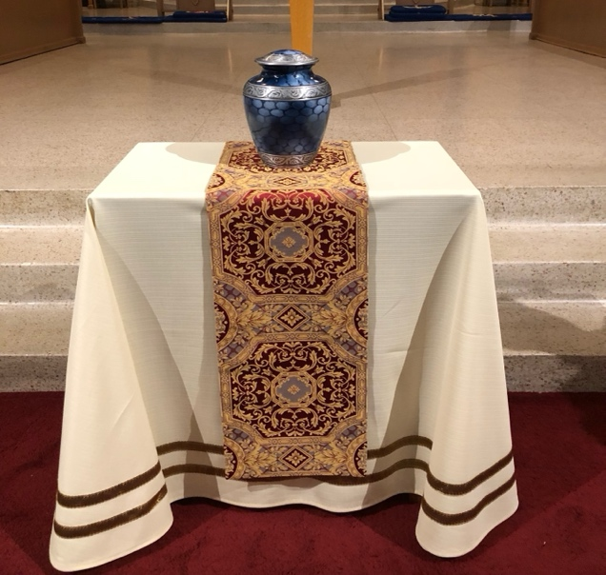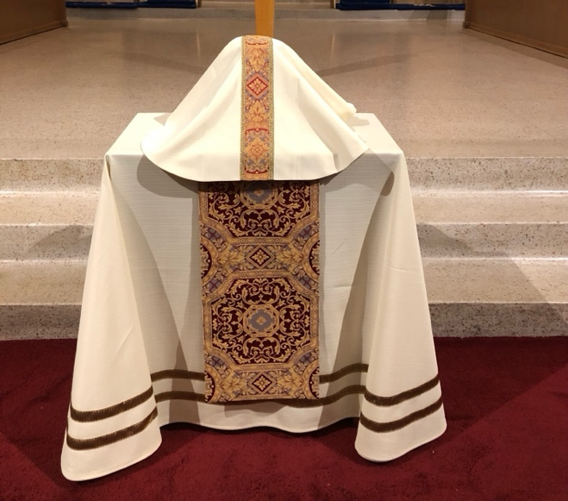

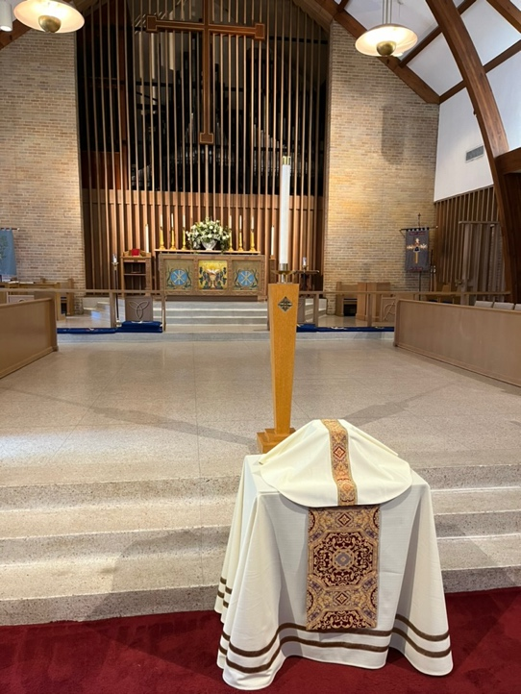
Flowers are not permitted on the table , the brocade, or the pall covering the urn. The church emphasizes that each of us who is buried from the church is sent out in the same way, a reminder of the universality of the promise of resurrection. Thus displays of photographs or memorabilia are not allowed inside the church. Memorabilia may be set up in the Common Room, where visitations or receptions are held.

Casket
If a person is to be buried in a casket, the casket is brought into the church, either by pallbearers or by the funeral home. Any sprays of flowers will be removed prior to bringing the casket in so that the casket can be covered with a pall(cover). No flowers are allowed on the pall. When the casket leaves the church, the pall will be removed, and flowers can then be placed back on the casket.
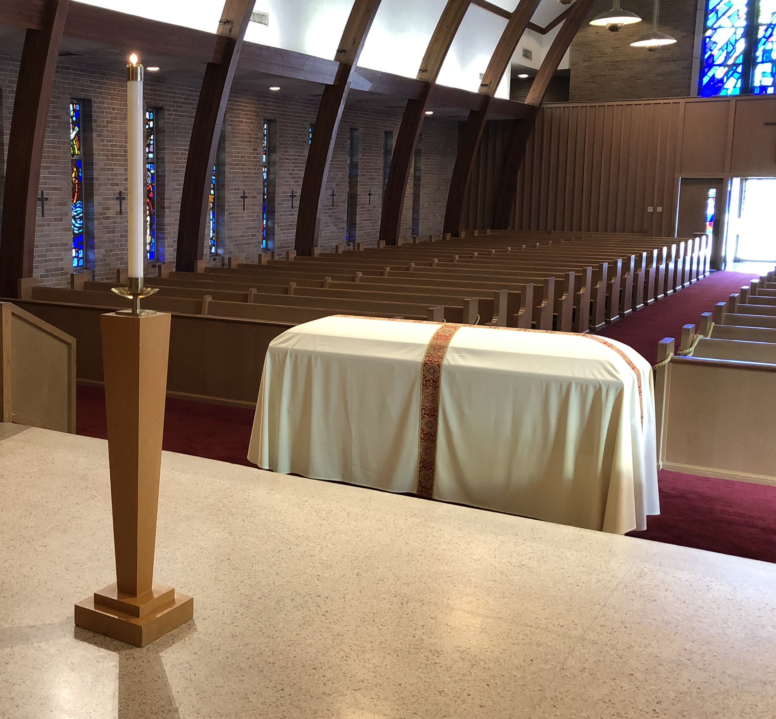.
Please note: For the funeral service, no open caskets are permitted.
Flowers
Flower arrangements are often, but not always, white, and are placed behind the altar. Several florists are familiar with the space and we can recommend one if asked. The dimensions of the permissible arrangements for the altar are as follows:
Arrangements from a florist should be no larger than 3 - 3.5 feet wide and 3 - 3.5 feet high. A typical funeral flower arrangement from a florist will cost somewhere between two hundred and three hundred dollars.
No other flowers are allowed in the church. Additional flower arrangements and sprays may be placed in the church narthex (entry area). Flowers may also be placed in the Common Room, where visitations and receptions are held.
Artificial flowers are not allowed for the arrangement in the church.
Please note: with the exception of the arrangement behind the altar, which is customarily left for the next Sunday worship service, the family should plan to take all other flowers with them after the funeral.
Heroman's on Government Street (225-344-0441) has often delivered flowers to Trinity. Please inform the church office as soon as possible if you plan a delivery from a florist, so that a volunteer can be there to receive the delivery.
The photo below shows a funeral flower arrangement.

Shown below are flower sprays in the narthex (left) and an arrangement on a table in the narthex (right).
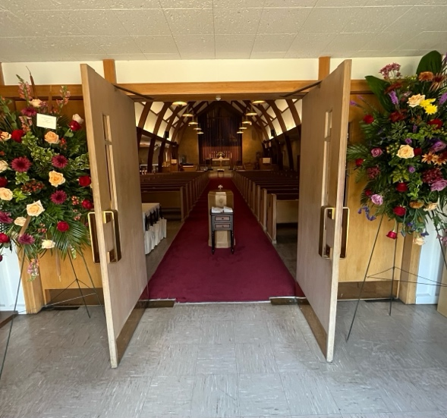

Funerals at Trinity Episcopal Church
Visitations

The Trinity Common Room can be used for a visitation preceding or following a funeral. The visitation should not be longer than 1 1/2 hours.
Photographs and other memorabilia in the Common Room may be displayed during the visitation. These may be displayed on the long table at the East side of the Common Room. If there is a slide show or other multimedia element which the family would like to have displayed during the visitation, those files should be made available no later than 24 hours prior to the scheduled start time of the visitation. Additionally, any need for easels or other means to display photos or collages should also be made known in the same time frame.
Church volunteers will provide coffee, tea, or lemonade as appropriate for the time of the gathering. If given enough planning time (typically at least 3 days), volunteers will also provide light refreshments such as cookies and fruit.
Volunteers from Trinity will help prepare the Common Room, setting out the food, plates, napkins, and utensils, and clean up afterwards.

Volunteers
The clergy are assisted by volunteers whenever there is a funeral at Trinity. The volunteers can sometimes help answer questions. You may call:

Mary Hoy (225-247-1587) or Anne Tillman (225-954-2048) Altar Guild
Emily Wilbert (225-937-4457) Flower Guild
Susan Brewer (225-933-3458) Visitations

Funerals at Trinity Episcopal Church:
Appendix A – Readings from Scripture
The number of readings for the service is largely dependent on the wishes of the family for the service. If the service is not to include a celebration of the Eucharist (Communion, Lord’s Supper) then there is no requirement for the readings to be included. If Eucharist is to be a part of the service, then a reading from one of the Gospels is required. The checklist in Appendix C will help to plan and prepare for the service. The family may choose one or more from the following list or some other appropriate reading from the Bible. The family may also choose to include a poem or other form of written expression to be read.
Old Testament Readings (First Reading)
choose one
Isaiah 25:6-9
(He will swallow up death forever)

On this mountain the Lord of hosts will make for all peoples
a feast of rich food, a feast of well-matured wines,
of rich food filled with marrow, of well-matured wines strained clear.
And he will destroy on this mountain
the shroud that is cast over all peoples,
the sheet that is spread over all nations;
he will swallow up death for ever.
Then the Lord God will wipe away the tears from all faces,
and the disgrace of his people he will take away from all the earth,
for the Lord has spoken.
It will be said on that day,
Lo, this is our God; we have waited for him, so that he might save us.
This is the Lord for whom we have waited;
let us be glad and rejoice in his salvation.

Isaiah 61:1-3
(To comfort those who mourn)

The spirit of the Lord God is upon me, because the Lord has anointed me; he has sent me to bring good news to the oppressed, to bind up the broken-hearted, to proclaim liberty to the captives, and release to the prisoners; to proclaim the year of the Lord’s favor, and the day of vengeance of our God; to comfort all who mourn; to provide for those who mourn in Zion—
to give them a garland instead of ashes,
the oil of gladness instead of mourning,
the mantle of praise instead of a faint spirit.
They will be called oaks of righteousness,
the planting of the Lord, to display his glory.

Lamentations 3:22-26, 31-33
(The Lord is good to those who wait for him)

The steadfast love of the Lord never ceases,
his mercies never come to an end;
they are new every morning;
great is your faithfulness.
‘The Lord is my portion,’ says my soul,
‘therefore I will hope in him.’
The Lord is good to those who wait for him,
to the soul that seeks him.
It is good that one should wait quietly
for the salvation of the Lord.
For the Lord will not reject forever.
Although he causes grief, he will have compassion
according to the abundance of his steadfast love;
for he does not willingly afflict or grieve anyone.

Wisdom 3:1-5, 9
(The souls of the righteous are in the hands of God)

But the souls of the righteous are in the hand of God,
and no torment will ever touch them.
In the eyes of the foolish they seemed to have died,
and their departure was thought to be a disaster,
and their going from us to be their destruction;
but they are at peace.
For though in the sight of others they were punished,
their hope is full of immortality.
Having been disciplined a little, they will receive great good,
because God tested them and found them worthy of himself;
Those who trust in him will understand truth,
and the faithful will abide with him in love,
because grace and mercy are upon his holy ones,
and he watches over his elect.

Job 19:21-27a
(I know that my Redeemer lives)
Have pity on me, have pity on me, O you my friends,
for the hand of God has touched me!
Why do you, like God, pursue me,
never satisfied with my flesh?
‘O that my words were written down!
O that they were inscribed in a book!
O that with an iron pen and with lead
they were engraved on a rock for ever!
For I know that my Redeemer lives,
and that at the last he will stand upon the earth;
and after my skin has been thus destroyed,
then in my flesh I shall see God,
whom I shall see on my side,
and my eyes shall behold, and not another.
My heart faints within me!

Psalms to be read between lessons (or in place of a hymn)
Choose One
Psalm 42
(Longing for God and His Help in Distress)

As a deer longs for flowing streams,
so my soul longs for you, O God.
My soul thirsts for God,
for the living God.
When shall I come and behold
the face of God?
My tears have been my food
day and night,
while people say to me continually,
‘Where is your God?’
These things I remember,
as I pour out my soul:
how I went with the throng,
and led them in procession to the house of God,
with glad shouts and songs of thanksgiving,
a multitude keeping festival.
Why are you cast down, O my soul,
and why are you disquieted within me?
Hope in God; for I shall again praise him,
my help and my God.
My soul is cast down within me;
therefore I remember you
from the land of Jordan and of Hermon,
from Mount Mizar.
Deep calls to deep
at the thunder of your cataracts;
all your waves and your billows
have gone over me.

Psalm 46
(God’s Defence of His City and People)

God is our refuge and strength,
a very present help in trouble.
Therefore we will not fear, though the earth should change,
though the mountains shake in the heart of the sea;
though its waters roar and foam,
though the mountains tremble with its tumult.
Selah
There is a river whose streams make glad the city of God,
the holy habitation of the Most High.
God is in the midst of the city; it shall not be moved;
God will help it when the morning dawns.
The nations are in an uproar, the kingdoms totter;
he utters his voice, the earth melts.
The Lord of hosts is with us;
the God of Jacob is our refuge.
Selah
Come, behold the works of the Lord;
see what desolations he has brought on the earth.
He makes wars cease to the end of the earth;
he breaks the bow, and shatters the spear;
he burns the shields with fire.
‘Be still, and know that I am God!
I am exalted among the nations,
I am exalted in the earth.’
The Lord of hosts is with us;
the God of Jacob is our refuge.
Selah

Psalm 90
(God’s Eternity and Human Frailty)

Lord, you have been our dwelling-place
in all generations.
Before the mountains were brought forth,
or ever you had formed the earth and the world,
from everlasting to everlasting you are God.
You turn us back to dust,
and say, ‘Turn back, you mortals.’
For a thousand years in your sight
are like yesterday when it is past,
or like a watch in the night.
You sweep them away; they are like a dream,
like grass that is renewed in the morning;
in the morning it flourishes and is renewed;
in the evening it fades and withers.
For we are consumed by your anger;
by your wrath we are overwhelmed.
You have set our iniquities before you,
our secret sins in the light of your countenance.
For all our days pass away under your wrath;
our years come to an end like a sigh.
The days of our life are seventy years,
or perhaps eighty, if we are strong;
even then their span is only toil and trouble;
they are soon gone, and we fly away.
Who considers the power of your anger?
Your wrath is as great as the fear that is due to you.
So teach us to count our days
that we may gain a wise heart.

Psalm 121
(Assurance of God’s Protection)

I lift up my eyes to the hills—
from where will my help come?
My help comes from the Lord,
who made heaven and earth.
He will not let your foot be moved;
he who keeps you will not slumber.
He who keeps Israel
will neither slumber nor sleep.
The Lord is your keeper;
the Lord is your shade at your right hand.
The sun shall not strike you by day,
nor the moon by night.
The Lord will keep you from all evil;
he will keep your life.
The Lord will keep
your going out and your coming in
from this time on and for evermore.

Psalm 130
(Waiting for Divine Redemption)

Out of the depths I cry to you, O Lord.
Lord, hear my voice!
Let your ears be attentive
to the voice of my supplications!
If you, O Lord, should mark iniquities,
Lord, who could stand?
But there is forgiveness with you,
so that you may be revered.
I wait for the Lord, my soul waits,
and in his word I hope;
my soul waits for the Lord
more than those who watch for the morning,
more than those who watch for the morning.
O Israel, hope in the Lord!
For with the Lord there is steadfast love,
and with him is great power to redeem.
It is he who will redeem Israel
from all its iniquities.

Psalm 139: 1-11
(The Inescapable God)

O Lord, you have searched me and known me.
You know when I sit down and when I rise up;
you discern my thoughts from far away.
You search out my path and my lying down,
and are acquainted with all my ways.
Even before a word is on my tongue,
O Lord, you know it completely.
You hem me in, behind and before,
and lay your hand upon me.
Such knowledge is too wonderful for me;
it is so high that I cannot attain it.
Where can I go from your spirit?
Or where can I flee from your presence?
If I ascend to heaven, you are there;
if I make my bed in Sheol, you are there.
If I take the wings of the morning
and settle at the farthest limits of the sea,
even there your hand shall lead me,
and your right hand shall hold me fast.
If I say, ‘Surely the darkness shall cover me,
and the light around me become night’,
even the darkness will not be dark to you;
the night will shine like the day,
for darkness is as light to you.

New Testament Readings (Second Reading)
choose One

Romans 8:14-19, 34-35, 37-39
(The Glory that shall be revealed)

For all who are led by the Spirit of God are children of God. For you did not receive a spirit of slavery to fall back into fear, but you have received a spirit of adoption. When we cry, ‘Abba! Father!’ it is that very Spirit bearing witness with our spirit that we are children of God, and if children, then heirs, heirs of God and joint heirs with Christ—if, in fact, we suffer with him so that we may also be glorified with him. I consider that the sufferings of this present time are not worth comparing with the glory about to be revealed to us. For the creation waits with eager longing for the revealing of the children of God; Who is to condemn? It is Christ Jesus, who died, yes, who was raised, who is at the right hand of God, who indeed intercedes for us.
Who will separate us from the love of Christ? Will hardship, or distress, or persecution, or famine, or nakedness, or peril, or sword? No, in all these things we are more than conquerors through him who loved us. For I am convinced that neither death, nor life, nor angels, nor rulers, nor things present, nor things to come, nor powers, nor height, nor depth, nor anything else in all creation, will be able to separate us from the love of God in Christ Jesus our Lord.

Corinthians 15:2-26, 35-38, 42-44,53-58
(The Imperishable Body)

Now I should remind you, brothers and sisters, of the good news that I proclaimed to you, which you in turn received, in which also you stand, through which also you are being saved, if you hold firmly to the message that I proclaimed to you—unless you have come to believe in vain. For I handed on to you as of first importance what I in turn had received: that Christ died for our sins in accordance with the scriptures, and that he was buried, and that he was raised on the third day in accordance with the scriptures, and that he appeared to Cephas, then to the twelve. Then he appeared to more than five hundred brothers and sisters at one time, most of whom are still alive, though some have died. Then he appeared to James, then to all the apostles. Last of all, as to someone untimely born, he appeared also to me. For I am the least of the apostles, unfit to be called an apostle, because I persecuted the church of God. But by the grace of God I am what I am, and his grace towards me has not been in vain. On the contrary, I worked harder than any of them—though it was not I, but the grace of God that is with me. Whether then it was I or they, so we proclaim and so you have come to believe.
Now if Christ is proclaimed as raised from the dead, how can some of you say there is no resurrection of the dead? If there is no resurrection of the dead, then Christ has not been raised; and if Christ has not been raised, then our proclamation has been in vain and your faith has been in vain. We are even found to be misrepresenting God, because we testified of God that he raised Christ—whom he did not raise if it is true that the dead are not raised. For if the dead are not raised, then Christ has not been raised. If Christ has not been raised, your faith is futile and you are still in your sins. Then those also who have died in Christ have perished. If for this life only we have hoped in Christ, we are of all people most to be pitied.
But in fact Christ has been raised from the dead, the first fruits of those who have died. For since death came through a human being, the resurrection of the dead has also come through a human being; for as all die in Adam, so all will be made alive in Christ. But each in his own order: Christ the first fruits, then at his coming those who belong to Christ. Then comes the end, when he hands over the kingdom to God the Father, after he has destroyed every ruler and every authority and power. For he must reign until he has put all his enemies under his feet. The last enemy to be destroyed is death.
But someone will ask, ‘How are the dead raised? With what kind of body do they come?’ Fool! What you sow does not come to life unless it dies. And as for what you sow, you do not sow the body that is to be, but a bare seed, perhaps of wheat or of some other grain. But God gives it a body as he has chosen, and to each kind of seed its own body.
So it is with the resurrection of the dead. What is sown is perishable, what is raised is imperishable. It is sown in dishonour, it is raised in glory. It is sown in weakness, it is raised in power. It is sown a physical body, it is raised a spiritual body. If there is a physical body, there is also a spiritual body. For this perishable body must put on imperishability, and this mortal body must put on immortality. When this perishable body puts on imperishability, and this mortal body puts on immortality, then the saying that is written will be fulfilled:
‘Death has been swallowed up in victory.’
‘Where, O death, is your victory?
Where, O death, is your sting?’
The sting of death is sin, and the power of sin is the law. But thanks be to God, who gives us the victory through our Lord Jesus Christ.
Therefore, my beloved, be steadfast, immovable, always excelling in the work of the Lord, because you know that in the Lord your labour is not in vain.

2 Corinthians 4:6-5:9
(Things that are unseen are eternal)

For it is the God who said, ‘Let light shine out of darkness’, who has shone in our hearts to give the light of the knowledge of the glory of God in the face of Jesus Christ. But we have this treasure in clay jars, so that it may be made clear that this extraordinary power belongs to God and does not come from us. We are afflicted in every way, but not crushed; perplexed, but not driven to despair; persecuted, but not forsaken; struck down, but not destroyed; always carrying in the body the death of Jesus, so that the life of Jesus may also be made visible in our bodies. For while we live, we are always being given up to death for Jesus’ sake, so that the life of Jesus may be made visible in our mortal flesh. So death is at work in us, but life in you. But just as we have the same spirit of faith that is in accordance with scripture—‘I believed, and so I spoke’—we also believe, and so we speak, because we know that the one who raised the Lord Jesus will raise us also with Jesus, and will bring us with you into his presence. Yes, everything is for your sake, so that grace, as it extends to more and more people, may increase thanksgiving, to the glory of God.

So we do not lose heart. Even though our outer nature is wasting away, our inner nature is being renewed day by day. For this slight momentary affliction is preparing us for an eternal weight of glory beyond all measure, because we look not at what can be seen but at what cannot be seen; for what can be seen is temporary, but what cannot be seen is eternal.
For we know that if the earthly tent we live in is destroyed, we have a building from God, a house not made with hands, eternal in the heavens. For in this tent we groan, longing to be clothed with our heavenly dwelling— if indeed, when we have taken it off we will not be found naked. For while we are still in this tent, we groan under our burden, because we wish not to be unclothed but to be further clothed, so that what is mortal may be swallowed up by life. He who has prepared us for this very thing is God, who has given us the Spirit as a guarantee. So we are always confident; even though we know that while we are at home in the body we are away from the Lord— for we walk by faith, not by sight. Yes, we do have confidence, and we would rather be away from the body and at home with the Lord. So whether we are at home or away, we make it our aim to please him.
1 John 3:1-2
(We shall be like Him)

See what love the Father has given us, that we should be called children of God; and that is what we are. The reason the world does not know us is that it did not know him. Beloved, we are God’s children now; what we will be has not yet been revealed. What we do know is this: when he is revealed, we will be like him, for we will see him as he is.

Revelation 7:9-17
(God will wipe away every tear)

After this I looked, and there was a great multitude that no one could count, from every nation, from all tribes and peoples and languages, standing before the throne and before the Lamb, robed in white, with palm branches in their hands. They cried out in a loud voice, saying,
‘Salvation belongs to our God who is seated on the throne, and to the Lamb!’
And all the angels stood around the throne and around the elders and the four living creatures, and they fell on their faces before the throne and worshipped God, singing,
‘Amen! Blessing and glory and wisdom and thanksgiving and honour
and power and might be to our God for ever and ever! Amen.’
Then one of the elders addressed me, saying, ‘Who are these, robed in white, and where have they come from?’ I said to him, ‘Sir, you are the one that knows.’ Then he said to me, ‘These are they who have come out of the great ordeal; they have washed their robes and made them white in the blood of the Lamb.
For this reason they are before the throne of God, and worship him day and night within his temple, and the one who is seated on the throne will shelter them. They will hunger no more, and thirst no more; the sun will not strike them, nor any scorching heat; for the Lamb at the centre of the throne will be their shepherd, and he will guide them to springs of the water of life, and God will wipe away every tear from their eyes.’

Revelation 21:2-7
(Behold, I make all things new)

And I saw the holy city, the new Jerusalem, coming down out of heaven from God, prepared as a bride adorned for her husband. And I heard a loud voice from the throne saying,
‘See, the home of God is among mortals.
He will dwell with them;
they will be his peoples,
and God himself will be with them;
he will wipe every tear from their eyes.
Death will be no more;
mourning and crying and pain will be no more,
for the first things have passed away.’
And the one who was seated on the throne said, ‘See, I am making all things new.’ Also he said, ‘Write this, for these words are trustworthy and true.’ Then he said to me, ‘It is done! I am the Alpha and the Omega, the beginning and the end. To the thirsty I will give water as a gift from the spring of the water of life. Those who conquer will inherit these things, and I will be their God and they will be my children.

Psalms to be read between lessons (or in place of a hymn)
Choose one if desired

Psalm 23

The Lord is my shepherd; I shall not want.
He maketh me to lie down in green pastures: he leadeth me beside the still waters.
He restoreth my soul: he leadeth me in the paths of righteousness for his name’s sake.
Yea, though I walk through the valley of the shadow of death, I will fear no evil: for thou art with me; thy rod and thy staff they comfort me.
Thou preparest a table before me in the presence of mine enemies: thou anointest my head with oil; my cup runneth over.
Surely goodness and mercy shall follow me all the days of my life: and I will dwell in the house of the Lord for ever.

Psalm 106

Praise ye the Lord. O give thanks unto the Lord; for he is good: for his mercy endureth for ever.
Who can utter the mighty acts of the Lord? who can shew forth all his praise?
Blessed are they that keep judgment, and he that doeth righteousness at all times.
Remember me, O Lord, with the favour that thou bearest unto thy people: O visit me with thy salvation;
That I may see the good of thy chosen, that I may rejoice in the gladness of thy nation, that I may glory with thine inheritance.

Psalm 27

The Lord is my light and my salvation; whom shall I fear? The Lord is the stronghold of my life; of whom shall I be afraid?
When evildoers assail me to devour my flesh— my adversaries and foes— they shall stumble and fall.
Though an army encamp against me, my heart shall not fear; though war rise up against me, yet I will be confident.
One thing I asked of the Lord, that will I seek after: to live in the house of the Lord all the days of my life, to behold the beauty of the Lord, and to inquire in his temple.
For he will hide me in his shelter in the day of trouble; he will conceal me under the cover of his tent; he will set me high on a rock.
Now my head is lifted up above my enemies all around me, and I will offer in his tent sacrifices with shouts of joy; I will sing and make melody to the Lord.
Hear, O Lord, when I cry aloud, be gracious to me and answer me!
“Come,” my heart says, “seek his face!” Your face, Lord, do I seek.
Do not hide your face from me. Do not turn your servant away in anger, you who have been my help. Do not cast me off, do not forsake me, O God of my salvation!
If my father and mother forsake me, the Lord will take me up.
Teach me your way, O Lord, and lead me on a level path because of my enemies.
Do not give me up to the will of my adversaries, for false witnesses have risen against me, and they are breathing out violence.
I believe that I shall see the goodness of the Lord in the land of the living.
Wait for the Lord; be strong, and let your heart take courage; wait for the Lord!

Psalm 116

I love the Lord, because he hath heard my voice and my supplications.
Because he hath inclined his ear unto me, therefore will I call upon him as long as I live.
The sorrows of death compassed me, and the pains of hell gat hold upon me: I found trouble and sorrow.
Then called I upon the name of the Lord; O Lord, I beseech thee, deliver my soul.
Gracious is the Lord, and righteous; yea, our God is merciful.
The Lord preserveth the simple: I was brought low, and he helped me.
Return unto thy rest, O my soul; for the Lord hath dealt bountifully with thee.
For thou hast delivered my soul from death, mine eyes from tears, and my feet from falling.
I will walk before the Lord in the land of the living.
I believed, therefore have I spoken: I was greatly afflicted:
I said in my haste, All men are liars.
What shall I render unto the Lord for all his benefits toward me?
I will take the cup of salvation, and call upon the name of the Lord.
I will pay my vows unto the Lord now in the presence of all his people.
Precious in the sight of the Lord is the death of his saints.
O Lord, truly I am thy servant; I am thy servant, and the son of thine handmaid: thou hast loosed my bonds.
I will offer to thee the sacrifice of thanksgiving, and will call upon the name of the Lord.
I will pay my vows unto the Lord now in the presence of all his people.
In the courts of the Lord’s house, in the midst of thee, O Jerusalem. Praise ye the Lord.

Readings from the Gospel
Choose one
(required if Communion is a part of the burial service)

John 5:24-27
(He who believes has everlasting life)

Very truly, I tell you, anyone who hears my word and believes him who sent me has eternal life, and does not come under judgment, but has passed from death to life. “Very truly, I tell you, the hour is coming, and is now here, when the dead will hear the voice of the Son of God, and those who hear will live. For just as the Father has life in himself, so he has granted the Son also to have life in himself; and he has given him authority to execute judgment, because he is the Son of Man.

John 6:37-40
(All that the Father gives me will come to you)

Everything that the Father gives me will come to me, and anyone who comes to me I will never drive away; for I have come down from heaven, not to do my own will, but the will of him who sent me. And this is the will of him who sent me, that I should lose nothing of all that he has given me, but raise it up on the last day. This is indeed the will of my Father, that all who see the Son and believe in him may have eternal life; and I will raise them up on the last day.”

John 10:11-16
(I am the Good Shepherd)

“I am the good shepherd. The good shepherd lays down his life for the sheep. The hired hand, who is not the shepherd and does not own the sheep, sees the wolf coming and leaves the sheep and runs away—and the wolf snatches them and scatters them. The hired hand runs away because a hired hand does not care for the sheep. I am the good shepherd. I know my own and my own know me, just as the Father knows me and I know the Father. And I lay down my life for the sheep. I have other sheep that do not belong to this fold. I must bring them also, and they will listen to my voice. So there will be one flock, one shepherd.

John 11:21-27
(I am the resurrection and the life)

Martha said to Jesus, “Lord, if you had been here, my brother would not have died. But even now I know that God will give you whatever you ask of him.” Jesus said to her, “Your brother will rise again.” Martha said to him, “I know that he will rise again in the resurrection on the last day.” Jesus said to her, “I am the resurrection and the life. Those who believe in me, even though they die, will live, and everyone who lives and believes in me will never die. Do you believe this?” She said to him, “Yes, Lord, I believe that you are the Messiah, the Son of God, the one coming into the world.”

John 14:1-6
(In my Father’s house are many rooms)

“Do not let your hearts be troubled. Believe in God, believe also in me. In my Father’s house there are many dwelling places. If it were not so, would I have told you that I go to prepare a place for you? And if I go and prepare a place for you, I will come again and will take you to myself, so that where I am, there you may be also.
And you know the way to the place where I am going.” Thomas said to him, “Lord, we do not know where you are going. How can we know the way?” Jesus said to him, “I am the way, and the truth, and the life. No one comes to the Father except through me.

Funerals at Trinity Episcopal Church:
Appendix B – Music for the Service
As with the service, musical selections are meant to reinforce the message of resurrection, of the certainty the church proclaims of the grace of God which redeems us. Trinity is blessed with a pipe organ and excellent musicians. We have a rich tradition of hymns which serve this purpose. No pre-recorded, streamed, or other such source of music is a part of our funeral services. These are more appropriate for family gatherings apart from the church.
A mighty fortress is our God 687
All my hope on God is founded 665
Alleluia, the strife is o’er 208
For all the saints 287
Guide me, O thou great Jehovah 690
How firm a foundation 636
I to the hills will life mine eyes 668 (setting of Psalm 121)
Jerusalem, my happy home 620
Jerusalem the golden 624
Let saints on earth in concert sing 526
Lord thou hast searched me 702 (setting of Psalm 139)
My shepherd will supply my need 664 (setting of Psalm 23)
O God our help in ages past 680 (setting of Psalm 90)
O love of God how strong and true 455
O worship the king, all glorious 388 (setting of Psalm 104)
Praise the Lord, ye heavens adore him 373 (setting of Psalm 148)
Sing, ye faithful sing with gladness 492
The king of love my shepherd is 645 (setting of Psalm 23)
The Lord my God, my shepherd is 663 (setting of Psalm 23)
Ye holy angels bright 625
Ye watchers and ye holy ones 618
Funerals at Trinity Episcopal Church:
Appendix C – Service Preparation
Name of decedent:
Decedent’s date of birth & death:
Date and Time of Service:
Visitation: Before service After service None
Type of Service: Burial Office Eucharist Graveside
Remains: Cremains Casket None
Readings:
- Old Testament:
- Psalm:
- New Testament:
- Gospel (required if the service includes Eucharist):
Music:
- Prelude:
- Opening Hymn:
- Gospel Hymn (Eucharist):
- Closing Hymn:
- Postlude:
- Other music:

