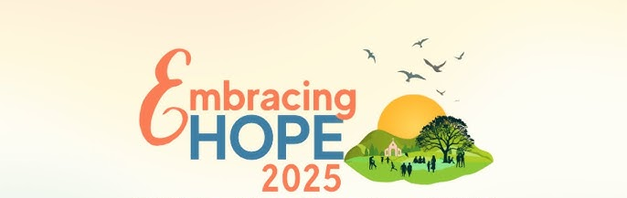

SCHEDULE OF LESSONS FOR 2025-26 Grade 7 Year 1
Students are expected to come prepared with their book, pencil or pen, and a notebook for journaling and recording their completed challenges as well as attend additional activities/events. Session 8:45-9:55 Mass 10am
09/21 Lesson 1: “Why am I here?” (An introduction)
Expectations/ Journal
10/05 Lesson 2: “What makes me happy?” (Discovering God as a source)
10/19 Lesson 3: “What’s your story?” (A Look at Salvation History)
10/30 JMJ mission talk on Blessed Carlo and the Eucharist
11/02 Lesson 4: “How do I know God is real?” (Understanding Divine Revelation)
11/16 Empowering God’s Children
12/07 Lesson 5: “Who is Jesus?” (The Person and Mission of Christ)
Immaculate Conception
12/21 Lesson 6: “Why be Catholic?” (Discovering the Church Jesus Founded

END OF FIRST SEMESTER
01/04 Lesson 7: “Where Am I going?” (A Look at the Last Four Things)
02/01 Lesson 8: “How do I get there?” (The Power and Purpose of the Sacraments)
How to get more out of Mass
02/? TBA
03/01 Lesson 9: “When did my journey begin?” (Baptism, your initiation into God’s Family)
03/15 lesson 10: “Why tell my sins to a priest?” (The Healing Power of Confession)
04/19 Lesson 11: “How does God help when it hurts?”(Anointing of the Sick/Redemptive Suffering)
05/03 Lesson 12: “Who is the Holy Spirit?”
END OF SECOND SEMESTER

Reviewing Prayers should be part of every session
Family Handbook is available on our website
(609)390-2203
cotrrreliged@yahoo.com
www.saintmaxkolbe.com

Catechist:__

