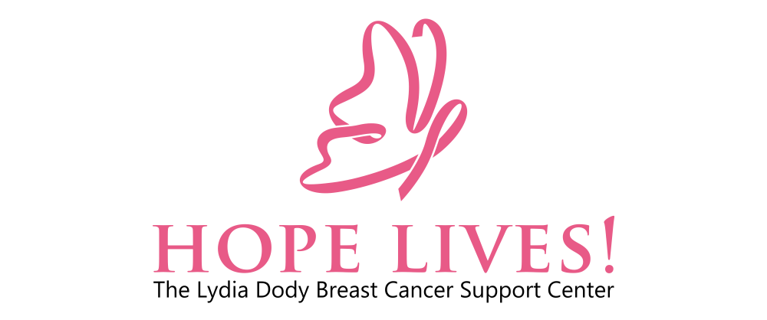

Board Meeting Minutes- July 10th, 2024

In attendance:
Mark Koepsell, Gretchen Johnson, Lana Schuler, Collis Woodward, Carole Crane, Elise Carver, Debbi Potts, Laura Hickey

General:
- Approval of May Meeting Minutes, approved unanimously.
- Approval of June Meeting Minutes, approved unanimously.
- When Lydia returns from her vacation, there will be an executive team strategic planning.
- Mark made an announcement that we need to respect office hours when communicating with one another. Office hours are 9AM-4PM, Monday-Friday.

Financials:
- Collis feels that over all we are sitting in pretty good shape
- We have $74K more in our cahs position than we did last year.
- Our liability is very low.
- Our donations are currently higher than we budgeted, but our event revenue is lower than we budgeted.
- We have spent $23K more on fundraising than we budgeted for, but that is expected to even out as the year goes on.
- We brought in a little over $12K from the 5K.
- Financials approved by board unanimously.

5K overview:
- Overall, the 5K went great.
- Laura proposes that next year we develop committees.
  - Vendor committee.
  - Volunteer coordinator.
  - Food and bev committee.
  - Sponsorship coordinator.
- Laura also proposes that these committee leaders meet in person twice a month for the 2 months leading up to the 5K.
- No professional timing next year, HAL Sports did not do the timing correctly and they did not have a strong follow up after the event. Better to save the $1500 next year.
- Board proposals for 5K next year:
  - Remove the “running” from the title. Perhaps Walking for Hope! next year?
  - Wanting to make it more playful, costumes and competition.
  - Bring the VIP tent closer. This year it was in the middle but HAL Sports changed their set up the same day.
  - Less food next year.
  - Developing more communication with clients to feel welcome to come.

Elise report:
- We are just over 2 months away from Golfing for Hope!
- Wants to have fun with the fact that the tournament is on September 13th. The 13th place award, the 2nd to last award, etc.
- Earlier start this year, 5AM hard start.
- We have a few sponsors but we need more.
  - Mark said Xanadu can do ball sponsorship if needed.
- We also need more players, we need 32 foursomes.
- Elise will send out a google sheet of things we need to all Board Members so they can sign up to bring items (tables, chairs, coolers, etc.).
- Also ready to start asking for silent auction items.

Debbi report:
- 85 people have applied, 75 people have been onboarded.
  - 3 not eligible.
  - 4 deceased.
  - 5 canceled and waiting to schedule.
- Currently have 5 new Ambassadors.
- Christmas in August is coming along.
  - Pink HL sunglasses and the leftover 5K t-shirts will be presents to our clients.
  - Built to be something that brings joy to our clients and saying that we care.
- We need gas cards, transportation is a huge issue for our clients.
- Wants to begin a “Sponsor a Woman” recurring donation.
  - “$500/year is $42 a month!”
- Timberline Church Table.
  - Debbi has sent out a list of who is working when.
  - Will build a cheat sheet of frequently asked questions so we are all on the same page.
  - Timberline provides the table, the chairs, and table cloth. We bring everything else.
  - We are not allowed to solicit. The purpose is to answer questions and be approachable and have organic conversations.

Laura report:
- Most of report was the 5K overview.
- Has been working on the Spanish brochure.
- Proposed the idea of microevents to support Hope Lives!.
  - Fundraiser at a movie theater.
  - Benefit concert with local bands, artists, and vendors.
  - Trivia night.
- Will be the volunteer coordinator for Golfing for Hope!.
- Also working on the 3rd Party Event Policy and application.

Next board meeting is scheduled IN PERSON on August 7th, 2024 from 5-7PM at
The Creative Agency
(3201 East Mulberry Suite I. Fort Collins, CO 80524)

