District Lead Volunteer

Skegness, Spilsby and District

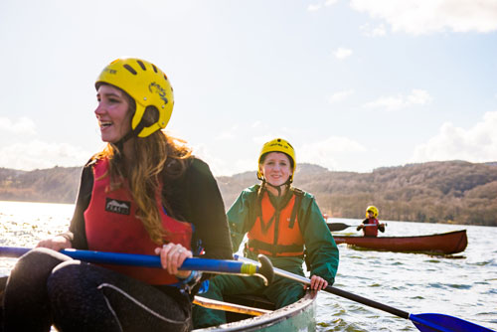

Volunteer Vacancy Pack

2 About us
Overview of Scouting
We are the UK’s biggest mixed youth organisation. We change lives by offering 4- to 25-year-olds fun and challenging activities, unique experiences, everyday adventure and the chance to help others so that we make a positive impact in communities. Scouts helps children and young adults reach their full potential. Our members gain valuable skills for life including teamwork, time management, leadership, initiative, planning, communication, self-motivation, cultural awareness and commitment. We help young people to get jobs, save lives and even change the world.
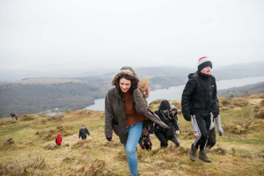

What do Scouts do?
Scouts take part in a wide range of activities as diverse as kayaking, abseiling, expeditions overseas, photography, climbing and zorbing. As a Scout you can learn survival skills, first aid, computer programming or even how to fly a plane. There’s something for everyone. It’s a great way to have fun, make friends, get outdoors, express your creativity and experience the wider world.
What do volunteers do?
This everyday adventure is only possible thanks to our team of adult volunteers, who support Scouts in a wide range of roles from working directly with young people, to helping manage a local community-based Group, to being a charity Trustee. We help volunteers get the most out of their experiences at Scouts by providing opportunities for adventure, training, fun and friendship. Our award-winning training scheme for volunteers means that adults get as much from Scouts as young people. Our approach focuses on what you want to get out of volunteering with Scouts, while respecting how much time you can offer. Over 90% of Scout volunteers say that their skills and experiences have been useful in their work or personal life.
3 Key facts and figures
The Scout Association is a UK charity founded in 1907 and now boasts a membership of over 620,000 young people and adult leaders. We are the largest mixed youth movement in the UK. Scouting activity is delivered through 7,000-plus community-based Scout Groups nationwide. Scouting is widely recognised and is one of the most trusted charities in the UK, giving it a significant level of influence and responsibility. Scouting’s greatest strength lies in its grass roots. It is locally that Scouting is best able to identify and work directly with young people most in need. We believe that through the everyday adventure of Scouting, young people and adult volunteers regularly experience new challenges that enrich and change their lives. The current focus for the Trustees and those in Scouting in the UK is delivering our strategic vision.

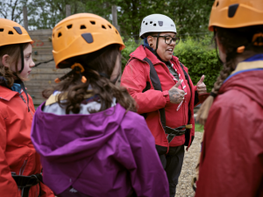
Our strategy

A new strategic plan for Scouting across the UK is currently nearing completion to secure a strategic direction through to 2025 and to grow on the success of the current plan. Team UK (the team of Lead Volunteers that leads Scouting across the UK) will play a key part in leading the delivery of this strategy. More details on the work towards our new plan are available at www.scouts.org.uk/ourplan

By 2025 we will have prepared more young people with skills for life, supported by amazing leaders delivering an inspiring programme. We will be growing, more inclusive, shaped by young people and making a bigger impact in our communities. Further information on our strategic objectives are provided on our website at www.scouts.org.uk/ourplan

4 Scouting’s fundamentals
Our mission
Scouting exists to actively engage and support young people in their personal development, empowering them to make a positive contribution to society.
Our values
As Scouts, we are guided by these values:
Integrity
Respect
Care
Belief
Co-operation
Further information on our fundamentals, including details of our values, are provided on our website at http://scouts.org.uk/about-us/key-policies/fundamentals-of-scouting/ Scouting’s key policies in common with all members in Scouting, District Lead Volunteers are required to promote and follow our key policies.
The policies cover:
Child Protection
Equal Opportunities
Religion
Safety
These policies are fully explained on our website at http://scouts.org.uk/about-us/key-policies/
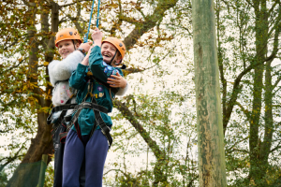
5 The role
Overview
We’re currently looking for a District Lead Volunteer. This is a management role, and we need someone who can provide leadership, inspiration, motivation and guidance to our other adult volunteers. A large part of this role involves supporting managers of local Groups. For any adult volunteer in Scouting, their manager will be a regular point of call for support. You don’t need any prior experience of Scouting to apply for this role: we’ll make sure you’re fully trained and supported.
About the district / area covered

Skegness and Spilsby District sits geographically at the East of Lincolnshire County including Skegness, Alford, Wainfleet and Spilsby.

It consists of 5 Scout Groups with a total of 230 young people between the ages of 6 and 17 supported by 67 adults.
Skegness and Spilsby District is part of Lincolnshire Scout County with nearly 7,000 young people and adults.

You will be supported in your role by the county lead volunteer and the county team. more information for an informal chat about the requirements of the role or if you have any questions or queries, please contact Malcolm Moore – County Team Lead (Volunteering) using the following: email: Malcolm.Moore@lincolnshirescouts.org.uk
telephone 07402 504818

Good Scouting Managers
District Lead Volunteers support other managers, known as Group Lead Volunteers, and other volunteers. Adults at every level need support to ensure that they are motivated, inspired and focused on providing first-class Scouting. A good manager thanks other volunteers for their hard work and helps to make sure that they feel happy and supported, week after week.
The District Lead Volunteer will also provide direction for the District and will help others see the bigger Scouting picture through solid leadership. We believe that everyone in management roles within Scouting should adopt an approach that combines the skills of both leadership and management.
6. Core Skill Areas
Providing direction
A good District Lead Volunteer will create a vision for Scouting in their District and provide clear leadership for their team to implement that vision.
Working with people
It is vital that a District Lead Volunteer can create team spirit amongst the other volunteers they work with, and can form effective working relationships based on trust and the fundamental principles of Scouting:
• integrity
• respect
• care
• belief
• cooperation
Achieving results
Good District Lead Volunteers ensure that goals are achieved, plans are seen through to completion, and that good relationships are maintained within and between Scout Groups. Forging links within the local community is also an important aspect of development.
Enabling change
It is important for District Lead Volunteers to encourage volunteers to think of creative ways to improve Scouting across the District. They should then provide the support to implement appropriate changes.
Using resources
A good District Lead Volunteer will ensure that information and resources are available, helping volunteers across the District to continue to provide excellent Scouting opportunities to young people.
Managing time and personal skills
A good District Lead Volunteer should use their time effectively and be willing to continue to learn and improve

Role description
Purpose: To manage and support the Scout District to ensure it runs effectively and that Scouting within the District develops in accordance with the rules and policies of The Scouts so that that the District provides good quality Scouting for young people and proactively supports and manages adults in the District.
Appointed by: County Lead Volunteer
Responsible to: County Lead Volunteer
Responsible for: Deputy District Lead Volunteers, Group Lead Volunteers, 14-24 Teams, District Scout Network Leaders, District Scout Active Support Managers, District Scouters, District Advisers, Nights Away Advisers
Key Alliances: County Leadership Team, other District Lead Volunteers locally and regionally, Adult Training Team External contacts: Local Community Leaders, Councillors, Guiding, other youth organisation, other groups and organisations with community interest
Key tasks: Ensure that the District thrives and has the best systems in place to support the Groups, to support all adult volunteers in the District and to develop Scouting in the District.
Provide line management and support to the adults in the District that directly report to you including setting objectives for their work and holding regular reviews and one-to-one meetings.
Produce a vision for the District and implement a development plan to meet that vision.
Ensure that Scouting in the District is attractive to young people and adults from all backgrounds in the District.
Support UKHQ to deliver Preparing Better Futures by working towards the District actions.
Ensure that the District has an adequate team of supported and appropriate adults working effectively together and with others to meet the Scouting needs of the area.
Ensure that problems within the District are resolved so that excellent Scouting is provided to young people in the District.
Work with the County Lead Volunteer and other District Lead Volunteers in the County to ensure that the Scouting in the County thrives.
Some of the tasks for which the District Lead Volunteer is responsible may be delegated to others in the District, including District Team Leaders, if appointed.
Time commitment: Approximately 5-10 hours a week. Most of our volunteers give their time at evenings and weekends.
Terms of appointment: Must complete the relevant training.
Must be eligible for charity trustee status (as a member of the District Trustee body).
It is expected that whilst volunteering for this role you will undertake regulated activity therefore require a disclosure check (DBS).
Expenses: All personal expenses are covered including a mileage rate as agreed by the District Trustees
8 Person specification
Skills and abilities: Excellent written and oral communication skills
Provide advice and guidance effectively to others
Provide inspirational leadership for the District Provide strategic direction for the District
Motivate adults volunteering in the District
Build, maintain and facilitate effective working relationships with a wide range of people
Enable others to identify issues, clarify objectives, develop attainable objectives and gain the necessary skills and confidence to work as an effective team
Ability to negotiate compromises
Plan, manage and monitor own tasks and time
Construct and implement long-term plans that improve and expand the Scouting offered to young people and identify any training, resources and other needs required to undertake this work
Use basic computer software is essential

Knowledge and experience: Ability to manage adults effectively
Understanding of the challenges of working in the voluntary sector is desirable
Experience of working with young people and/or community work with adult groups Desirable
Experience of working in the Scout or Guide Movement as an adult

Personal qualities: An understanding of the needs of adult volunteers
Flexible approach Essential
Self-motivated
Able to work as part of a team and promote good teamwork
Resourceful, energetic and enthusiastic about the job
Acceptance of the fundamentals of the Scout Movement
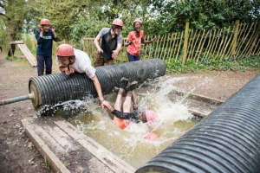

How to apply
Key dates
The closing date for applications is 15 January 2026
District Inclusion
The Scout District will be consulted formally and invited to offer nominations from both members and non-members
Applications:
Applicants are welcomed to apply by downloading the form from the County Website via this link: https://www.lincolnshirescouts.org.uk/volunteervacancies and once complete emailing to malcolm.moore@lincolnshirescouts.org.uk
Nominations: We welcome nominations and will approach the nominee. Nominations should be made via County Website or by email: malcolm.moore@lincolnshirescouts.org.uk
We will shortlist applicants / nominees and invite them for interview.
The applicants / nominees will be invited to describe how they plan to develop scouting within the District at the
interview. Applicants are invited to choose how they wish to set out their vision. This can be with a presentation,
however, applicants are invited to use formats they are comfortable with and innovate.

Further information
For an informal chat about the requirements of the role or if you have any questions or queries, please contact
Howard Nelson, County Lead Volunteer at Howard.nelson@lincolnshirescouts.org.uk ( 07764 162444) or
Malcolm.Moore@lincolnshirescouts.org,uk ( 07402 504818).

