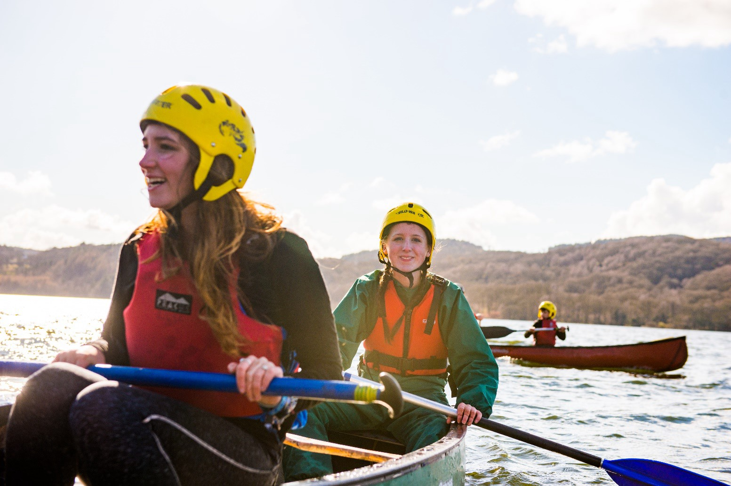
District Lead Volunteer
Information for anyone considering the role of District Lead Volunteer for Rutland



scouts.org.uk/join #SkillsForLife

About us

Overview of Scouting
We are the UK’s biggest mixed youth organisation. We change lives by offering 4 to 25 year olds, fun and challenging activities, unique experiences, everyday adventure and the chance to help others so that we make a positive impact in communities.
Scouts helps children and young adults reach their full potential. Our members gain valuable skills for life including teamwork, time management, leadership, initiative, planning, communication, self-motivation, cultural awareness and commitment. We help young people to get jobs, save lives and even change the world.

What do Scouts do?
Scouts take part in a wide range of activities as diverse as kayaking, abseiling, expeditions overseas, photography, climbing and zorbing. As a Scout you can learn survival skills, first aid, computer programming or even how to fly a plane. There’s something for everyone. It’s a great way to have fun, make friends, get outdoors, express your creativity, and experience the wider world.

What do volunteers do?
This everyday adventure is only possible thanks to our team of adult volunteers, who support Scouts in a wide range of roles from working directly with young people, to helping manage a local community-based Group, to being a charity Trustee. We help volunteers get the most out of their experiences at Scouts by providing opportunities for adventure, training, fun and friendship.
Our award-winning training scheme for volunteers means that adults get as much from Scouts as young people. Our approach focuses on what you want to get out of volunteering with Scouts, while respecting how much time you can offer. Over 90% of Scout volunteers say that their skills and experiences have been useful in their work or personal life.

Key facts and figures
The Scout Association is a UK charity founded in 1907 and now boasts a membership of over 620,000 young people and adult leaders. We are the largest mixed youth movement in the UK. Scouting activity is delivered through 7,000-plus community-based Scout Groups nationwide.
Scouting is widely recognised and is one of the most trusted charities in the UK, giving it a significant level of influence and responsibility. Scouting’s greatest strength lies in its grass roots. It is locally that Scouting is best able to identify and work directly with young people most in need.
We believe that through the everyday adventure of Scouting, young people and adult volunteers regularly experience new challenges that enrich and change their lives.
The current focus for the Trustees and those in Scouting in the UK is delivering our strategic vision.

Our strategy

A new strategic plan for Scouting across the UK is currently nearing completion to secure a strategic direction through to 2025 and to grow on the success of the current plan. Team UK (the team of volunteers that leads Scouting across the UK) will play a key part in leading the delivery of this strategy. More details on the work towards our new plan are available online.

By 2025 we will have prepared more young people with skills for life, supported by amazing leaders delivering an inspiring programme. We will be growing, more inclusive, shaped by young people and making a bigger impact in our communities.

Scouting’s fundamentals

Our mission
Scouting exists to actively engage and support young people in their personal development, empowering them to make a positive contribution to society.

Our values
As Scouts, we are guided by these values:
Integrity
Respect
Care
Belief
Co-operation
Further information on our fundamentals, including details of our values, are provided on our website.

Scouting’s key policies
In common with all members in Scouting, District Lead Volunteers are required to promote and follow our key policies. The policies cover:
Development Policy
Equal Opportunities
Privacy and Data Protection
Religion
Safety
Safeguarding
Vetting
Youth Member Anti-Bullying Policy
These policies are fully explained on the Scouts website

Rutland Scouts
- Rutland is located within Lincolnshire County and is made up of 4 Groups, covering Rutland and the surrounding area. Rutland Scouts total membership is currently 307, which includes:
- 10 Squirrels (4 – 6 year olds) within 1 Dreys
- 45 Beaver Scouts (6 - 8 year olds) within 4 Colonies
- 72 Cub Scouts (8 - 10 ½ year olds) within 4 Packs
- 58 Scouts (10 ½ - 14 year olds) within 4 Troops
- 28 Explorer Scouts (14 – 18 year olds) within 2 Units
- 85 Adults (18+ year olds)

The current vacancy
We’re currently looking for a District Lead Volunteer. This is a management role, and we need someone who can provide leadership, motivation and guidance to our adult volunteers.
A large part of this role involves managing and supporting Group Lead Volunteers, who manage local Groups. A key source of support for the District Lead Volunteer is their line manager, who is the County Lead Volunteer
You don’t need any prior experience of Scouting to apply for this role, we’ll make sure you’re fully trained and supported. The management structure of Scouting is as follows:

Group Lead
Volunteer
•
Supports a
Scout Group
District Lead
Volunteer
•
Supports a
collection of
Scout Groups,
known as a
District
County Lead
Volunteer
•
Supports a
collection of
Scout Districts,
known as a
County
Regional Lead
Volunteer
•
Supports the
County
Lead Volunteers
In addition to managing Group Lead Volunteers, District Lead Volunteers also ensure that support is available at every level, so that all volunteers feel valued, motivated, inspired and focused on providing first-class Scouting for young people. The most successful District Lead Volunteers recognise the importance of valuing the hard work of volunteers, seeks to ensure that they feel happy and supported, week after week and that they are regularly thanked for what they do.
The District Lead Volunteer provides direction for the District and will help others see the bigger Scouting picture through their leadership.
We encourage everyone in management roles within Scouting to adopt an approach that combines the skills of both leadership and management.

Core Skill Areas
We’ve identified six core skill areas that make a good Scouting manager and leader:

1. Providing direction
Core
Skills
Managing
time and
personal
skills
Providing
direction
Working
with people
Achieving
results
Enabling
change
Using
resources
A good District Lead Volunteer will create a vision for Scouting in their District and provide clear leadership to implement that vision.
2. Working with people
It is vital that a District Lead Volunteer can create team spirit amongst the other volunteers they work with, and can form effective working relationships based on trust and the fundamental principles of Scouting:
- integrity
- respect
- care
- belief
- cooperation

3. Achieving results
District Lead Volunteers ensure that goals are achieved, plans are seen through to completion, and that good relationships are maintained within and between Scout Groups. Forging links within the local community is also an important aspect of development.

4. Enabling change
It is important for a District Lead Volunteer to encourage volunteers to think of creative ways to improve Scouting across the District. They should then provide the support to implement appropriate changes.

5. Using resources
A District Lead Volunteer will ensure that information and resources are available, helping volunteers across the District to continue to provide excellent Scouting opportunities to young people.

6. Managing time and personal skills
A good District Lead Volunteer should use their time effectively and be willing to continue to learn and improve their skills.
Follow this link for more information on core skills (we are working on getting these videos up to date)

We’re looking for someone that can grow into the role
We are looking for an individual or team of people with the above skills to ensure that Scouting in Rutland thrives. So, if you have some of the skills detailed and the drive and enthusiasm to develop Scouting in Rutland, you could be the person we are looking for. You can expect to receive support and training as part of your development within this role.

How to apply

Process
Thank you for your interest in volunteering. On the following pages you will find a role description and the person specification. The District Lead Volunteer’s nomination and application forms are on pages 9 and 10.
You can apply for the role yourself using the application form or nominate someone else using the nomination form. Nominated people are under no commitment to apply unless they wish to.
Shortlisting will be based solely on the information provided by each candidate in their application form. All applications should address the requirements of the role, as laid out in the role description and person specification.

Key dates
The closing date for applications is 31 May 2026
Interviews will be held week commencing 8 June 2026 at a convenient location to the applicants

Further information
For more information, or for an informal chat about this vacancy, please contact:
Name: Malcolm Moore
Phone: 07402504818
Email: malcolm.moore@lincolnshirescouts.org.uk


The role - District Lead Volunteer
Role description
Outline:
To manage and support the Scout District to ensure it runs effectively, and that Scouting within the District develops in accordance with the rules and policies of The Scout Association. To ensure the District provides good quality Scouting for young people and proactively supports and manages adults in the District.
Responsible to: County Lead Volunteer
Responsible for: Group Lead Volunteers, District Youth Leads, District Leadership Team Members, 14-24 Team Leaders, Programme Team Leaders, Support Team Leaders, Volunteering Development Team Leaders, District Leadership sub-teams,
Main Contacts:
- County Lead Volunteer, County Trustee Board, County Team Members
- District Trustee Board Chair, District Trustee Board, District Team Members,
- Group Lead Volunteers,
- Wider community contacts, businesses, other youth organisation leads, etc

Appointment requirements:
Must complete the relevant training for the role within the prescribed timescales. Must be eligible for charity trustee status (as a member of the District Trustee Board). This role is likely to include contact with young people and will therefore require disclosure checks.

Main Tasks
- Ensure that the District thrives and has the best systems in place to support the Groups, to support all adult volunteers in the District and to develop Scouting in the District
- Provide line management and support to the adults in the District that directly report to you including setting objectives for their work and holding regular reviews and one-to-one meetings.
- Produce a vision for the District and implement a development plan to meet that vision.
- Ensure that Scouting in the District is attractive to young people and adults from all backgrounds in the District.
- Ensure that the District has an adequate team of supported and appropriate adults working effectively together and with others to meet the Scouting needs of the area.
- Ensure that problems within the District are resolved so that excellent Scouting is provided to young people in the District.
- Work with the County / Area / Region Lead Volunteer and other District Lead Volunteers in the County to ensure that Scouting thrives.
- Ensure that an excellent safeguarding and safety culture exists across the District including addressing issues if they arise, with help from County, Regional and National teams.

Note: Some of the tasks for which the District Lead Volunteer is responsible may be delegated to others in the District Team

Person specification
Knowledge and experience:
Ability to manage adults effectively | Essential
Understanding of the challenges of working in the voluntary sector | Desirable
Experience of working with young people and/or community work with adult groups | Desirable
Experience of working in the Scout or Guide Movements as an adult | Desirable
Skills and abilities:
Excellent written and oral communication skills | Essential
Provides advice and guidance effectively to others | Essential
Provides inspirational leadership for the District | Essential
Provides strategic direction for the District | Essential
Motivate adults volunteering in the District | Essential
Can build, maintain and facilitate effective working relationships with a wide range of people | Essential
Enables others to identify issues, clarify objectives, develop attainable objectives and gain the necessary skills and confidence to work as an effective team | Essential
Ability to negotiate compromises | Essential
Plans, manages and monitors own tasks and time | Essential
Can construct and implement long-term plans that improve and expand the Scouting offered to young people, and identify any training, resources and other needs required to undertake this work | Essential
Can use basic computer software | Essential
Personal qualities:
An understanding of the needs of adult volunteers | Essential
Flexible approach | Essential
Self-motivated | Essential
Able to work as part of a team and promote good teamwork | Essential
Resourceful, energetic, and enthusiastic about the job | Essential
Acceptance of the fundamentals of the Scout Movement | Essential

Nomination Form
If you think you know the right person for this District Lead Volunteer role, please complete the nomination form below. Nominating an individual does not commit them to applying, but, if they choose to, they will be required to complete a more thorough application form.
Privacy Statement - This form is used to collect information about you for the purpose of volunteer recruitment.
This is to be used by Lincolnshire Scouts for this role. As part of this form we collect personal data, this detail is required so that we can identify you, the nominator and assess the skills of the nominee for the role. We don't share your personal data provided in this form with any third parties outside of the Scouts. We take your personal data
privacy seriously. The data you provide to us is securely stored on secure online storage. For further detail
please visit our Data Protection Policy. We will keep the data we capture from this form for only as long as
necessary. For further detail on our retention periods please visit our Data Retention Policy.

Nominee’s details
Name
Telephone number
Email address
Please outline why you felt motivated to nominate this person for the role of District Lead Volunteer:

Your details
Nominated by
Telephone number
Email address

Please return this form to:
The closing date for receiving nominations is:

Application Form
If you are interested in applying for this District Lead Volunteer role, please complete the application form below.
Privacy Statement - This form is used to collect information about you for the purpose of volunteer recruitment; this is to be used by Lincolnshire Scouts for this role. As part of this form, we collect personal data about you, this detail is required so that we can identify you and assess your skills for the vacancies. We don't share your
personal data provided in this form with any third parties outside of the Scouts. We take your personal data privacy seriously. The data you provide to us is securely stored on secure online storage. For further detail
please visit our Data Protection Policy. We will keep the data we capture from this form for only as long as necessary. For further detail on our retention periods please visit our Data Retention Policy.
Name
Telephone number
Email address
Please outline why you want to apply for the role of District Lead Volunteer:
Please briefly explain why you would be suitable for this role, including professional and voluntary experience, within or outside Scouting (refer to role description):
Please describe the skills you would bring to this role (refer to person specification):
Please return this form to:
The closing date for receiving nominations is:

