Enter to Win Holiday Gift Basket & Prizes
from Wyolina Kennels
& Good Dog Training & Behavior Services
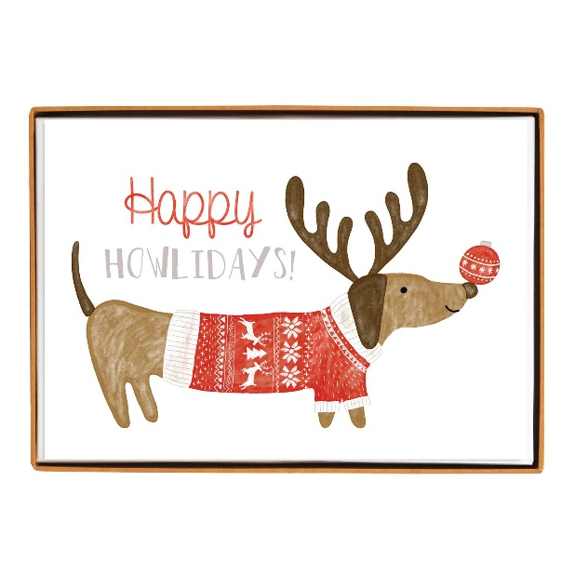
Your Name: ________________________ Your Dog’s Name: ________________________
Phone: _______________________ Email Address: ________________________________
Please Circle & Share Your Preferred Contact Information below:
Call Text Email
**You authorizing consent to receive newsletter & event announcements
from Good Dog Training & Wyolina Kennels**

*Drawing will take place on January 2nd, 2026
Please check below if you are interested in the services offered below:

Please contact me to discuss Private Training: _______
Please contact me to discuss Day Training at Wyolina Kennnels: ______
Please contact me to discuss Day Care at Wyolina Kennels: ________

For any Questions please contact: Layne or Jill @ 704-281-3708
www.gooddogtrainingnc.com / layne.tubby@yahoo.com

